Project | IEEE 802.16 Broadband Wireless Access Working Group <http://ieee802.org/16>
Title | A New HARQ Scheme for DL MIMO
Date Submitted | 2008-05-05
Source(s) | Cheng-Ming Chen, Jen-Yuan Hsu,  Jia-Hao Wu, Yu-Tao Hsieh,  Pang-An Ting, Richard Li,  ITRI  Pei-Kai Liao, Chih-Yuan Lin, Ciou-Ping Wu, Paul Cheng  MediaTek Inc. | Voice: +886-3-5914854  E-mail: ythsieh@itri.org.tw  pk.liao@mediatek.com
Re: | Call for Contributions of IEEE 802.16m_08/016r1 on the topic of “Hybrid ARQ”
Abstract | This contribution proposes a HARQ scheme for DL MIMO
Purpose | Discussion and approval by the task group.
Notice | This document does not represent the agreed views of the IEEE 802.16 Working Group or any of its subgroups. It represents only the views of the participants listed in the “Source(s)” field above. It is offered as a basis for discussion. It is not binding on the contributor(s), who reserve(s) the right to add, amend or withdraw material contained herein.
Release | The contributor grants a free, irrevocable license to the IEEE to incorporate material contained in this contribution, and any modifications thereof, in the creation of an IEEE Standards publication; to copyright in the IEEE’s name any IEEE Standards publication even though it may include portions of this contribution; and at the IEEE’s sole discretion to permit others to reproduce in whole or in part the resulting IEEE Standards publication. The contributor also acknowledges and accepts that this contribution may be made public by IEEE 802.16.
Patent Policy | The contributor is familiar with the IEEE-SA Patent Policy and Procedures:  <http://standards.ieee.org/guides/bylaws/sect6-7.html#6> and <http://standards.ieee.org/guides/opman/sect6.html#6.3>.  Further information is located at <http://standards.ieee.org/board/pat/pat-material.html> and <http://standards.ieee.org/board/pat>.
A New HARQ Scheme for DL MIMO

Cheng-Ming Chen, Jen-Yuan Hsu, Jia-Hao Wu, Yu-Tao Hsieh,
Pang-An Ting, Richard Li
ITRI
Pei-Kai Liao, Chih-Yuan Lin, Ciou-Ping Wu, Paul Cheng
MediaTek Inc.

Introduction
HARQ technique is effective to offer a reliable packet transmission over error-prone wireless communication systems by combing original transmission and retransmissions. The combining can be performed before or after detectors. Bit-level combining is a straightforward method after detectors. Unfortunately, it’s hard for a MIMO detector to get soft bits, unless List Symbol Candidates are obtained for calculation of the LLR soft bits. On the other hand, symbol-level combining, performed prior to detectors, is an approach for MIMO HARQ scheme.
It is suggested to concatenating the received channels and signals in [1]. The equivalent MIMO system which has more received antenna numbers by retransmit the same Spatial Multiplexing Signal again can be obtained. This contribution describes another approach, which performs MIMO CC HARQ with STTD retransmissions of partial signals and combine the signals in symbol-level.

Proposed Symbol-Level Combining before MIMO Equalization
The received signal model at the original transmission for MIMO is:
,
where
is the received signal for the 0-th transmission
is the MIMO channel for the 0-th transmission,
is the transmit signal for the 0-th transmission, .
where t and m of stands for t-th transmission and m-th constellation signal, respectively.
is the noise plus interference vector for the 0-th transmission.

The System Block Diagram is shown as follows:
Figure 1. Original Transmission Block Diagram

In the HARQ scheme, we suggest the retransmission with STTD (Matrix A) to take the advantage of diversity gain without complexity increasing for receiver implementation. Using STTD retransmission, the spectrum efficiency will degrade. However, instead of retransmitting the whole packet, the proposed scheme retransmits only partial of original packet. For example, if the original transmission of a particular packet is , the re-transmitted packet during two consecutive OFDMA symbols is:
in symbol 0:
,
and in symbol 1:
.
The corresponding retransmission block diagram is as follows:
Figure 2. First Retransmission Diagram

With this arrangement, the overall spectrum efficiency is the same as to retransmit the whole packet again. By using STTD Equalizer, we can obtain hard symbol decision of . To eliminate the interference of from , we obtain a degenerated SIMO system of signal .
.
where t and c of stand for t-th transmission and c-th column of , respectively. After SIMO Maximum Ratio Combining, we obtain hard symbol decision of , this time, we eliminate the interference of from , the degenerated SIMO system of signal is obtained. Signal will be obtained in this degenerated SIMO system, and its soft value can be Chase-Combined with before Soft De-mapper. Thus, the overall block diagram is as following:
Figure 3. Symbol-Level Combining with our proposed scheme

Without complex non-linear detectors such as Sphere Decoding, the proposed scheme obtains with diversity two and with near diversity six. We can obtain the soft information of after MRC and soft De-mapper. The soft information of is also available after STTD Equalizer, MRC and soft De-mapper. Finally, the proposed scheme can easily obtain soft information of and without using complex List MIMO detectors such as List Sphere Decoding.
If the packet is still failed in be CRC check after retransmission, the proposed scheme retransmits STTD signal which contain the other partial of the packet, denoted as . The soft value of after STTD equalizer may Chase-Combined with degenerated SIMO signal , which is obtained in the first retransmission. Hence, in the second retransmission, the signal and can obtain equal diversity with approximate six. The packet in latter retransmission will follow this concept with CC-combining and STTD retransmission of partial signal in the original Spatial Multiplexing System.

Comparison of Various Combining Methods
It has been stated that symbol-combining before MIMO detector is better, in terms of PER, than other combining scheme, such as bit-level combining and symbol-level combining after MIMO detector [1]. By using ML-like detector such as Sphere Decoding, two streams can get equal diversity with four in the first retransmission, but without ML-like detector, the diversity gain will degrade. Unfortunately, the complexity will be restricted by higher dimension QR decomposition and redo Sphere Decoding in each retransmission. It means that the receiver design of QR decomposition should be very flexible to deal with higher dimensional QR decomposition with the increasing of retransmit times.
By using the proposed scheme, no matter the MIMO Detector is ML-like, Linear or Successive Interference Cancellation Detectors, diversity near six and two can be obtained easily in the first retransmission with the help of traditional STTD equalizer, MRC equalizer and symbol-level Chase-Combining. The obtained soft-bits are much reliable for packet decoding. The proposed scheme does not need to implement higher complexity List Detectors such as List Sphere Detector to obtain soft bit values. To sum up, it has three advantages compare to the retransmission scheme in [1].
1. Detector Complexity is lower
2. Soft Bit Information is more easily to obtain
3. Decision Feedback can be applied to obtain higher diversity of the retransmitted stream

Simulation Results
In the contribution, simulation results for Spatial Multiplexing with 2 Tx and 2 Rx are presented. Simulation parameters are as following:

Table 1 Simulation Parameters
Carrier Frequency (GHz) | 2.5
Subcarrier Spacing (kHz) | 10.94
Channel Model | ITU-PB3, ITU-VA60
Channel Correlation | Low
FFT Size | 1024
Guard Interval | 1024/8=128
Permutation | PUSC
Channel Coding | Convolutional Turbo Coding (Vertical)
Coding Rate | id0~id7
Packet Size | 60 slots (2 symbols by 30 subchannels per antenna)
HARQ | Chase Combining, Maximum 4 retransmission
Channel Estimation | ideal
MIMO Detector | Linear MMSE Detector
The transmission pattern is the same as defined in 802.16e Vertical Matrix B. A simplified table is shown below:
Figure 4. Vertical Spatial Multiplexing Pattern
In each retransmission, the spectrum usage is half of the first transmission and only one-fourth of the original transmitted pattern will be retransmitted. Thus the consecutive retransmission patterns are:
Figure 5. First STTD retransmission pattern

Figure 6. Second STTD retransmission pattern

Figure 7. Third STTD retransmission pattern

Figure 8. Fourth STTD retransmission pattern
Finally, throughput is defined as:
.
Simulation Results are shown below:
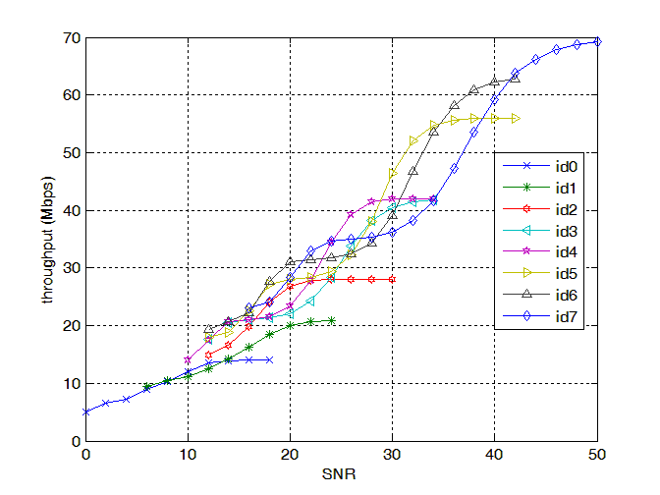
Figure 9. Throughput of PB3
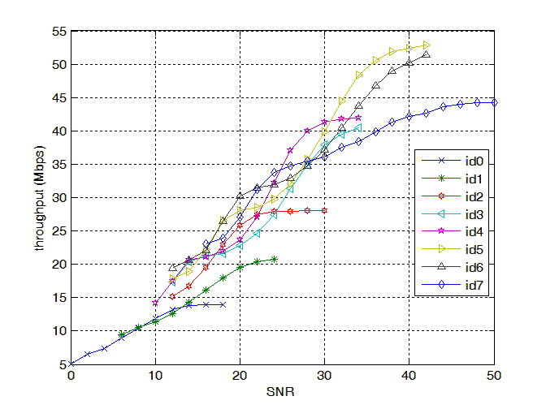
Figure 10. Throughput of VA60

Conclusion
The symbol-level combining before MIMO detector has good performance, but the receiver will face a higher complexity problem. Hence, this contribution proposes a HARQ scheme which retransmits partial packet with STTD, resulting in the same spectrum efficiency compared to [1]. The receiver design can easily get diversity gain and soft-bits are easily obtained with this scheme.

Proposed Text
------------------------------------------------------- Start of the proposed text ---------------------------------------------
11. Physical layer
11.x Hybrid ARQ
HARQ scheme with STTD retransmission can be considered for 802.16m systems. In the HARQ scheme, the retransmission is performed by STTD (Matrix A), and only partial signal is retransmitted to keep the same spectrum efficiency with retransmission by SM (Matrix B).

------------------------------------------------------- End of the proposed text -------------------------------------------

Reference
[1] IEEE C802.16m-07/172

