Project | IEEE 802.16 Broadband Wireless Access Working Group <http://ieee802.org/16>
Title | A joint transceiver design for MIMO precoder and antenna selection mechanism
Date Submitted | 2008-05-05
Source(s) | Jen-Yuan Hsu, Lai-Huei Wang, Yu-Tao Hsieh, Pang-An Ting, Richard Li  ITRI  Hsi-Pin Ma  NTHU | Voice: + 886 3 5914854  E-mail: ythsieh@itri.org.tw
Re: | Call for Contributions of IEEE 802.16m_08/016r1 on the topic of DL MIMO schemes
Abstract | A joint transceiver design for MIMO precoder and antenna selection mechanism
Purpose | Discussion and approval by the task group.
Notice | This document does not represent the agreed views of the IEEE 802.16 Working Group or any of its subgroups. It represents only the views of the participants listed in the “Source(s)” field above. It is offered as a basis for discussion. It is not binding on the contributor(s), who reserve(s) the right to add, amend or withdraw material contained herein.
Release | The contributor grants a free, irrevocable license to the IEEE to incorporate material contained in this contribution, and any modifications thereof, in the creation of an IEEE Standards publication; to copyright in the IEEE’s name any IEEE Standards publication even though it may include portions of this contribution; and at the IEEE’s sole discretion to permit others to reproduce in whole or in part the resulting IEEE Standards publication. The contributor also acknowledges and accepts that this contribution may be made public by IEEE 802.16.
Patent Policy | The contributor is familiar with the IEEE-SA Patent Policy and Procedures:  <http://standards.ieee.org/guides/bylaws/sect6-7.html#6> and <http://standards.ieee.org/guides/opman/sect6.html#6.3>.  Further information is located at <http://standards.ieee.org/board/pat/pat-material.html> and <http://standards.ieee.org/board/pat>.
A joint transceiver design for MIMO precoder and antenna selection mechanism

Jen-Yuan Hsu, Lai-Huei Wang, Yu-Tao Hsieh, Pang-An Ting, Richard Li
ITRI
Hsi-Pin Ma
NTHU

- Introduction
A joint design transceiver for MIMO communications with high performance and reduced complexity is proposed. The proposed transceiver adopt a geometric mean decomposition (GMD) precoder with channel state information at the transmitter (CSIT) for performance improvement and a minimum mean-squared-error (MMSE) V-BLAST detector at the receiver for reduced complexity. To compensate the severe performance loss for GMD precoder under ill-conditioned channels, a low complexity transmit antenna selection scheme is proposed. System simulation results show the proposed MIMO transceiver has better BER performance than other transceiver schemes under i.i.d. channel and correlated channel conditions.

MMSE V-BLAST with GMD and Transmit Antenna Selection
  - System model
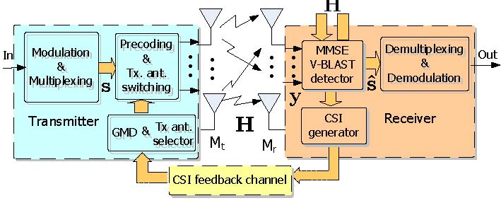

Fig. 1. The proposed MIMO transceiver with CSIR and CSIT.
The mathematical model of a precoded MIMO system is:
(1)
where is the transmitted symbol vector with . is assumed to be a full column rank complex channel matrix (the rank ). n is the complex Gaussian noise vector with zero mean and variance per entry. The signal-to-noise ratio (SNR) is defined as . The received symbol vector is , where is equal to for a spatial multiplexing scheme.

  - MMSE V-BLAST with GMD
In [1], the authors propose a novel algorithm named geometric mean decomposition (GMD) for a joint transceiver design. The algorithm can provide significant improvements in capacity and error-rate performance compared with a zero-forcing V-BLAST (ZF V-BLAST). With this method, a precoder can be obtained by applying GMD to . Pre-multiply by both sides in (1), and the system can be represented as:
(2)
where , and is the -th nonzero singular value of . However, under ill-conditioned channels, the system employing GMD may suffer from considerable capacity loss or BER performance loss. [2] proposes a joint transceiver design with a MMSE V-BLAST detector, and the water filling before GMD can increase the flexibility of the system. However, the technique still can not offer any contribution under ill-conditioned channels at low SNR.
In another aspect, antenna selection is also a practical technique to improve BER performance [3] and has been demonstrated on ZF V-BLAST system [4].
From [2], suppose the extended channel matrix of the MMSE V-BLAST detector can be decomposed as:
(3)
where , and is an upper triangular matrix, which diagonal elements are all positive real numbers. After applying the GMD algorithm to and some manipulations, the can be decomposed as:
(4)
where and are unitary matrices. is a semi-unitary matrix. Let precoder and in (1). After pre-multiplying by both sides, the system representation will be similar to (2) with the upper triangular matrix , which diagonal elements are:
(5)
Observation of (3), (4), and Lemma III.3 of [2], the diagonal elements of satisfy:
(6)
where is the signal-to-interference-and-noise ratio (SINR) of the -th layer ﬁltering in precoded MIMO. According to (5) and (6), we can maximize SINRs to improve the BER performance by maximizing min(). Consider the following equality:

  - Transmit Antenna Selection
The value of after GMD precoding depends on the extended channel matrix . As a result, the antenna selection can be used to select a proper so that the diagonal elements of of the precoded system is maximized. The optimal antenna selection criterion is:
(7)
where, and ^{t} is the subset matrix of the complete channel information with antenna selection. and are the number of receiver and transmitter antennas, respectively.
For transmit antenna selection, it is straightforward to compute the determinants of all possible candidates and select with maximum results. Therefore, candidates should be evaluated.
To save computation complexity further, the column/row vector selection methods can be used. In [5], the authors select a subset matrix from a given matrix by successively deleting unfavorable rows or columns. However, the deleting criterion requires inverse matrix calculation, which is impractical for implementation. It is well-known that the fundamental geometric meaning of an absolute determinant is the volume of the parallelepiped formed by the rows or columns of the matrix. Therefore, a simple selection procedure similar to Gram-Schmidt orthogonalization (GSO) process can be adopted [4]. Start from the column with largest norm, and choose the next column with the largest projection distance to the space spanned by the selected column vectors until columns have been determined.
Consider a complete channel information with transmit antenna selection . To use this approximative selection, we have to define another extended matrix as . Thereon, apply the above approximative GSO-based determinant method to select columns from which are also the column indices of after transmit antenna selection.
Fig. 2 shows BER performance evaluation for transmit antenna selection using different approximative implementations compared with exhaustive determinant computation. Fig. 2(a) is under i.i.d. channels. It shows that there will be certain performance loss by using GSO-based column selection to approximate maximum determinant. In Fig. 2(b), the GSO-based method is almost fail and even worse than the system without transmit antenna selection under SCM environment. This is because the GSO-based method may probably find the ill-conditioned subset matrix.
Although GSO-based approximation can save a lot of computational complexity compared to exhaustive determinants search, the BER performance loss is unacceptable. Here, we do some modifications to the GSO-based approximation to solve this weakness and name this method as a modified GSO-based method. There are two stages in this modified method. In the first stage, first columns are determined by original GSO-based method. In the second stage, the residual columns are determined by computing possible determinants under known columns. The second stage search can re-capture appropriate column vectors in case the first stage fail to find the correct columns and avoid serious concatenate selection errors in successive projection process.
For a spatial-multiplexing MIMO system selected from a modified GSO-based transmit antenna selection, the first two columns can be determined by the first stage, and then the second stage decides the rest columns. The corresponding uncoded BER performance simulation results are in Fig. 2(c) and Fig. 2(d). Obviously, the BER performance is consistent with the exhausted determinant search method. Moreover, the computation complexity is still much lower than the exhausted determinant search method since only candidates are needed to evaluate instead of . Take a transmit antenna selection for example, only candidates are needed to evaluate instead of candidates.

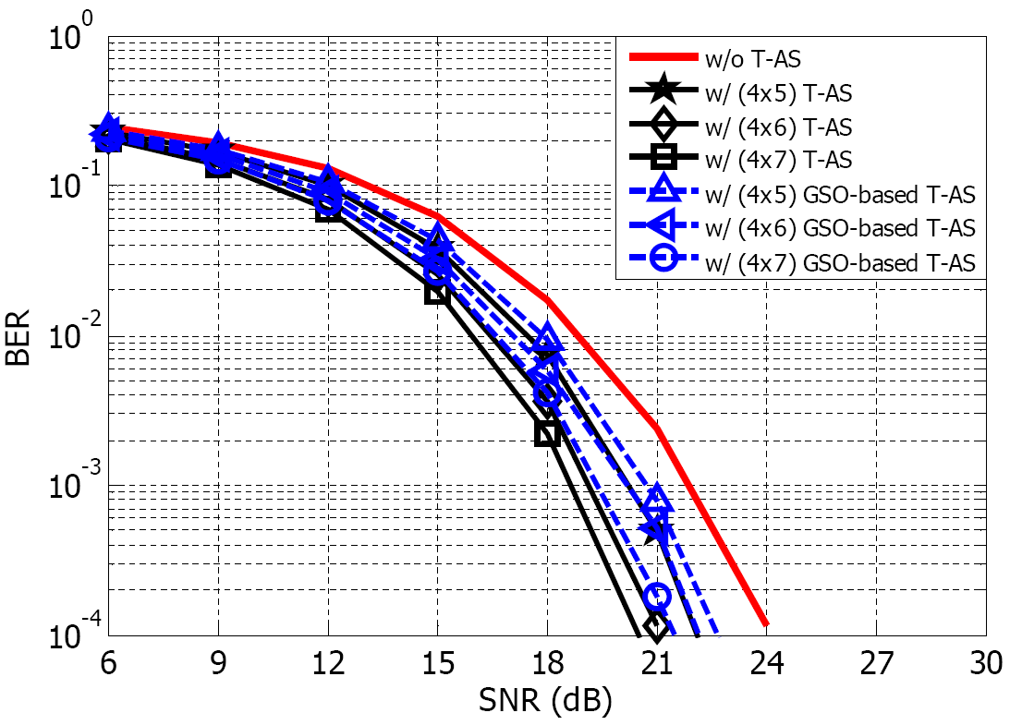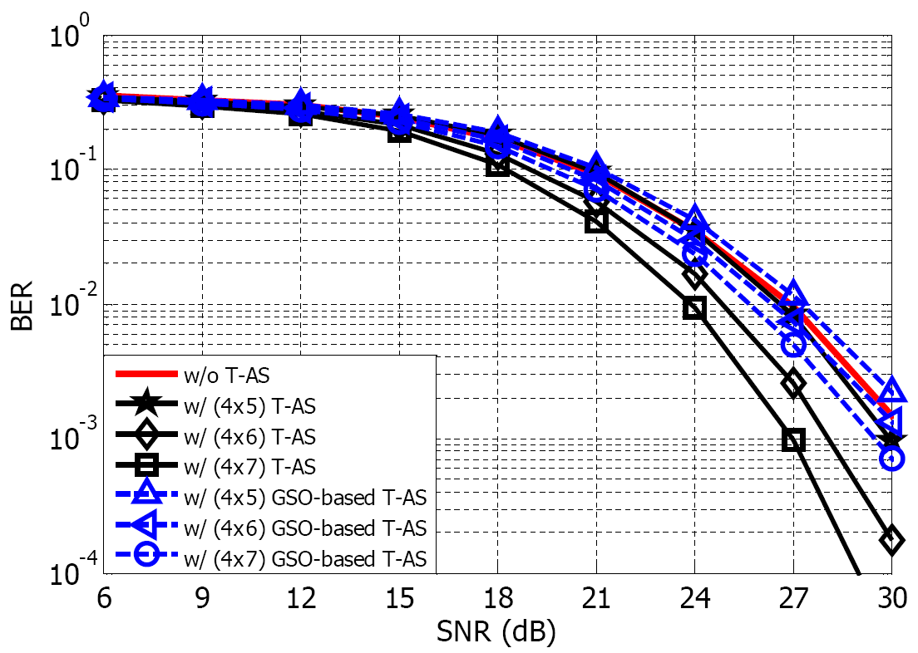
(a) GSO-based transmit AS under i.i.d. fading channel (b) GSO-based transmit AS under SCM
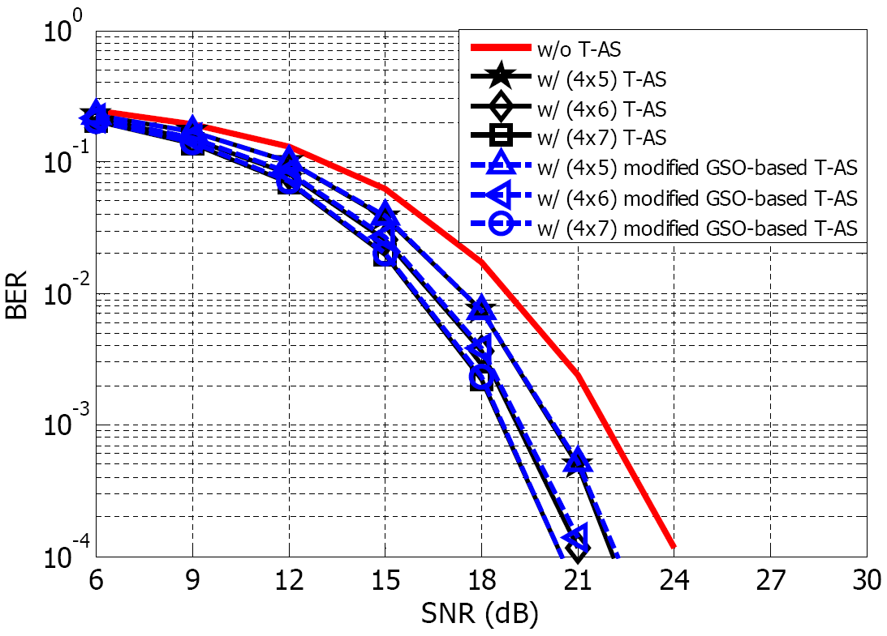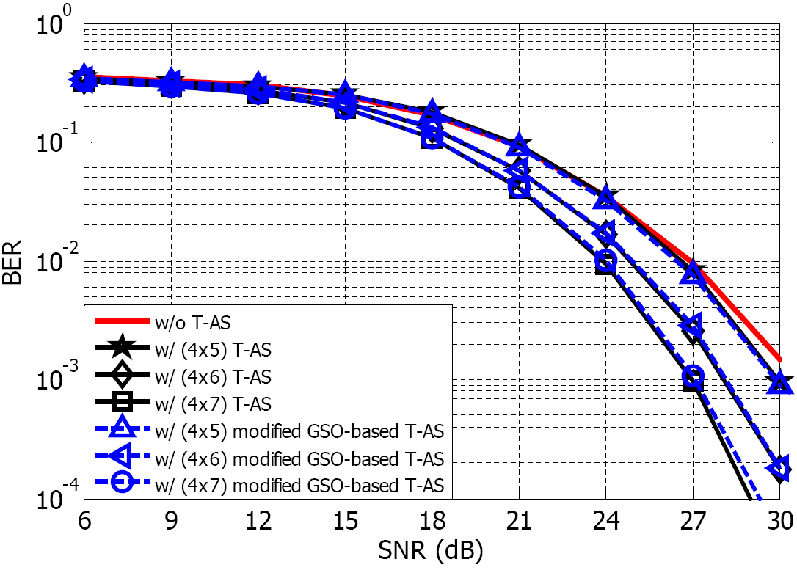
(c) Modified transmit AS under i.i.d. fading channel (d) Modified transmit AS under SCM

Fig. 2. BER performance evaluation for transmit antenna selection with GSO-based approximation and modified GSO-based approximation.

Simulation Results
Assume the system is a 16-QAM spatial multiplexing MIMO baseband transceiver without channel codec. Four transmit antennas are selected by the (2, 2) modified GSO-based method of the proposed transceiver with , , and . Suppose that the channel estimation and CSI feedback is perfect and is no feedback delay for CSI feedback. The simulation results in Fig. 3 are under i.i.d. Rayleigh fading environment. Open-loop ML has only 1 dB better than the ZF V-BLAST detector with GMD. While the MMSE V-BLAST one has the same even slightly better performance as ML. The proposed transceiver outperforms others. Fig. 4 shows the performance comparison under the SCM channel model (SCM-11-01-2005 V1.2 released by WINNER project). The carrier frequency is 2.5 GHz. The antenna spacing at the base-station and mobile-station are and , respectively. The communication environment is under urban-macro and without vehicular speed. The obvious difference is that the ZF V-BLAST with GMD has bad performance under correlated channel especially at low SNR, while the MMSE V-BLAST with GMD acts well and the proposed transceiver still outperforms others.

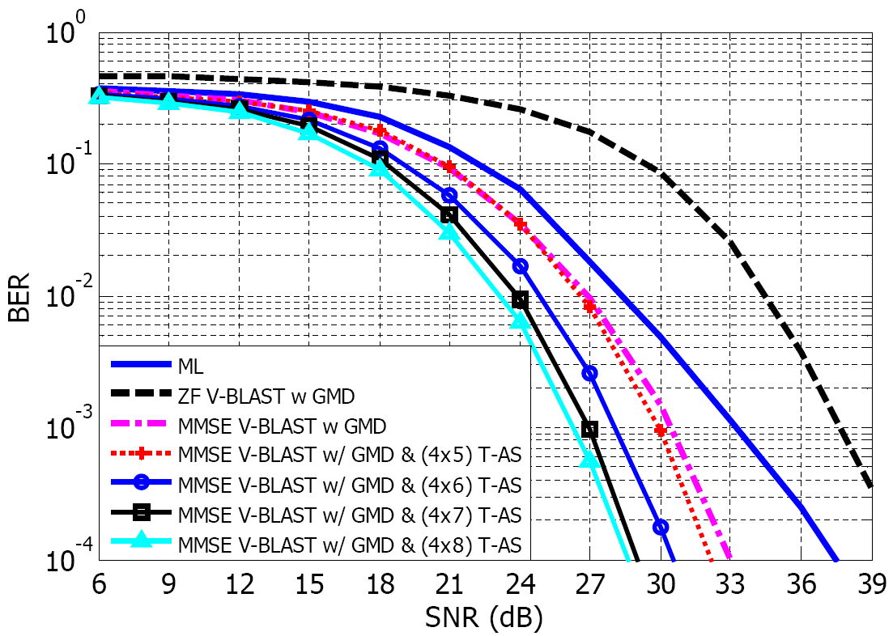
Fig. 3. Uncoded BER performance under i.i.d. Rayleigh fading channel.

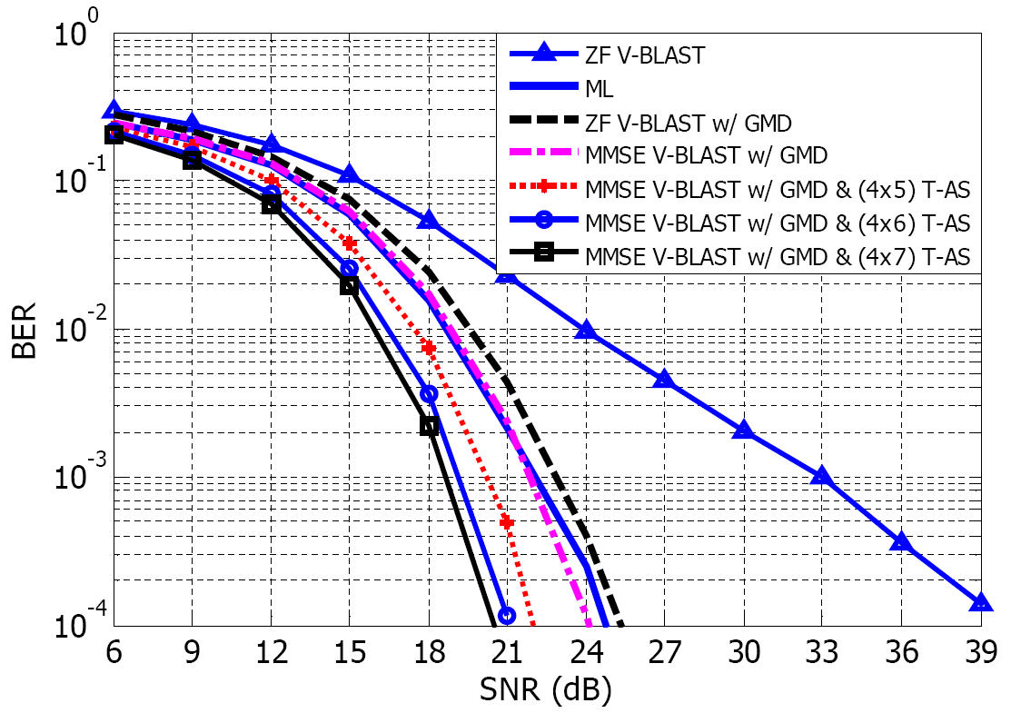
Fig. 4. Uncoded BER performance under SCM channel model.

Proposed SDD Text
11 Physical Layer

11.x DL MIMO schemes

11.x.y Antenna selection mechanism

The joint design of antenna selection with MIMO precoding can be considered for DL MIMO. Fig. x gives an example of combining geometric mean decomposition (GMD) precoder and antenna selection.
Fig x An example of combining geometric mean decomposition (GMD) precoder and antenna selection.

Reference

[1] Y. Jiang, J. Li, and W. W. Hager, “Joint transceiver design for MIMO communications using geometric mean decomposition,” IEEE Trans. Signal Process., vol. 53, no. 10, pp. 3791–3803, Oct. 2005.
[2] Y. Jiang, J. Li, and W. W. Hager, “Uniform channel decomposition for MIMO communications,” IEEE Trans. Signal Process., vol. 53, no. 11, pp. 4283–4294, Nov. 2005.
[3] A. F. Molisch and M. Z. Win, “MIMO systems with antenna selection,” IEEE Microwave Mag., pp. 46–56, Mar. 2004.
[4] Y. Bae and J. Lee, “Antenna selection for MIMO systems with sequential Nulling and cancellation,” Conf. on Information Science and Systems, Princeton University, Princeton, New Jersey , pp.745–749, Mar. 2006.
[5] F.R. de Hoog and R.M.M. Mattheij, “Subset selection for matrices,” Linear Algebra and its Applications, vol. 422, pp. 349–359, April 2007.

