Project | IEEE 802.16 Broadband Wireless Access Working Group <http://ieee802.org/16>
Title | Sub-carrier Alignment Mechanism for Multi-carrier Support in IEEE 802.16m
Date Submitted | 2008-05-15
Source(s) | I-Kang Fu, Pei-Kai Liao, Yih-Shen Chen, Kelvin Chou, Paul Cheng  MediaTek Inc.  No.1, Dusing Rd. 1, Hsinchu Science Park, Hsinchu, Taiwan  Mo-Han Fong, Sophie Vrzic, Robert Novak, Jun Yuan, Dongsheng Yu, Sang-Youb Kim, Kathiravetpillai Sivanesan, Anna Tee  Nortel Networks  Richard Li, Chie-Ming Chou  ITRI | IK.Fu@mediatek.com  mhfong@nortel.com  richard929@itri.org.tw
Re: | IEEE 802.16m-08/016, “Call for Contributions on Project 802.16m System Description Document (SDD),” – Comments on P802.16m SDD
Abstract | In order to utilize the guard sub-carriers between contagious frequency channels for data transmission, those overlapped sub-carriers must be well aligned in frequency domain. This contribution overviews this problem and suggest to simply apply a fraction of sub-carrier spacing for each FA to resolve this problem.
Purpose | For TGm discussion and adoption on the proposal text into P802.16m SDD.
Notice | This document does not represent the agreed views of the IEEE 802.16 Working Group or any of its subgroups. It represents only the views of the participants listed in the “Source(s)” field above. It is offered as a basis for discussion. It is not binding on the contributor(s), who reserve(s) the right to add, amend or withdraw material contained herein.
Release | The contributor grants a free, irrevocable license to the IEEE to incorporate material contained in this contribution, and any modifications thereof, in the creation of an IEEE Standards publication; to copyright in the IEEE’s name any IEEE Standards publication even though it may include portions of this contribution; and at the IEEE’s sole discretion to permit others to reproduce in whole or in part the resulting IEEE Standards publication. The contributor also acknowledges and accepts that this contribution may be made public by IEEE 802.16.
Patent Policy | The contributor is familiar with the IEEE-SA Patent Policy and Procedures:  <http://standards.ieee.org/guides/bylaws/sect6-7.html#6> and <http://standards.ieee.org/guides/opman/sect6.html#6.3>.  Further information is located at <http://standards.ieee.org/board/pat/pat-material.html> and <http://standards.ieee.org/board/pat>.
Sub-carrier Alignment Mechanism for Multi-carrier Support in IEEE 802.16m

I-Kang Fu, Pei-Kai Liao, Yih-Shen Chen, Kelvin Chou, Paul Cheng
MediaTek Inc.
Mo-Han Fong, Sophie Vrzic, Robert Novak, Jun Yuan, Dongsheng Yu, Sang-Youb Kim, Kathiravetpillai Sivanesan, Anna Tee
Nortel Networks
Richard Li, Chie-Ming Chou
ITRI

Abstract
In order to fulfill the IMT-Advanced requirements on 1Gbps peak transmission rate for 4th Generation (4G) mobile cellular systems, much wider radio bandwidth is considered in P802.16m SDD. Instead of equipping a large size FFT to utilize much wider radio bandwidth, the architecture to have multiple smaller size FFTs combine with multiple RF carriers (RF channels) may be preferred by its flexibility to utilize non-contiguous frequency channels (bands), to serve the mobile station (MS) equipped with different number of RF carriers, lower PAPR etc. However, the primary drawback of this architecture is the necessity to reserve guard sub-carriers to prevent ICI across adjacent frequency channels. Because those guard sub-carriers from adjacent channels are not well aligned in frequency domain, they are not orthogonal to each other. In order to mitigate this drawback and utilize those guard sub-carriers for higher peak transmission rate and higher spectrum efficiency, a sub-carrier alignment mechanism will be necessary before utilizing the guard sub-carriers for data transmission.

- Motivation

IEEE 802.16 Task Group m (TGm) aims to develop the standard to amend the IEEE 802.16 WirelessMAN-OFDMA specification to provide an advanced air interface for operation in licensed bands. It meets the cellular layer requirements of IMT-Advanced next generation mobile networks and provides continuing support for legacy WirelessMAN-OFDMA equipment [1].

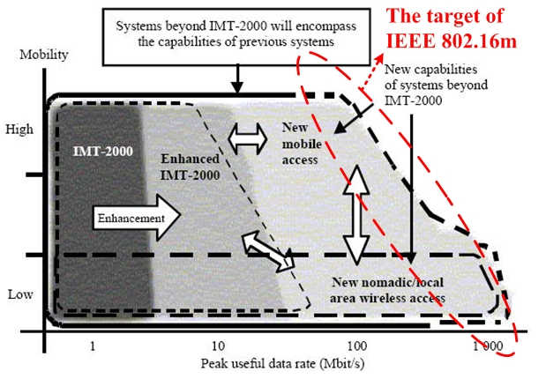
Fig.1 Illustration of capability of IMT-2000 and systems beyond IMT-2000 [2]

In order to meet the IMT-Advanced requirement on 1Gbps peak transmission rate, much wider radio bandwidth than current one (i.e. 10MHz) shall be considered in IEEE 802.16m. There are two possible architectures to utilize much wider radio bandwidth while keeping the legacy support. One is using single FA* (Frequency Assignment) with large size FFT (e.g. 4096) to utilize wider bandwidth, and another one is using multiple FAs with smaller size FFT (e.g. 1024). The first one is addressed in 16m frame structure with wider bandwidth support, and this contribution will emphasize on the design issues for the second one (i.e. multi-carrier support issues). Compare with the first architecture, the second architecture may be favored by its flexibility to utilize non-contiguous frequency channels, to serve the mobile station (MS) equipped with different number of RF carriers, lower PAPR, easier to achieve legacy support etc.
Figure 2 shows an example for multi-carrier support by having total 40MHz bandwidth, while the legacy system uses 10MHz bandwidth.

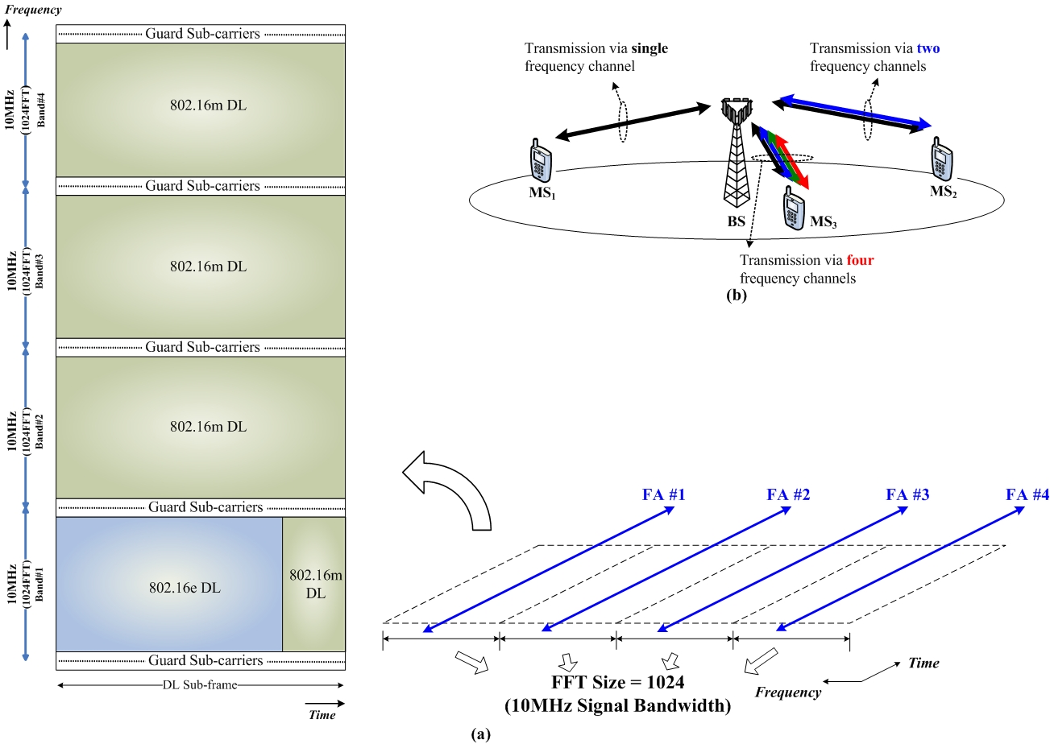

Fig.2 (a) An example on multi-carrier frame structure with legacy support in IEEE 802.16m, and (b) the flexibility to serve the MS equipped with different number of RF carriers

However, Figure 2(a) also shows a major drawback of this architecture by reserving the guard sub-carriers. The reason is because the sub-carriers from adjacent frequency channels does not well aligned due to the mismatch between the separation between adjacent FAs (e.g.10MHz) and current frequency 10.94kHz sub-carrier spacing. Figure 3 shows the reason why the sub-carriers from adjacent frequency channels will be overlapped and not aligned.

* Frequency Assignment (FA): A logical assignment of downlink center frequency and channel bandwidth programmed to the base station.
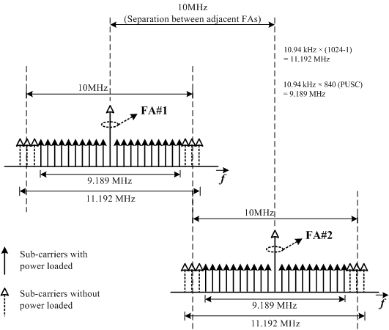

Fig.3 The sub-carrier distribution for 10MHz system bandwidth based on 10.94kHz sub-carrier spacing

Because the sub-carriers from adjacent frequency channels are not well aligned as shown in Figure 4, they are not orthogonal to each other. Allocating power on those guard sub-carriers will result in ICI not only to the guard sub-carriers but also to other data sub-carriers in adjacent frequency channel. Therefore, those guard sub-carriers cannot be utilized to prevent the ICI across adjacent frequency channels and hence result in worse peak transmission rate and spectrum efficiency.

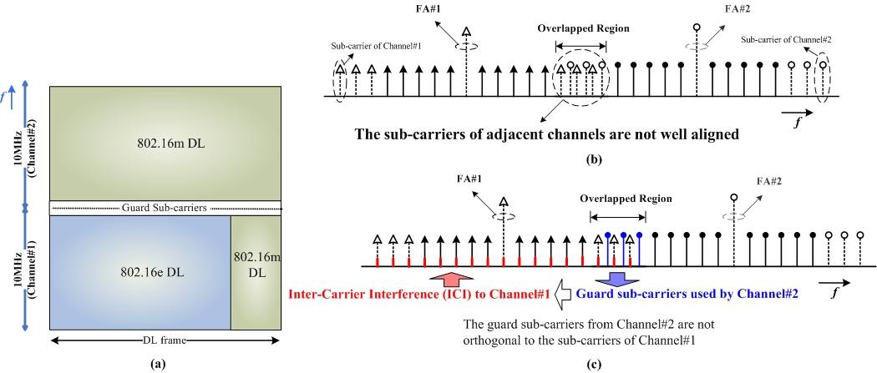

Fig. 4 (a) Take two adjacent frequency channels as an example. (b) If the overlapped sub-carriers are not well aligned, (c) allocating power to the guard sub-carriers in one frequency channel will result in ICI to not only the guard sub-carriers but also the data sub-carriers in another frequency channel.

From system operator’s point of view, it’s a waste to reserve guard sub-carriers if the adjacent frequency channels are controlled by the same operator. This will result in lower peak transmission rate and lower spectral efficiency [3]. Therefore, the motivation of this contribution is proposing a sub-carrier alignment mechanism so that those guard sub-carriers between adjacent frequency channels can be well aligned and be utilized for data transmission without resulting ICI to the data sub-carriers in adjacent frequency channel.

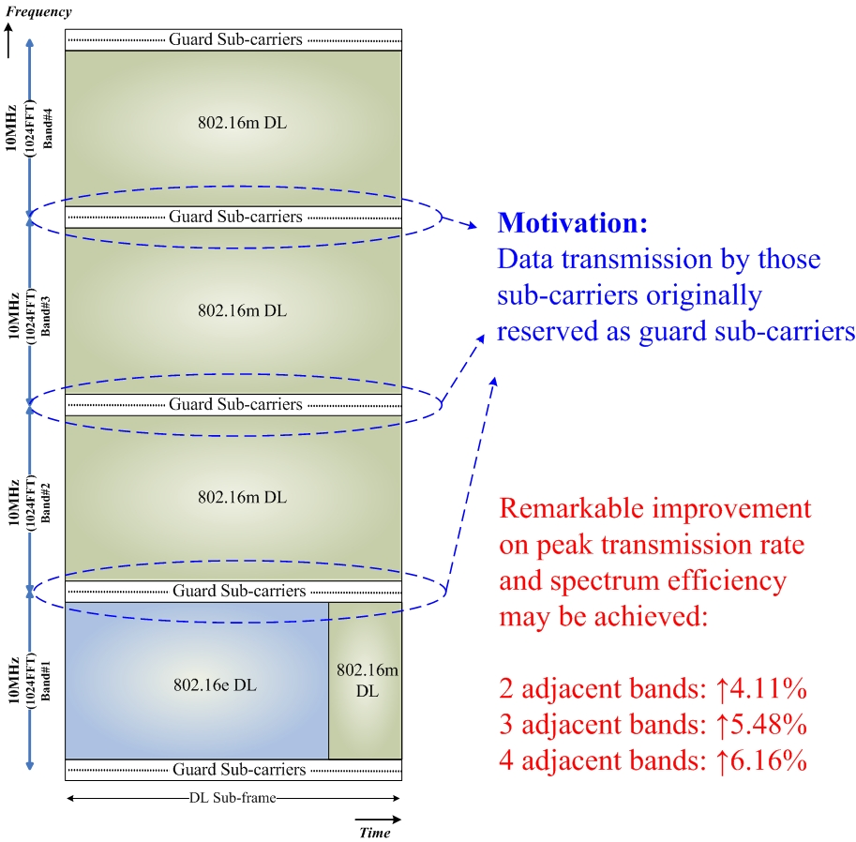

Fig.5 Motivation to utilize those guard sub-carriers for data transmission

- Proposed Sub-carrier Alignment Mechanism

The fundamental concept of the proposed mechanism is simply shifting the center frequency of the adjacent frequency channel to achieve sub-carrier alignment. There are two methods to achieve the sub-carrier alignment.

Method 1:

As shown in Figure 6, the RF center frequency of channel#2 is shifted to compensate the frequency offset (Δf’) so that the sub-carriers in overlapped region can be well aligned. Note that this frequency offset will be within the range -Δf /2 ≦ Δf’ < Δf /2, where Δf is the sub-carrier spacing and Δf’ is actually a fraction of sub-carrier spacing. For sub-carrier spacing Δf = 10.94kHz, this frequency offset will be in the range -5.47kHz ≦ Δf’ < 5.47kHz. Adjusting the center frequency to compensate this can be obtained by existing frequency synthesizer.

Actually, the major problem will be: “how to know this frequency offset in advance?”
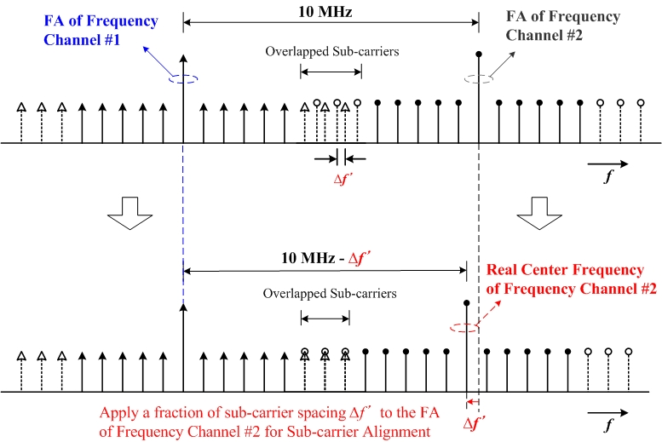

Fig.6 Sub-carrier alignment by applying a fraction of sub-carrier spacing to the FA of adjacent frequency channel

For downlink transmission, the BSs can estimate the frequency offset and perform sub-carrier alignment by itself. Therefore, the standard may only need to state the sub-carriers from adjacent frequency bands shall be aligned in frequency domain without defining specific alignment mechanism. The major problem comes from uplink transmission, where the MS has no idea the distribution of frequency channels and if there exists frequency offset need to compensate when initial network access or when handover. In addition, the frequency offset value will depends on the bandwidth (e.g. 5MHz, 10MHz or 20MHz) of adjacent channels and the combination of contiguous frequency channels. For example, if we shift the center frequency of the first adjacent channel, the offset for aligning the sub-carriers of the second channel and the third channel are different.
Figure 7 shows the fundamental philosophy of the proposed mechanism, which includes an example that MS has the capability to utilize two frequency channels for data transmission.

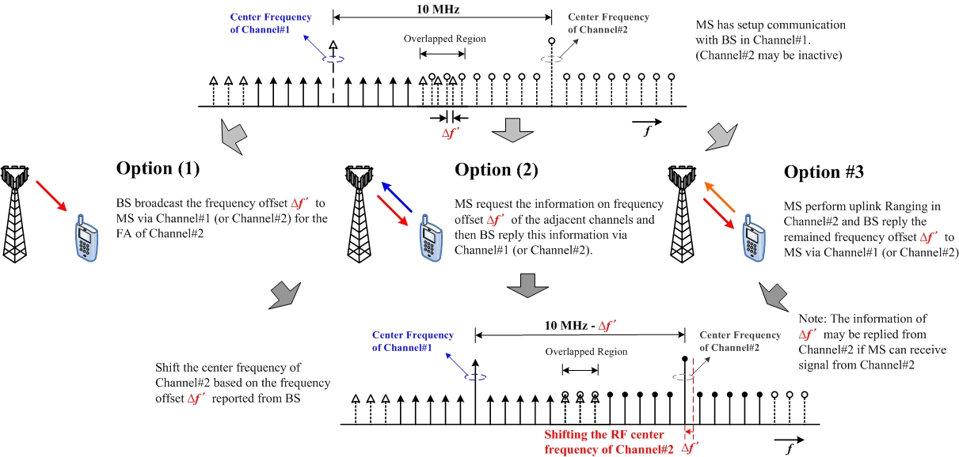

Fig. 7 The proposed mechanism to perform uplink sub-carrier alignment and possible options to obtain frequency offset information

In Figure 7, there are several possible ways to obtain the frequency offset information. For (1) and (2), the basic assumption is BS can know the frequency offset need to be compensated for each FA in advance. For (3), it can either work without BS’s broadcast information or it can combine with (1) or (2) as part of Ranging process to refine the center frequency.
Option (1) is to broadcast this information to all the MSs, and option (2) is unicast or multi-cast this information by MS request. Option (3) is performing uplink Ranging, which can combine with other options or it can be operated stand alone. Since the uplink Ranging is always needed when initializing each frequency channel, the option (3) should be the fundamental step to guarantee the sub-carriers are well aligned.

In summary, the proposed sub-carrier alignment mechanism can be concluded by the following characteristics:
- Achieve the sub-carrier alignment by applying a frequency offset (a fraction of sub-carrier spacing) to the FAs of the contagious frequency channels (i.e. adjusting the center frequency of adjacent frequency channels.
- For downlink transmission, BS can align the sub-carriers by itself.
- For uplink transmission, MS can perform sub-carrier alignment by acquiring the frequency offset information through following ways:
  - BS broadcast the fractions of sub-carrier spacing should be applied to each FA.
  - BS multi-cast or unicast the fractions of sub-carrier spacing should be applied to each FA by MS request.
  - MS perform uplink Ranging and then BS reply the remained frequency offset need to compensate.

Method 2:

This is proposed in C802.16m-08/355. The center frequency spacing of adjacent channels can be adjusted such that the spacing is in units of the raster size as well as in units of the sub-carrier spacing. For the case of sub-carrier spacing of 10.94kHz, the corresponding system bandwidths of 5/10/20MHz are not divisible by the sub-carrier spacing. However, 7x250kHz = 1.75MHz is divisible by 10.94kHz. Therefore, Nx1.75MHz, e.g. 5.25MHz, 10.5MHz, 21MHz are divisible by the sub-carrier spacing and can be used as the center frequency spacing between adjacent channels.

An illustration for the carrier bandwidth of 5MHz is shown in Figure 8. On sub-frame within the 16m zone, no guard tones are required between adjacent carriers beyond the carrier bandwidth (see Figure 9). On sub-frame within the legacy zone, guard tones are still required on sub-frames within the legacy zone due to the legacy permutation format (see Figure 9). For the non-legacy carrier, as shown in Figure 8, uneven number of guard sub-carriers is used on both sides of a carrier

Fig. 8 Center frequencies spacing and guard tones of adjacent legacy enabled carrier and non-legacy carrier

Fig 9 Guard tones of adjacent legacy enabled carrier and non-legacy carrier for legacy sub-frames and 16m sub-frames

- Proposed Text Input to P802.16m SDD

------------------------------------------------------Start of the Text--------------------------------------------------------------
[Adopt the following text modification begin from line#16, page#12 in P802.16m SDD]

Multi-carrier (MC) block enables a common MAC entity to control a PHY spanning over multiple frequency channels. The channels may be of different bandwidths (e.g. 5, 10 and 20 MHz), be non-contiguous or belong to different frequency bands. The channels may be of the same or different duplexing modes, e.g. FDD, TDD, or a mix of bidirectional and broadcast only carriers. For contiguous frequency channels, the overlapped guard sub-carriers shall be aligned in frequency domain in order to be used for data transmission.

[Add the following text and figure into Section 19 of P802.16m SDD]

19 Support for Multi-carrier

When multiple contiguous frequency channels are enabled, the guard sub-carriers between contiguous frequency channels can be utilized for data transmission only if the sub-carriers from adjacent frequency channels are well aligned. In order to align those sub-carriers from adjacent frequency channel, a frequency offset (Δf’) can be applied to its FA. The basic idea is shown by the example in Figure y.

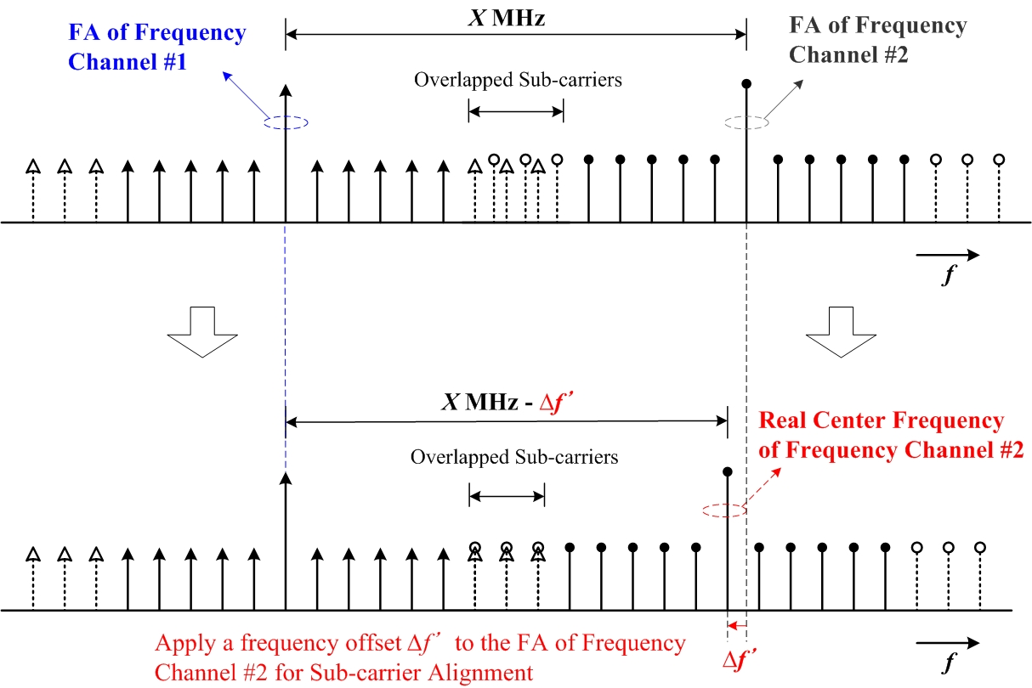
Fig.y Sub-carrier alignment by applying a fraction of sub-carrier spacing to the FA of adjacent frequency channel

In order to utilize the guard sub-carrier for data transmission, the information on the available guard sub-carriers eligible for data transmission shall be sent to MS. This information shall include the numbers of available sub-carriers in upper side and in lower side with respect to the DC sub-carrier of each frequency channel.

-------------------------------------------------------End of the Text--------------------------------------------------------------

Reference

[1] P802.16m Project Authorization Request (PAR), December 2006.
http://standards.ieee.org/board/nes/projects/802-16m.pdf
[2] Recommendation ITU-R M.1645, “Framework and overall objectives of the future development of IMT-2000 and systems beyond IMT-2000,” June 2006.
http://www.itu.int/rec/R-REC-M.1645/e
[3] Kwanhee Roh et al, “Proposed 802.16m DL Control Channel Scheme to Use More Subcarriers in Guard Band,” IEEE C802.16m-08/208r2, March 2008.

