Project | IEEE 802.16 Broadband Wireless Access Working Group <http://ieee802.org/16>
Title | Uplink Control Structure, Ranging and Initialization Procedure with Multi-carrier Support for IEEE 802.16m
Date Submitted | 2008-05-05
Source(s) | I-Kang Fu, Yih-Shen Chen, Kelvin Chou, Paul Cheng  MediaTek Inc.  No.1, Dusing Rd. 1, Hsinchu Science Park, Hsinchu, Taiwan | IK.Fu@mediatek.com
Re: | IEEE 802.16m-08/016, “Call for Contributions on Project 802.16m System Description Document (SDD),” – Uplink Control Structures
Abstract | This contribution proposes the uplink control structure, Ranging and MS initialization procedure with multi-carrier support for IEEE 802.16m
Purpose | For TGm discussion and adoption on the proposed text input for TGm SDD
Notice | This document does not represent the agreed views of the IEEE 802.16 Working Group or any of its subgroups. It represents only the views of the participants listed in the “Source(s)” field above. It is offered as a basis for discussion. It is not binding on the contributor(s), who reserve(s) the right to add, amend or withdraw material contained herein.
Release | The contributor grants a free, irrevocable license to the IEEE to incorporate material contained in this contribution, and any modifications thereof, in the creation of an IEEE Standards publication; to copyright in the IEEE’s name any IEEE Standards publication even though it may include portions of this contribution; and at the IEEE’s sole discretion to permit others to reproduce in whole or in part the resulting IEEE Standards publication. The contributor also acknowledges and accepts that this contribution may be made public by IEEE 802.16.
Patent Policy | The contributor is familiar with the IEEE-SA Patent Policy and Procedures:  <http://standards.ieee.org/guides/bylaws/sect6-7.html#6> and <http://standards.ieee.org/guides/opman/sect6.html#6.3>.  Further information is located at <http://standards.ieee.org/board/pat/pat-material.html> and <http://standards.ieee.org/board/pat>.
Uplink Control Structure, Ranging and Initialization Procedure
with Multi-carrier Support for IEEE 802.16m

I-Kang Fu, Yih-Shen Chen, Kelvin Chou, Paul Cheng
MediaTek Inc.

Abstract
In order to fulfill the IMT-Advanced requirements on 1Gbps peak transmission rate for 4th Generation (4G) mobile cellular systems, much wider radio bandwidth is considered in P802.16m SDD. Instead of equipping a large size FFT to utilize much wider radio bandwidth, the architecture to have multiple smaller size FFTs combine with multiple RF carriers (RF channels) may be preferred by its flexibility to utilize non-contiguous frequency channels (bands), to serve the mobile station (MS) equipped with different number of RF carriers, lower PAPR etc. Because the MSs may equipped with different number of RF carriers, this contribution suggests the uplink control structure to have one primary frequency channel among several contiguous frequency channels. The MSs can acquire complete system information from primary channel and then enable its first RF carrier by uplink Ranging in primary channel. When MS tries to enable its non-primary channels for multi-carrier transmission, several Ranging options are investigated for further discussion. By taking the multi-carrier support into consideration, a possible initialization procedure is provided for TGm discussion.

- Motivation

IEEE 802.16 Task Group m (TGm) aims to develop the standard to amend the IEEE 802.16 WirelessMAN-OFDMA specification to provide an advanced air interface for operation in licensed bands. It meets the cellular layer requirements of IMT-Advanced next generation mobile networks and provides continuing support for legacy WirelessMAN-OFDMA equipment [1].

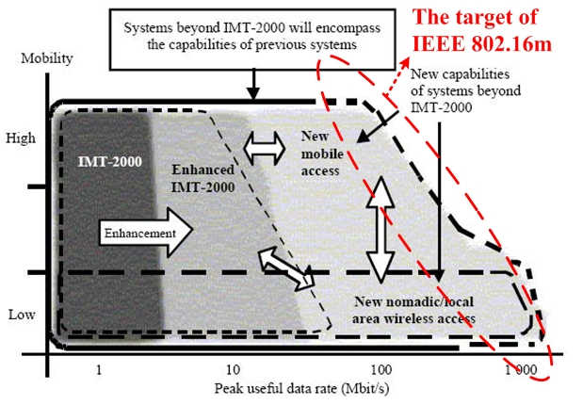
Fig.1 Illustration of capability of IMT-2000 and systems beyond IMT-2000 [2]

In order to meet the IMT-Advanced requirement on 1Gbps peak transmission rate, much wider radio bandwidth than current one (i.e. 10MHz) shall be considered in IEEE 802.16m. There are two possible architectures to utilize much wider radio bandwidth while keeping the legacy support. One is using single FA* (Frequency Assignment) with large size FFT (e.g. 4096) to utilize wider bandwidth, and another one is using multiple FAs with smaller size FFT (e.g. 1024). The first one is addressed in 16m frame structure with wider bandwidth support, and this contribution will emphasize on the uplink control structure design for the second one (i.e. multi-carrier support issues). Compare with the first architecture, the second architecture may be favored by its flexibility to utilize non-contiguous frequency channels, to serve the mobile station (MS) equipped with different number of RF carriers, lower PAPR, easier to achieve legacy support etc.
Figure 2 shows an example for multi-carrier support by having total 40MHz bandwidth, while the legacy system uses 10MHz bandwidth.

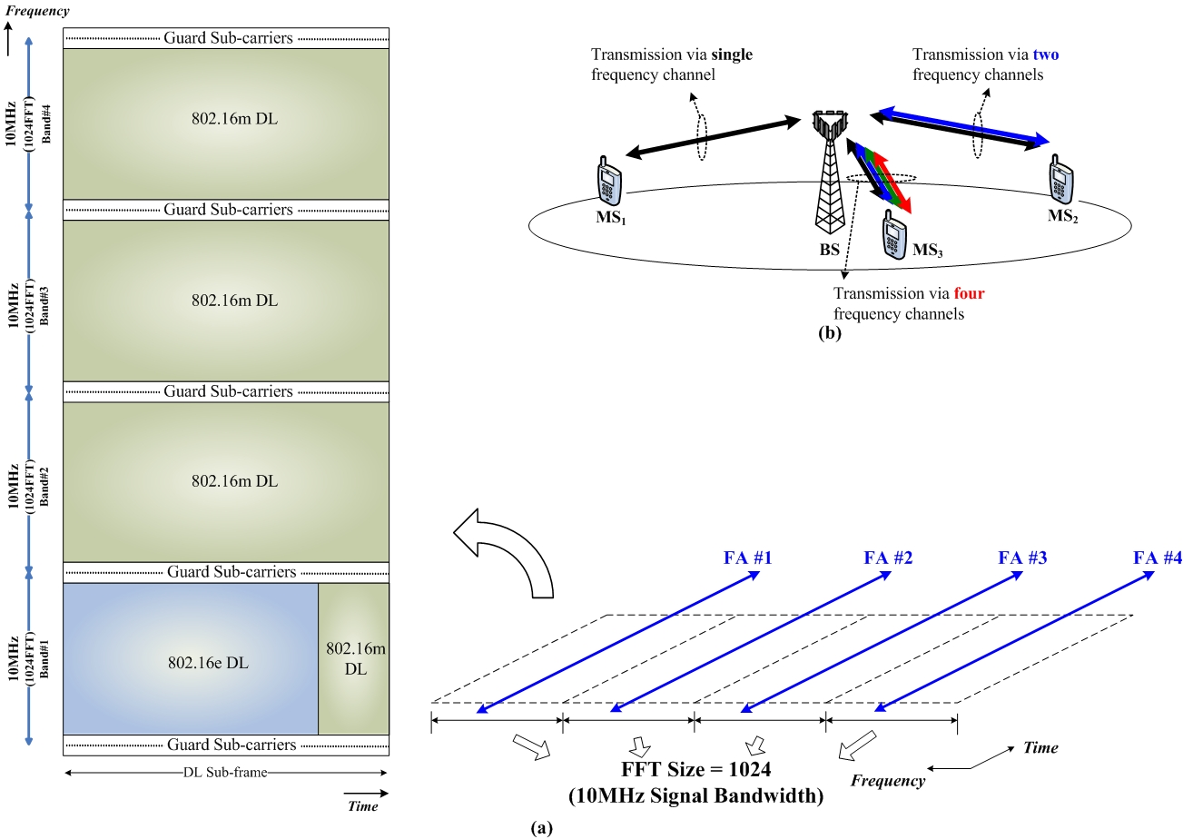

Fig.2 (a) An example on multi-carrier frame structure with legacy support in IEEE 802.16m, and (b) the flexibility to serve the MS equipped with different number of RF carriers

- Proposed Uplink Control Structure

The proposed uplink control structure for multi-carrier support is shown in Figure 3, where each group of contiguous frequency channels will have one primary channel. The primary frequency channel will broadcast complete system information for MS initial network acquisition, and the carrier frequency of the primary channel shall be the multiply of channel raster (e.g. 250kHz or 200kHz). Therefore, MS can locate the carrier frequency of primary channel by initial blind scanning. For the non-primary channels, the carrier frequency might be slightly shifted due to the requirement for sub-carrier alignment.
* Frequency Assignment (FA): A logical assignment of downlink center frequency and channel bandwidth programmed to the base station.
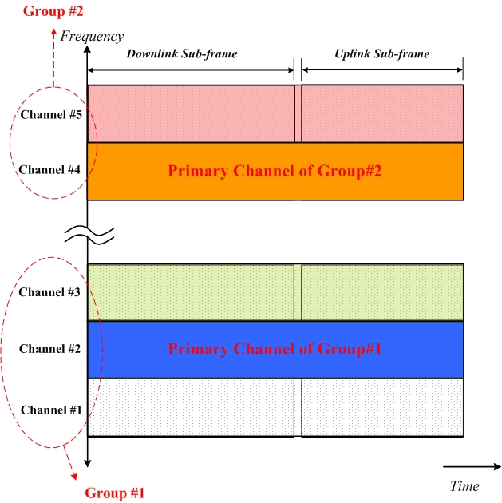
Fig.3 Proposed UL control structure

When multi-carrier transmission is enabled in IEEE 802.16m system, there are several possibilities for BS to inform the location of Ranging channel to MS:
- BS broadcast the carrier frequencies and other PHY information of non-primary channels via the primary channel
- BS multi-cast or unicast the carrier frequencies and other PHY information of non-primary channels via the primary channel by MS request.
- BS broadcast the Ranging channel information in non-primary bands
After acquiring the Ranging channel information, MS may perform uplink Ranging in following ways:

Mode#1: MS perform UL Ranging in primary band and BS send Ranging response via primary band
Possible Usage Scenario: Initial Ranging, Periodic Ranging and Handover Ranging for channel#2,4.

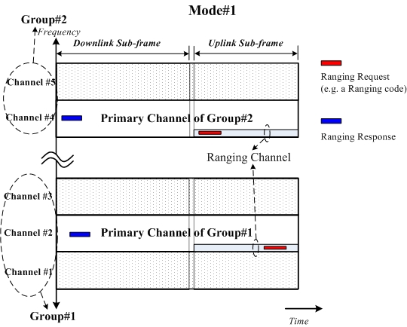
Fig.4 UL Ranging with multi-carrier support – Mode#1

Mode#2: MS perform UL Ranging in non-primary band and BS send Ranging response via primary band
Possible Usage Scenarios: Initial Ranging, Periodic Ranging and Handover Ranging for Channel#1,3,5.

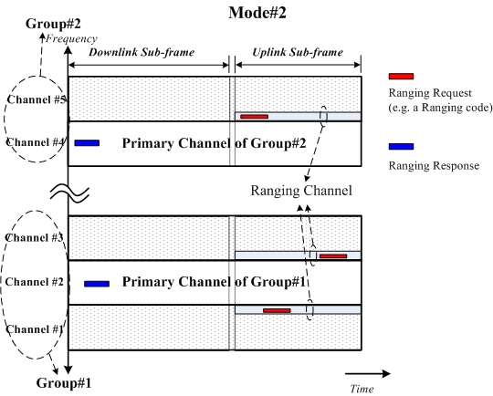
Fig.5 UL Ranging with multi-carrier support – Mode#2

Mode#3: MS perform UL Ranging in non-primary band and BS send Ranging response via non-primary band
Possible usage scenarios: Initial Ranging, Periodic Ranging and Handover Ranging for Channel#1,3,5.

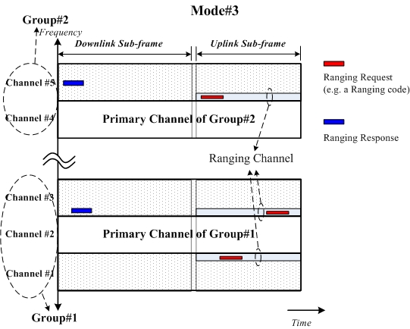
Fig.6 UL Ranging with multi-carrier support – Mode#3

According to the aforementioned control structure and Ranging mechanisms for multi-carrier support, the MS initialization procedure may be updated as Figure 7. In this procedure, MS and BS need to exchange their multi-carrier capability with each other after MS Ranging in primary channel.
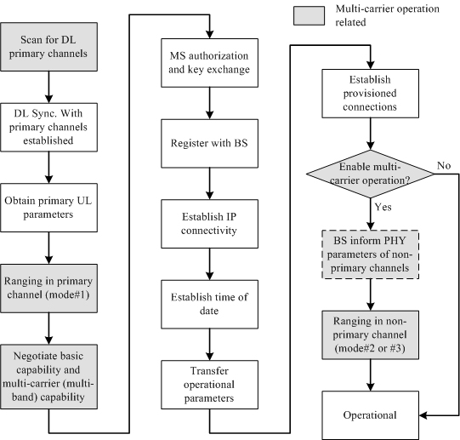
Fig.7 MS initialization procedure for multi-carrier support
- Text Proposal
-------------------------------------------------------------Start of the Text-------------------------------------------------------
[Add the following text into P802.16m SDD]

Ranging is the process of acquiring the correct timing offset and power adjustments so that the SS’s transmissions are aligned with the BS receive frame for OFDMA PHY, and received within the appropriate reception thresholds. When multiple RF channels are enabled in IEEE 802.16m network, the SS shall synchronize to the DL of primary frequency channel to learn the characteristics of UL channels and find an initial Ranging interval in primary frequency channel.
After completing the Ranging in primary frequency channel, the SS shall negotiate the multi-carrier capability with the BS. In order to enable additional RF channels for multi-carrier transmission, the SS shall find the Ranging intervals from primary frequency channels and then perform Ranging in non-primary channels. The Ranging opportunities in non-primary channels may be broadcast or unicast in primary channel or be broadcast in non-primary channels. Note that the BS may send Ranging response via the primary channel to SS. The aforementioned SS initialization operations are concluded in Figure x.

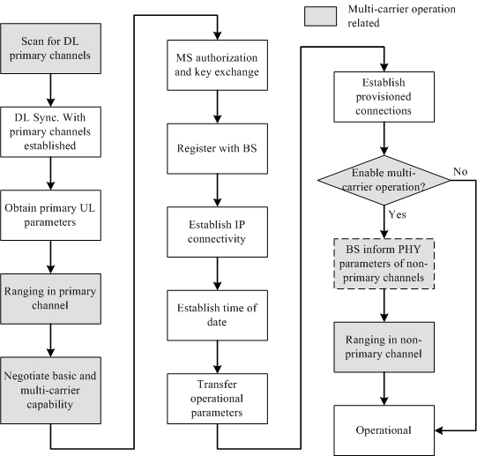
Fig.x SS initialization procedure for multi-carrier support

--------------------------------------------------------------End of the Text-------------------------------------------------------

