Project | IEEE 802.16 Broadband Wireless Access Working Group <http://ieee802.org/16>
Title | Clarification on RBIR and BLER Mapping for P802.16m EMD
Date Submitted | 2008-05-09
Source(s) | Ciou-Ping Wu, I-Kang Fu, Pei-Kai Liao, Paul Cheng  MediaTek Inc. No.1, Dusing Road 1, Science-Based Industrial Park, Hsinchu, Taiwan 300, R.O.C.  Ren-Jr Chen, Richard Li  ITRI  Youn-Tai Lee  III | CiouPing.Wu@mediatek.com  IK.Fu@mediatek.com  richard929@itri.org.tw  lyt@nmi.iii.org.tw
Re: | IEEE 802.16m-08/016, “Call for Contributions on Project 802.16m System Description Document (SDD).” – Comments on P802.16m EMD
Abstract | The mapping between RBIR and BLER is missed in current P802.16m EMD, which is hard to be obtained from open literatures. This contribution aims to clarify the possible way to derive this information for member’s discussion and reference.
Purpose | For TGm members discussion and possible adoption on proposed text to P802.16m EMD.
Notice | This document does not represent the agreed views of the IEEE 802.16 Working Group or any of its subgroups. It represents only the views of the participants listed in the “Source(s)” field above. It is offered as a basis for discussion. It is not binding on the contributor(s), who reserve(s) the right to add, amend or withdraw material contained herein.
Release | The contributor grants a free, irrevocable license to the IEEE to incorporate material contained in this contribution, and any modifications thereof, in the creation of an IEEE Standards publication; to copyright in the IEEE’s name any IEEE Standards publication even though it may include portions of this contribution; and at the IEEE’s sole discretion to permit others to reproduce in whole or in part the resulting IEEE Standards publication. The contributor also acknowledges and accepts that this contribution may be made public by IEEE 802.16.
Patent Policy | The contributor is familiar with the IEEE-SA Patent Policy and Procedures:  <http://standards.ieee.org/guides/bylaws/sect6-7.html#6> and <http://standards.ieee.org/guides/opman/sect6.html#6.3>.  Further information is located at <http://standards.ieee.org/board/pat/pat-material.html> and <http://standards.ieee.org/board/pat>.
Clarification on RBIR and BLER Mapping for P802.16m EMD
Ciou-Ping Wu, I-Kang Fu, Pei-Kai Liao and Paul Cheng
MediaTek Inc.
Ren-Jr Chen, Richard Li
ITRI
Youn-Tai Lee
III

Introduction

In IEEE 802.16m-08/004r1 (P802.16m Evaluation Methodology Document (EMD)) [1], the RBIR PHY abstraction is the baseline for system level simulation. However, it is very confusing that the current EMD only introduce how to calculate the RBIR without providing the mapping between RBIR and BLER. Since the system level simulation needs BLER instead of RBIR, members may face to some difficulties to establish their simulator without knowing this mapping.
The authors of this contribution spent time to study and investigate the possible ways to derive the mapping between BLER and RBIR. An example on how to derive the mapping curves will be given in this contribution as an example. The text proposal will be some informative clarification to P802.16m EMD to point out possible ways to derive this mapping without restricting on specific technique.

Background and Motivation

The number of radio links need to be simulated in system level simulation depends on the number of MS, the number of BS and the number of Tx/Rx antennas, and the amount is usually the multiply of all these values. Therefore, it results in huge computational load and takes a lot of time to obtain few simulation curves. In order to simplify the complexity, the system level simulation will define an interface to input the simulated SINR for mapping to a corresponding BLER (obtained by link level simulation in advance). This step is also called PHY abstraction and it can decouple the system level and link level simulation.
However, a coded block is transmitted over one or multiple sub-channels in OFDMA systems which associate to different set of physical sub-carriers with different per tone SINR from time to time. It’s hard to map such a complex SINR combination to BLER because it’s hard to derive the link level performances which are function to various SINR combinations. Therefore various PHY abstraction techniques for multi-carrier systems to predict the coded block error rate (BLER) for given a received channel realization across the OFDM subcarriers used to transmit the coed FEC block were proposed. The basic concepts of those techniques are very similar, i.e. mapping the multiple per tone SINRs into an equivalent SINR. The implication is to translate the multi-carrier system into an equivalent single carrier system (i.e. equivalent SINR mapping, ESM), and then use the SINR↔BLER mapping for single carrier systems to obtain the BLER.
There are several well-known ESM approaches widely applied to predict the link performances for multi-carrier systems, such as mean instantaneous capacity, exponential-effective SINR Mapping (EESM) and Mutual Information Effective SINR Mapping (MIESM). In this contribution, we focus on one of the MIESM techniques: received bit mutual information rate (RBIR) method [2], which is the baseline technique defined in P802.16m EMD [1].
In [1], the normalized mutual information per bit (RBIR) is given by

$\text{RBIR}=\frac{\sum_{n=1}^{N}{\text{SI}({\text{SINR}}_{n,}m(n))}}{\sum_{n=1}^{N}{m(n)}}$ (1)
, where SI is the symbol mutual information, as follows:

$\text{SI}({\text{SINR}}_{n},m(n))={\text{log}}_{2}M−\frac{1}{M}\sum_{m=1}^{M}{E_{U}\left\{{\text{log}}_{2}(1+\sum_{k=1,k≠m}^{M}{\text{exp}\left[−\frac{{\left|X_{k}−X_{m}+U\right|}^{2}−{\left|U\right|}^{2}}{(1/{{\text{SINR}}_{n}})}\right]})\right\}}$ (2)

An example of RBIR values for each modulation order is given in Table 24 in [1]. After acquiring the SI for each subcarrier base on Table 24 with input of its modulation order and per tone SINR. The normalized mutual information per bit (RBIR) can be computed by Equation (1). Unfortunately, current EMD skip the next step on the way to associate the RBIR and BLER. In next section, an example is given to explain the possible way to compute the block error rate using the RBIR value.

- Discussion of Proposed Clarification

Since the mean RBIR value can be obtained by Equation (1) and Table 24 in [1], we try to explore the possible procedure to obtain the effective SINR and the BLER in this section. Because a coded block may be carried over a set of subcarriers and transmitted at different time (with/without different modulation schemes), there are two cases need to be considered:
Case A. The entire coded block is transmitted over the same modulation scheme
Case B. part of the coded block is transmitted over different modulation schemes

  - The Entire Coded Block is Transmitted by the same Modulation Scheme

If a coded block is carried over a set of subcarriers and symbol time with the same modulation order with the mean RBIR obtained by Equation (1), per symbol effective SINR can be directly obtained from the Table 24 according to its modulation order. Based on the demodulation scheme in the receiver, per bit effective SINR can be derived. Therefore, one example is using this effective SINR (i.e. Effective SINR (per bit) in Figure 1(a)) and the coding system performances in AWGN channel (i.e. Figure 1(b) [3]) to obtain the corresponding SINR_{eff}↔BLER mapping (i.e. Figure 1(c)). Given the coding system performances under AWGN channel with different code rates, the SINR_{eff}↔BLER mapping for different MCS (Modulation and Coding Scheme) can be easily derived. Figure 1(c) gives an example by considering turbo code with 1/3 coding rate.
(a)
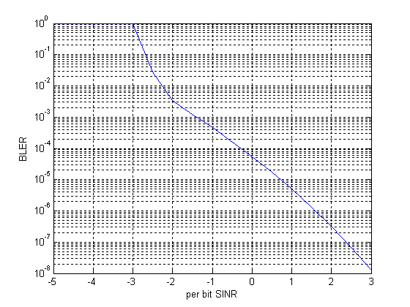
(b)
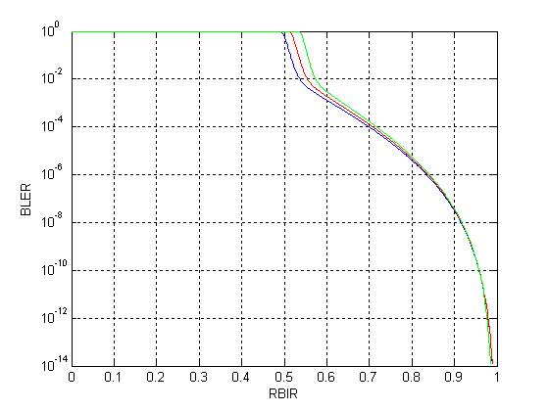
(c)
Fig. 1 (a) The mapping between RBIR and per bit equivalent SINR for different modulation scheme, (b) and (c) the corresponding mapping between RBIR and BLER for Turbo Code with 1/3 code rate.

  - Part of the Coded Block is Transmitted over Different Modulation Schemes
If part of the coded block is transmitted over different modulation schemes (e.g. transmitted over different time by interleaving), there may exist slight offset between the curve for mapping RBIR to per bit effective SINR because the coding performances under different modulation scheme may be slightly different. Therefore, even the mean RBIR can still be directly computed via Equation (1) and Table 24, some heuristic interpolation adjust may be used to fine tune the mapping between RBIR to per bit effective SINR. Note that this part depends on the calibration efforts conducted by each company and might be out of the scope of P802.16m EMD. Therefore, no specific interpolation procedure will be proposed in this contribution.

- Summary

In summary, the example to obtain the mapping between RBIR and BLER can be concluded as following steps and Figure 2:
- Calculate per bit effective SINR (SINR_{eff}) based on RBIR and Table 24 in [1]
- Reference the coding system performances to obtain the mapping between SINR and BLER
- Use the SINR_{eff} obtained in step 1 and the mapping obtained in step 2 to derive the mapping between SINR_{eff} and BLER
Fig.2 The procedure to obtain BLER from RBIR

Note that the RBIR ESM is fundamentally a BLER prediction technique, the mapping between RBIR and BLER under different coding scheme, coding rate, modulation schemes, interleaver and channel model is still a problem under research. This contribution does not intend to provide an optimized mapping, but performing an example how members may simply derive a workable mapping for their system level simulation. Therefore, the following we only suggest to add some clarification text into P802.16m EMD to state how member can derive the RBIR and BLER mapping by themselves.

- Proposed Text Modification
----------------------------------------------------------Start of the text-----------------------------------------------------------
[Add the following text after line#14, page#62 in IEEE 802.16m-08/004r1[1]]

In order to derive the mapping between RBIR and BLER, the following steps may be considered:
- Calculate the per bit effective SINR (SINR_{eff}) based on RBIR and Table 24
- Reference the coding system performances to obtain the mapping between SINR and BLER
- Use the SINR_{eff} obtained in step 1 and the mapping obtained in step 2 to derive the mapping between SINR_{eff} and BLER
If the coded block is transmitted at different time and over different modulation schemes, some interpolation may need to be applied to refine the mapping in step 3.

------------------------------------------------------------End of the text----------------------------------------------------------

References
[1] R. Srinivasan, J. Zhuang, L. Jalloul, R. Novak, J. Park, “Project 802.16m Evaluation Methodology Document (EMD),” IEEE C80216m-08-004/r1, March 28, 2008.
[2] L. Wan, S. Tsai, M. Almgren, “A Fading-Insensitive Performance Metric for a Unified Link Quality Model”, IEEE Wireless Communications and Networking Conference, Vol.4, pp. 2110-2114, April 2006.
[3] D. Divsalar, S. Dolinar, R. J. McEliece, and F. Pollara, “Transfer function bounds on the performance of turbo codes,” TDA Progress Report 42-121, JPL, August 1995.
http://ipnpr.jpl.nasa.gov/progress_report/42-122/122A.pdf

