Project | IEEE 802.16 Broadband Wireless Access Working Group <http://ieee802.org/16>
Title | Support for Location Based Services
Date Submitted | 2008-05-09
Source(s) | Mei-Dai Chen, I-Kang Fu, Yih-Shen Chen, Kelvin Chou, and Paul Cheng  MediaTek Inc.  No.1, Dusing Rd. 1, Hsinchu Science-Based Industrial Park, Hsinchu, Taiwan 300, R.O.C.  Chung-Hsien Hsu, Chao-Lin Chen, and Kai-Ten Feng  NCTU/MediaTek Inc.  1001 Ta Hsueh Road, Hsinchu, Taiwan 300, R.O.C. | dora.chen@mediatek.com  IK.Fu@mediatek.com  stanley.hsu@mediatek.com
Re: | IEEE 802.16m-08/016, “Call for Contributions on Project 802.16m System Description Document (SDD)”. – Comments on P802.16m SDD
Abstract | This contribution discusses the requirement of the parameters to describe and transmit the MS’s location.
Purpose | To be discussed and adopted by TGm into the P802.16m SDD.
Notice | This document does not represent the agreed views of the IEEE 802.16 Working Group or any of its subgroups. It represents only the views of the participants listed in the “Source(s)” field above. It is offered as a basis for discussion. It is not binding on the contributor(s), who reserve(s) the right to add, amend or withdraw material contained herein.
Release | The contributor grants a free, irrevocable license to the IEEE to incorporate material contained in this contribution, and any modifications thereof, in the creation of an IEEE Standards publication; to copyright in the IEEE’s name any IEEE Standards publication even though it may include portions of this contribution; and at the IEEE’s sole discretion to permit others to reproduce in whole or in part the resulting IEEE Standards publication. The contributor also acknowledges and accepts that this contribution may be made public by IEEE 802.16.
Patent Policy | The contributor is familiar with the IEEE-SA Patent Policy and Procedures:  <http://standards.ieee.org/guides/bylaws/sect6-7.html#6> and <http://standards.ieee.org/guides/opman/sect6.html#6.3>.  Further information is located at <http://standards.ieee.org/board/pat/pat-material.html> and <http://standards.ieee.org/board/pat>.
Support for Location Based Services

Mei-Dai Chen, I-Kang Fu, Yih-Shen Chen, Kelvin Chou, and Paul Cheng
MediaTek Inc.
Chung-Hsien Hsu, Chao-Lin Chen, and Kai-Ten Feng
NCTU/MediaTek Inc.

1. Introduction
With the increasing population of the mobile devices, people require not only the basic high quality voice services, but also other advanced services, such as location based services (LBSs). In addition to assist MS to acquire its location [1], the BS may also need to know MS’s location so as to perform the LBSs, such as emergency services, information services, location based billing services, tracking and management services and etc. In the contribution, we discuss the applications of LBS and some issues that should be considered for supporting LBSs.

- Lists of LBS Applications
Here we briefly describe some popular LBS applications.

- Emergency 911 safety services
One of the most important applications of LBSs is emergency safety service which geometrically locates a person who is unaware of his/her location or is not able to reveal it due to the emergency situation such as injury, criminal attack, and so forth. With the exact location automatically transferred to the emergency services, the assistance can be provided quickly and efficiently.

- Information services
Location-based information services provide information that is related to MS’ location. For example, services such as guided tours, notification about nearby places of interest (restaurants, theaters, etc.), transportation services, and other services that can be provided to tourists moving around in the unfamiliar environment or city.

- Location based billing services
Location-based billing services enable a mobile location service provider to dynamically charge service fee depending on MS’s location.

- Tracking and management services
Tracking and management services are applicable both corporate markets and consumers. For example, by tracking postal packages, a company can know easily where their goods are at any time. Vehicle tracking can also be applied to locate and dispatch an ambulance that is nearest to a given call. Another similar application allows companies to locate their field person (salespeople, or repair engineers) so that they are able to dispatch the nearest engineer and provide their customers with accurate personal arrival time.

Estimation of MS Location
To enable the above-mentioned LBS applications, the BS should acquire MS location as well as track it. A variety of wireless location techniques have been studied and investigated, which can be classified into network-based, terminal-based, and hybrid schemes. In the following, we will discuss how the BS acquires MS location with these schemes individually.

3.1. Network-based location estimation scheme
The network-based location estimation schemes are adopted while the MS doesn’t have the global positioning system (GPS) receiver. The representative algorithms for the schemes are the angle of arrival (AOA) and the time difference of arrival (TDOA) algorithms. The AOA technique observes the arriving angle of signal from MS, while the TDOA scheme measures the time difference of signals coming from different BSs. As shown in Fig. 1, the BS can utilize the AOA measurement to estimate MS location. Moreover, it also can request MS to respond the location information which was derived by the TDOA measurement.

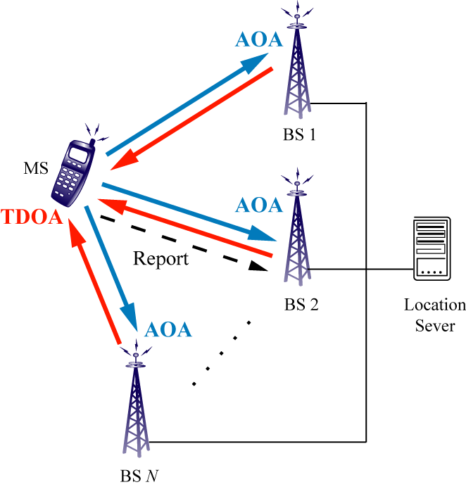
Fig. 1. The schematic diagram of the network-based location estimation scheme.

3.2. Terminal-based location estimation scheme
For the terminal-based location estimation scheme, the GPS is the well-adapted technique. It measures the time of arrival (TOA) of signals coming from different satellites as shown in Fig. 2. The MS can use this method to estimate its location and then report it to the BS. According to the received GPS information, the BS can acquire MS location and provide LBSs to the MS.

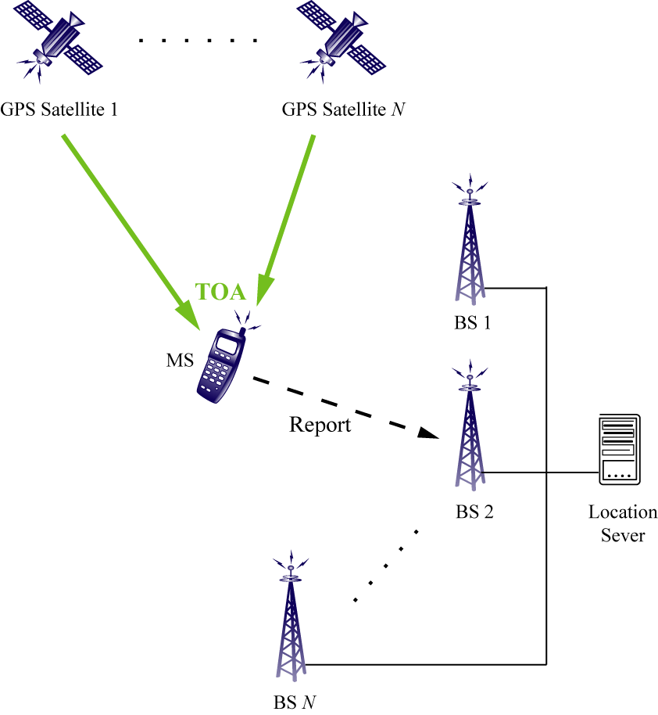
Fig. 2. The schematic diagram of the terminal-based location estimation scheme.

3.3. Hybrid location estimation scheme
Unfortunately, the MS location estimated via the GPS is not always accurate. For example, the performance of GPS degrades considerably while the satellite signals are severely blocked (e.g. at urban valley area). In order to achieve the better accuracy for the location estimation, the hybrid method, which combines both the network-based and the terminal-based schemes, should be considered. Fig. 3 shows the schematic diagram of the exemplified hybrid location estimation scheme.

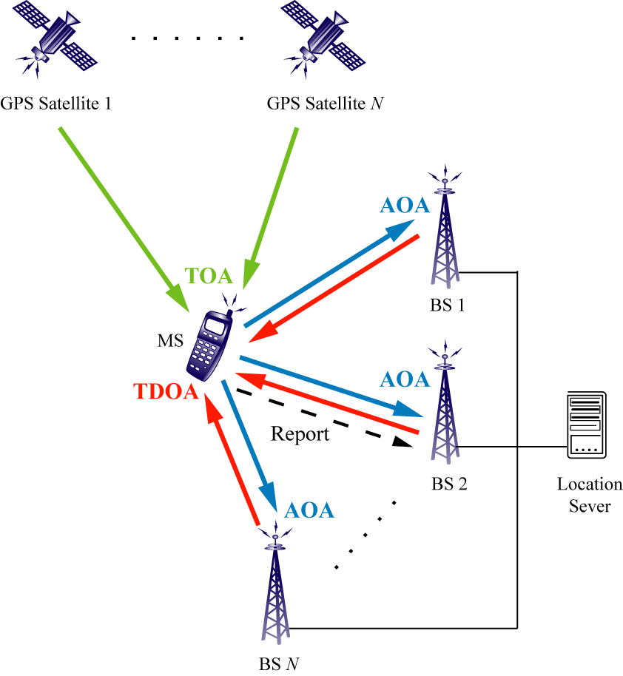
Fig. 3. The schematic diagram of the hybrid location estimation scheme.

As shown in Fig. 3, the MS obtains the TOA measurements from the satellites. The TDOA measurements are also conducted at the MS by obtaining the signals via the downlink from the BSs. Furthermore, the information estimated at both locations is transmitted to the BS. On the other hand, the AOA measurements are performed at the BS using its antenna arrays for two-dimensional adaptive beam steering. With the above-mentioned information, the more accurate location of MS can be estimated by the BS.

3.4. Simulation results and comparison
This section presents the simulation results for the performances of MS location estimation techniques. The MS is assumed to travel at a constant speeds of (3, 4, 0) m/s along the x and y directions, i.e. (x, y, z) = (27 + 3t, 36 + 4t, 300) in meters. Fig. 4 shows the performance of the hybrid scheme (measured in RMS error) comparing with the terminal-based and the network-based schemes under urban, suburban, and rural environments. It can be seen that the terminal-based has the worst performance comparing with the other two systems in the urban area; while the network-based causes degraded results in the rural area. The hybrid scheme is capable of adjust itself to accommodate different situations, which provides consistent performance comparing with the terminal-based and the network-based schemes.

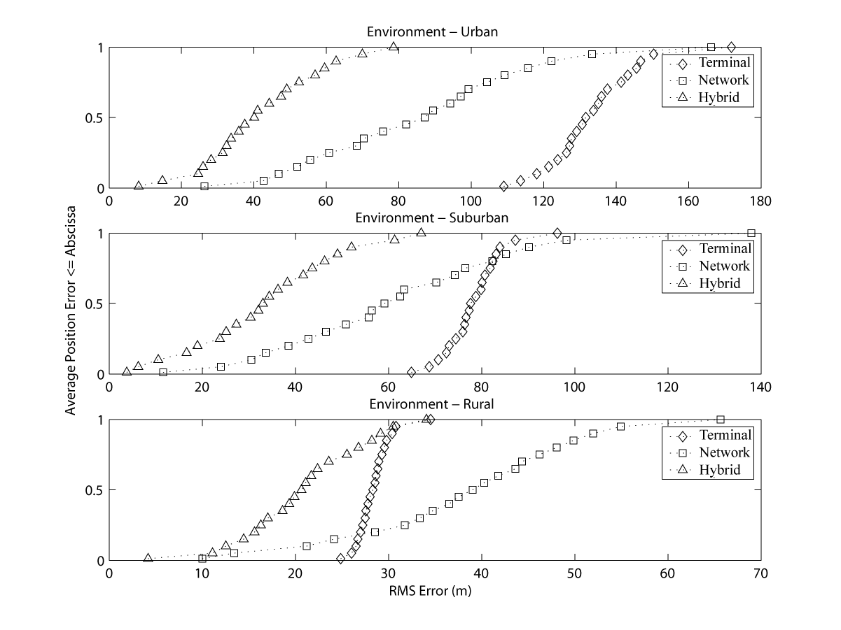
Fig. 4. Performance comparisons among the terminal-based, the network-based, and the hybrid schemes in urban (top), suburban (middle), and rural (bottom) areas.

4. Conclusion
In order to enable the LBS applications, the BS should acquire MS location as well as track it. Different categories of location estimation and tracking schemes should be considered under different environments. The location-related parameters, which are exchanged between MS and BS, are depended on the location estimation schemes. Therefore, three main issues should be considered for supporting LBS:
- Location estimation method
- Location parameters to be updated
- Parameters updating method

5. Proposed Text

----------------------------------------------------Start of the Text----------------------------------------------------------------
[Insert the following text after line#3, page#23 in 802.16m-08/003r1 (P802.16m SDD)]
14 Support for Location Based Services

14.1 Mobile Station Location Estimation and Tracking

14.1.1 Terminal based MS Location Estimation and Tracking

14.1.2 Network based MS Location Estimation and Tracking

14.1.3 Hybrid MS Location Estimation and Tracking

----------------------------------------------------End of the Text---------------------------------------------------------------

References

[1] P802.16Rev2/D4.
[2] Chung-Hsien Hsu et al, “Location Estimation and Tracking System for Mobile Devices in Project 802.16m SDD,” IEEE C802.16m-07/202r1, November 2007.

