IEEE C802.16m-08/331

Project | IEEE 802.16 Broadband Wireless Access Working Group <http://ieee802.org/16>
Title | An Unified Code Book for Single Stream MIMO and Interference Mitigation Using Base Station Cooperation
Date Sub. | 2008-05-05
Source(s) | Vinosh Babu James  Bhaskar Ramamurthi  Ganesh Venkatraman  Kiran Kuchi  J Klutto Milleth  K Giridhar | vinosbabu@cewit.org.in  bhaskar@tenet.res.in  ganeshv@cewit.org.in  kkuchi@cewit.org.in  klutto@cewit.org.in  giri@tenet.res.in
Re: | IEEE C802.16m-08/016r1 - Call for Contributions on Project 802.16m System Description Document (SDD)
Abstract | A three bit feedback based code book is proposed for 2 transmit antennas system for single stream MIMO. The same code book will be used for interference mitigation using base station cooperation.
Purpose | To be discussed by TGm to facilitate the decision on code books for downlink MIMO
Notice | This document does not represent the agreed views of the IEEE 802.16 Working Group or any of its subgroups. It represents only the views of the participants listed in the “Source(s)” field above. It is offered as a basis for discussion. It is not binding on the contributor(s), who reserve(s) the right to add, amend or withdraw material contained herein.
Release | The contributor grants a free, irrevocable license to the IEEE to incorporate material contained in this contribution, and any modifications thereof, in the creation of an IEEE Standards publication; to copyright in the IEEE’s name any IEEE Standards publication even though it may include portions of this contribution; and at the IEEE’s sole discretion to permit others to reproduce in whole or in part the resulting IEEE Standards publication. The contributor also acknowledges and accepts that this contribution may be made public by IEEE 802.16.
Patent Policy | The contributor is familiar with the IEEE-SA Patent Policy and Procedures:  <http://standards.ieee.org/guides/bylaws/sect6-7.html#6> and <http://standards.ieee.org/guides/opman/sect6.html#6.3>.  Further information is located at <http://standards.ieee.org/board/pat/pat-material.html> and <http://standards.ieee.org/board/pat>.

An Unified Code Book for Single Stream MIMO and Interference Mitigation Using Base Station Cooperation
Vinosh Babu James, Bhaskar Ramamurthi, Ganesh Venkatraman, Kiran Kuchi, J Klutto Milleth, K Giridhar
CEWiT, Chennai, India

A 3- bit feedback based code book is proposed for 2 transmit antennas system for single stream MIMO. The same code book will be used for interference mitigation using base station cooperation in order to improve the performance of cell edge users. The following 3-bit code book is proposed:

Index | Code vector
0 | $$\frac{1}{\sqrt{2}}\left[\begin{matrix}1 \\ 1\end{matrix}\right]$$
1 | $$\frac{1}{\sqrt{2}}\left[\begin{matrix}1 \\ γ\end{matrix}\right]$$
2 | $$\frac{1}{\sqrt{2}}\left[\begin{matrix}1 \\ j\end{matrix}\right]$$
3 | $$\frac{1}{\sqrt{2}}\left[\begin{matrix}1 \\ jγ\end{matrix}\right]$$
4 | $$\frac{1}{\sqrt{2}}\left[\begin{matrix}1 \\ −1\end{matrix}\right]$$
5 | $$\frac{1}{\sqrt{2}}\left[\begin{matrix}1 \\ −γ\end{matrix}\right]$$
6 | $$\frac{1}{\sqrt{2}}\left[\begin{matrix}1 \\ −j\end{matrix}\right]$$
7 | $$\frac{1}{\sqrt{2}}\left[\begin{matrix}1 \\ −jγ\end{matrix}\right]$$

Table 1a: 3-bit code book with $γ=e^{\frac{−jπ}{4}}$

Figure 1a, shows the link level performance for a rate ½ QPSK single stream 2×2 CL-MIMO system with 30 Kmph vehicular speed with a feedback delay of 2ms. It is shown that the proposed code book performs within 0.5 dB of ideal channel feedback scheme. We would like to emphasize that the same code book provides excellent interference mitigation gain in the presence of co-channel interference as well.

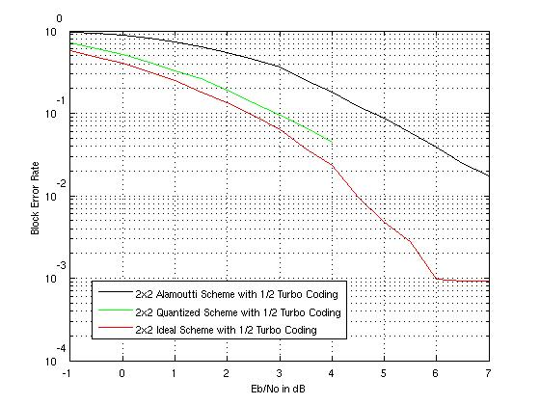
Figure 1a: Single Stream 2X2 CL-MIMO, Ideal vs Quantized

------------------------------------------- Proposed SDD Text -------------------------------

x.x
The following 3-bit code book is proposed for 2 transmit antennas system for single stream MIMO. The same code book will be used for interference mitigation using base station cooperation in order to improve the performance of cell edge users.
Index | Code vector
0 | $$\frac{1}{\sqrt{2}}\left[\begin{matrix}1 \\ 1\end{matrix}\right]$$
1 | $$\frac{1}{\sqrt{2}}\left[\begin{matrix}1 \\ γ\end{matrix}\right]$$
2 | $$\frac{1}{\sqrt{2}}\left[\begin{matrix}1 \\ j\end{matrix}\right]$$
3 | $$\frac{1}{\sqrt{2}}\left[\begin{matrix}1 \\ jγ\end{matrix}\right]$$
4 | $$\frac{1}{\sqrt{2}}\left[\begin{matrix}1 \\ −1\end{matrix}\right]$$
5 | $$\frac{1}{\sqrt{2}}\left[\begin{matrix}1 \\ −γ\end{matrix}\right]$$
6 | $$\frac{1}{\sqrt{2}}\left[\begin{matrix}1 \\ −j\end{matrix}\right]$$
7 | $$\frac{1}{\sqrt{2}}\left[\begin{matrix}1 \\ −jγ\end{matrix}\right]$$

Table 1a: 3-bit code book with $γ=e^{\frac{−jπ}{4}}$

------------------------------------------- Proposed SDD Text --------------------------------

