Project | IEEE 802.16 Broadband Wireless Access Working Group <http://ieee802.org/16>
Title | Text Changes for 802.16m H-FDD Frame Structure
Date Submitted | 2008-05-05
Source(s) | Sean McBeath, Huawei Technologies  Lina Liu, Huawei Technologies  Jeff Zhuang, Motorola | Voice:  E-mail:  smcbeath@huawei.com  liulina@huawei.com  Jeff.Zhuang@motorola.com  *<http://standards.ieee.org/faqs/affiliationFAQ.html>
Re: | IEEE 802.16m-08/016r1: Call for Contributions on Project 802.16m System Description Document (SDD).  Target topic: Entire content of 80216m-08_003r1
Abstract | This contribution proposes the use of irregular uplink subframes for H-FDD operation to improve uplink utilization.
Purpose | Discussion and approval
Notice | This document does not represent the agreed views of the IEEE 802.16 Working Group or any of its subgroups. It represents only the views of the participants listed in the “Source(s)” field above. It is offered as a basis for discussion. It is not binding on the contributor(s), who reserve(s) the right to add, amend or withdraw material contained herein.
Release | The contributor grants a free, irrevocable license to the IEEE to incorporate material contained in this contribution, and any modifications thereof, in the creation of an IEEE Standards publication; to copyright in the IEEE’s name any IEEE Standards publication even though it may include portions of this contribution; and at the IEEE’s sole discretion to permit others to reproduce in whole or in part the resulting IEEE Standards publication. The contributor also acknowledges and accepts that this contribution may be made public by IEEE 802.16.
Patent Policy | The contributor is familiar with the IEEE-SA Patent Policy and Procedures:  <http://standards.ieee.org/guides/bylaws/sect6-7.html#6> and <http://standards.ieee.org/guides/opman/sect6.html#6.3>.  Further information is located at <http://standards.ieee.org/board/pat/pat-material.html> and <http://standards.ieee.org/board/pat>.
Proposal for IEEE 802.16m FDD Frame Structure
Sean McBeath, Lina Liu
Huawei Technologies
Jeff Zhuang
Motorola

Introduction and Background
In 802.16 Rev 2, one of the main H-FDD design objectives was maximizing UL utilization. Figure 1 shows the H-FDD frame structure in 802.16Rev2/D4.
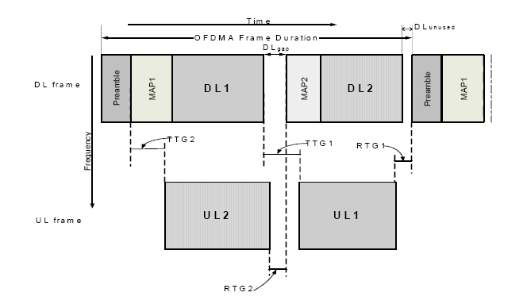
Figure 1—Generic OFDMA FDD frame structure supporting H-FDD MS in two groups

In Figure 1, the mobile stations are divided into two groups, each group occupying a particular time domain portion of the frame. Neither group 1 nor group 2 transmits on the UL during the preamble, which is the only “broadcast” information shared between group 1 and group 2.

In the proposed H-FDD frame structure for 802.16m, there is no UL transmission from either group during the first sub-frame of each radio frame. This represents an UL utilization of 87.5%. Depending on the amount of broadcast information in the first sub-frame of each radio frame, this may represent unnecessary inefficiency. In this contribution, we propose the use of irregular UL subframes for increasing the UL utilization.

Proposed Text for SDD
Modify the text in line 5 page 19 of SDD document 003r1 as follows
------------------------------- Text Start ---------------------------------------------------
To ensure efficient use of the radio resources when operating with H-FDD mobile stations in an FDD network, the mobile stations within the coverage area of the BS should be grouped into two complementary groups whose downlink and uplink transmissions are not concurrent (an example is shown in Figure 11). The frame structure from the point of view of the BS and the full FDD mobile stations is not affected by the H-FDD characteristics of some mobile stations and is identical to the FDD frame structure. However, the frame structure from the point of view of the H-FDD mobile stations is different and DL and UL transmissions do not occur simultaneously. Nevertheless the downlink and uplink transmission frequencies are different. Since the beginning of the DL radio frame and super-frame may contain broadcast information (i.e., synchronization channel or legacy preamble for legacy support, as well as super-frame header containing the broadcast channel); this is marked in red in Figure 11.4-3, the H-FDD mobile station groups should not have any uplink transmissions scheduled in the first sub-frame of those radio frames containing broadcast information assuming the entire sub-frame is occupied for broadcast usage (this is marked in red in Figure 11) of each super frame. In cases where only a portion of a sub-frame is occupied for broadcast usage, irregular uplink subframes can be used as shown in Figure YYY to increase UL utilization. The complementary grouping and scheduling scheme described here can ensure efficient utilization of the radio resources. Also note that the H-FDD mobile stations require a switching time between any DL to UL or UL to DL transition, which could also result in irregular DL or UL sub-frames.
------------------------------- Text End ---------------------------------------------------

Replace the existing figure 11 with the following figure:

UL
UL
UL
UL
UL
UL
UL
UL
UL
UL
UL
UL
UL
UL
UL
UL
DL
DL
DL
DL
DL
DL
DL
DL
DL
DL
DL
DL
DL
DL
DL
DL
DL
DL
UL
UL
UL
UL
DL
DL
DL
DL
DL
UL
UL
UL
UL
UL
UL
DL
DL
DL
DL
DL
DL
UL
UL
UL
UL
DL
DL
DL
DL
DL
F₁
UL
F₂
DL
F₁
UL
F₁
DL
F₂
UL
F₂
Frame Structure from the BS point of view (full FDD)
Frame Structure from the Group I MS point of view (H-FDD)
Frame Structure from the Group II MS point of view (H-FDD)
UL

Figure 11: Example of Complementary Grouping And
Scheduling of H-FDD Mobile Stations

Add new figure as follows:
Figure 12: Irregular Uplink Subframes

