Project | IEEE 802.16 Broadband Wireless Access Working Group <http://ieee802.org/16>
Title | Enhanced Constellation Rearrangement for HARQ with Adaptive Modulation
Date Submitted | 2008-05-05
Source(s) | Tao Wu, Yinwei Zhao, Xueqin Gu, Chongli Liu  Huawei | Voice: 86-755-28970182  E-mail: liuchongli@huawei.com
Re: | IEEE 802.16m-08/016 - Call for Contributions on Project 802.16m System Description Document (SDD)  Target topic: “Hybrid ARQ”
Abstract | This document proposes a new constellation rearrangement approach for HARQ with adaptive modulation
Purpose | For discussion and approval by TGm.
Notice | This document does not represent the agreed views of the IEEE 802.16 Working Group or any of its subgroups. It represents only the views of the participants listed in the “Source(s)” field above. It is offered as a basis for discussion. It is not binding on the contributor(s), who reserve(s) the right to add, amend or withdraw material contained herein.
Release | The contributor grants a free, irrevocable license to the IEEE to incorporate material contained in this contribution, and any modifications thereof, in the creation of an IEEE Standards publication; to copyright in the IEEE’s name any IEEE Standards publication even though it may include portions of this contribution; and at the IEEE’s sole discretion to permit others to reproduce in whole or in part the resulting IEEE Standards publication. The contributor also acknowledges and accepts that this contribution may be made public by IEEE 802.16.
Patent Policy | The contributor is familiar with the IEEE-SA Patent Policy and Procedures:  <http://standards.ieee.org/guides/bylaws/sect6-7.html#6> and <http://standards.ieee.org/guides/opman/sect6.html#6.3>.  Further information is located at <http://standards.ieee.org/board/pat/pat-material.html> and <http://standards.ieee.org/board/pat>.
Enhanced Constellation Rearrangement for HARQ with Adaptive Modulation
Tao Wu, Yinwei Zhao, Xueqin Gu, Chongli Liu
Huawei

Introduction
In the proposal [1], a HARQ method with constellation rearrangement has been introduced and the performance is improved compared with Chase-Combining. In this proposal, we deliver an extended constellation rearrangement method used in HARQ process with adaptive modulation.
If a packet modulated by 64-QAM has not been received correctly in the HARQ process, the packet will be re-transmitted. In some scenarios, the re-transmitted packet may be modulated by 16QAM. In this case, we can also use the constellation rearrangement method to enhance the performance.

Proposed Scheme

Description of Proposed Method
In traditional scheme, if a packet modulated by 64-QAM in the latest transmission will be re-transmitted with 16-QAM, the bits of the packet will be mapped to the 16-QAM symbols in the same order. The position relationship of each bit in 64-QAM symbol and 16-QAM symbol is shown in Figure 1.
Figure 1．The traditional mapping rule from 64-QAM to 16-QAM
As shown in Error: Reference source not found, in the 6 bits of a 64-QAM symbol, different bits with different colors have different reliability, the bits with red color have high reliability, the bits with blue color have medium reliability and the bits with black color have low reliability. Alike, in the 4 bits of a 16-QAM symbol, the bits with red color have high reliability and the bits with blue color have low reliability.
According to the traditional mapping rule, the following reliability analysis is shown as Table 1.
Table 1． The reliability analysis of traditional scheme
Reliability in 16-QAM | Reliability in 64-QAM
6 bits with high reliability | 2 bits with high reliability  2 bits with low reliability  2 bits with medium reliability
6 bits with low reliability | 2 bits with medium reliability  2 bits with high reliability  2 bits with low reliability
Obviously, the average reliability of bits in the two transmissions can be optimized furthermore. For example, the bits with high reliability in 64-QAM symbol should be mapped to the bit position with low reliability and the bits with low reliability in 64-QAM symbol should be mapped to the bit position with high reliability.
The following figure is an example of our suggested proposal.
Figure 2. The proposed mapping rule from 64-QAM to 16-QAM
According to the proposed mapping rule, the reliability analysis is shown as Table 2.
Table 2．The reliability analysis of proposed scheme
Reliability in 16-QAM | Reliability in 64-QAM
6 bits with high reliability | 4 bits with low reliability  2 bits with medium reliability
6 bits with low reliability | 4 bits with high reliability  2 bits with medium reliability

Simulation results
The performance of the traditional scheme and proposed scheme is simulated here to make a comparison in AWGN. The turbo coding with rate 1/3 was used. The constellation of 64QAM and 16QAM is utilized according to IEEE 802.16e.
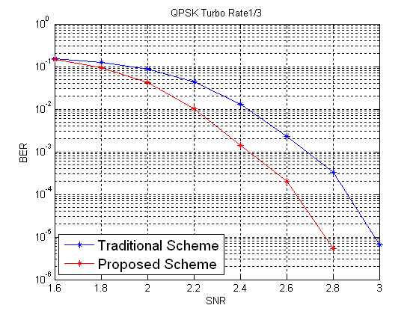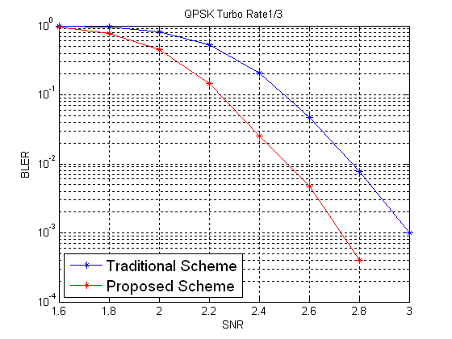
Figure 3. Performance comparisons of proposed scheme and traditional scheme

Conclusion
In this proposal, an extended constellation rearrangement method has been proposed to HARQ with adaptive modulation procedure. By averaging out reliability of bits carried by repeatedly transmitted symbols over retransmissions, the proposed scheme shows a performance gain with respect to traditional scheme, where both system complexity and terminal complexity are increased only slightly.

Reference
[1] C80216m-07_292 Enhanced HARQ technique uses Constellation Rearrangement

Text Proposal to SDD
------------------------------------Start text proposal------------------------------------
[Adopt the following text in the ToC of P802.16m System Description Document (SDD)]

11.X HARQ
In retransmission, if the modulation scheme changes, the constellation rearrangement should be supported.
------------------------------------End text proposal------------------------------------

