Project | IEEE 802.16 Broadband Wireless Access Working Group <http://ieee802.org/16>
Title | Hybrid-ARQ structure for IEEE 802.16m
Date Submitted | 2008-05-05
Source(s) | Hyungho Park, Seunghyun Kang, Sukwoo Lee  LG Electronics | Voice : +82-31-450-1852  E-mail: hyunghopark@lge.com, sh_kang@lge.com, sugoo@lge.com
Re: | IEEE 802.16m-08/016r1 - Call for Contributions on Hybrid ARQ
Abstract | The contribution describes and proposes many consideration points and some candidates for IEEE 802.16m HARQ
Purpose | To be discussed and adopted by TGm for use in the IEEE 802.16m SDD
Notice | This document does not represent the agreed views of the IEEE 802.16 Working Group or any of its subgroups. It represents only the views of the participants listed in the “Source(s)” field above. It is offered as a basis for discussion. It is not binding on the contributor(s), who reserve(s) the right to add, amend or withdraw material contained herein.
Release | The contributor grants a free, irrevocable license to the IEEE to incorporate material contained in this contribution, and any modifications thereof, in the creation of an IEEE Standards publication; to copyright in the IEEE’s name any IEEE Standards publication even though it may include portions of this contribution; and at the IEEE’s sole discretion to permit others to reproduce in whole or in part the resulting IEEE Standards publication. The contributor also acknowledges and accepts that this contribution may be made public by IEEE 802.16.
Patent Policy | The contributor is familiar with the IEEE-SA Patent Policy and Procedures:  <http://standards.ieee.org/guides/bylaws/sect6-7.html#6> and <http://standards.ieee.org/guides/opman/sect6.html#6.3>.  Further information is located at <http://standards.ieee.org/board/pat/pat-material.html> and <http://standards.ieee.org/board/pat>.
Hybrid-ARQ structure for IEEE802.16m
Hyungho Park, Seunghyun Kang, Sukwoo Lee.
LG Electronics

Introduction

In the reference system, only Chase HARQ mode is provided with the given MCS table. However, IR HARQ mode should be included in IEEE802.16m since it has technical benefits in terms of performance and scheduling gain in various channel conditions. In the context, we suggest a unified HARQ structure so that it can be incorporated in the consideration of protocol and timing for HARQ.

Consideration on Hybrid-ARQ structure for IEEE 802.16m

HARQ functionality in the reference system is defined only by Chase method, which is to combine received packets at a fixed code rate and modulation. However, the HARQ functionality shall be improved for IEEE 802.16m with the consideration of IR support, large granularity of MCS set, and incorporation of MIMO even though specific methods are FFS. We suggest a unified HARQ structure with the following considerations.

Fig. 1 HARQ structure for HARQ Architecture (protocol and timing) consideration

- MCS set for HARQ
  - MCS set of the reference system shall be further elaborated for IEEE 802.16m since it keep technical deficiency in the aspects of limitation of code rate and code block size, granularity of set, and MIMO support.

- Common signaling for Chase and IR HARQ mode
  - Since Chase HARQ mode can be regarded as a special case of IR HARQ mode, the Chase HARQ can be defined as the process of IR HARQ mode.
  - In the reference system, the Chase HARQ modes are indicated by different MAP message, i.e., DL HARQ MAP IE consists of various HARQ subburst IEs. For low overhead control process, the common signaling shall be used due to the unified HARQ structure in the IEEE 802.16m.

- FEC block generation
  - This stage includes padding and CRC attachment for PDU (Physical Data Unit) passed from the MAC layer, concatenation of resource block to support larger blocks of coding under a restriction on segmentation, and randomization. A specific method is FFS.

- Subpacket generation for HARQ mode
  - When SPID is fixed to 0, Chase HARQ is chosen. Otherwise the subpacket generation of IR HARQ is associated with values of SPID.

- Data modulation with Constellation Rearrangement (CoRe)
  - Constellation Rearrangement (CoRe) is adopted for performance enhancement in Chase HARQ by defining the pre-defined bitwise mapping rule between MS and BS at every retransmission.

- MIMO encoding
  - MIMO-HARQ schemes should also consider in 16m with respect to spatial multiplexing and diversity.

Enhancement of HARQ for 16m HARQ

Constellation Rearrangement (CoRe) is one of cost-effective solutions for enhancement of Chase HARQ. We propose the concept of CoRe in Figure 2, which exploits different spatial mapping with the given constellation rearrangement at every retransmission. The proposed CoRe consists of two stages as follows.

- Horizontal bitwise mapping
  - Horizontal bitwise mapping changes the bit position and its value on signal constellation in order to get diversity gain during retransmissions.
- Vertical bitwise mapping
  - Vertical bitwise mapping exchanges components bits between transmit antennas for averaging the channel difference.

Fig. 2 Constellation Rearrangement considering spatial mapping

As the simulation result is shown in figure 3, the proposed CoRe obtains significant performance gain comparing to the conventional Chase HARQ mode.

Table 1: Simulation Parameters
Parameters | Assumption
Bandwidth | 10 MHz
Number of subcarrier | 1024
Frame length | 5ms
Channel estimation | Perfect
Channel code | CTC 1/2
Modulation | 16 QAM
MIMO configuration | Tx: 2, Rx:2
Resource allocation | PUSC
Channel model | VEH A
MS mobility | 120km/h
Receiver type | Linear MMSE
Maximum number of retransmission | 1, 2, 3
Retransmission latency | 10ms

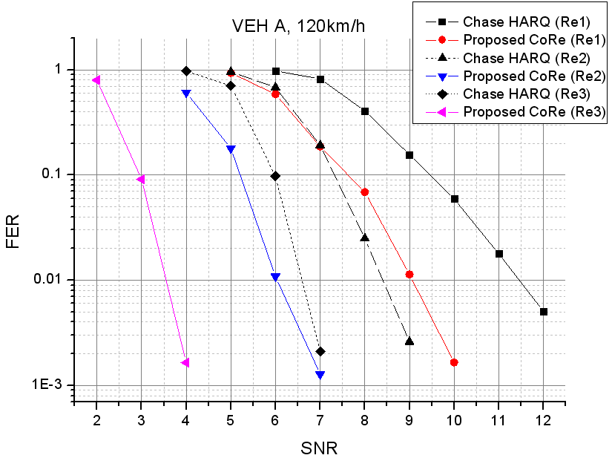
Fig 3. Performance comparison of CoRe (Re: Maximum number of retransmission)

Conclusion

We would like to replace conclusion with the following text proposal.
Text Proposal for the IEEE802.16m SDDs [2]

================================= Start of Proposed Text ====================================
x.x HARQ mode

Both Chase HARQ and IR HARQ mode shall be provided as mandatory mode for IEEE802.16m.

x.x.x Chase HARQ mode

x.x.x.x Constellation Rearrangement

Constellation rearrangement considering spatial mapping in a single/multiple transmit antenna system shall be adopted for IEEE 802.16m.

yy.y HARQ structure for IEEE802.16m

The following points shall be considered for IEEE802.16m in order to design unified HARQ structure.

- MCS set for HARQ
  - MCS set of the reference system shall be further elaborated for IEEE 802.16m since it keep technical deficiency in the aspects of limitation of code rate and code block size, granularity of set, and MIMO support.

- Common signaling for Chase and IR HARQ mode
  - Since Chase HARQ mode can be regarded as a special case of IR HARQ mode, the Chase HARQ can be defined as the process of IR HARQ mode.
  - In the reference system, the Chase HARQ modes are indicated by different MAP message, i.e., DL HARQ MAP IE consists of various HARQ subburst IEs. For low overhead control process, the common signaling shall be used due to the unified HARQ structure in the IEEE 802.16m.

- FEC block generation
  - This stage includes padding and CRC attachment for PDU (Physical Data Unit) passed from the MAC layer, concatenation of resource block to support larger blocks of coding under a restriction on segmentation, and randomization. A specific method is FFS.

- Subpacket generation for HARQ mode
  - When SPID is fixed to 0, Chase HARQ is chosen. Otherwise the subpacket generation of IR HARQ is associated with values of SPID.

- Data modulation with Constellation Rearrangement (CoRe)
  - Constellation Rearrangement (CoRe) is adopted for performance enhancement in Chase HARQ by defining the pre-defined bitwise mapping rule between MS and BS at every retransmission.

- MIMO encoding
  - MIMO-HARQ schemes should also consider in 16m with respect to spatial multiplexing and diversity.

Fig. yy.y HARQ structure for HARQ Architecture (protocol and timing) consideration

=================================== End of Text Proposal ===================================

Reference
[1] IEEE 802.16m-07/002r4, IEEE 802.16m System Requirement, 2007-10-19
[2] IEEE 802.16m-08/003, “The draft IEEE802.16m System Description Document”
[3] IEEE GLOBECOM 2007 , “Optimal bitwise mapping for Hybrid ARQ in MIMO”, Sung Ho Moon, Hyung Ho Park, Andrea Goldsmith, and Minseok Oh
[4] WBWF 2007, “A New constellation rearrangement for MIMO systems with Hybrid ARQ”, Hyung Ho Park and Jin Sung Choi

