Project | IEEE 802.16 Broadband Wireless Access Working Group <http://ieee802.org/16>
Title | PMI Restriction for the downlink Closed-loop MIMO
Date Submitted | 2008-07-14
Source(s) | Dongguk Lim  Sunam Kim  Jaewan Kim  Bin-Chul Ihm  LG Electronics  LG R&D Complex, 533 Hogye-1 dong  Dongan-gu, Anyang, 431-749, Korea | Voice: +82-31-450-1931  E-mail: dongguk@lge.com  snkim816@lge.com  lgjohnkim@lge.com  bcihm@lge.com
Re: | IEEE 802.16m-08/016r1 Call for Contributions on Project 802.16m System Description Document (SDD).  Specific topic : Downlink MIMO schemes
Abstract | Propose PMI restriction for IEEE 802.16m MIMO section
Purpose | For IEEE 802.16m discussion and adoption
Notice | This document does not represent the agreed views of the IEEE 802.16 Working Group or any of its subgroups. It represents only the views of the participants listed in the “Source(s)” field above. It is offered as a basis for discussion. It is not binding on the contributor(s), who reserve(s) the right to add, amend or withdraw material contained herein.
Release | The contributor grants a free, irrevocable license to the IEEE to incorporate material contained in this contribution, and any modifications thereof, in the creation of an IEEE Standards publication; to copyright in the IEEE’s name any IEEE Standards publication even though it may include portions of this contribution; and at the IEEE’s sole discretion to permit others to reproduce in whole or in part the resulting IEEE Standards publication. The contributor also acknowledges and accepts that this contribution may be made public by IEEE 802.16.
Patent Policy | The contributor is familiar with the IEEE-SA Patent Policy and Procedures:  <http://standards.ieee.org/guides/bylaws/sect6-7.html#6> and <http://standards.ieee.org/guides/opman/sect6.html#6.3>.  Further information is located at <http://standards.ieee.org/board/pat/pat-material.html> and <http://standards.ieee.org/board/pat>.

The PMI Restriction for the downlink Closed-loop MIMO
Dongguk Lim, Sunam Kim, Jaewan Kim and Bin-Chul Ihm
LG Electronics

Introduction
In general, it is known that closed-loop MIMO can enhance the average user-throughput and cell-edge throughput in the multi-cell environments. But cell-edge area users are still vulnerable to the inter-cell interference from adjacent cells. In particular, the usage of certain subset of codebook can give a bad influence on cell-edge users of other cells. This implies that the usage of a certain PMI (Pre-coding Matrix Index) affecting other cell-edge users should be restricted to obtain increased DL throughput and reduce inter-cell interference.

Proposed scheme

To increase the average user throughput and cell edge user throughput in DL closed-loop MIMO, we propose PMI restriction scheme in the multi-cell environments. This scheme restricts the usage of codebook subsets in part for the interfering cells with cell edge users’ restricted PMI feedback information.

In each cell, cell-edge users search the optimal PMI for the interfering signals from other cells, for example, by calculating a received SINR per PMI that acts as the strongest interference. And then, the PMI information for restriction is reported to the serving BS periodically. Other related information of the PMI restriction can be also fedback along with the restricted PMI. Here, the ‘restricted PMI’ indicates the PMI of the interfering BS.

Inner cell users served by the interfering BS can use only the reduced codebook set due to the PMI restriction. On the contrary, cell edge users can use the full codebook without any restrictions of PMI in order to maximize beamforming gain. Like this, only cell edge users get benefits from the PMI restriction because of the mitigated ICI by sacrificing the inner users’ throughput while total sector average throughput is enhanced.

Operation of PMI restriction

Figure 1 shows an example for the operation principle of closed-loop MIMO for PMI restriction. Here, the restricted PMI is expressed as red in the codebook for pre-coding and all BSs are connected via the backbone network. In the figure, we assume that all BSs use the same codebook for pre-coding. MS_{edge} means the cell-edge user located at the cell_A boundary and affected by the neighboring cells (cell_B and cell_C). The other MSs that receive a high transmit power signal are located at the inner side of each cell.
For the PMI restriction, the MS_{edge} searches the optimal PMIsfrom the reference signals of the interfering BSs (BS₂ ,BS₃) and feedbacks them to the serving BS (BS₁). And the serving BS (BS₁) transfers the PMI restriction information to the corresponding interfering BS (cell_B or cell_C) through the backbone network. If the BS₂ located in Cell_C receives the PMI restriction information from the serving BS (BS₁), it does not allocate the same PMI as the PMI restriction information to the inner user because the PMI is restricted in usage by the request of the MS_{edge} of the cell_A.
Figure 1 Example of the PMI restriction Scheme for DL Closed-loop MIMO

There are two kinds of method for the PMI restriction at the interfering BS side. First method is that the interfering BS does not assign the restricted PMI to the inner users who request the PMI. This is a scheduling issue but could impact the system performance. The second method is that the inner cell users receive the information about the restricted PMI from its serving BS and search PMI except for the restricted PMI.

Performance Evaluation

In this section, we show the performance of the codebook-based pre-coding MIMO with PMI restriction.

Table 1 lists the basic parameters for the system-level evaluation.

Table 1 Parameters for the system-level evaluation
Parameter | Assumption
Cellular Layout | 19 cell, 3 sectors per cell
Inter-site distance (ISD) | 1500m
Fading Channel | IEEE 802.16m ITU-PEDB
MS speed | 3 km/h,
Center frequency | 2.5GHz
Bandwidth | 10 MHz
Number of MS per Sector | 10
Feedback delay | 3 subframes
Channelization | Band AMC mode
Subframe duration | 2.5 ms
Antenna configuration | 2 x 2, 4 x 2
Receiver type | MMSE
Codebook size | 3, 6

Here, we assumed the perfect channel estimation and usage of rank adaptation. And when rank adaptation is used, subset of only rank 1 codebook is restricted by PMI restriction scheme

We compared the performance of the proposed PMI restriction scheme with that of the conventional closed-loop MIMO scheme in multi-cell environments. As the below table, we show the normalized throughput for comparison and edge user throughput indicates the level of ration at 5% in CDF graph of user throughput.

Table 2 Relative throughput gain of PMI restriction in no rank adaptation
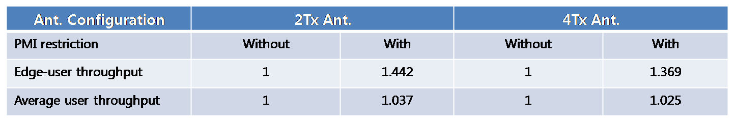

In Table 2, we compared the user throughput of with and without PMI restriction according to number of transmit antenna. Here we consider the number of transmit antenna as 2 and 4 and rank adaptation is not used. When the close-loop MIMO scheme is supported by 2 transmit antenna, about 3.7% and 44.2% gains in the aspect of average user throughput and edge user throughput have been obtained in case of the PMI restriction. As the table above, we can be got the 36.9% and 2.5% gains in the case of PMI restriction which is supported by 4 transmit antenna. Therefore, PMI restriction can provide the similar enhancement of user throughput regardless of number of transmit antenna. We can confirm the above results from Figure 2. Figure 2 shows the CDF of user throughput for number of transmit antenna and no rank adaptation at cases with and without PMI restriction.

Figure 2 CDF of user throughput in no rank adaptation

Table 3 shows the performance of user throughput when rank adaptation is used. Here we apply the PMI restriction when each user uses the rank 1 codebook in rank adaptation. But, if the rank 2 codebook is used for cell users, these users do not undergo the PMI restriction so cell users can use the full subset of codebook. And for more diversity gain, the number of Tx antenna is increased from 2 to 4.

As below the table, we could have achieved up to 39.7% and 1.9% gains in the case of PMI restriction over the case of no PMI restriction for 2Tx. And if 4 Tx antennas are applied, we can obtain the 32% gain and 0.5% loss in aspect of edge user throughput and average user throughput. Therefore when the number of Tx antenna is increased to 4, the gain in aspects of edge-user throughput and average user throughput is very similar to that of 2 Tx antenna.

We can confirm the above results from Figure 3. Figure 3 shows the CDF of user throughput at cases with and without PMI restriction in rank adaptation.

Table 3 Relative throughput gain of PMI restriction in rank adaptation
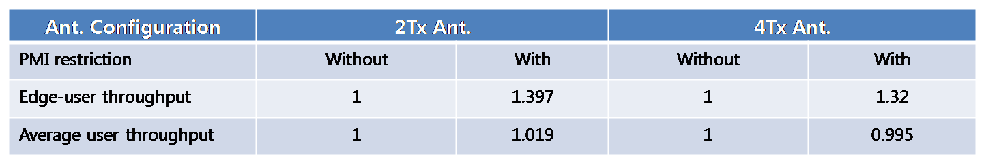

Figure 3 CDF of user throughput in rank adaptation

Up to the previous results, 3 bit codebook is used for PMI restriction. Here we consider the usage of large size codebook for the codebook based closed-loop MIMO in the downlink.

Table 4 indicates the performance of PMI restriction for 6bit codebook when 4Tx antennas are supported. As you can see, we can get the gain with rank adaptation and without rank adaptation in aspect of edge user throughput and average user throughput when 6 bit codebook is used for the closed-loop MIMO in the downlink.

Table 4 Relative performance of PMI restriction for 6bit codebook
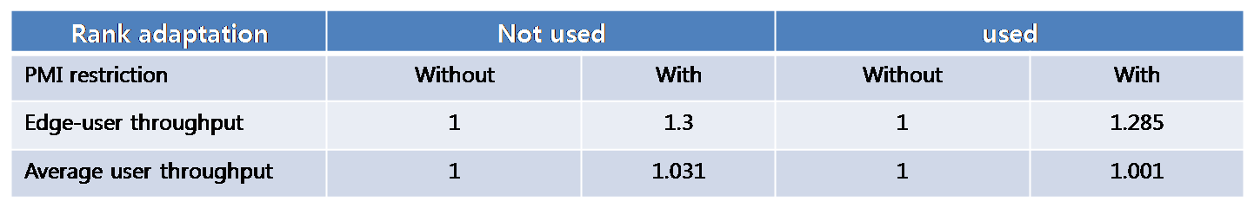

Conclusions
The simulation results show that the introduction of PMI restriction into the codebook based closed-loop MIMO in the downlink provides significant gains on sector throughput and cell edge user throughput as amount of 44.2% and 3.7%, respectively. In addition, we can obtain the satisfactory gain from increase of Tx antenna as well as large size codebook. And if rank adaptation is applied for closed-loop MIMO in downlink, we can also get the similar gain over in case of no rank adaptation by using the PMI restriction. These meaningful benefits can be obtained at very low cost of infrequent feedback of one interfering PMI per MS which is in low geometry below certain threshold.

Based in the above observation, we propose the codebook based closed-loop MIMO scheme with PMI restriction as one of technologies to achieve target requirements for IEEE 802.16m.

Reference
[1] IEEE 80216m-08/003r3 “Draft IEEE 802.16m System Description Document (SDD)”
[2] IEEE 80216m-08/004r2, “Project 802.16m Evaluation Methodology Document (EMD)”

