Project | IEEE 802.16 Broadband Wireless Access Working Group <http://ieee802.org/16>
Title | A Novel UEP Scheme for MBS Using D-STTD
Date Submitted | 2008-05-05
Source(s) | Yinggang Du, Hongjie Si  Huawei  Shunqing. Zhang, Lilian L. Luo, Edward Au, Vincent K. N. Lau, Roger R.S. Cheng,  Wai Ho Mow, Eddy Chiu  Hongkong University Of Science & Technology | Voice:  E-mail: sihongjie@huawei.com
Re: | IEEE 802.16m-08/016r1 “Call for Contributions on Project 802.16m System Description Document (SDD)”  Target topic: “Downlink MIMO Scheme”
Abstract | This contribution proposed a novel UEP scheme for MBS using D-STTD, it is straight to adopt the similar concept to STBC mode.
Purpose | For discussion and approval by TGm.
Notice | This document does not represent the agreed views of the IEEE 802.16 Working Group or any of its subgroups. It represents only the views of the participants listed in the “Source(s)” field above. It is offered as a basis for discussion. It is not binding on the contributor(s), who reserve(s) the right to add, amend or withdraw material contained herein.
Release | The contributor grants a free, irrevocable license to the IEEE to incorporate material contained in this contribution, and any modifications thereof, in the creation of an IEEE Standards publication; to copyright in the IEEE’s name any IEEE Standards publication even though it may include portions of this contribution; and at the IEEE’s sole discretion to permit others to reproduce in whole or in part the resulting IEEE Standards publication. The contributor also acknowledges and accepts that this contribution may be made public by IEEE 802.16.
Patent Policy | The contributor is familiar with the IEEE-SA Patent Policy and Procedures:  <http://standards.ieee.org/guides/bylaws/sect6-7.html#6> and <http://standards.ieee.org/guides/opman/sect6.html#6.3>.  Further information is located at <http://standards.ieee.org/board/pat/pat-material.html> and <http://standards.ieee.org/board/pat>.
A Novel UEP Scheme for MBS Using D-STTD
Yinggang Du, Hongjie Si
Huawei
Shunqing. Zhang, Lilian L. Luo, Edward Au,
Vincent K. N. Lau, Roger R.S. Cheng, Wai Ho Mow, Eddy Chiu
Hongkong University of Science & Technology

Introduction
In the current IEEE 802.16 specification draft [1], MBS service refers to the service flow that carries broadcast or multicast information delivered to a plurality of subscriber station (SS) or mobile station (MS). Such service flows have certain QoS parameters and some may need real-time services (e.g. VoIP, teleconference, online TV). In order to support the MBS service for high bandwidth-efficiency transmission, multiple-input-multiple-output (MIMO) technology is incorporated in the IEEE802.16m requirements [2]. Furthermore, for MBS service, different users may receive signals with different qualities. To provide high bandwidth efficiency, the digital transmission systems must be designed to provide a gradual degradation of the received signals, such that the users with strong receiving signals can receive the full information while the users with weak receiving signals can still detect part of the information which is more reliable (i.e., better error protection). Hence, to provide the UEP (unequal error protection) property of the MBS information is crucial.
In the existing requirements for 802.16m systems [2], MIMO technology should be supported. D-STTD (Double Space Time Transmission Diversity) is a typical 4 by 2 MIMO scheme for the downlink transmission. In the downlink D-STTD scheme, the BS divides the packet into two halves, each of which is encoded by Alamouti’s scheme [3] to provide the transmission diversity. Although the existing regular D-STTD system can offer 2 streams per channel use, it may not be suitable for the MBS service due to the loss of unequal error protection property. Meanwhile, the received two streams may interfere with each other at the receiver side. Since the power is equally distributed into two streams at the transmitter, the decoding performance with SIC receiver may not be good enough. To adopt the D-STTD scheme in the MBS service transmission, a novel unequal error protection scheme for MBS service using D-STTD was proposed in this contribution.

Proposal
Hierarchical Modulation is widely used in the broadcast system to provide the unequal error protection, but it is not applicable in D-STTD system, since the decoding error is mainly due to the interference between different streams and the regular Hierarchical Modulation approach can only provide the unequal error property within each stream.

Unequal power allocation can also be used to achieve the UEP property. The BS uses different powers for different signal depending on the error protection level of the transmitted signals. For example, when the BS delivers important bits in the current interval, it uses high power to transmit. In contrast, the power is reduced when the BS wants to deliver less important bits. Then another straightforward approach to introduce UEP in D-STTD is unequal power allocation between the two Alamouti encoded streams of the D-STTD, as illustrated in Figure 1. In that approach, the transmission power is allocated to the two streams (x₁, x₂) and (x₃, x₄) with unequal ratio $α_{1}$and$α_{2}$, where $α_{1}>α_{2}$. However, as the equivalent channel condition may be different for different users due to the varying nature of the wireless condition, even with unequal power allocation, the UEP property can not be easily achieved using this structure. For example, considering those users for whom the channel condition for stream (x₃, x₄) is very better than the channel condition for stream (x₁, x₂). Although the stream (x₁, x₂) is transmitted with more power than the other, at the receive side, the SINR for stream (x₁, x₂) may be even smaller than that for stream (x₃, x₄) due to the worse channel condition.
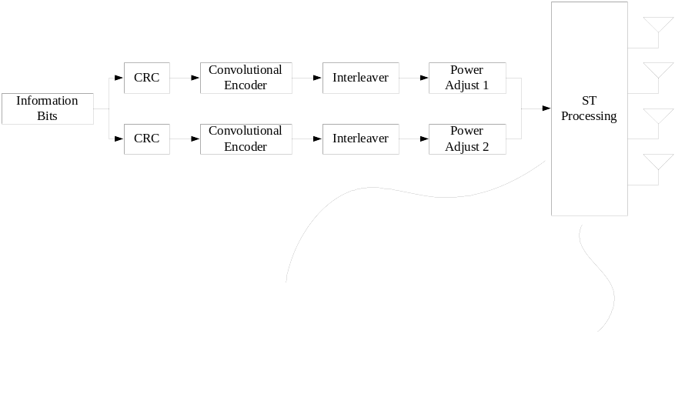
Fig 1. D-STTD with the straightforward unequal power allocation

To avoid the UEP property introduced by unequal power allocation being destroyed by the different channel condition, a novel UEP scheme with D-STDD is proposed here. Unequal power allocation is still the approach to introduce UEP, while the unequal power allocation is not between the two Alamouti block but within each Alamouti block. As illustrated in Fig 2, transmission power is allocated into stream (x₁, x₃) and stream (x₂, x₄) with unequal ratio $α_{1}$and$α_{2}$ ($α_{1}>α_{2}$), where x₁ and x₂ are encoded into an Alamouti block, and x₃ and x₄ are encoded into another block. As the channel condition is always the same for the two symbols in each Alamouti block(x₁ and x₂, or x₃ and x₄), the unequal power allocation between the two symbols within one Alamouti block would always result in the unequal error protection.

The basic Alamouti STBC scheme can be denoted in two equivalents, Scheme $A=\left[\begin{matrix}s_{1} & s_{2} \\ −s_{2}^{} & s_{1}^{}\end{matrix}\right]$ and Scheme $B=\left[\begin{matrix}−s_{2}^{} & s_{1}^{} \\ s_{1} & s_{2}\end{matrix}\right]$. In D-STTD which consists of two parallel Alamouti blocks, there are two cases of the combination: 1) two blocks with the same Alamouti STBC scheme (both with A, or both with B); 2) two blocks with different Alamouti STBC scheme (one with Scheme A and another with Scheme B). The above two cases are not equivalent because the different interference between two Alamouti blocks. In the proposed UEP scheme with D-STTD, we can further change the scheme of one block alternatively during the transmission to achieve the interference diversity. For example, as shown in Fig 2, the scheme of lower block was swapped during the transmission.

Fig 2. System diagram for MBS service with MIMO technology using proposed mechanism

Furthermore, due to the unequal protection, SIC (Successive Interference Cancellation) can be used to improve the decoding performance. The SIC enabled receiver always decodes the stream with more power first and then use the SIC process to decode the second information.

Conclusion
A novel UEP scheme with D-STTD applicable for MBS service is proposed in this contribution, the following advantages can be introduced:
- Providing two streams in D-STTD system with unequal error protection levels.
- Average over the interference configurations between different streams;
- More reliable decoding performance with SIC process at the receiver side.
Although this contribution is focused on the D-STTD mode, it is very straight to adopt the unequal power allocation concept to STBC mode.

References
[1] IEEE 802.16(Draft Mar 2007), “Draft Standard for Local and Metropolitan Area Networks Part16; Air Interface for Fixed Broadband Wireless Access Systems”, IEEE Standard, May 2007.
[2] IEEE 802.16 C802.16m-07/076r3,”Draft IEEE 802.16M Requirements”, March 2007.
[3] S. Alamouti, “A simple transmit diversity technique for wireless communications”, IEEE Journal on Selected Areas in Communications, Vol. 16, Issue 8, 1998, pp. 1451-1458

Text Proposal to SDD

------------------------------------Start text proposal------------------------------------
[Adopt the following text in the ToC of P802.16m System Description Document (SDD)]

11. x.x.x MIMO Schemes for MBS
STBC should be supported for MBS service when the antenna configuration is 2x2, and D-STTD should be supported for MBS service when the antenna configuration is 4x2. When STBC or D-STTD is used for MBS service, unequal power allocation between the two symbols within each Alamouti encoded block may be used to provide unequal error protect levels for two MBS streams.
------------------------------------End text proposal------------------------------------

