Project | IEEE 802.16 Broadband Wireless Access Working Group <http://ieee802.org/16>
Title | Adaptive Frequency Interleaving for HARQ
Date Submitted | 2008-05-05
Source(s) | Rongdao Yu, Martin Liu  Huawei  Ray Wang, Vincent Lau, Roger Cheng, Eddy Chiu  Hongkong University of Science & Technology | E-mail: yurongdao@huawei.com
Re: | IEEE 802.16m-08/016r1 “Call for Contributions on Project 802.16m System Description Document (SDD)”  Target topic: “Hybrid ARQ”
Abstract | This document proposes an adaptive frequency interleaving scheme with low complexity and more robustness for 16m systems.
Purpose | For discussion and approval by TGm.
Notice | This document does not represent the agreed views of the IEEE 802.16 Working Group or any of its subgroups. It represents only the views of the participants listed in the “Source(s)” field above. It is offered as a basis for discussion. It is not binding on the contributor(s), who reserve(s) the right to add, amend or withdraw material contained herein.
Release | The contributor grants a free, irrevocable license to the IEEE to incorporate material contained in this contribution, and any modifications thereof, in the creation of an IEEE Standards publication; to copyright in the IEEE’s name any IEEE Standards publication even though it may include portions of this contribution; and at the IEEE’s sole discretion to permit others to reproduce in whole or in part the resulting IEEE Standards publication. The contributor also acknowledges and accepts that this contribution may be made public by IEEE 802.16.
Patent Policy | The contributor is familiar with the IEEE-SA Patent Policy and Procedures:  <http://standards.ieee.org/guides/bylaws/sect6-7.html#6> and <http://standards.ieee.org/guides/opman/sect6.html#6.3>.  Further information is located at <http://standards.ieee.org/board/pat/pat-material.html> and <http://standards.ieee.org/board/pat>.

Adaptive Frequency Interleaving for HARQ
Rongdao Yu , Martin Liu
Huawei
Ray Wang, Vincent Lau, Roger Cheng, Eddy Chiu
Hongkong University of Science & Technology

Introduction
HARQ defines packet retransmission mechanisms that allow efficient combining of received information from multiple transmissions. There are two types HARQ scheme. Type I is Chase Combining, in which same coded bits are retransmitted .Type II is incremental redundancy, in which additional coded bits are transmitted.

Since the transmitter only has the ACK/NAK feedback of the receiver, the retransmission does not exploit the knowledge of what the receiver needs most in the next retransmission.

Conventional HARQ ACK/NAK feedback carries only 1 bit. In practice, there are plenty of overheads associated with delivery of the 1 bit ACK/NAK. It will be more efficient if more bits are contained in the ACK/NAK feedback, which is feedback of soft HARQ.

In chase combing, since the ordering of symbols in retransmission packets is the same, symbols suffering from deep fading are still put on bad subcarriers. The retransmission cannot provide sufficient SNR gain to those symbols on bad subcarriers; hence, they are the bottleneck of the decoding

Proposed Scheme

Frequency Interleaving
The frequency interleaving is as figure 1.

Figure 1 Frequency Interleaving

Adaptive Frequency Interleaving
We propose a more powerful design of adaptive frequency interleaving. A common set of interleaving patterns is known to the transmitter and the receiver. And the receiver shall make use of the estimated channel state information to choose a most suitable interleaving pattern and feedback the index of the pattern to the transmitter. The transmitter just uses the selected interleaving pattern indicated in the feedback to do interleaving.

Figure 2 Adaptive Frequency Interleaving

Message Flow

Figure 3 Message Flow

The pattern Selectin Algorithm
$\left\{h_{i,1},h_{i,2},\text{.}\text{.}\text{.},h_{i,n−1}\right\}$
$h_{i}^{m}$Assume is the channel gains encountering by the i-th transmitted symbol in the first n-1 times transmissions; are the channel gain of the i-th transmitted symbol when the m-th interleaving pattern is used; there are totally K transmitted symbols. Hence, in the n-th transmission, the controller will choose an interleaving pattern which maximizes the summation of the mutual information of each symbol, i.e.:
$\underset{m=1}{\overset{M}{\text{max}}}\underset{i=1}{\overset{K}{Π}}(1+\frac{|h_{i}^{m}|^{2}+\sum_{j=1}^{n−1}{|h_{i,j}|^{2}}}{σ_{z}^{2}}p)$

$p$Where is the transmission power and $σ_{z}^{2}$ is the power of noise.
The transmitter just follows the selected pattern to do interleaving no more processing is needed.

Simulation
Simulation Parameter：
Channel Coding: Convolutional Code rate 1/2
Modulation: QPSK
FFT Size: 1024
Number of information bits per coding block: 48
Maximum number of transmissions: 4
Channel：ITU PB, 3km/hr

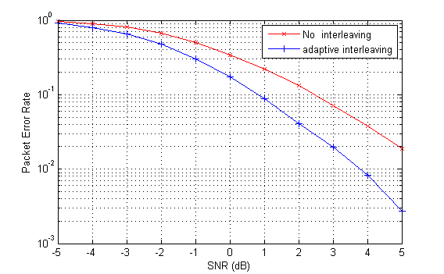
Figure 4 simulation result of adaptive interleaving
From above simulation results, it shows that the proposed scheme achieves about 1.3dB gain over than the no frequency interleaving.

Conclusion
In the contribution, we introduce an adaptive frequency interleaving scheme, which is with low complexity and more robustness for 16m systems.

Text Proposal to SDD

------------------------------------Start text proposal------------------------------------
[Adopt the following text in the ToC of P802.16m System Description Document (SDD)]

11. x.x.x HARQ
Retransmitted symbols are interleaved and the interleaving pattern is adapted by the feedback from the receiver.
------------------------------------End text proposal------------------------------------

