Project | IEEE 802.16 Broadband Wireless Access Working Group <http://ieee802.org/16>
Title | Results and Considerations for Downlink Pilot Structures
Date Submitted | 2008-5-11
Source(s) | Havish Koorapaty, Jiann-Ching Guey  Ericsson Inc.  8001 Development Drive, P.O. Box 13969  RTP, NC 27709 | E-mail: Havish.Koorapaty@ericsson.com
Re: | IEEE 802.16mDL_PHY-08/046 and IEEE 802.16mDL_PHY-08/009r5
Abstract | Results and considerations for evaluation of pilot structure are presented.
Purpose | Review and discuss.
Notice | This document does not represent the agreed views of the IEEE 802.16 Working Group or any of its subgroups. It represents only the views of the participants listed in the “Source(s)” field above. It is offered as a basis for discussion. It is not binding on the contributor(s), who reserve(s) the right to add, amend or withdraw material contained herein.
Release | The contributor grants a free, irrevocable license to the IEEE to incorporate material contained in this contribution, and any modifications thereof, in the creation of an IEEE Standards publication; to copyright in the IEEE’s name any IEEE Standards publication even though it may include portions of this contribution; and at the IEEE’s sole discretion to permit others to reproduce in whole or in part the resulting IEEE Standards publication. The contributor also acknowledges and accepts that this contribution may be made public by IEEE 802.16.
Patent Policy | The contributor is familiar with the IEEE-SA Patent Policy and Procedures:  <http://standards.ieee.org/guides/bylaws/sect6-7.html#6> and <http://standards.ieee.org/guides/opman/sect6.html#6.3>.  Further information is located at <http://standards.ieee.org/board/pat/pat-material.html> and <http://standards.ieee.org/board/pat>.

Results and Considerations for Downlink Pilot Structures
Havish Koorapaty, Jiann-Ching Guey
Ericsson AB

Introduction
This contribution shows some link simulation results for downlink pilot structures and discusses some aspects that need to be considered in defining the evaluation criteria.

Simulation Results
Link simulation results for some cases are presented in this section. Figure 1 shows simulation results with QPSK modulation, rate-1/2 coding on a Vehicular A channel at 120 kmph. The impairment is assumed to be AWGN. The block error rate is plotted against the signal-to-noise ratio. The results are generated with the use of a single resource block. Results are shown for some of the proposed pilot patterns that have an overhead of 6 symbols over the 18x6 resource block. It can be seen that at a target block error rate of 10% the differences between the different patterns are less than 0.25 dB and are quite small. At a block error rate of 1%, the differences are still under 0.4 dB.

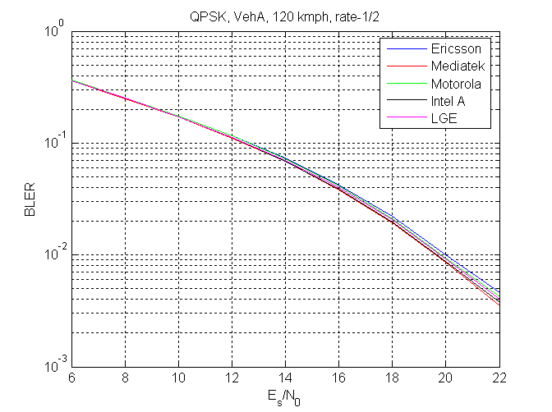
Figure 1: Link simulation with QPSK rate-1/2 in Veh. A channel at 120 kmph

Figure 2 shows the results with the same conditions but with 16-QAM modulation. Here the differences increase to 0.45 and 0.75 dB at the 10% and 1% block error rate metrics respectively.

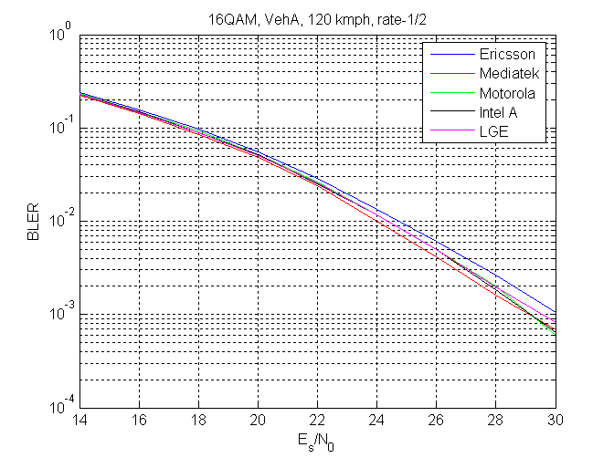
Figure 2: Link simulation with 16QAM rate-1/2 in Veh. A channel at 120 kmph
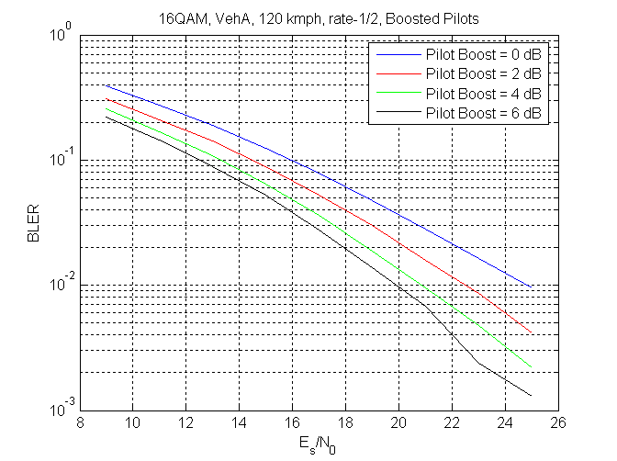
Figure 3: Performance in Interference limited environment. Pilots interfere with data between sectors.
Figure 3 shows gains that may be obtained via pilot boosting in an interference limited environment. The pilot pattern labeled ‘Ericsson’ in Figure 2 is simulated with different pilot boosting levels. Interference is modeled using two equal strength interferers. In figure 3, the desired channel and the two interferers use different pilot locations. Figure 4 shows the corresponding performance with different boosting levels when pilot locations of the desired and interfering sectors use the same locations.

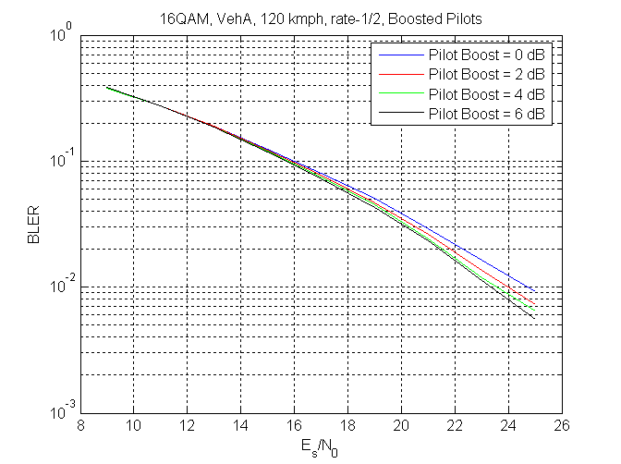
Figure 4: Performance in interference limited environment. Pilots interfere only with pilots between sectors

Discussion
The following observations may be made:
- Given the same overhead, the performance of various pilot patterns proposed is in the same range.
- In general, the pilot patterns exhibiting slightly better performance also seem to have a lower degree of uniqueness between sectors.
- Pilot boosting can help even in interference limited environments provided pilot locations are different between different base stations. Therefore, pilot patterns that provide fewer collisions between sectors could improve performance in the system.

The following aspects must be considered in evaluation of pilot structures:
- The results on boosting were obtained using only two interferers. In a practice the number of interferers may vary and the level of pilot boosting may also determine the number of interferers that should be considered in the evaluation. Hence, it is important that the evaluation methodology for pilot patterns consider performance taking into account interference characteristics that might occur in a practical system.
- The uniqueness properties provided by pilot structures across base stations are a key element that allow good system performance and must therefore be considered in the evaluation process.

