Project | IEEE 802.16 Broadband Wireless Access Working Group <http://ieee802.org/16>
Title | Results and Considerations for Downlink Pilot Structures
Date Submitted | 2008-5-11
Source(s) | Havish Koorapaty, Jiann-Ching Guey  Ericsson Inc.  8001 Development Drive, P.O. Box 13969  RTP, NC 27709 | E-mail: Havish.Koorapaty@ericsson.com
Re: | IEEE 802.16mDL_PHY-08/046 and IEEE 802.16mDL_PHY-08/009r5
Abstract | Results and considerations for evaluation of pilot structure are presented.
Purpose | Review and discuss.
Notice | This document does not represent the agreed views of the IEEE 802.16 Working Group or any of its subgroups. It represents only the views of the participants listed in the “Source(s)” field above. It is offered as a basis for discussion. It is not binding on the contributor(s), who reserve(s) the right to add, amend or withdraw material contained herein.
Release | The contributor grants a free, irrevocable license to the IEEE to incorporate material contained in this contribution, and any modifications thereof, in the creation of an IEEE Standards publication; to copyright in the IEEE’s name any IEEE Standards publication even though it may include portions of this contribution; and at the IEEE’s sole discretion to permit others to reproduce in whole or in part the resulting IEEE Standards publication. The contributor also acknowledges and accepts that this contribution may be made public by IEEE 802.16.
Patent Policy | The contributor is familiar with the IEEE-SA Patent Policy and Procedures:  <http://standards.ieee.org/guides/bylaws/sect6-7.html#6> and <http://standards.ieee.org/guides/opman/sect6.html#6.3>.  Further information is located at <http://standards.ieee.org/board/pat/pat-material.html> and <http://standards.ieee.org/board/pat>.

Results and Considerations for Downlink Pilot Structures
Havish Koorapaty, Jiann-Ching Guey
Ericsson AB

Introduction
This contribution presents some simulation results for downlink pilot structures and discusses some aspects that need to be considered in defining the evaluation criteria. Link simulations are used to assess channel estimation performance of some of the various pilot patterns that have been proposed and the effect of channel estimation performance on link performance. A single transmit and receive antenna is used to transmit information over one block of 18 subcarriers by 6 symbols. Six symbols in the block are used to transmit pilots for each of the pilot patterns considered. The pilot patterns vary in the locations chosen for the pilots. A rate-1/2 turbo encoder is used. Channel estimation is performed using an MMSE estimator with knowledge of the covariance matrix of the channel and the noise.

Simulation Results
Link simulation results for some cases are presented in this section. Figure 1 shows simulation results with QPSK modulation, rate-1/2 coding on a Vehicular A channel at 120 kmph. The impairment is assumed to be AWGN. The block error rate is plotted against the signal-to-noise ratio. The results are generated with the use of a single resource block. Results are shown for some of the proposed pilot patterns that have an overhead of 6 symbols over the 18x6 resource block. It can be seen that at a target block error rate of 10% the differences between the different patterns are less than 0.25 dB and are quite small. At a block error rate of 1%, the differences are still under 0.4 dB.

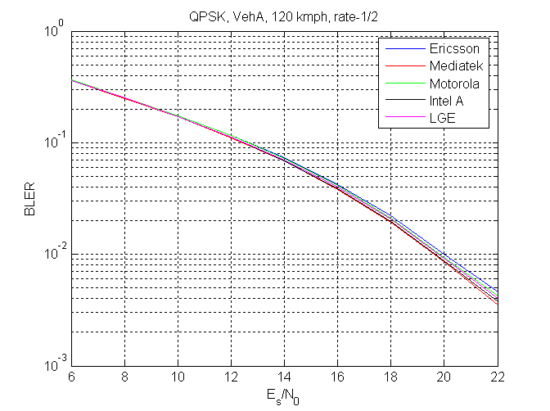
Figure 1: Link simulation with QPSK rate-1/2 in Veh. A channel at 120 kmph

Figure 2 shows the results with the same conditions but with 16-QAM modulation. Here the differences increase to 0.45 and 0.75 dB at the 10% and 1% block error rate metrics respectively.
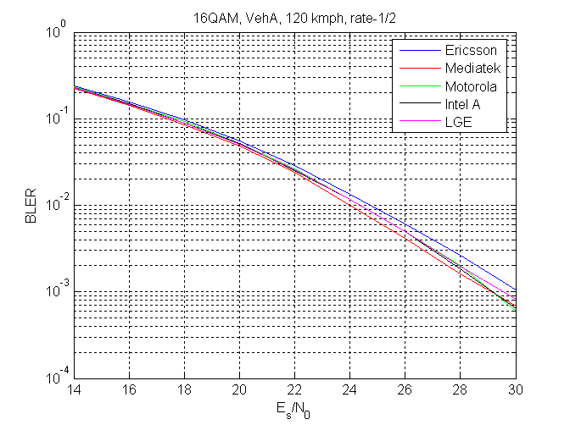
Figure 2: Link simulation with 16QAM rate-1/2 in Veh. A channel at 120 kmph
Figure 3 shows results with the same conditions as in figure 2 with the vehicle speed increased to 350 kmph. The figure shows that some of the patterns proposed are not robust to high vehicle speeds.
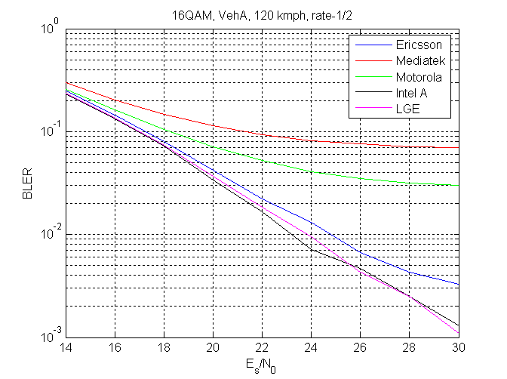
Figure 3: Link simulation with 16QAM rate-1/2 in Veh. A channel at 350 kmph
Figure 4 shows gains that may be obtained via pilot boosting in an interference limited environment. The interference limited environment is modeled by setting the signal-to-noise ratio (SNR as opposed to SINR) to 50 dB which is much higher than the range of SINR values considered in the figure. The pilot structure labeled ‘Ericsson’ in figure 2 is simulated with different pilot boosting levels. A key element of this pilot structure is the ability to minimize collisions between neighboring sectors. Interference is modeled using two equal strength interferers. Independent fading channel realizations are applied to the signals from each of the desired sector and the interfering sectors.

In figure 4, the desired channel and the two interferers use different pilot locations. This is achieved by using different cyclic rotations of a base pattern. Figure 5 shows the corresponding performance with different boosting levels when pilot locations of the desired and interfering sectors use the same locations. It is notable that the gains achieved through boosting are far lower than those shown in figure 3 where pilot to pilot interference is not present.

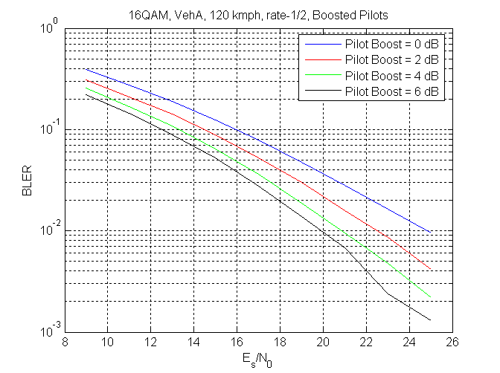
Figure 4: Performance in Interference limited environment. Pilots interfere with data between sectors.

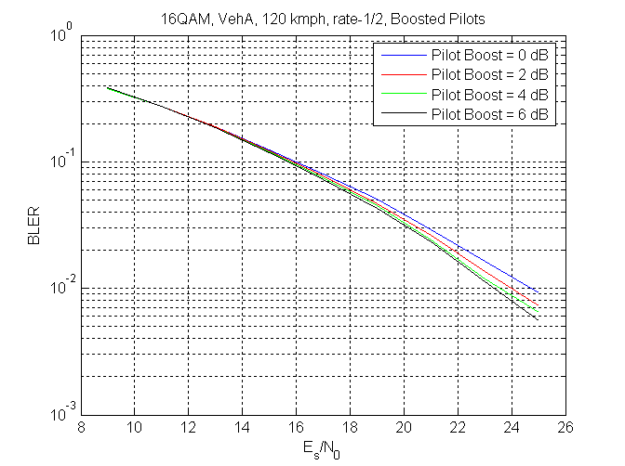
Figure 5: Performance in interference limited environment. Pilots interfere only with pilots between sectors

Discussion
The following observations may be made:
- Given the same overhead, the performance of various pilot patterns proposed are close when pilot boosting is not considered Some pilot patterns that perform best at low speeds also show performance degradation at high speed.
- In general, the pilot patterns exhibiting slightly better performance also seem to have a lower degree of uniqueness between sectors, where uniqueness of locations populated by pilots for different sectors determines the ability to avoid collisions between pilots transmitted from different sectors.
- Pilot boosting can help even in interference limited environments provided pilot locations are different between different base stations. Therefore, pilot patterns that minimize collisions between sectors could take advantage of boosting and improve performance in the system in an interference limited environment. The pilot pattern considered in figures 4 and 5 minimizes pilot collisions between cells to a greater degree than any of the other proposals.

Considerations for Evaluation of Pilot Structures
The following aspects should be considered in defining the evaluation methodology for pilot structures:
- The ability to distinguish between pilot patterns transmitted by different cells is important in order to estimate the desired channel in a multi-cell environment. This may be achieved by
  - Co-locating the pilots for each cell and using different pilot symbol sequences for different cells. In this scenario, pilot symbols for different cells interfere with each other. The uniqueness of sequences is potentially limited by the number of symbols available within the coherence bandwidth and time of the channel.
  - Locating pilots from different cells in different locations so that pilots from different cells interfere minimally. This method provides for better uniqueness properties but the effects of the interference of pilot symbols on data symbols must be captured accurately.
- It is important that the performance of pilot schemes should be considered not merely for a single cell evaluation, but rather in a multi-cell scenario.The flexibility of the pilot schemes to accommodate distinguishable pilot patters over multiple cells and sectors should be an important consideration; e.g., a scheme with a limited number of pilot patters will require careful planning of the deployment.
- The benefits or lack thereof of pilot boosting are closely dependent on the pilot structure and therefore should be considered to be an integral part of the pilot structure.
- In general, each pattern will perform best for a certain Doppler-Delay spread profile. However, robustness of patterns across multiple channel environments must be considered.

Many of these factors may not be adequately captured by a performance evaluation that uses simplified interference modeling. For example, the benefits due to pilot boosting might depend on the number of interferers and the number of antennas being used on the interferering signals, i.e., the number of pilot patterns transmitted. Hence, the evaluation methodology for pilot patterns should consider performance taking into account interference characteristics that might occur in a practical system. This would provide a more complete picture of the performance of various pilot structures.

Based on the above, we recommend that the following be aspects be considered for inclusion in section 11.5.3.2 of C802.16mDL_PHY-08/046 on metrics for comparison of various proposed pilot structures.
- Scenarios for the interference limiting environment other than the two equal interferer case should be considered.
- If pilot boosting is used with dedicated pilots, the number of streams on the interfering signals should be varied.
- The assignment of pilot sequences or patterns to the interfering signals must be varied according to the pilot distribution scheme of the proposed pilot structure.
- If pilot boosting is used, it should be applied to the desired signal and all interferers.

