Project | IEEE 802.16 Broadband Wireless Access Working Group <http://ieee802.org/16>
Title | Enhanced Synchronization via MIMO Structures
Date Submitted | 2008-07-06
Source(s) | Fatih Kocak, Sinan Gezici  Bilkent University  Electrical and Electronics Engineering  Bilkent, Ankara 06800, Turkey | Voice: +90-312-290-3139  E-mail: {fkocak,gezici}@ee.bilkent.edu.tr
Re: | Preamble Rapporteur Group Discussions
Abstract | In this contribution to the TGm SDD on Preamble, performance improvements in synchronization of OFDM signals by means of MIMO structures are discussed. Theoretical and simulation results are presented. Utilization of MIMO structures in the 802.16m preambles is proposed for enhanced synchronization.
Purpose | To be considered and incorporated into the Draft of the Preamble SDD document
Notice | This document does not represent the agreed views of the IEEE 802.16 Working Group or any of its subgroups. It represents only the views of the participants listed in the “Source(s)” field above. It is offered as a basis for discussion. It is not binding on the contributor(s), who reserve(s) the right to add, amend or withdraw material contained herein.
Release | The contributor grants a free, irrevocable license to the IEEE to incorporate material contained in this contribution, and any modifications thereof, in the creation of an IEEE Standards publication; to copyright in the IEEE’s name any IEEE Standards publication even though it may include portions of this contribution; and at the IEEE’s sole discretion to permit others to reproduce in whole or in part the resulting IEEE Standards publication. The contributor also acknowledges and accepts that this contribution may be made public by IEEE 802.16.
Patent Policy | The contributor is familiar with the IEEE-SA Patent Policy and Procedures:  <http://standards.ieee.org/guides/bylaws/sect6-7.html#6> and <http://standards.ieee.org/guides/opman/sect6.html#6.3>.  Further information is located at <http://standards.ieee.org/board/pat/pat-material.html> and <http://standards.ieee.org/board/pat>.

Enhanced Synchronization via MIMO Structures
Fatih Kocak and Sinan Gezici
Bilkent University

Introduction
Multiple-input multiple-output (MIMO) systems facilitate high speed and reliable communications by means of multiplexing and diversity techniques. In addition to communications, MIMO structures can also improve performance of radar systems by providing better detection and characterization of target objects [1]. Similarly, they can be employed for enhanced time delay estimation and synchronization. In [2], advantages of multiple receive antennas are quantified for time delay estimation of narrowband signals by means of Cramer-Rao lower bound (CRLB) calculations. This contribution emphasizes the advantages of MIMO structures for timing synchronization and proposes effective use of space diversity for enhanced synchronization in IEEE 802.16m systems.

Synchronization with Multiple Transmit Antennas
Consider a downlink MISO system with M transmit antennas and one receive antenna. Note that the results can easily be extended to the case of multiple receive antennas by using the results in [2]. The received signal can be expressed as
$r(t)=\sum_{i=1}^{M}{α_{i}s_{i}(t−τ)+n(t)}$ , (1)
where s_{i}(t) is the signal transmitted from the ith transmit antenna, α_{i} is the channel coefficient for the ith signal, and n(t) is additive white Gaussian noise with spectral density σ². Note that each signal is assumed to have significantly larger duration than the maximum distance between the antennas divided by the speed of light; hence, the same time delays are considered. The model in (1) also covers OFDM systems when the signals s_{i}(t) are considered as different subcarriers.
From the signal model in (1), the CRLB on the variances of unbiased time delay estimators can be obtained. For the special case in which the signals s_{i}(t) are orthogonal to each other, and to their derivatives, the CRLB can be expressed as
$\text{CRLB}={\left(\frac{1}{σ^{2}}\int_{0}^{T}{{\left|\sum_{i=1}^{M}{α_{i}s_{i}^{'}(t−τ)}\right|}^{2}}\text{dt}\right)}^{−1}$ , (2)
where $s_{i}^{'}(t)$is the first derivative of s_{i}(t) and [0,T] is the observation interval (symbol time).
For orthogonal first derivatives, (2) becomes
$\text{CRLB}={\left(\frac{1}{σ^{2}}\sum_{i=1}^{M}{{\left|α_{i}\right|}^{2}}\int_{0}^{T}{{\left|s_{i}^{'}(t−τ)\right|}^{2}}\text{dt}\right)}^{−1}$ . (3)
Note that when the channel coefficients are independent, lower CRLBs can be achieved. However, for highly correlated channel coefficients, a strong fading can result in very large CRLBs. In other words, independently fading channels can provide “diversity” for time delay estimation.

Simulation Results
In order to illustrate the advantages of multiple antennas in synchronization, consider a simple case with 2 OFDM subcarriers. In the first case, these subcarriers are transmitted from the first and the second antennas, respectively, in a 2x1 (MISO) system. In the second case, both subcarriers are sent from the same antenna in a 1x1 (SISO) system. The signals are the first and the second subcarriers of an OFDM signal with duration 100 μs. Both channels experience Rician fading with a K-factor of 1, and there is a correlation of ρ between the channel coefficients. In the MISO case, the channels are assumed to be uncorrelated, but in the SISO case, they are highly correlated as the subcarriers are closely spaced. Figure 1 illustrates the CRLBs for the MISO case and the SISO case for ρ=1 and ρ=0.75. The MISO case provides about 2dB gain over the SISO case with ρ=0.75 and 8dB gain over the SISO case with ρ=1.
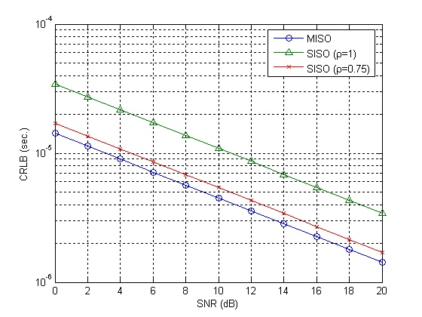
Figure 1: CRLB versus SNR for the 2 antennas/subcarriers scenario.

In Figure 2, a similar scenario is considered for 4 subcarriers. For the MISO case, a 4x1 structure is considered. Similar results as in Figure 1 are observed. In addition, 4 antennas/subcarriers provide better time delay estimation accuracy than 2 antennas/subcarries do.
The previous results are simple examples of gains that can be obtained from MIMO structures for timing synchronization. The space diversity can be also useful for IEEE 802.16m preambles. Therefore, the following text is proposed for the SDD.

Text Proposal to the 802.16m SDD
Add this into Section 11.4.x of the SDD document (IEEE 802.16m-08_003r3).
================================= Text Start ==================================
The preamble provides support for MIMO systems:
- The preamble can be coded and transmitted from different antennas.
- The subcarriers of the preamble can be divided into disjoint sets and transmitted from different antennas.
- The preamble can be transmitted from one of the antennas.
================================== Text End ==================================

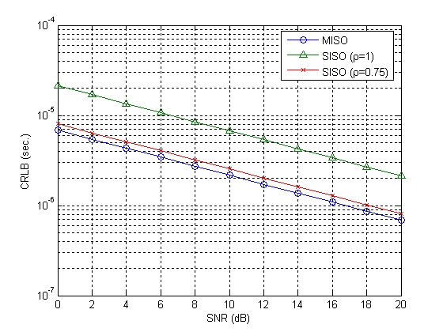

Figure 2: CRLB versus SNR for the 4 antennas/subcarriers scenario.

Bibliography
[1] E. Fishler, A. Haimovich, R. Blum, L. Cimini, D. Chizhik, and R. Valenzuela, “MIMO radar: An idea whose time has come,” in Proc. IEEE Int. Conf. on Radar, Philadelphia, PA, Apr. 2004.
[2] S. Gezici and Z. Sahinoglu, “Ranging in a single-input multiple-output (SIMO) system,” IEEE Communications Letters, vol. 12, issue 3, pp. 197-199, March 2008.

This work was supported by the EU FP7 Project WiMAGIC under grant no. 215167.

