Project | IEEE 802.16 Broadband Wireless Access Working Group <http://ieee802.org/16>
Title | Initial State Procedure
Date Submitted | 2008-07-07
Source(s) | Chongli Liu, Allan Xu  Huawei | Voice: 86-755-28970182  E-mail: {liuchongli, zhier81}@huawei.com
Re: | IEEE 80216m-08_024 Call for Comments and Contributions on Project 802.16m System Description Document (SDD)
Abstract | This proposal gives a correct Initial State Procedure.
Purpose | For discussion and approval by TGm.
Notice | This document does not represent the agreed views of the IEEE 802.16 Working Group or any of its subgroups. It represents only the views of the participants listed in the “Source(s)” field above. It is offered as a basis for discussion. It is not binding on the contributor(s), who reserve(s) the right to add, amend or withdraw material contained herein.
Release | The contributor grants a free, irrevocable license to the IEEE to incorporate material contained in this contribution, and any modifications thereof, in the creation of an IEEE Standards publication; to copyright in the IEEE’s name any IEEE Standards publication even though it may include portions of this contribution; and at the IEEE’s sole discretion to permit others to reproduce in whole or in part the resulting IEEE Standards publication. The contributor also acknowledges and accepts that this contribution may be made public by IEEE 802.16.
Patent Policy | The contributor is familiar with the IEEE-SA Patent Policy and Procedures:  <http://standards.ieee.org/guides/bylaws/sect6-7.html#6> and <http://standards.ieee.org/guides/opman/sect6.html#6.3>.  Further information is located at <http://standards.ieee.org/board/pat/pat-material.html> and <http://standards.ieee.org/board/pat>.
Initial State Procedure
Chongli Liu, Allan Xu
Huawei

Introduction
After power on, the first step of a 16m terminal is to perform synchronization to the BS, and then, system information and random access related parameters should be acquired before starting random access procedure.

Initial State
If Access related parameters are transmitted in BCH, Common control channel acquisition is not necessary.
If Access related parameters are transmitted in Dynamic BCH, since the Dynamic BCH is located in physical data channel, we have to decode Common control channel after BCH decoding. Dynamic broadcast channel is defined as data channel that carries extended broadcast information.
So the procedure in the diagram should be:
Broadcast Channel Acquisition-> Cell-selection decision
[Access related parameters transmitted in BCH]
Or
Broadcast Channel Acquisition-> Common Control Channel Acquisition -> Dynamic Broadcast Channel Acquisition-> Cell-selection decision
[Access related parameters transmitted in Dynamic BCH]

The figure should be modified as following:

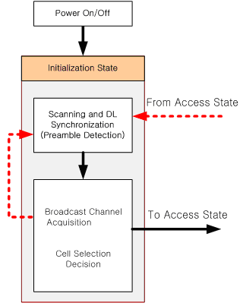
Figure 1 Initialization State Transition Diagram for scheme 1

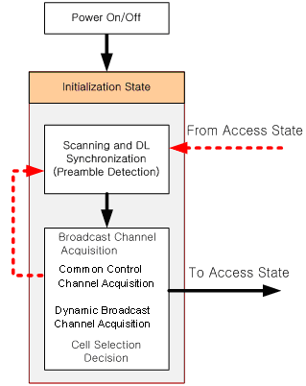
Figure 2 Initialization State Transition Diagram for scheme 2

The first procedure and figure 1 are recommended.

Conclusion
The procedure description in Initialization State Transition Diagram should be modified.

Reference
[1] 80216m-08_003r3.doc The Draft IEEE 802.16m System Description Document

Text Proposal to SDD
------------------------------------Start text proposal------------------------------------
[Adopt the following text in the ToC of P802.16m System Description Document (SDD)]

Initialization State
Initial State is where an MS performs cell selection by scanning and synchronizing to a BS preamble, and acquiring the system configuration information through BCH before it is ready to perform a ranging process to enter Access State. The MS can return back to scanning step in case that it fails to perform action required to each step.

Figure 6 Initialization State Transition Diagram

During this state, if the MS could not properly perform the BCH information decoding and cell selection, it should be back to perform the scanning and DL synchronization. The red dashed line stands the abnormal case. If the MS successfully decodes BCH information, it goes to Access state. If the abnormal case occurs in Access state, the stats transition should be achieved from the Initialization state again.

------------------------------------End text proposal------------------------------------

