Project | IEEE 802.16 Broadband Wireless Access Working Group <http://ieee802.org/16>
Title | Modulation and Coding Set designing for 16m system
Date Submitted | 2008-07-07
Source(s) | Hua Zhou, Sengbao Liang, Jie Zhang, Yuantao Zhang, Jinyin Xue, Jun Tian  Fujitsu R&D Center Ltd. | { zhouhua; sengbaol; jie.zhang; zyuantao; xuejy; tianjun}@cn.fujitsu.com
Re: | IEEE 802.16m-08/0021r2 Call for Contributions on Project 802.16m SDD  Topic: Link adaptation scheme
Abstract | MCS set designing is proposed for optimizing the system throughput, with backward compatibility to 16e system
Purpose | Proposal for consideration in the 802.16m SDD
Notice | This document does not represent the agreed views of the IEEE 802.16 Working Group or any of its subgroups. It represents only the views of the participants listed in the “Source(s)” field above. It is offered as a basis for discussion. It is not binding on the contributor(s), who reserve(s) the right to add, amend or withdraw material contained herein.
Release | The contributor grants a free, irrevocable license to the IEEE to incorporate material contained in this contribution, and any modifications thereof, in the creation of an IEEE Standards publication; to copyright in the IEEE’s name any IEEE Standards publication even though it may include portions of this contribution; and at the IEEE’s sole discretion to permit others to reproduce in whole or in part the resulting IEEE Standards publication. The contributor also acknowledges and accepts that this contribution may be made public by IEEE 802.16.
Patent Policy | The contributor is familiar with the IEEE-SA Patent Policy and Procedures:  <http://standards.ieee.org/guides/bylaws/sect6-7.html#6> and <http://standards.ieee.org/guides/opman/sect6.html#6.3>.  Further information is located at <http://standards.ieee.org/board/pat/pat-material.html> and <http://standards.ieee.org/board/pat>.

Modulation and Coding Scheme designing for 16m system
FUJITSU

Introduction
The existing 16e MCS for data transmission is based on punctured CTC and QAM, which have the following performance as showing blow.
Figure 1 BLER performance of MCS sets in 16E standard
Here, we find that if the target BLER is 10%, the SINR threshold to select different MCS is 1.5dB, 4.5dB, 7.0dB, 10.5dB, 11.5dB, 15dB, 16dB, and 17.5dB. The SINR distance between two continuous MCS levels is 3dB, 2.5dB, 3.5dB, 1.0dB, 3.5dB, 1dB, and 1.5dB, which have big variance. In some case, this set of MCS levels will cause system throughput, for example, most of the user in one system can have limited SINR range, such as, from 0dB to 10dB, but in this range, the MCS satisfied for target BLER for user can be only selected from 3 MCS levels (QPSK ½, QPSK ¾, 16QAM 1/2,). On the other hand, if we can know roughly the SINR distribution range, then we can assign appropriate MCS levels for optimizing system throughput.
Figure 2 shows the PDF of instantaneous SINR for 16e baseline system. From this figure, we can see that most of SINR value are between -10dB and 15dB. If we want to have a higher system throughput, we should optimize it for those users with SINR between -10dB and 15dB. One straightforward way to achieve this is to assign more MCS level in this SINR area, i.e., we design more MCS level for SNR with high probability, and less MCS level for SNR with less probability. But when we look at the BLER performance of MCS levels in 16E system as shown in Figure 1, we can find out that the MCS levels are designed not very reasonable, i.e., too many MCS levels greater than 15dB, less MCS levels between -10dB and 15dB. We should add more MCS between -10dB and 15dB.
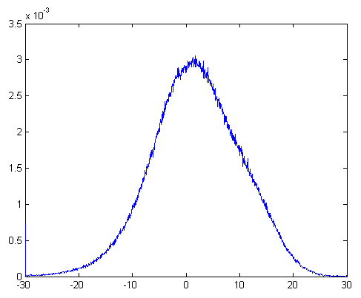
Figure 2 PDF of Instantaneous SINR for 16E baseline system

MCS design
For illustrating MCS set design by example, figure 3 shows a modified MCS sets with more MCS level and its corresponding BLER performance in PB3 channel and for PUSC permutation.
Figure 3 Performance of Modified MCS set in PB3 channel

In this figure we add QPSK 5/8 and QPSK 5/6, in this case, we can get the following table showing the spectrum efficiency and corresponding target SINR values.

MCS level | Spectrum efficiency | Required SINR | Distance between two continuous MCS levels
QPSK ½ | 1.0 | 6.3
QPSK 5/8 | 1.25 | 8.5 | 2.2
QPSK ¾ | 1.5 | 11.0 | 2.5
16QAM ½ | 2.0 | 11.8 | 0.8
QPSK 5/6 | 1.67 | 13.8 | 2.0
64QAM ½ | 3.0 | 16.0 | 2.2
16QAM ¾ | 3.0 | 17.0 | 1.0
64QAM 5/8 | 3.75 | 19.3 | 2.3
64QAM 2/3 | 4.0 | 20.5 | 1.2
64QAM ¾ | 4.5 | 22.0 | 1.5
64QAM 5/6 | 5.0 | 24.5 | 2.5

Text proposal

Insert the following text into SDD Sections indicated below

---------------------------text start-----------------------------

11.x.x Link Adaptation

11.x.1 Modulation and Coding Set
In order to achieve higher system throughput, MCS set should be optimized to give more granularity, for example, more MCS levels to the SNR range with high probability, and less levels to the SNR range with less probability, if necessary.

------------------------------text end---------------------------

References
[1] IEEE 802.16m-07/002r4, “802.16m System Requirements”

