Project | IEEE 802.16 Broadband Wireless Access Working Group <http://ieee802.org/16>
Title | Proposal to delete the description of IP Address
Date Submitted | 2008-07-07
Source(s) | Lina Liu，Libra Xiao  Huawei Technologies CO., LTD. | liulina@huawei.com  libra_xiao@huawei.com
Re: | IEEE 802.16m-08/024, “Call for Comments and Contributions on Project 802.16m System Description Document (SDD),” – Call for comments
Abstract | The contribution proposes to delete the description of the IP Address, because it is out of scope of 16m
Purpose | For TGm discussion and adoption on the proposal text into P802.16m SDD.
Notice | This document does not represent the agreed views of the IEEE 802.16 Working Group or any of its subgroups. It represents only the views of the participants listed in the “Source(s)” field above. It is offered as a basis for discussion. It is not binding on the contributor(s), who reserve(s) the right to add, amend or withdraw material contained herein.
Release | The contributor grants a free, irrevocable license to the IEEE to incorporate material contained in this contribution, and any modifications thereof, in the creation of an IEEE Standards publication; to copyright in the IEEE’s name any IEEE Standards publication even though it may include portions of this contribution; and at the IEEE’s sole discretion to permit others to reproduce in whole or in part the resulting IEEE Standards publication. The contributor also acknowledges and accepts that this contribution may be made public by IEEE 802.16.
Patent Policy | The contributor is familiar with the IEEE-SA Patent Policy and Procedures:  <http://standards.ieee.org/guides/bylaws/sect6-7.html#6> and <http://standards.ieee.org/guides/opman/sect6.html#6.3>.  Further information is located at <http://standards.ieee.org/board/pat/pat-material.html> and <http://standards.ieee.org/board/pat>.
Proposal to delete the description of IP Address
Lina Liu, Libra Xiao
Huawei

Introduction
In the IEEE 802.16m SDD [1], Figure 7 describes the access state transition diagram. As shown in this figure, there is the process of the IP Address Assignment after the Registration procedure. The purpose of this contribution is to discuss if the concept of IP Address Assignment should be deleted.

In our opinion, the scope of IEEE 802.16m ASN doesn’t support the IP Address Assignment but support the Relay functionality for establishing Layer-3 (L3) connectivity with an IEEE 802.16e/m MS (i.e. IP address allocation), and the CSN is defined as a set of network functions that provide IP connectivity services to the IEEE 802.16e/m subscriber(s), which is described in chapter 4 of page 6~7.

In IEEE 802.16m standard, there should not exist the process description of IP Address Assignment, which should be in the protocol for the CSN in WiMAX Forum.

So we suggest that all description about IP Address Assignment should be deleted in the description for the IEEE 802.16m system of the SDD document.

Proposed Text
The following text is proposed to be captured in the IEEE 802.16m system description document (SDD) [1].

=============================== Start of Proposed Text ==============================
[Modify the following text after line#1, page# 14 of TGm SDD]

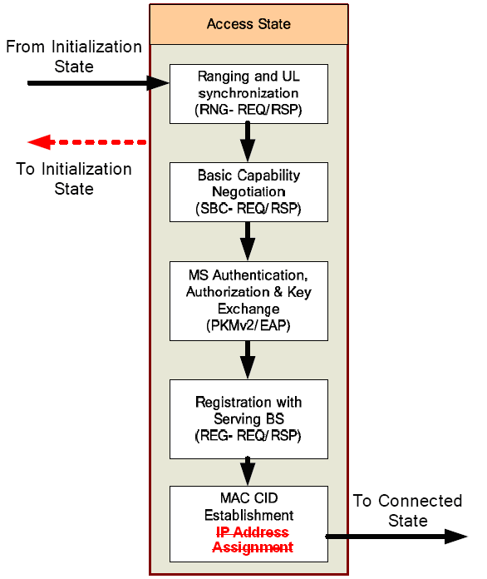
Figure 7 Access State Transition Diagram
================================== End of the Text ================================

5 References
[1] 80216m-08_003r3 SDD

