Project | IEEE 802.16 Broadband Wireless Access Working Group <http://ieee802.org/16>
Title | Proposal to include dynamic paging groups in the SDD document
Date Submitted | 2008-07-07
Source(s) | Shih-Lin Wu  Ming-Jer Chiang  Shiou-Wen Wang  Jui-Te Chang  Chang Gung University Computer Science and Information Engineering , Kwei-Shan Tao-Yuan,Taiwan, | Voice:+886 3 211-8800 ext.5320  mailto: slwu@mail.cgu.edu.tw
Re: | IEEE 802.16m-08/024 - Call for Comments and Contributions on Project 802.16m System Description Document (SDD), shoot for “Upper MAC concepts and methods” topic.
Abstract | This contribution describes the dynamic planning of paging groups for the requirements of P802.16m.
Purpose | For discussion and approval by TGm.
Notice | This document does not represent the agreed views of the IEEE 802.16 Working Group or any of its subgroups. It represents only the views of the participants listed in the “Source(s)” field above. It is offered as a basis for discussion. It is not binding on the contributor(s), who reserve(s) the right to add, amend or withdraw material contained herein.
Release | The contributor grants a free, irrevocable license to the IEEE to incorporate material contained in this contribution, and any modifications thereof, in the creation of an IEEE Standards publication; to copyright in the IEEE’s name any IEEE Standards publication even though it may include portions of this contribution; and at the IEEE’s sole discretion to permit others to reproduce in whole or in part the resulting IEEE Standards publication. The contributor also acknowledges and accepts that this contribution may be made public by IEEE 802.16.
Patent Policy | The contributor is familiar with the IEEE-SA Patent Policy and Procedures:  <http://standards.ieee.org/guides/bylaws/sect6-7.html#6> and <http://standards.ieee.org/guides/opman/sect6.html#6.3>.  Further information is located at <http://standards.ieee.org/board/pat/pat-material.html> and <http://standards.ieee.org/board/pat>.

Introduction

This contribution proposes the dynamic planning of paging groups for discussion and approval to be included in the 802.16m System Description Document (SDD).

Description of Proposal

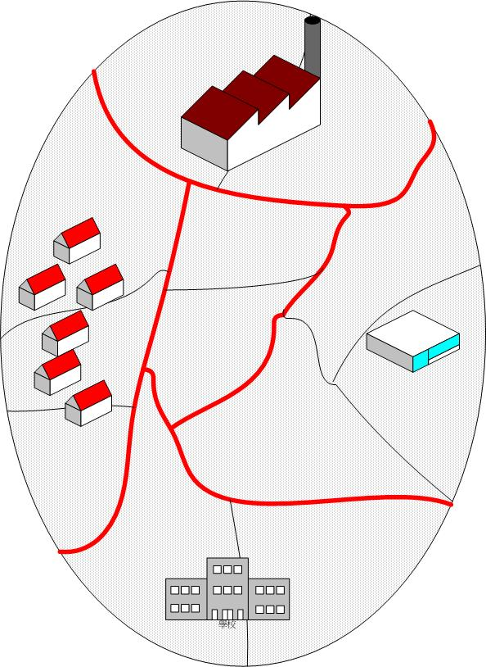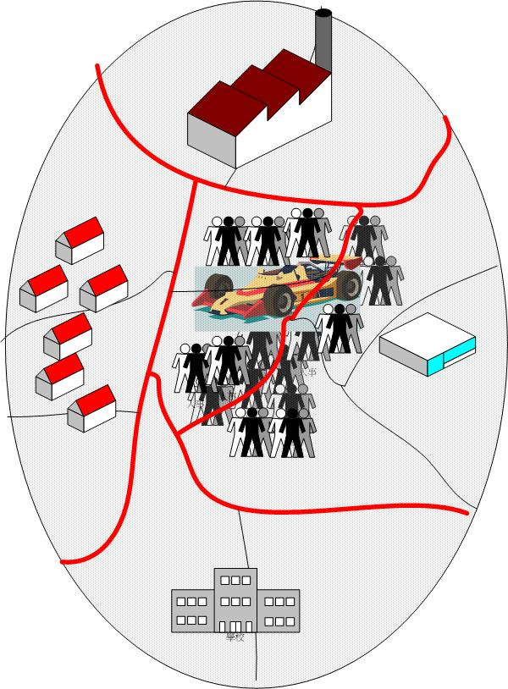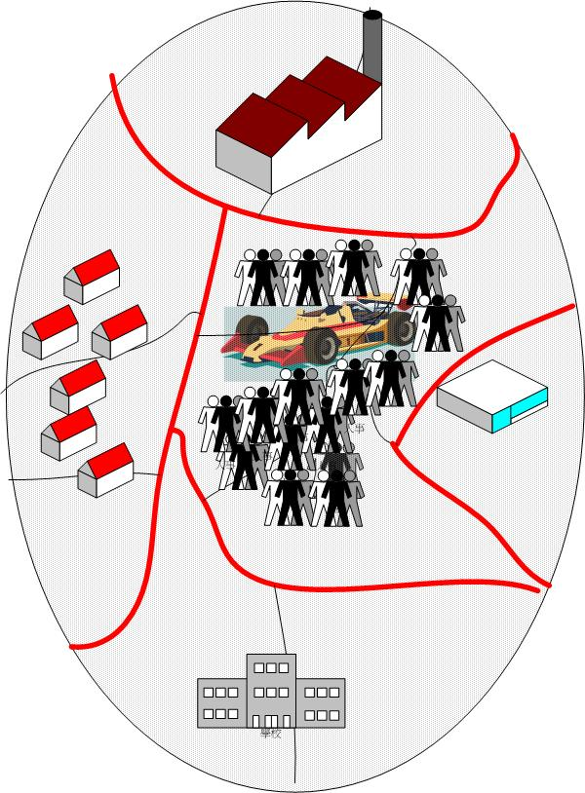
(a) (b) (c)
Figure 1. Benefits with dynamic paging group planning. The gray line is the boundary of cells while the red line is the boundary of paging groups.

Paging group planning possesses an important factor in cellular networks because of the tradeoff caused by paging and location update cost. The legacy protocol, IEEE 802.16e, assumes the scheme of fixed paging groups which would not have the lower cost due to the change of population, residence time, and call arrival rate in a given area. The problem can be alleviated by using the scheme with dynamic paging group planning [1-6].

Figure 1 illustrates how benefits the scheme with dynamic paging group planning can get. Figure 1(a) shows the original planning of paging groups. As we can see that the central area of the Figure 1(a) does not held any exhibition or event. As the time past, a festival is hold in the central area as shown in Figure 1(b). We can find a problem that the location update cost may increase because the festival locates across two paging groups. The problem can be alleviated if the paging groups can be rearranged, as shown in Figure 1(c), based on the new collected information such as the population, residence time, and call arrival rate in the specified area.

Proposed SDD Text

---------------------------------------------Start of Proposed Text-------------------------------------------

X.X Dynamic planning of paging groups
The system may support the scheme with dynamic planning of paging groups. Paging groups can be adjusted dynamically according to the factors of population, residence time, call arrival rate, and other useful parameters in a given area.

---------------------------------------------------End of Text--------------------------------------------------

Reference
[1] Ilker Demirkol, Ersoy Cem, Mehmet Ufuk Caglayan and Delic Hakan, “Location area planning and cell-to-switch assignment in cellular networks,” Wireless Communications, IEEE Transactions on Vol. 3, Issue 3, May 2004, pp.880 – 890.
[2] Hang-Wen Hwang, Ming-Feng Chang, and Chien-Chao Tseng, “A Direction Based Location Update Scheme with a Line-Paging Strategy for PCS Networks,” IEEE Communications Letters, Vol. 4, NO.5, MAY 2000, pp. 149-151.
[3] Jie Li, Atsushi Kubota and Hisao Kameda, “Location management for PCS networks with consideration of mobility patterns,” INFOCOM 2005. 24th Annual Joint Conference of the IEEE Computer and Communications Societies, Proceedings IEEE Vol. 2, 13-17 Mar. 2005, pp.1207 - 1216.
[4] Jalil Modares, and Faramarz Hendessi and Ali Montazeri, ”A Profile-Based Scheme for Location Updating and Paging in Wireless Systems”, IEEE EUROCON 2007. The International Conference on “Computer as a Tool” 9-12 Sept. 2007, pp.1116 – 1123.
[5] Wenchao Ma, Fang Yuguang and Phone Lin, “Mobility Management Strategy Based on User Mobility Patterns in Wireless Networks,” Vehicular Technology, IEEE Transactions on Volume 56, Issue 1, Jan. 2007, pp.322 – 330.
[6] Jun Zheng, Emma Regentova and Radhika Varadarajan, ” Dynamic Planning of Personalized Location Areas for Future PCS Networks with a Simulated Annealing Algorithm,” Vehicular Technology Conference, VTC 2006-Spring. IEEE 63rd Vol. 2, 2006, pp.608 – 612.

