Project | IEEE 802.16 Broadband Wireless Access Working Group <http://ieee802.org/16>
Title | Fractional Frequency Reuse in IEEE 802.16m
Date Submitted | 2008-07-07
Source(s) | I-Kang Fu, Yih-Shen Chen, Kelvin Chou, Dora Chen, Stanley Hsu, Paul Cheng  MediaTek Inc.  No.1, Dusing Rd. 1, Hsinchu Science Park, Hsinchu, Taiwan, R.O.C. | IK.Fu@mediatek.com
Re: | 802.16m-08/024, “Call for Comments and Contributions on Project 802.16m System Description Document (SDD),”  - Interference Mitigation
Abstract | This contribution provides some background introduction on fraction frequency reuse (FFR) and investigate its possible usage base on draft IEEE 802.16m frame structure and inter-BS coordination function.
Purpose | For TGm discussion and possible harmonization on text proposal.
Notice | This document does not represent the agreed views of the IEEE 802.16 Working Group or any of its subgroups. It represents only the views of the participants listed in the “Source(s)” field above. It is offered as a basis for discussion. It is not binding on the contributor(s), who reserve(s) the right to add, amend or withdraw material contained herein.
Release | The contributor grants a free, irrevocable license to the IEEE to incorporate material contained in this contribution, and any modifications thereof, in the creation of an IEEE Standards publication; to copyright in the IEEE’s name any IEEE Standards publication even though it may include portions of this contribution; and at the IEEE’s sole discretion to permit others to reproduce in whole or in part the resulting IEEE Standards publication. The contributor also acknowledges and accepts that this contribution may be made public by IEEE 802.16.
Patent Policy | The contributor is familiar with the IEEE-SA Patent Policy and Procedures:  <http://standards.ieee.org/guides/bylaws/sect6-7.html#6> and <http://standards.ieee.org/guides/opman/sect6.html#6.3>.  Further information is located at <http://standards.ieee.org/board/pat/pat-material.html> and <http://standards.ieee.org/board/pat>.
Fractional Frequency Reuse in IEEE 802.16m

I-Kang Fu, Yih-Shen Chen, Kelvin Chou, Dora Chen, Stanley Hsu, Paul Cheng
MediaTek Inc.

Abstract

In cellular OFDMA systems, the capacity is usually bounded by multiple access interference rather than available channel number when frequency reuse factor is 1. Increasing the transmit power can only provide marginal improvement because it will also result in higher interference level. Typical solution is to increase frequency reuse factor by partitioning the available radio spectrum into multiple frequency bands (e.g. resource segments or multi-carrier channels) and exclusively allocate to different cells to mitigate inter-cell interference. However, the user distribution, traffic demand, interference fluctuation and etc. are time variant. The traditional static or semi-static frequency reuse may not best utilize the scarce radio resource and usually needs worst-case coverage planning to guarantee the QoS for cell edge users. In recent years, fractional frequency reuse (FFR) comes to real system from academic research by dynamic or semi-dynamic self-reconfiguration network capability. This contribution will provide some background introduction on FFR and its possible usage in IEEE 802.16m.

- Background Introduction

Figure 1 shows the basic idea of frequency reuse in cellular systems, where the available frequency channels are partitioned into K (i.e. cluster size, K=4 for this example) subsets and exclusively allocated to K adjacent cells.

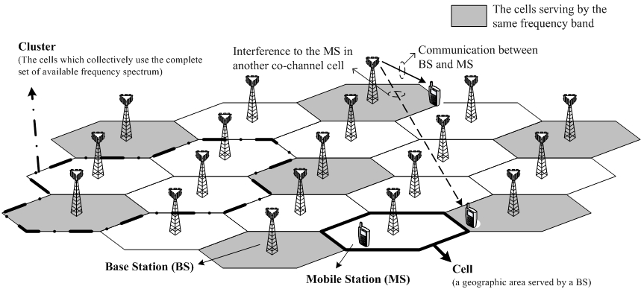
Fig.1 Frequency reuse in cellular systems

Consider a mobile station i (MS_{i}) located at cell boundary with the downlink received SINR_{i} as S_{i}/(I_{i}+N), where S_{i} is the received signal power, I_{i} is the received interference power and N is the thermal noise power, and the transmit powers of each base station (BS) are the same. Consider the first extreme case that the received interference power I_{i} is much larger than the thermal noise power N, so the SINR_{i} can be approximated as SIR_{i} (i.e. interference-limited). Increasing the transmit power of each BS does not increase the SIR_{i} nor the system capacity in the first extreme case. Then consider the second extreme case, where the received interference power I_{i} is much smaller than the thermal noise power N, so the SINR_{i} can be approximated as SNR_{i} (i.e. non interference-limited). Increasing the transmit power of each BS can proportionally increase the SNR_{i} for MS_{i} and hence lead to higher system capacity.
When the received SINR is approaching to interference-limited region, the efficiency to translate the transmit power increment to SINR and capacity increment will be worsen. This will result in the shortage on transmit power in link budget and result in interference-limited capacity. On the other hand, the efficiency will be increased of the received SINR is away from interference-limited region. Increasing the transmit power in this case can easily lead to larger cell coverage or higher system capacity in this case.
However, the worse interfering situation (i.e. higher ratio between received interference power and thermal noise power) usually comes along with smaller cluster size (K), which is beneficial to system capacity by more available frequency channels in each cell and higher trunking efficiency. On the other hand, the lower interference is usually achieved at the expense on less available frequency channels for each cell by larger cluster size (K). Therefore, the cellular network planning has been an important research and engineering issues studied for a long time. The proper planning on cell size, link budget and frequency assignment to each cell (e.g. cluster size) can lead to optimized spectrum efficiency (i.e. revenue) and guaranteed QoS.

- Introduction on Fractional Frequency Reuse (FFR)

Fractional Frequency Reuse (FFR) is a kind of cellular structure, where different cell region can apply with different cluster size (K) or frequency reuse factor (1/K). The basic idea of FFR in cellular OFDMA systems is introduced in Fig.2.

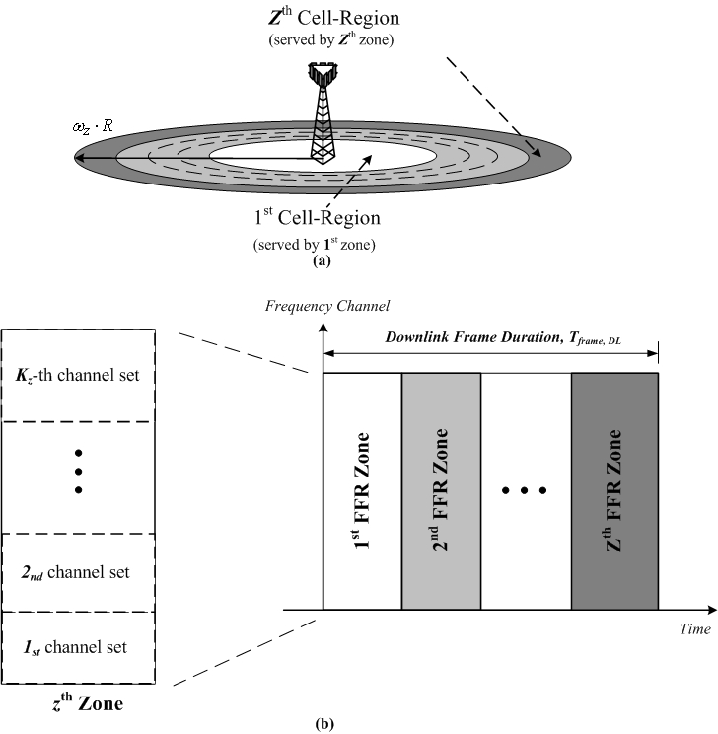
Fig.2 The general concept of Fractional Frequency Reuse (FFR): (a) divide the cell into Z concentric regions and (b) serve each region by corresponding frame zone with different cluster size

In Fig.2, the FFR Zone is the unit to realize FFR by having different K_{z} in each zone, which is a time zone in this example. But theoretically the FFR Zone may also be a frequency zone or composite time-frequency zone, where the radio resources inside are partitioned into K_{z} sets of time slot or K_{z} sets of radio resource allocation unit (i.e. composite time-frequency resource) respectively. However, having the FFR zone as time zone or composite time-frequency zone may be preferable in IEEE 802.16m because the current interference randomization designs are based on sub-carrier permutation in frequency domain. For simplicity, the following FFR examples are given by having FFR zone as time zone and the channels are sub-channels in frequency domain.
In Fig.2, there are five major parameters define the pattern of FFR in each frame: the number of FFR zone, the size of each FFR zone, the frequency reuse factor for each FFR zone, the size of each sub-channel set, and the permutation of each sub-channel set. Take IEEE 802.16m frame structure for example, different level of flexibility on FFR can be performed:
- Static FFR pattern – the aforementioned FFR parameters will not changed for a long time (e.g. 1 day)
- Semi-static FFR pattern – some of the FFR parameters may be changed in a period of time (e.g. changing the frequency reuse factor per super frame), especially for those parameters need to be exchanged between different cells.
- Dynamic FFR pattern – some FFR parameters may be changed in a short time, especially for those parameters does not need to be exchanged between different cells. (e.g. change sub-carrier permutation for each sub-channel set in each regular frame)

The current downlink sub-carrier to resource block mapping defined in P802.16m SDD [1] has implied the ways to implement FFR in IEEE 802.16m system, where the semi-static FFR control is limited to the parameters need inter-BS coordination and dynamic FFR control is limited to changing those parameters which does not need inter-BS coordination. Consider the aforementioned FFR parameters, the possible usage scenario is pre-defining several combinations on different sizes of sub-channel sets, different permutation for each sub-channel set and different frequency reuse factor.
Different system control methodologies may be implemented. The first one may be pre-planning several sets of FFR configurations and allow each cell flexibly select different frequency reuse factor and the corresponding configurations by central controller (e.g. ASN gateway or some self-organization control entity). The second way may be allowing each BS distributed to request additional frequency sub-channel set from adjacent BSs and grant the pre-allocated frequency sub-channel set to others like the ideas described in C802.16m-07/165. But more possible resolution is the mixture of both centralized control and distributed control over different scopes.
In Fig.3, the example in Fig.2 is redrawn again with IEEE 802.16m frame structure and possible system control assumptions.

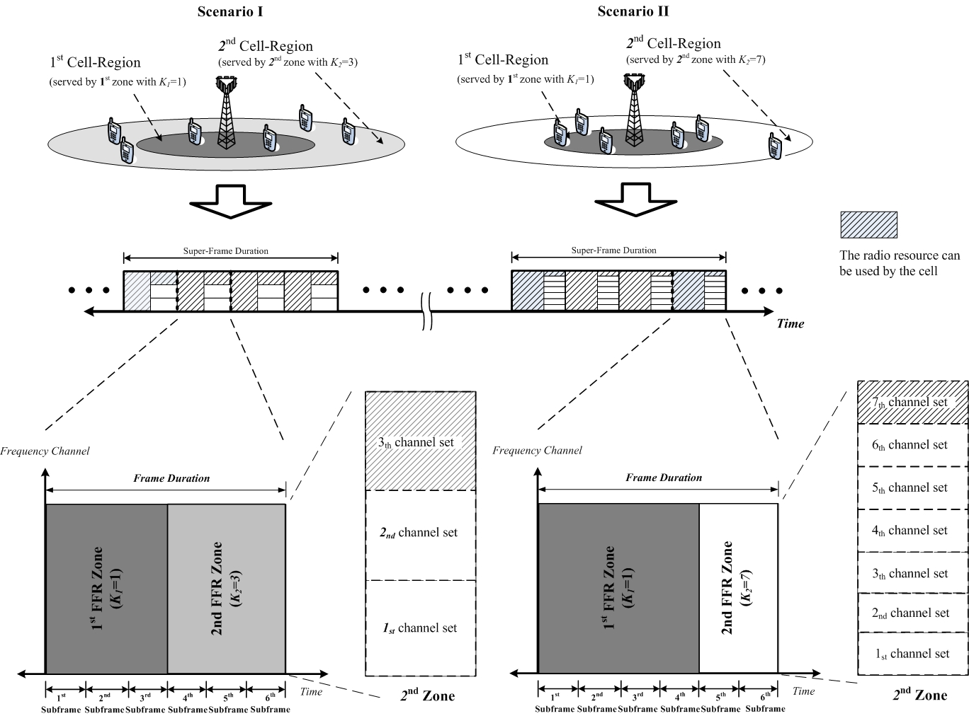

Fig.3 An example for super-frame based semi-static FFR operation
In Fig.3, an example is given to introduce how the FFR configuration may be changed in response to system condition. For Scenario I, some MSs are closed to BS and relative far away from interfering BSs. These MSs enjoy good received signal power from BS and suffer less interference power from other BSs. Therefore, BS can schedule those MSs be served by the FFR zone (i.e. the 1st FFR Zone in Fig.3) with frequency reuse factor =1 for higher sector throughput by more available radio resource without degrade the received signal quality to an unacceptable level. For the rest MSs who are relatively close to cell boundary, BS may schedule those MSs be served by the FFR zone (i.e. the 2nd FFR Zone in Fig.3) with frequency reuse factor =1/3 (i.e. K₂=3) for lower received interference power and better signal quality to prevent service outage. Note that this signal quality improvement is obtained by the expense on preserving radio resource for interference avoidance.
Since the MS distribution and their channel conditions are time variant, the system may change the FFR configuration periodically. In Scenario II, most MSs are more closed to BS but one of the MSs is more closed to cell boundary. The system may enlarge the 1st FFR Zone to enjoy higher throughput by serving more MSs by frequency reuse factor =1, while it may also change the frequency reuse factor from 1/3 to 1/7 to further reduce the interference level in 2nd FFR Zone to save the link quality for the cell edge MSs.
In order to help members to understand the relationship between frequency reuse factor and the separation between adjacent interfering cells, Fig.4 is the figure conducted base on fundamental cellular network theory under ideal hexagonal cellular structure. For idea cell structure, the relation between the frequency reuse factor (1/K) and the distance between adjacent interfering cells (D) is: . Note that the R is the radius of each cell.

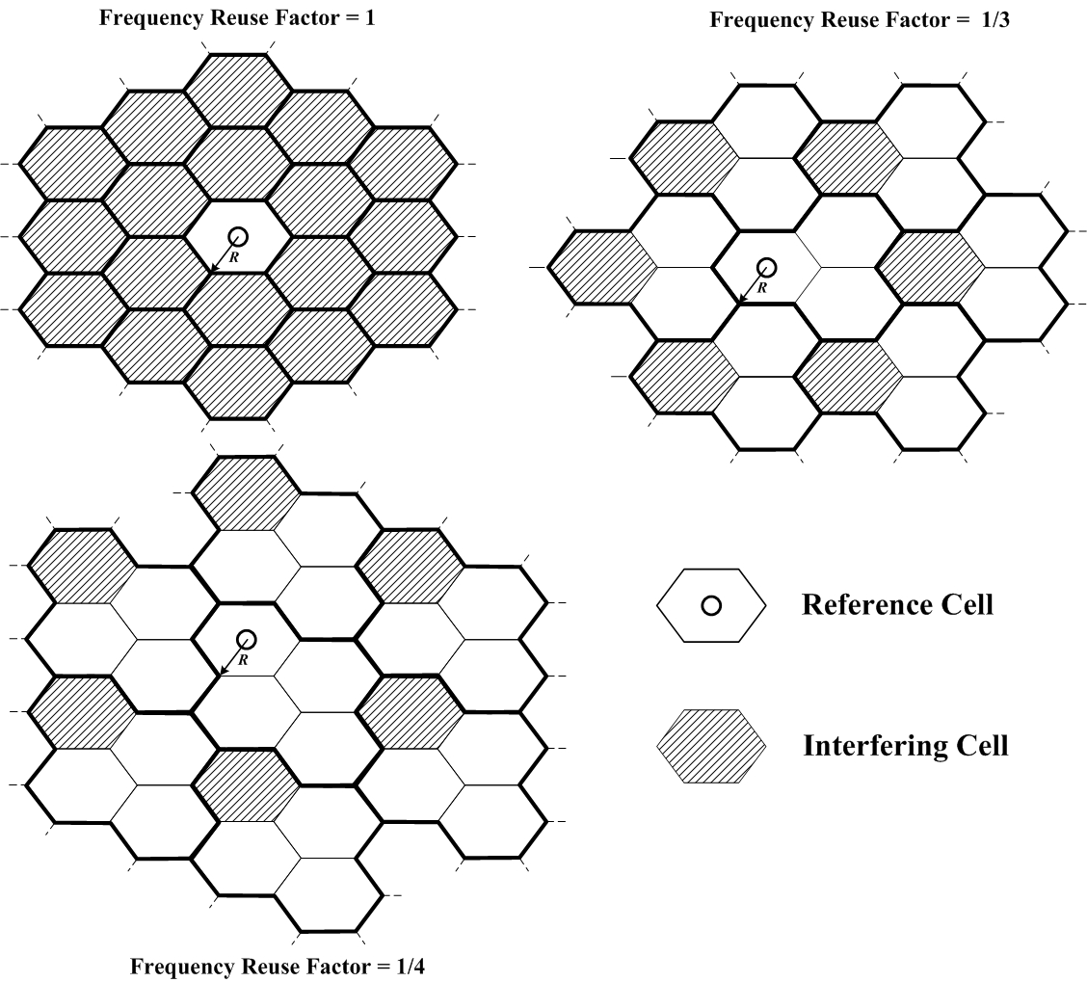

Fig.4 Relationship between frequency reuse factor and the distance between adjacent interfering cells

By focusing on the interfering cells in Fig.4, Fig.5 is drawn to clearly explain the relationship between frequency reuse factor (1/K) and the separation from adjacent interfering cells. By having larger K, the separation from adjacent interfering cells will be enlarge which lead to smaller received interference power for the MSs in serving cell. However, the available radio resource for each cell will also be 1/K compared to the case with universal frequency reuse. The designs on various tradeoffs to determine the FFR configuration is actually a complicated work and require many network planning consideration. Therefore, it’s not easy to achieve frame-by-frame reconfiguration for FFR. Semi-static adjustment in one or multiple super-frame will be more reasonable scale to tradeoff the implementation complexity and the level of multi-user diversity can be further explored.

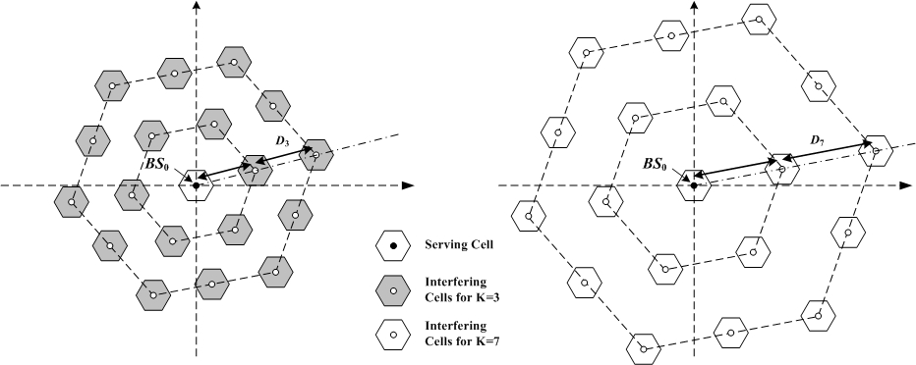

Fig.5 The larger cluster size (K) will lead to longer separation between adjacent interfering cells

- Supports for FFR Realization in IEEE 802.16m

A. Inter-BS Coordination

For traditional frequency reuse, the frequency channel assigned to each cell is predefined and will not changed for a long time. Changing the frequency assignment to each cell and the corresponding frequency reuse pattern needs experienced engineer to perform network planning and fine tune the radio parameters of each BS for optimizing the performances. For the semi-static or dynamic FFR considered in IEEE 802.16m, the FFR configuration and the corresponding radio parameters may be changed in a relative short time. It’s almost impossible for engineers to continuously monitor the conditions of each cell and adjust those radio parameters manually. Therefore, the automatic adjustment via backhaul signaling among multiple BSs is expected to be the way to realize semi-static and dynamic FFR in IEEE 802.16m.
Fig.6 is a simple figure to illustrate the idea of backhaul signaling to perform inter-BS coordination.

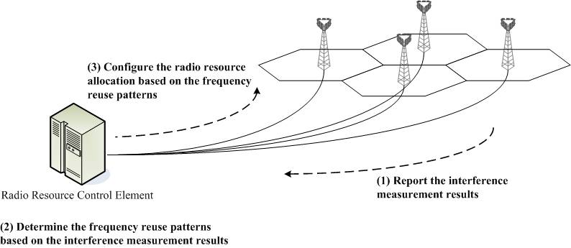

Fig.6 Inter-BS coordination to exchange the interference statistics of each cell and determine the FFR configurations for each cell

B. Interference Measurement

- Text Proposal

------------------------------------------------------Start of the Text----------------------------------------------------

[Add the following section titles into P802.16m SDD]

X. Support for Interference Management

X.1 Interference Mitigation by Fractional Frequency Reuse (FFR)

Fractional Frequency Reuse (FFR) allows IEEE 802.16m system applies different frequency reuse factor in different frame zones to mitigate inter-cell interference for the cell edge MSs or the MSs with worse signal quality. In response to time variant interference characteristics, the IEEE 802.16m system can reconfigure the FFR pattern of each cell in unit of super-frames or schedule the MSs be served in different FFR zone in unit of frames. Note that the FFR zone is a logic zone in unit of sub-frame with specific frequency reuse factor, and the FFR pattern is a list to record the range, the frequency resource usage and the permutation for each frequency resource of each FFR zone in each cell.
In order to facilitate the interference-aware scheduling for dynamic FFR operation, each MS shall report the interference measurement results to its serving BS. For semi-static FFR pattern reconfiguration, the interference characteristics measured over air interface should be exchanged via Inter-BS Coordination function with/without specific request on FFR pattern by each BS. Note that the BS shall also broadcast the FFR configuration as part of the PHY information to MSs in advance.

-------------------------------------------------------End of the Text----------------------------------------------------

