Project | IEEE 802.16 Broadband Wireless Access Working Group <http://ieee802.org/16>
Title | Subsidiary Communication by using Guard Sub-carriers in IEEE 802.16m
Date Submitted | 2008-07-07
Source(s) | I-Kang Fu, Paul Cheng, Pei-Kai Liao  MediaTek Inc.  No.1, Dusing Rd. 1, Hsinchu Science Park, Hsinchu, Taiwan, R.O.C. | IK.Fu@mediatek.com
Re: | IEEE 802.16m-08/024, “Call for Comments and Contributions on Project 802.16m System Description Document (SDD)”  - Comments on P802.16m SDD
Abstract | This contribution introduces the subsidiary communication by data transmission over guard sub-carrier and recommends to define the “Subsidiary Carrier” to categorize the proper control and PHY structure for IEEE 802.16m.
Purpose | For TGm discussion and harmonization on the control and PHY structure to enable data transmission over guard sub-carriers
Notice | This document does not represent the agreed views of the IEEE 802.16 Working Group or any of its subgroups. It represents only the views of the participants listed in the “Source(s)” field above. It is offered as a basis for discussion. It is not binding on the contributor(s), who reserve(s) the right to add, amend or withdraw material contained herein.
Release | The contributor grants a free, irrevocable license to the IEEE to incorporate material contained in this contribution, and any modifications thereof, in the creation of an IEEE Standards publication; to copyright in the IEEE’s name any IEEE Standards publication even though it may include portions of this contribution; and at the IEEE’s sole discretion to permit others to reproduce in whole or in part the resulting IEEE Standards publication. The contributor also acknowledges and accepts that this contribution may be made public by IEEE 802.16.
Patent Policy | The contributor is familiar with the IEEE-SA Patent Policy and Procedures:  <http://standards.ieee.org/guides/bylaws/sect6-7.html#6> and <http://standards.ieee.org/guides/opman/sect6.html#6.3>.  Further information is located at <http://standards.ieee.org/board/pat/pat-material.html> and <http://standards.ieee.org/board/pat>.
Subsidiary Communication by using Guard Sub-carriers
in IEEE 802.16m

I-Kang Fu, Paul Cheng, Pei-Kai Liao
MediaTek Inc.

Abstract
In order to fulfill the IMT-Advanced requirements on 1Gbps peak transmission rate for 4th Generation (4G) mobile cellular systems, much wider radio bandwidth is considered in P802.16m SDD. Instead of equipping a large size FFT to utilize much wider radio bandwidth, the architecture to have multiple smaller size FFTs combine with multiple RF carriers (RF channels) may be preferred by its flexibility to utilize non-contiguous frequency channels (bands), to serve the mobile station (MS) equipped with different number of RF carriers, lower PAPR etc. However, the primary drawback of this architecture is the necessity to reserve guard sub-carriers to prevent ICI across adjacent frequency channels. In order to further improve the system performances on peak transmission rate and spectrum efficiency, this contribution proposes to have a new logical carrier “Subsidiary Carrier” for the data transmission over the guard sub-carriers between contiguous frequency channels operated by the same system. The necessary control and PHY structure to enable data transmission over guard sub-carrier are also discussed in this contribution for further harmonization.

- Motivation

IEEE 802.16 Task Group m (TGm) aims to develop the standard to amend the IEEE 802.16 WirelessMAN-OFDMA specification to provide an advanced air interface for operation in licensed bands. It meets the cellular layer requirements of IMT-Advanced next generation mobile networks and provides continuing support for legacy WirelessMAN-OFDMA equipment [1].

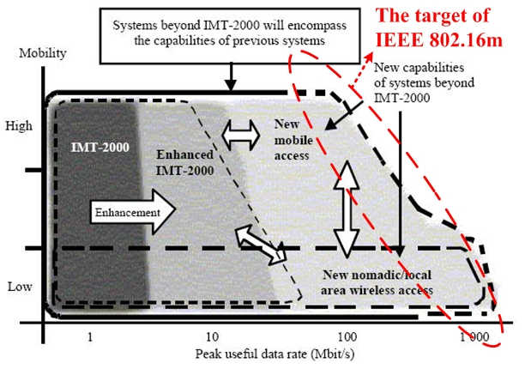
Fig.1 Illustration of capability of IMT-2000 and systems beyond IMT-2000 [2]

In order to meet the IMT-Advanced requirement on 1Gbps peak transmission rate, much wider radio bandwidth than current one (i.e. 10MHz) shall be considered in IEEE 802.16m. There are two possible architectures to utilize much wider radio bandwidth while keeping the legacy support. One is using single FA* (Frequency Assignment) with large size FFT (e.g. 4096) to utilize wider bandwidth, and another one is using multiple FAs with smaller size FFT (e.g. 1024). The first one is addressed in 16m frame structure with wider bandwidth support, and this contribution will emphasize on the design issues for the second one (i.e. multi-carrier support issues). Compare with the first architecture, the second architecture may be favored by its flexibility to utilize non-contiguous frequency channels, to serve the mobile station (MS) equipped with different number of RF carriers, lower PAPR, easier to achieve legacy support etc.
Figure 2 shows an example for multi-carrier support by having total 40MHz bandwidth, while the legacy system uses 10MHz bandwidth.

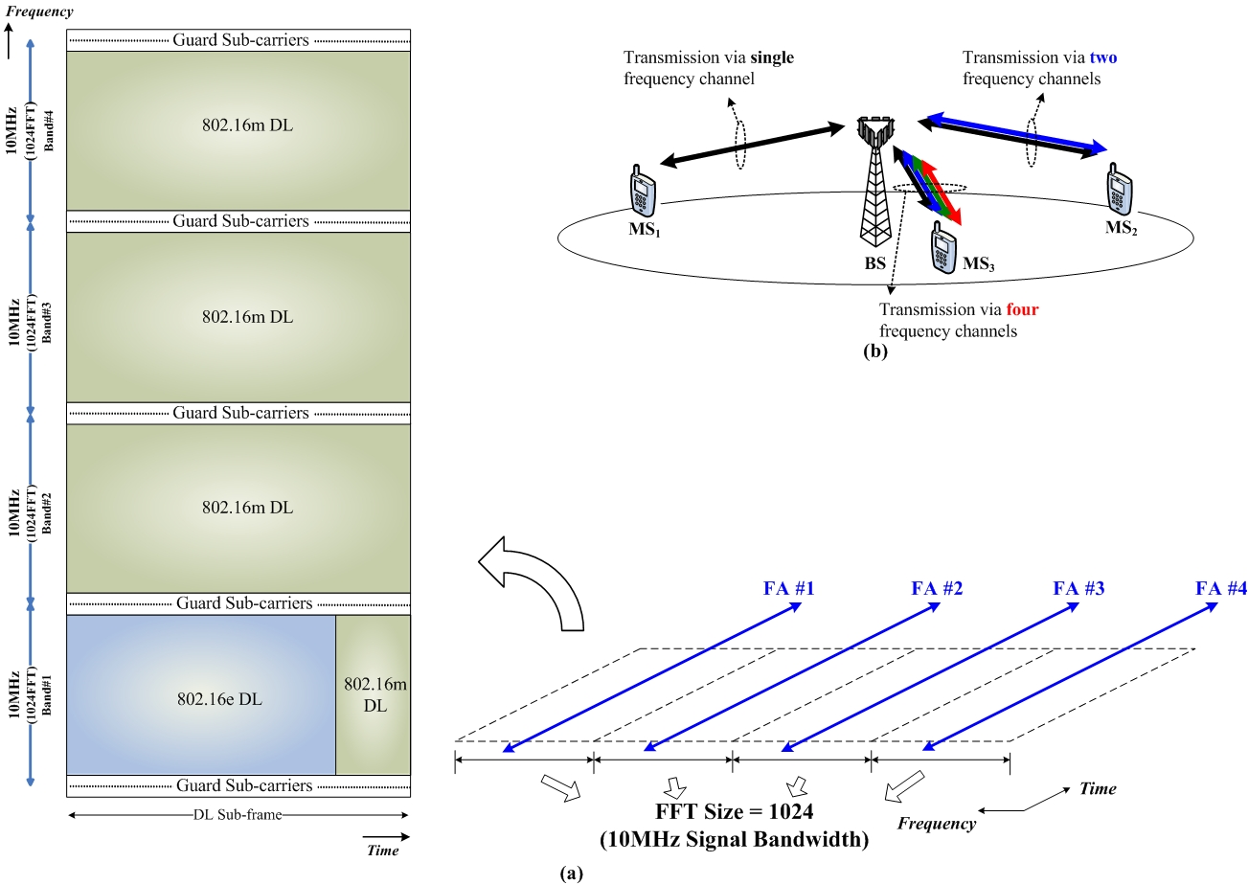

Fig.2 (a) An example on multi-carrier frame structure with legacy support in IEEE 802.16m, and (b) the flexibility to serve the MS equipped with different number of RF carriers

In P802.16m SDD [3], the current text states “When carriers are in the same spectrum and adjacent and when the separation of center frequency between two adjacent carriers is multiples of subcarrier spacing, no guard subcarriers are necessary between adjacent carriers”. Since the sub-carrier alignment had been resolved by the technique depicted in section 19, this contribution aims to discuss the possible method to utilize guard sub-carrier for data transmission. Therefore, the motivation of this contribution is proposing a sub-carrier alignment mechanism so that those guard sub-carriers between adjacent frequency channels can be well aligned and be utilized for data transmission without resulting ICI to the data sub-carriers in adjacent frequency channel.

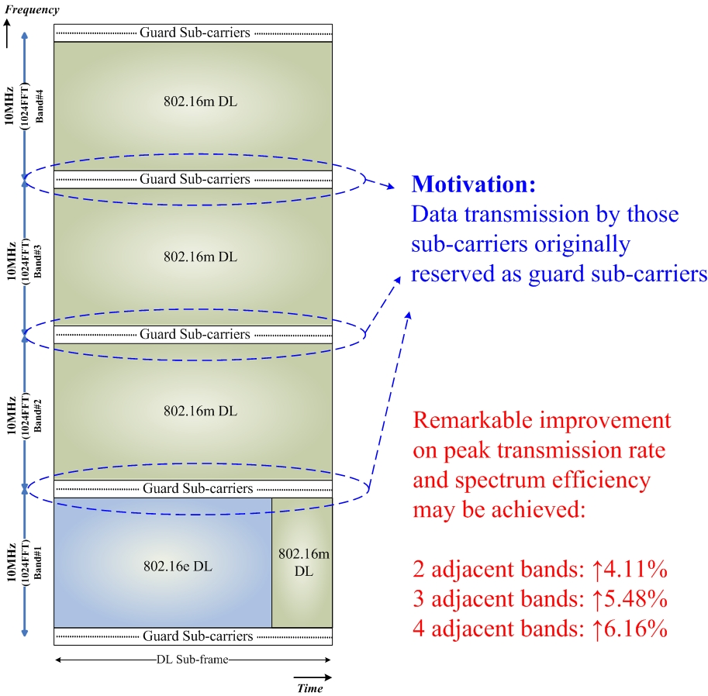

Fig.3 Motivation to utilize those guard sub-carriers for data transmission

- Subsidiary Communication in IEEE 802.16m System

The subsidiary communication was used in FM radio broadcast network for various low data rate communication services, where the brief introduction can be found on FCC website:
(source: http://www.fcc.gov/mb/audio/subcarriers/)
“A subcarrier, known also as Subsidiary Communications Authority or SCA, is a separate audio or data channel which is transmitted along with the main audio signal over a broadcast station. These subcarrier channels are not receivable with a regular radio; special receivers are required. Subcarriers are used for many different purposes, including (but not limited to) paging, inventory distribution, bus dispatching, stock market reports, traffic control signal switching, point-to-point or multipoint messages, foreign language programming, radio reading services, radio broadcast data systems (RBDS), station control and meter reading, utility load management, and muzak. A broadcast station may transmit more than one subcarrier signal. Licensing of subcarrier operations ended in 1983 when the service was deregulated.”

Fig.4 Subsidiary communication in FM radio broadcast system

By extending the idea of subsidiary communication, the subsidiary communication for OFDMA systems with multi-carrier support can be interpreted as Fig.5.

Fig.5 The basic concept of subsidiary communication in OFDMA systems with multi-carrier support

Possible Control Structure of Subsidiary Carrier

By taking the frame structure example in Fig.2 for example, the idea of subsidiary communication in IEEE 802.16m multi-carrier system can be easily extended as the example in Fig.6.

Fig.6 Multi-carrier control structure for IEEE 802.16m system

In Fig.6, the Subsidiary Carrier is defined as a RF carrier different than primary carrier and secondary carrier defined in P802.16m SDD. The subsidiary carrier is composed by those sub-carriers which were originally reserved as guard sub-carrier, and the subsidiary carrier can only be enabled for data transmission when the center frequency separation between adjacent carriers (e.g. the f₀ and f₁ with respect to f_{0,1}) is multiple of sub-carrier spacing and operated by the same system. Therefore, the subsidiary carrier is just like another secondary carrier with smaller bandwidth and can only be enabled under certain condition.

Possible PHY Structure of Subsidiary Carrier

The size of subsidiary carrier is different case by case. For example, the available guard sub-carriers for subsidiary communication between 5MHz+5MHz RF carriers and between 10MHz+10MHz RF carriers are different. Therefore, certain radio resource unit shall be defined in advance according to the minimum available guard sub-carrier number eligible for possible data transmission. Based on the legacy system profile, such extreme case should happen when the subsidiary carrier in between two 5MHz frequency channels.
In addition, the subsidiary carrier is also expected to be composed by data sub-carrier, pilot sub-carrier and null sub-carrier as the case in regular carriers. For example, the DC carrier is also required in subsidiary carrier to prevent similar problem. The possible PHY structure of subsidiary carrier is given in Fig.7.

Fig.7 PHY structure for subsidiary carrier

In addition, another potential problem is that receiver side may have no idea on which sub-carriers are used for data transmission since the subsidiary carrier may not utilize all the sub-carriers and the location of those sub-carriers may be different case by case. Therefore, certain reference signal transmitted over the sub-carriers which are used for data transmission will be necessary to identify the range of sub-carriers that receiver shall decode. The basic idea is explained by the example given in Fig.8.

Fig.8 Periodically transmit the reference signal over the used sub-carriers in subsidiary carrier

In summary, there are still a lot of issues need to be resolved to enable data transmission over guard sub-carriers. Defining the Subsidiary Carrier can substantially simplify the control structure to treat the aggregation of guard sub-carrier as another RF carrier and apply similar control rules as the secondary carriers. Due to some natural uncertainty of guard sub-carriers, proper PHY structure design will be necessary to facilitate the data transmission over guard sub-carriers.

- Text Proposal

-------------------------------------------------------Start of the Text-------------------------------------------------------------
[Apply the following text modification since line#14, page#45 of IEEE 802.16m-08/003r3]

The carriers involve in a multi-carrier system, from one MS point of view, can be divided into two three types:
• Primary carrier is the carrier where the BS and the MS exchange traffic and full PHY/MAC control
information defined in 16m specification. Further, the primary carrier is in charge of delivering all
control information for proper MS operation. Each MS shall have only one primary carrier.
• Secondary carrier is the carrier which the MS may use for traffic, only per BS’s specific allocation
commands and rules received from the primary carrier. The secondary carrier may also include control
signaling to support multi-carrier operation..
• Subsidiary carrier is the carrier which is composed by the sub-carrier which were originally reserved as
guard sub-carriers. MS may use subsidiary carrier for data transmission only when the separation of the
center frequencies of the carriers (i.e. primary carrier or secondary carrier) adjacent to subsidiary carrier is
multiple of sub-carrier spacing.

[Add the following text ine line#3, page#46 of IEEE 802.16m-08/003r3]
A primary carrier shall be fully configured while a secondary or a subsidiary carrier may be fully or partially configured depending on usage and deployment model.

--------------------------------------------------------End of the Text-------------------------------------------------------------

Reference

[1] P802.16m Project Authorization Request (PAR), December 2006.
http://standards.ieee.org/board/nes/projects/802-16m.pdf
[2] Recommendation ITU-R M.1645, “Framework and overall objectives of the future development of IMT-2000 and systems beyond IMT-2000,” June 2006.
http://www.itu.int/rec/R-REC-M.1645/e
[3] IEEE 802.16m-08/003r3, “The Draft IEEE 802.16m System Description Document,” June 2008.

