Project | IEEE 802.16 Broadband Wireless Access Working Group <http://ieee802.org/16>
Title | Resource Optimized Link Adaptation
Date Submitted | 2008-07-07
Source(s) | Jiun-Yo Lai, Yu-Tao Hsieh, Jen-Yuan Hsu, Lai-Huei Wang, Pang-An Ting, Richard Li  ITRI  Y. -S. Lu, C. -L. Weng, Yu T. Su  NCTU | Voice: +886-3-5914854  E-mail: ythsieh@itri.org.tw
Re: | Call for Contributions of IEEE 802.16m_08/024 on the topic of link adaptation schemes
Abstract | A multiuser resource optimization scheme for improving the system throughput is proposed in this contribution. The proposed algorithm can shorten the retransmission delay as well as increase the efficiency of the resource utilization.
Purpose | Discussion and approval by the task group.
Notice | This document does not represent the agreed views of the IEEE 802.16 Working Group or any of its subgroups. It represents only the views of the participants listed in the “Source(s)” field above. It is offered as a basis for discussion. It is not binding on the contributor(s), who reserve(s) the right to add, amend or withdraw material contained herein.
Release | The contributor grants a free, irrevocable license to the IEEE to incorporate material contained in this contribution, and any modifications thereof, in the creation of an IEEE Standards publication; to copyright in the IEEE’s name any IEEE Standards publication even though it may include portions of this contribution; and at the IEEE’s sole discretion to permit others to reproduce in whole or in part the resulting IEEE Standards publication. The contributor also acknowledges and accepts that this contribution may be made public by IEEE 802.16.
Patent Policy | The contributor is familiar with the IEEE-SA Patent Policy and Procedures:  <http://standards.ieee.org/guides/bylaws/sect6-7.html#6> and <http://standards.ieee.org/guides/opman/sect6.html#6.3>.  Further information is located at <http://standards.ieee.org/board/pat/pat-material.html> and <http://standards.ieee.org/board/pat>.

Resource Optimized Link Adaptation
Jiun-Yo Lai, Yu-Tao Hsieh, Jen-Yuan Hsu, Lai-Huei Wang, Pang-An Ting, Richard Li,
ITRI
Y.-S. Lu, and C.- L. Weng, Yu T. Su
NCTU

I. Introduction
By adapting certain transmission parameters, link adaptation (LA) techniques enable a radio link to operate as efficiently as possible. Transmission resources considered by conventional LA techniques are limited to modulation and coding options, with ARQ (Automatic Retransmission Request) being regarded as a special adaptive coding scheme. IEEE 802.16e has included both AMC (Automatic modulation and coding) and HARQ (Hybrid Automatic Retransmission Request) as link adaptive mechanism. Generalizing the notion of LA by taking other transmission resources like transmit power and signal dimensions-frequency, time, and space-into consideration, one can surely further improve link quality and enhance radio coverage. Such a generalization is particular attractive and meaningful for IEEE 802.16m since OFDMA admits very flexible PHY/Link layer adaptations. It also allows practical implementation of dynamic resource allocation and opportunistic scheduling, resulting in high resource utilization efficiency while meeting various multiuser multimedia communication requirements.

We present a multiuser HARQ protocol based on the above concept of generalized link adaptation (GLA) that combines dynamic resource management and HARQ for use in an OFDMA network. Numerical results show that the proposed protocol is capable of achieving significant performance gain. Transmission strategies combining adaptive modulation (bit-loading) with power and subcarrier assignments have been used or proposed for ADSL/VDSL and other scenarios, but so far as we know, no ARQ or HARQ protocol similar to what is presented below has been reported before.

II. Resource-Optimized Multiuser HARQ
An HARQ protocol is often designed to optimize the delay/throughput performance. As the performance of packet transmission depends on the radio resource given, the allocation of the available resources to different users is crucial. Incorporating proper transmission resource allocation (and perhaps scheduling) in the HARQ design will certainly improve its performance. These transmission resources should include modulation and coding schemes, transmit power, subcarriers, time-slots, spatial (eigen)channels, and, perhaps, cooperative relays and transmit schedule. 802.16m defines a resource block (RB) as the collection of a few consecutive subcarriers and symbols. Our proposal can be applied to other RBs so long as the property of a RB (e.g., subcarrier gain during a few OFDM symbols) remains unchanged. For simplicity, our description assumes a one-dimensional RB, i.e., a subcarrier as a RB, but numerical performance assuming an 802.16m RB is given. Power and bit allocation, transmit scheduling and other resources are not considered here but a unified approach will be addressed in another contribution.

III. Simulation results

(A) System parameters and assumptions
The simulated performance of the proposed algorithm is reported in this section. We assume that there are 12 users in the system and the frequency band contains 1024 subcarriers. The priority of users is fixed for simplicity. Chase-combining with (480,240) LDPC code is used in the HARQ protocol. In addition, we use the channel model of ITU-R (Indoor office test environment channel A and channel B) as the channel model of the simulation environment.

(B) Performance of the proposed algorithm
In Fig.2 and Fig.3, we compare the performance of the proposed scheme to the conventional HARQ (without resource allocation). The system parameters α,β and λ are 70, 80 and 2.0, respectively. Here we let a resource unit be a group of 18 consecutive subcarriers in 6 OFDM symbols (18*6). From the figures we can find that the proposed algorithm provides almost 5dB gain over conventional HARQ both in throughput and delay.

(C) Performance of the proposed algorithm with different α and β
In Fig.4 and Fig.5, we compare the performance of the proposed scheme with different system parameters (α=10,β=20; α=70,β=80). We let a resource unit be a group of 6 consecutive subcarriers in 6 OFDM symbols (6*6). We plot the average throughput of the users with highest priority and lowest priority in Fig.4 and in Fig.5, correspondingly. From the results, we can find that if increasing the value of α and β, the performance of the user with the lowest priority can be improved significantly while the performance of the user with the highest priority almost remains the same.

IV. Conclusion
In this contribution, we propose a generalized link adaptation scheme that combines resource allocation with multiuser HARQ transmission. The simulation results show that our proposed algorithm offers significant performance gain with respect to the conventional HARQ protocol.

Proposed Texts

===== texts start =======================================
In order to improve link quality and enhance radio coverage, generalizing the notion of link adaptation by taking other transmission resources like transmit power and signal dimensions, e.g., frequency, time, space, into consideration. Besides, fairness is another key issue for resource allocation. For utilizing resource efficiently and gaining multiuser diversity, link adaptation schemes that combine resource allocation with multiuser HARQ transmission shall be considered.

===== texts end =======================================

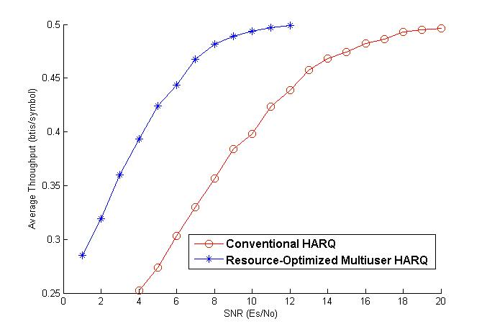
Fig.2 Average throughput of the proposed algorithm and conventional HARQ
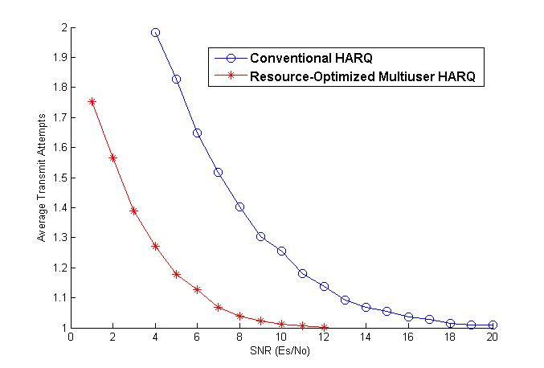
Fig.3 Average transmit attempts of the proposed algorithm and conventional HARQ

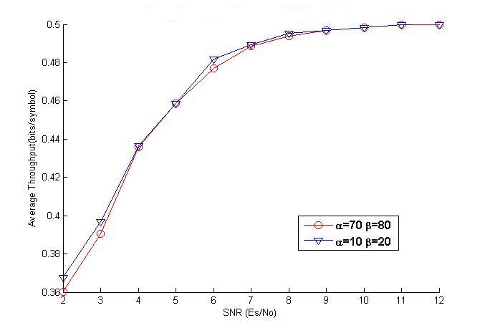
Fig.4 Average throughput of the user with highest priority

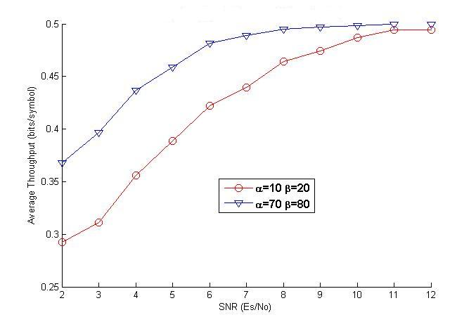
Fig.5 Average throughput of the user with lowest priority

