Project | IEEE 802.16 Broadband Wireless Access Working Group <http://ieee802.org/16>
Title | Resource Optimized Link Adaptation
Date Submitted | 2008-07-15
Source(s) | Jiun-Yo Lai, Yu-Tao Hsieh, Jen-Yuan Hsu, Lai-Huei Wang, Pang-An Ting, Richard Li ITRI  Y.-S. Lu, C.- L. Weng, Yu T. Su  NCTU  Pei-Kai Liao  MediaTek Inc. | Voice: +886-3-5914854  E-mail: ythsieh@itri.org.tw  Email: pk.liao@mediatek.com
Re: | Call for Contributions of IEEE 802.16m_08/024 on the topic of link adaptation schemes
Abstract | A multiuser resource optimization scheme for improving the system throughput is proposed in this contribution. The proposed algorithm can shorten the retransmission delay as well as increase the efficiency of the resource utilization.
Purpose | Discussion and approval by the task group .
Notice | This document does not represent the agreed views of the IEEE 802.16 Working Group or any of its subgroups. It represents only the views of the participants listed in the “Source(s)” field above. It is offered as a basis for discussion. It is not binding on the contributor(s), who reserve(s) the right to add, amend or withdraw material contained herein.
Release | The contributor grants a free, irrevocable license to the IEEE to incorporate material contained in this contribution, and any modifications thereof, in the creation of an IEEE Standards publication; to copyright in the IEEE’s name any IEEE Standards publication even though it may include portions of this contribution; and at the IEEE’s sole discretion to permit others to reproduce in whole or in part the resulting IEEE Standards publication. The contributor also acknowledges and accepts that this contribution may be made public by IEEE 802.16.
Patent Policy | The contributor is familiar with the IEEE-SA Patent Policy and Procedures:  <http://standards.ieee.org/guides/bylaws/sect6-7.html#6> and <http://standards.ieee.org/guides/opman/sect6.html#6.3>.  Further information is located at <http://standards.ieee.org/board/pat/pat-material.html> and <http://standards.ieee.org/board/pat>.

Resource Optimized Link Adaptation
Jiun-Yo Lai, Yu-Tao Hsieh, Jen-Yuan Hsu, Lai-Huei Wang,
Pang-An Ting, Richard Li,
ITRI
Y.-S. Lu, and C.- L. Weng, Yu T. Su
NCTU
Pei-Kai Liao
MediaTek Inc.

I. Introduction
By adapting certain transmission parameters, link adaptation (LA) techniques enable a radio link to operate as efficiently as possible. Transmission resources considered by conventional LA techniques are limited to modulation and coding options, with ARQ (Automatic Retransmission Request) being regarded as a special adaptive coding scheme. IEEE 802.16e has included both AMC (Automatic modulation and coding) and HARQ (Hybrid Automatic Retransmission Request) as link adaptive mechanisms. Generalizing the notion of LA by taking other transmission resources into consideration such as transmit power, frequency, time, and space, one can surely further improve link quality and enhance radio coverage. Such a generalization is particular attractive and meaningful for IEEE 802.16m since OFDMA admits very flexible PHY/Link layer adaptations. In this contribution we propose a combined LA mechanism that incorporates HARQ and Band AMC schemes. Numerical results show that the proposed mechanism is capable of achieving significant performance gain.

II. Enhanced HARQ through channel information feedback
An HARQ protocol is often designed to optimize the delay/throughput performance. As the performance of packet transmission depends on the radio resource given, the allocation of the available resources to different users is crucial. Incorporating proper transmission resource allocation (and perhaps scheduling) in the HARQ design will certainly improve its performance. These transmission resources should include modulation and coding schemes, transmit power, subcarriers, time-slots, spatial correlation, etc. We also have Band AMC schemes as depicted in 802.16e, where the user data is transmitted through one or several cluster of physical subcarriers (bands). The users are allocated AMC bands via the CQI feedback from the MS with the preferred bands, and the feedback overhead is not high. However, the band information of Band AMC is feedback independently and the feedback timing does not take into account the ACK/NAK timing of HARQ. In the following we propose two important features to enhance the link adaptation quality and delay.

(A) In the normal operation of Band AMC mode, the period and type of the CQI feedback is determined irrespective of HARQ. When retransmission for a certain user occurs, the BS selects the preferred bands for that user according to its last CQI information sent by MS. The time when the CQI feedback is issued may be different from that of ACK/NAK feedback from HARQ. The asynchronous characteristic between the two feedback information makes the CQI update less effective for use of band selection. When the channel is varying (maybe slowly) with time, the update time of best bands may become more critical when the packet fails successful detection. We think that the most efficient feedback for the CQI update shall be made available for the next retransmission. On the other hand, the CQI-embedded feedback of ACK (for a successful packet) reception seems not to improve the system throughput yet increase the feedback overhead. The BS can select the bands for all users to perform HARQ according to their latest CQI information. Thus a better link adaptation scheme to improve the Band AMC performance with help of HARQ is performed by feedback of the updated CQI for the selected AMC bands when the retransmission request occurs.

(B) We also observe that HARQ reception can be further enhanced when the signal reliability is properly arranged in each retransmission and evenly distributed for each subcarrier or band. A novel constellation arrangement mechanism for enhanced HARQ performance was proposed in [1] where the constituent bits of each constellation symbol are re-ordered in each retransmission. Thus more uniform signal protection for each bit can be obtained. The HARQ performance will be improved a step further if the concept of averaging signal reliability across the bit level can be applied to the subcarrier (band) level. Since the data protection capabilities are different for each subcarrier (band) due to disparate channel conditions, it is beneficial to permute the user data within the same set of bands used for the last transmission. The performance gain will be greatest when the permutation leads to more uniform reliabilities among the selected bands across all the (re)transmission. Thus the second feature of the proposed link adaptation for HARQ is to conduct subcarrier- or RU-based intra packet permutation for each re-transmission.

III. An example
We present an example of the proposed algorithm in this section. The FFT size is 1024 and there are 11 users. The priority of users is fixed for simplicity. Chase-combining with (480,240) LDPC code is used in the HARQ process and the channel model of ITU-R (Indoor office test environment channel A and channel B) is selected for simulation. In Fig.1 and Fig.2, we compare the performance of the proposed scheme to conventional HARQ without optimization of band allocation. Here we let a resource unit be a group of 18 consecutive subcarriers by 6 OFDM symbols. From the figures we can find that the proposed algorithm provides almost 5dB gain over conventional approach both in throughput and delay.

IV. Conclusion
In this contribution, we propose a link adaptation scheme that combines resource allocation with HARQ transmission. The simulation results show that our proposed algorithm offers significant performance gain with respect to the conventional HARQ protocol.

Proposed Texts
===== =========================== texts start ======================================
11.x Link Adaptation
11.x.y Link adaptation with HARQ
In order to utilize resource efficiently and gain multiuser diversity, link adaptation schemes that combine resource allocation with HARQ transmission shall be considered. Band AMC mode can be considered to function with HARQ NAK feedback, where the selected bands and the corresponding CQI values can be sent to the BS along with the NAK message. The CQI feedback period may not be constant during one CQI allocation instruction.
The data allocation on the resource units for different retransmissions shall be permuted among bands such that the averaged signal receive strengths for the whole data across HARQ re-transmissions are made as uniform as possible.
================================= texts end =======================================

[1] Jer-Chung Lin, et al, Enhanced HARQ technique using Constellation Rearrangement, IEEE 802.16m-08/292r1, Nov. 2007.

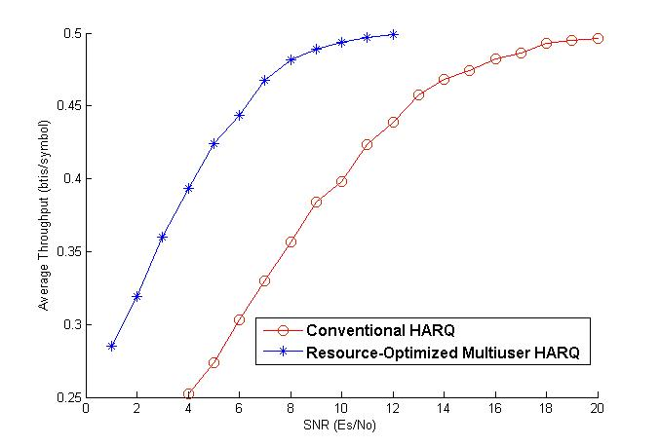
Fig.1 Average throughput of the proposed algorithm and conventional HARQ

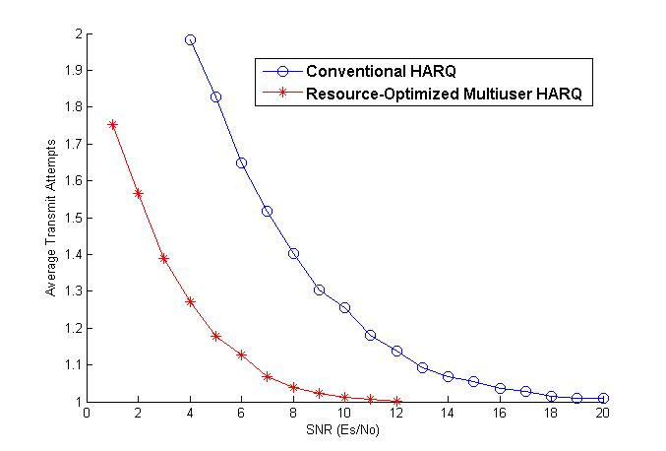
Fig.2 Average transmit attempts of the proposed algorithm and conventional HARQ

