Project | IEEE 802.16 Broadband Wireless Access Working Group <http://ieee802.org/16>
Title | Maximized Micro-Sleep Duration in Active Mode
Date Submitted | 2008-07-07
Source(s) | Ming-Hung Tao, Mamadou Kone, Ying-Chuan Hsiao, Richard Li  ITRI | E-mail: minghung02@gmail.com, richard929@itri.org.tw
Re: | IEEE 802.16m-08/024 - Call for Comments and Contributions on Project 802.16m System Description Document (SDD), shoot for “Upper MAC concepts and methods” topic.
Abstract | This contribution proposes how to maximize micro-sleep duration for a 16m MS in active mode.
Purpose | For discussion and approval by TGm.
Notice | This document does not represent the agreed views of the IEEE 802.16 Working Group or any of its subgroups. It represents only the views of the participants listed in the “Source(s)” field above. It is offered as a basis for discussion. It is not binding on the contributor(s), who reserve(s) the right to add, amend or withdraw material contained herein.
Release | The contributor grants a free, irrevocable license to the IEEE to incorporate material contained in this contribution, and any modifications thereof, in the creation of an IEEE Standards publication; to copyright in the IEEE’s name any IEEE Standards publication even though it may include portions of this contribution; and at the IEEE’s sole discretion to permit others to reproduce in whole or in part the resulting IEEE Standards publication. The contributor also acknowledges and accepts that this contribution may be made public by IEEE 802.16.
Patent Policy | The contributor is familiar with the IEEE-SA Patent Policy and Procedures:  <http://standards.ieee.org/guides/bylaws/sect6-7.html#6> and <http://standards.ieee.org/guides/opman/sect6.html#6.3>.  Further information is located at <http://standards.ieee.org/board/pat/pat-material.html> and <http://standards.ieee.org/board/pat>.
Maximized Micro-Sleep Duration in Active Mode
Ming-Hung Tao, Mamadou Kone, Ying-Chuan Hsiao, and Richard Li
ITRI

1. Introduction
Under different traffic conditions, mobile stations (MSs) are supposed to utilize different power saving modes to efficiently save their power. In addition to the sleep mode and idle mode known in WiMAX system, we propose an extra mode named doze submode to realize micro-sleep mechanism for an MS in active mode. Compared to the sleep mode and idle mode which have long power down duration (multiple superframes), the doze submode only turns off some unused modules in several subframes. The doze submode allows the MS to save power through the micro-sleep mechanism without entering into the sleep or the idle mode. Moreover, dynamically switching between different modes for an MS according to the traffic density or power saving requirements will provide great flexibility and significant power saving gain.

2. The power saving modes
For flexibility, different power saving mechanisms/modes should be applied between the MS and BS according to different traffic conditions and power saving requirements. The MS state diagram in SDD [1] shows that the sleep mode is applied in the connected state and the idle mode is applied in the idle state. However, there is no power saving mechanism applied in the active mode. Thus we propose applying doze submode in the active mode of the connected state, as shown in Figure 1, which makes the MS facilitate micro-sleep mechanisms to save power. Another reason to apply the doze submode is that it can enable an MS which has low-latency traffic to turn off its hardware modules for short time, while both sleep mode and idle mode cannot be activated for low-latency traffic due to their long power down duration and cycles (always multiple superframes).

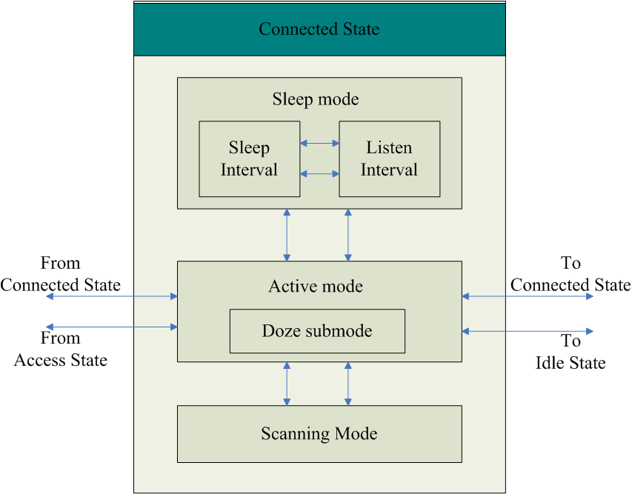

Figure 1. MS’s station transition diagram in connected state.

2.1 Doze submode (Micro-sleep mode)
Doze submode is applied to an MS operating in the active mode of the connected state. In doze submode, an MS shall turn off unused hardware modules after receiving the control message from the BS until the specified time for data accessing or the next control message arrives. According to SDD, an MS must keep tracking every downlink control block to know its allocated access region, which means the micro-sleep duration is too short to have significant power saving gain, especially for an MS who cannot enter the sleep or the idle mode. For example, if unicast service control blocks are located two subframes apart, as shown in Figure 2(a), an MS should decode each block every two subframes with the maximal micro-sleep duration less than two subframes, to access the Relay subframe. Obviously, if we want to increase the micro-sleep duration, we have to decrease the frequency of decoding control blocks. By obtaining the subframe information such as subframe type and characteristic in the Superframe Header (SFH), the MS is able to jump directly to the control blocks before or within the Relay subframes (see Figure 2(b)). Obviously, Figure 2(b) has longer micro-sleep duration than Figure 2(a) has for the MS operating in doze submode at the cost of including subframe information in the SFH.

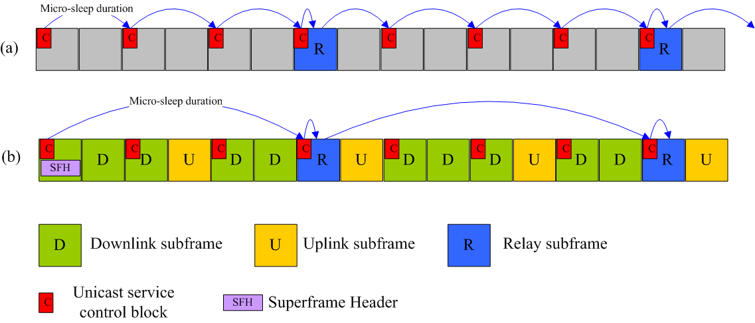

Figure 2. Increase the micro-sleep duration by referring to subframe information in the SFH.

The subframe information in SFH may describe the traffic direction of a subframe (DL or UL), the usage of a subframe (16m or 16e), the MCS of a subframe (64-QAM, 16-QAM, or QPSK), the mobility of a subframe (high mobility subframe), the MBS subframe, relay related subframe, and so on. For scheduling flexibility, a subframe may be described as a general DL or UL subframe in subframe information such that every MS should visit this subframe.

2.2 Sleep mode
If the traffic density for an MS is low enough, the MS can enter the sleep mode from active mode to have longer sleep duration. The MS will go back to the active mode if the traffic density comes back to a normal value. Furthermore, if there is almost no traffic for an MS, the MS can enter idle mode for saving more power. In sleep mode, the duration of the sleep/listen phase is configurable and can be dynamically changed according to the traffic pattern.

2.3 Idle mode
An MS can enter the idle mode by releasing its connections at any time or can be triggered to enter the idle mode if the traffic density is very low. Idle mode saves the most power compared to other power saving modes, but it takes the longest time to return to the connected phase since connections have to be reestablished. Moreover, the tradeoff between location update cost and paging signaling overhead should be taken into consideration when designing idle mode functions. We have another contribution C802.16m-08/xxx addressing this issue.

3. Proposed text for SDD
[Insert the following into section 10 of [1]]
--------------------------------------- Text start ---------------------------------------------
10.x Power Management
For power saving and resource utilization, IEEE 802.16m MAC layer shall support sleep mode in which an MS conducts pre-negotiated periods of absence from the serving BS. For further power saving requirements, the MAC layer shall support idle mode which allows the MS to become periodically available for DL broadcast information without maintaining the connections between the MS and BS. Operating in sleep mode or in idle mode for an MS can be configured manually or be triggered by traffic conditions or power saving requirements. Furthermore, in order to allow the MS to save power in active mode, a well-designed micro-sleep mechanism is required.

10.x.1 Micro-sleep mechanism
Micro-sleep mechanism is applied to an MS operating in the active mode of the connected state. By applying the micro-sleep mechanism, an MS can turn off unused hardware modules after receiving the control message from the BS until the specified time for data accessing or the next control message arrives. The micro-sleep duration (the duration where an MS can turn off unused hardware modules) can be increased by decreasing the frequency of decoding control blocks. Including the subframe information such as subframe type and characteristic in the Superframe Header (SFH) facilitates the MS to jump directly to the control blocks before or within the subframes of its interests (see Figure x1(b)).

Figure x1. Increase the micro-sleep duration by referring to subframe information in the SFH.
10.x.2 MS sleep mode
10.x.3 MS idle mode

--------------------------------------- Text end -----------------------------------------------

References

[1] IEEE 802.16m-08/003r3, “The Draft IEEE 802.16m System Description Document”, June 2008.
[2] IEEE 802.16m-07/002r4, “IEEE 802.16m System Requirements”, October 2007.

