Project | IEEE 802.16 Broadband Wireless Access Working Group <http://ieee802.org/16>
Title | Location-Based Paging Mechanism in 16m
Date Submitted | 2008-07-07
Source(s) | Ming-Hung Tao, Ying-Chuan Hsiao, Mamadou Kone, Richard Li  ITRI | E-mail: minghung02@gmail.com, richard929@itri.org.tw
Re: | IEEE 802.16m-08/024 - Call for Comments and Contributions on Project 802.16m System Description Document (SDD), shoot for “Upper MAC concepts and methods” topic.
Abstract | This contribution proposes a location-based paging mechanism in the IEEE 802.16m.
Purpose | For discussion and approval by TGm.
Notice | This document does not represent the agreed views of the IEEE 802.16 Working Group or any of its subgroups. It represents only the views of the participants listed in the “Source(s)” field above. It is offered as a basis for discussion. It is not binding on the contributor(s), who reserve(s) the right to add, amend or withdraw material contained herein.
Release | The contributor grants a free, irrevocable license to the IEEE to incorporate material contained in this contribution, and any modifications thereof, in the creation of an IEEE Standards publication; to copyright in the IEEE’s name any IEEE Standards publication even though it may include portions of this contribution; and at the IEEE’s sole discretion to permit others to reproduce in whole or in part the resulting IEEE Standards publication. The contributor also acknowledges and accepts that this contribution may be made public by IEEE 802.16.
Patent Policy | The contributor is familiar with the IEEE-SA Patent Policy and Procedures:  <http://standards.ieee.org/guides/bylaws/sect6-7.html#6> and <http://standards.ieee.org/guides/opman/sect6.html#6.3>.  Further information is located at <http://standards.ieee.org/board/pat/pat-material.html> and <http://standards.ieee.org/board/pat>.
Location-Based Paging Mechanism for 16m

Ming-Hung Tao, Ying-Chuan Hsiao, and Mamadou Kone
ITRI

1. Introduction
In the mobile communication system, there are two important concerns when implementing idle mode: location update cost and paging control overhead. The location update cost and paging control overhead becomes tradeoff if the size of location area or tracking area is configurable. If we increase the size of a location area to include more BSs in the area, the location update cost will be down (the frequency that a MS performs location update decreases), but the paging control overhead will increase (the size of paging message becomes large). In this proposal, we propose a location-based paging mechanism which classifies MSs into global-wide MSs and local-wide MSs. Based on the classification, paging information can be efficiently distributed among a location area to significantly decrease the paging control overhead.

2. Location-based paging mechanism
In idle mode, an MS is allowed to become periodically available for DL broadcast information without registering to a certain BS if it travels within a location area composed by several BSs. The MS does have to transmit any uplink message unless it arrives to a new location area. By restricting MS activity to scanning at discrete intervals and avoiding handover, MS can save lots of power and operational resources when operating in idle mode. The BSs are divided into logical groups called paging groups; the coverage area of a paging group is the location area of this group. The purpose of these groups is to offer a contiguous coverage region in which the MS doesn’t need to transmit in the uplink, and can be paged in downlink if there is DL traffic targeting to this MS. The location area (paging group) should be large enough so that most MSs won’t easily go outside the area, thus the location update cost can be reduced. However, large location area implies large paging control overhead since the paging message should be big enough to include all idle mode MSs within a location area.

To efficiently reduce the paging overhead, we propose a location-based paging mechanism which classifies MSs into global-wide MSs and local-wide MSs. The paging information for a global-wide MS shall be broadcast in the whole paging group, while the paging information for a local-wide MS shall be broadcast in the camped BS only. An example illustrated in Figure 1 shows the paging overhead can be significantly reduced by classifying MSs. In the figure, MS A and MS C stay in BS 2 and BS 1 for a long time while MS B moves between BS 1, 2, and 3 frequently. If the system doesn’t apply the location-based paging mechanism, as shown in the left part of Figure 1, BS 3 must broadcast the paging message including the paging information for MS A and MS C who never enter the cell coverage of BS 3. On the other hand, if the location-based paging mechanism is applied, only the paging information for MS B is broadcast globally; the paging information for MS A and MS C are broadcast locally within their camped BSs.

2.1 The procedure of the location-based paging
The following is the procedure of the location-based paging mechanism.
- Whenever an MS starts idle mode, it is regarded as a global-wide MS by the paging controller. The paging information for this MS is broadcast globally in the current paging group.
- As time goes by, if the MS is found to be within a certain BS for a long time, it is regarded as a local-wide MS. The paging information for this MS is broadcast locally within the BS.
- If a local-wide MS moves to another BS, then this MS is not able to receive its paging information. As a result, the MS will perform location update through the new BS. Whenever the paging controller receives a location update of an MS from a different BS, it will update the location state of the MS as a global-wide MS. The paging information for this MS is again broadcast in the whole paging group.
- In the case where the paging controller requests a local-wide MS to perform location update or network entry, but does not receive any response from the MS within a certain time, the paging controller then changes the state of this MS from local-wide MS to global-wide MS.

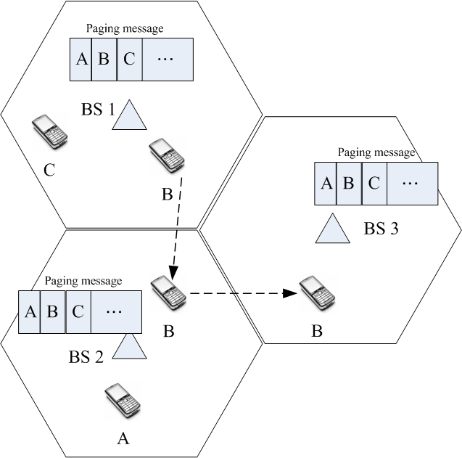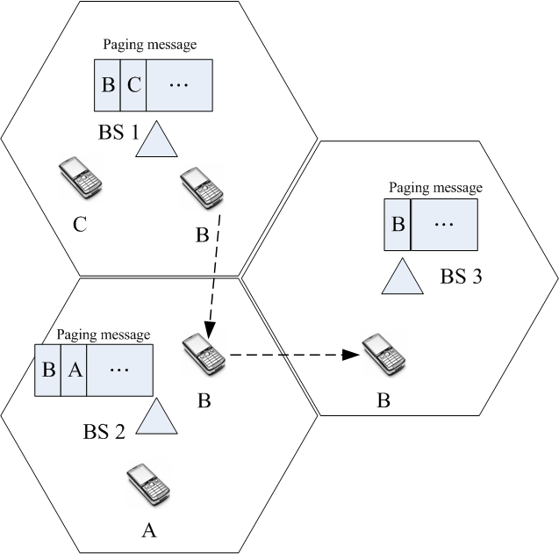

Figure 1. Reduce the paging overhead by classifying MSs.

2.2 Judge the location of an MS
Although there are many methods that a paging controller can use to judge how long an MS stays in a BS, we think referring to the location update records of an MS is a reliable, efficient, and easily implemented method. The paging controller first determines a threshold value, named R_{t}, if an MS stays in the same BS from the last R_{t} location update records, the paging controller judges this MS as a local-wide MS. The following lists four location update conditions mentioned in the IEEE 802.16e standard [1]:
- Paging group (change) update,
- Timer update,
- Power down update, and
- MAC hash skip threshold update.
The paging controller will take all location update records triggered by the above four conditions into account when judging the location state of an MS.

2.3 Reduce paging message by assigning paging ID
In generally, the paging information for each MS is indexed by the MAC address, which occupies lots of bits in the paging message so that the number of idle mode MSs that a paging group can support is limited. Although 16e uses MAC hash instead of real MAC address, it still needs a 24-bits filed to identify a MAC hash value. To reduce the size of paging messages, we propose that a paging controller should use the Paging ID (PID) which is unique to an MS during its paging duration instead of using MAC address to identify an MS in paging information. As shown in Figure 2, an MS receives its paging ID through DREG-CMD or RNG-RSP when the MS starts its idle mode or camps to a different paging group during its idle mode. Then the MS will monitor the paging information containing its paging ID until it moves to another paging group. With the help of paging cycle and paging offset, the size of PID can be around 8 bits, while the exact size is still FFS.
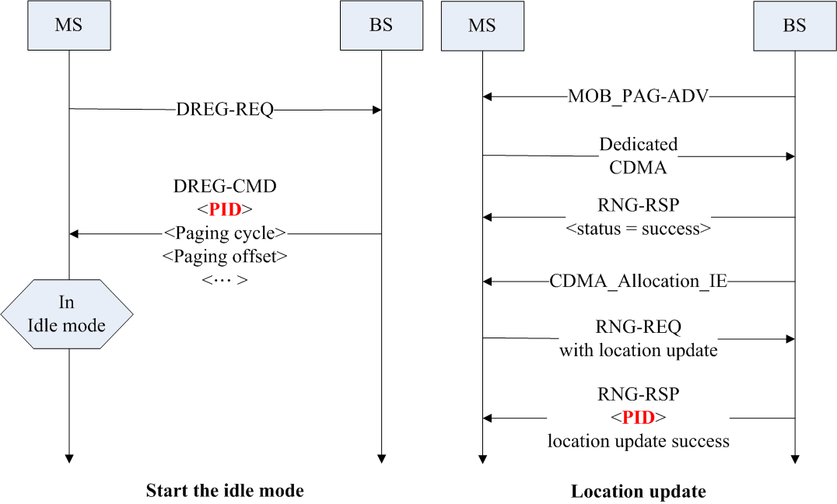
Figure 2. BS assigns Paging ID (PID) to the MS in idle mode.

3. Conclusions
Two important issues on implementing MS idle mode in a mobile communication system are reducing paging control overhead and lowering location update cost. In this proposal, we propose a location-based paging mechanism which significantly reduces the paging control overhead on broadcasting paging messages. The basic idea is the paging message is divided into the local paging message (broadcast around a BS) and the global paging message (broadcast around a paging group area). The global paging message contains all paging information for global-wide MSs, while the local paging message contains the paging information for global-wide MSs. A BS only has to transmit its own local paging message plus global paging message in order to avoid transmitting paging information to the MS that is obviously not camping to this BS. In this way, a great amount of paging control overhead can be prevented.

4. Proposed text for SDD
[Insert the foll owing into section 10 of [2]]
--------------------------------------- Text start ---------------------------------------------
10.x Power Management
10.x.y MS idle mode
10.x.y.z Location-based paging mechanism
To efficiently reduce the paging overhead, classifying MSs into global-wide and local-wide is necessary. The paging information for a global-wide MS shall be broadcast in the whole paging group, while the paging information for a local-wide MS shall be broadcast in the camped BS only.
The following is the procedure of the location-based paging mechanism.
- Whenever an MS starts idle mode, it is regarded as a global-wide MS by the paging controller. The paging information for this MS is broadcast globally in the current paging group.
- As time go by, if the MS is found to be within a certain BS for a long time, it is regarded as a local-wide MS. The paging information for this MS is broadcast locally within the BS.
- If a local-wide MS moves to another BS, then this MS is not able to receive its paging information. As a result, the MS will perform location update through the new BS. Whenever the paging controller receives a location update of an MS from a different BS, it will update the location state of the MS as a global-wide MS. The paging information for this MS is again broadcast in the whole paging group.
- In the case where the paging controller requests a local-wide MS to perform location update or network entry, but does not receive any response from the MS within a certain time, the paging controller then changes the state of this MS from local-wide to global-wide.

To judge how long an MS stays in a BS, the paging controller first determines a threshold value, named R_{t}. If an MS stays in the same BS from the last R_{t} location update records, the paging controller judges this MS as a local-wide MS.
--------------------------------------- Text end -----------------------------------------------

References
[1] P802.16Rev2/D5, “DRAFT Standard for Local and metropolitan area networks–Part 16: Air Interface for Broadband Wireless Access Systems”, June 2008.
[2] IEEE 802.16m-08/003r3, “The Draft IEEE 802.16m System Description Document”, June 2008.
[3] IEEE 802.16m-07/002r4, “IEEE 802.16m System Requirements”, October 2007.

