Project | IEEE 802.16 Broadband Wireless Access Working Group <http://ieee802.org/16>
Title | Inter-cell measurement for self-organization support
Date Submitted | 2008-07-15
Source(s) | Chie Ming Chou, Richard Li, Fang-Ching (Frank) Ren, Chun-Yen Wang, ITRI | Voice:  E-mail: chieming@itri.org.tw  richard929@itri.org.tw
Re: | IEEE 802.16m-08/024- Call for Contributions on Project 802.16m System Description Document (SDD)  Topic: Interference Mitigation
Abstract | This contribution proposes the designs of inter-BS measurement for supporting self-organization and interference controls.
Purpose | For discussion and approval by TGm
Notice | This document does not represent the agreed views of the IEEE 802.16 Working Group or any of its subgroups. It represents only the views of the participants listed in the “Source(s)” field above. It is offered as a basis for discussion. It is not binding on the contributor(s), who reserve(s) the right to add, amend or withdraw material contained herein.
Release | The contributor grants a free, irrevocable license to the IEEE to incorporate material contained in this contribution, and any modifications thereof, in the creation of an IEEE Standards publication; to copyright in the IEEE’s name any IEEE Standards publication even though it may include portions of this contribution; and at the IEEE’s sole discretion to permit others to reproduce in whole or in part the resulting IEEE Standards publication. The contributor also acknowledges and accepts that this contribution may be made public by IEEE 802.16.
Patent Policy | The contributor is familiar with the IEEE-SA Patent Policy and Procedures:  <http://standards.ieee.org/guides/bylaws/sect6-7.html#6> and <http://standards.ieee.org/guides/opman/sect6.html#6.3>.  Further information is located at <http://standards.ieee.org/board/pat/pat-material.html> and <http://standards.ieee.org/board/pat>.
Inter-cell measurements for self-organization support
Chie Ming Chou, Richard Li, Frank Ren, Chun-Yen Wang
ITRI

- Introduction
Supporting self-organization is one function of 802.16m. A BS is required to automatically configure its transmitting frequency, power, neighbor list, handover parameters and etc. To achieve this objective, both BSs and MSs shall perform measurements to detect neighboring environment and make the decisions of self-organization based on measuring results. The neighboring environment may include same or different RAT (Radio Access Technologies) belonged to same or different developers. In this contribution, we focus on Inter-cell measurements. Based on different scenarios, the controls for Inter-cell measurements are proposed. With our proposal, a 16m BS can perform Inter-cell measurements with less impairment on its connected MSs.

- Inter-Cell measurement scenarios
Until now, there are different kinds of RATs deployed in the wireless environment. In a conventional wireless cellular network, the cell-planning mechanism is always applied to decide what cell parameters such as transmitting frequency, transmitting power are suitable for operations. Due to complex wireless environment, an operator always wastes a lot of cost on employing engineers to figure out the best planning by practical testing. To reduce the costs, the concept of self-organization and optimization network is proposed: Network is suggested to be capable of measuring its neighboring environment and configure its operating parameters by itself. In 16m network, there are two possible scenarios for 16m BS to measure its neighboring environment:
(1) Inter-cell measurement in IEEE 802.16m network
This scenario could be applied to homogeneous IEEE 802.16m network. During development, a new 16m BS will perform Inter-cell measurement with respect to 16m network before providing services. Based on measurement results, a new 16m BS can be able to configure its operating parameters to organize and optimize its network performance. Furthermore, an operating 16m BS can also perform Inter-cell measurement in specific time interval ex: midnight, to optimize overall 16m network performance.
Another possible case in this scenario is that the development of 16m femto-cell station. Figure 1 is an example of this scenario. Femto-cell station is operated in the indoor environment. Several 16m Femto-cell stations’ coverage may be covered within a 16m BS’s coverage. The operating frequency of a 16m femto-cell station may be reused with a 16m BS’s. Unlike a 16m BS, femto-cell station is a client-own station which has frequent power on/off. When a femto-cell station is developed, it often needs to measure its neighboring 16m femto-cell stations and 16m BSs to make a good interference migration.
Figure 1; the example of Inter-cell measurement in IEEE 802.16m network

(2) Inter-cell measurement with non-IEEE 802.16m networks
Different RATs may be developed in the common area. A multi-RAT mode MS can switch between systems to acquire the best QoS. In 16m, Multi-Radio Coexistence block also performs functions to support concurrent operations of IEEE 802.16m and non-IEEE 802.16m radios. To support this, Inter-cell measurements with non-IEEE 802.16m networks will be required to provide the analysis. In this application, a common backhaul between different RATs may be existed to provide information and facilitate the measurement. Another possible application is that 16m network is suggested to share and utilize the available spectrum on other non-IEEE 802.16m networks. Dynamic spectrum sensing is a main function to sense available spectrum. If the spectrum is free, then users can configure its parameters to operate in this spectrum.

- Inter-cell measurement controls
Based on different scenarios, there are different proposals for controlling Inter-cell measurement.
- Measurement controls for Inter-cell measurement in IEEE 802.16m network:
When performing Inter-cell measurement in IEEE 802.16m network, a 16m BS can take turns to transmit an additional sounding signal in a coordinated region of a super-frame. By pre-coordinating with other BSs, other BSs can measure the sounding signal and acquire valid channel information for facilitating self-configuration. Figure 2 is an example of this mechanism, BS #2 can negotiate with BS #1, #3, and #4 that a sounding signal will be transmitted in SF6 in F0. And then other BSs will configure its sub-frame to be UL sub-frames without allocating any resources for its serving MSs. By the way, BS#1, #3 and #4 can be able to measure the sounding signal and get the channel condition.
Figure 2, BS sounding mechanism in IEEE 802.16m transmission

If neighboring cells are developed by a common operator, neighborhood information such as operating frequency, cell ID… and etc can be exchanged through backhaul and facilitate the Inter-cell measurements. Oppositely, if neighboring cells are developed by different owner, ex: Femto-cell, the measurement gap can be created, but fully cell search process may be required in this period to scan other BSs and get regarding information.

- Measurement controls for Inter-cell measurement with non-IEEE 802.16m networks:
For Inter-cell measurement with non-IEEE 802.16m networks, a BS may not coordinate with other network in-advanced. Therefore, it may require a lot of time to finish the measurement. Unfortunately, it’s impossible for a network to continue measurement with terminating all its on-going services for a long period. To resolve this problem, a MS-assisted inter-cell measurement is proposed to support a fast measurement. A specific MS which enters idle mode is requested to collect information of other networks first and make reports to its serving BS when returns to the active mode, Based on received information, BS can treat other non-IEEE 802.16m networks as special users and schedule a suitable period to measure its channel condition. In IEEE 802.16e system, a MS will enter idle mode when there is no on-demand transmission. During this mode, there are two periods: One is called unavailable period, in which MS will disconnect with its serving BS. The other is available period, in which a MS will return to listening mode to listen the broadcast message from serving BS. A modified idle mode procedure which can be used to provide other non-IEEE 802.16m network’s information is shown in Figure 3. The provided information includes: frequency, frame structure, network identification and etc.

Figure 3, modified idle mode for collecting neighborhood information

In this modification, a MS will send a DREG-REQ message to request entering idle mode. When BS gives the DREG-RSP, it will use a new identifier (also called action code) to indicate that MS is recommended to help BS collect other network information in its unavailable period. Unlike legacy operations, MS won’t disconnect with BS immediately after receiving DREG-CMD message. Instead, MS will disconnect with BS until listening the latest broadcast message from its serving BS. And that, MS can get the latest neighbor list with respect to its serving BS. In the unavailable period, MS will start to scan these frequencies which are not listed in the neighbor list. If MS finds an unknown synchronized signal, MS will try to listen further broadcast message and record regarding information. In the following, a MS will perform the network re-entry to establish the connection with serving BS and make reports.

With above method, a BS can get information of unknown networks without terminating its services. BS will compare the frame structure of target network between itself. As shown in Figure 4, if there is an overlapped period between DL transmission of target network and UL transmission of BS, then BS will take target network as a serving MS and allocate corresponding resources in the overlapped period for receiving the transmission of target network and measure the signal strength. Oppositely, as shown in Figure 5, if there is no overlapped period, BS will give indications to all serving MSs to command that they need to keep silence during one specific frame. And BS will turn its DL transmission into UL transmission to listen the transmission from target network and performs measurement.
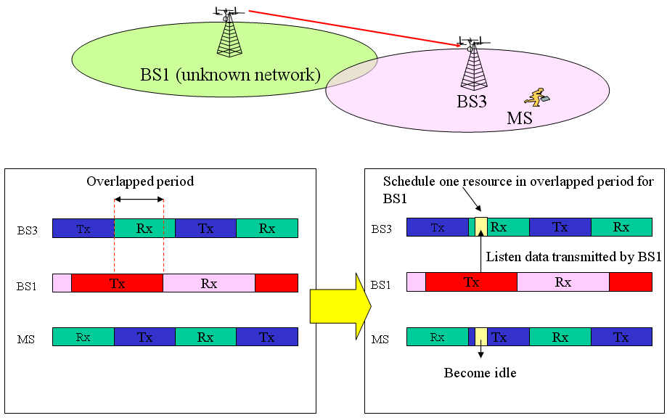
Figure 4, Inter-cell measurement with overlapped period
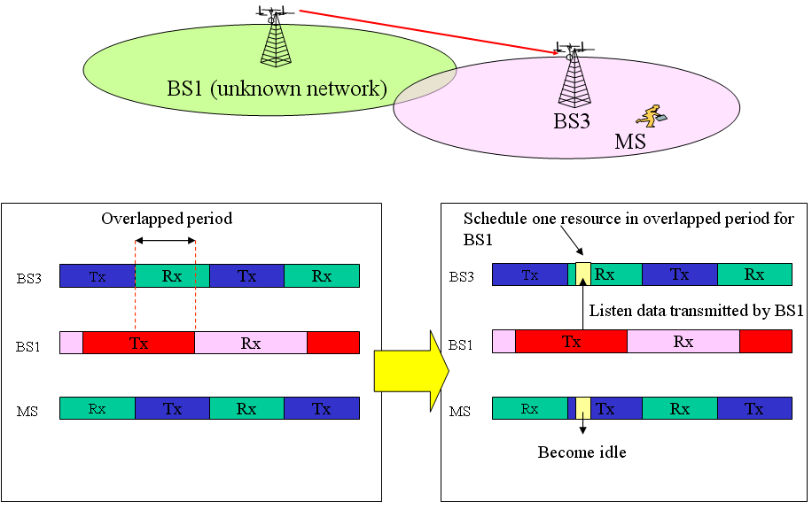
Figure 5, Inter-cell measurement without overlapped period

- Proposed Text
---------------------------------------------Start of the text------------------------------------------------
8.1 The IEEE 802.16m Protocol Structure
[Insert the following text in Section 8.1 of SDD]
Self Organization block performs functions to support self configuration and self optimization mechanisms. The functions include procedures to request MSs to report measurements for self configuration and self optimization and receive the measurements from the MSs. Besides, the function of Inter-cell measurements which is performed by BSs is to provide information and support the self organization.

18. Support for Self-organization
[Insert the following text in Section 18 of SDD]
18. X. Inter-cell measurement
To support self-organization, an IEEE802.16m BS needs to scan its neighborhood. The neighborhood can include IEEE 802.16m network and non-IEEE 802.16m networks. Both networks can be coordinated though backbone or not. The required information from other networks is TBD. Based on different scenarios, there are two different controls. One is used for Inter-cell measurement in IEEE 802.16m network; the other is used for Inter-cell measurement with non-IEEE 802.16m network.

18. X.1 Inter-cell measurement in IEEE 802.16m network
To perform Inter-cell measurement in IEEE 802.16m network, a 16m BS can coordinate with other 16m BSs to employ sounding mechanism. A specific period will be negotiated along BSs. A selected BS can transmit the pre-defined sounding signal in the coordinated period. Other BSs will try to receive this signal and measure its signal strength.

18. X.2 Inter-cell measurement with non-IEEE 802.16m networks
To facilitate Inter-cell measurement with a non-IEEE 802.16m network, a multiple-RAT mode MS can be recommended to help collect the information of other RATs. During its idle mode, a MS will try to entry other RATs and acquire regarding network information. After make reports in active mode, a 16m BS can be able to configure a suitable period to receive neighborhood’s transmission and measure its signal strength.

---------------------------------------------End of the text------------------------------------------------

