IEEE C802.16m-08/595

Project | IEEE 802.16 Broadband Wireless Access Working Group <http://ieee802.org/16>
Title | Interference Mitigation using Conjugate Data Repetition
Date Sub. | 2008-07-07
Source(s) | Kiran Kuchi  J Klutto Milleth  Vinod Ramaswamy  Baskaran Dhivagar  K Giridhar  Bhaskar Ramamurthi  CEWiT, India | kkuchi@cewit.org.in  klutto@cewit.org.in  vinodr@cewit.org.in  dhiv@cewit.org.in  giri@tenet.res.in  bhaskar@tenet.res.in
Re: | IEEE C802.16m-08/024 - Call for Comments and Contributions on Project 802.16m System Description Document (SDD), on the topic Interference Mitigation.
Abstract | We propose a scheme in which data repetition is done in conjugate pairs among all co-channel base stations in same subcarrier locations so that the receiver fully exploits interference suppression gain, irrespective of the channel conditions. Moreover, conjugate data repetition permits full IC benefit in a localized resource block (RB) which has limited or no channel variation. Therefore, conjugate data repetition results in a very flexible resource allocation.
Purpose | To be discussed by TGm for incorporation into the SDD
Notice | This document does not represent the agreed views of the IEEE 802.16 Working Group or any of its subgroups. It represents only the views of the participants listed in the “Source(s)” field above. It is offered as a basis for discussion. It is not binding on the contributor(s), who reserve(s) the right to add, amend or withdraw material contained herein.
Release | The contributor grants a free, irrevocable license to the IEEE to incorporate material contained in this contribution, and any modifications thereof, in the creation of an IEEE Standards publication; to copyright in the IEEE’s name any IEEE Standards publication even though it may include portions of this contribution; and at the IEEE’s sole discretion to permit others to reproduce in whole or in part the resulting IEEE Standards publication. The contributor also acknowledges and accepts that this contribution may be made public by IEEE 802.16.
Patent Policy | The contributor is familiar with the IEEE-SA Patent Policy and Procedures:  <http://standards.ieee.org/guides/bylaws/sect6-7.html#6> and <http://standards.ieee.org/guides/opman/sect6.html#6.3>.  Further information is located at <http://standards.ieee.org/board/pat/pat-material.html> and <http://standards.ieee.org/board/pat>.

Interference Mitigation using Conjugate Data Repetition
Kiran Kuchi, J Klutto Milleth, Vinod Ramaswamy, Baskaran Dhivagar, K Giridhar, Bhaskar Ramamurthi CEWiT, Chennai, India

- Background
In 802.16m networks employing frequency reuse-1 deployments, cell edge link performance will be limited by co-channel interference. At cell edge, the data is typically modulated using rate ½ QPSK and same data is further repeated 2, 4, or 6 times to meet the target BLER. For example, in 802.16e networks, DL control channel uses rate ½ QPSK and bit-level data repetition of up to 6-times. For data users at cell edge, both UL and DL supports rate ½ QPSK and data repetition up to 6-times which results in significant loss in spectrum efficiency.

In C802.16m-07/211, coordinated data repetition is suggested to suppress co-channel interference using MMSE receiver processing. This method is limited to resource allocation only in a distributed mode. In that proposal, data is repeated on distinct subcarriers which are spaced sufficiently far apart in frequency domain so that those subcarriers experience different channel realizations, which is a requirement for interference suppression. In this contribution, we propose a scheme in which data repetition is done in conjugate data pairs (preferably across adjacent subcarriers) among all co-channel base stations so that the receiver fully exploits interference suppression gain, irrespective of the channel conditions. Moreover, conjugate data repetition permits full interference cancellation (IC) benefit even though data is repeated in a localized resource block (RB), which has very limited or no channel variation. Therefore, conjugate data repetition results in a very flexible resource allocation and efficient receiver implementation.

  - Proposal

In Fig. 1a, we show an example pattern for data allocation in a localized RB in which data is repeated in adjacent subcarrier locations in conjugate pairs. In Fig. 1b, pairs of conjugate data symbols are repeated in the same subcarrier but in different OFDM symbols. In both figures, F denotes subcarrier index, T denotes the OFDM time index, P denotes pilot locations, and X,Y denote data transmitted from base station 1 and 2, respectively.

The proposal has the following features.
- Conjugate symbol repetition in a pair of subcarriers, or OFDM symbols
- After complex de-conjugation, the receiver has two copies of signal and interference with different channel states
  - 2-antenna MMSE can suppress 3-dominant CCI
  - An advanced receiver can reject up to 4-domainnt CCI
- The proposal is suitable for common control channels, which are always transmitted in predetermined locations
- Conjugate repetition is applied in localized RBs of deterministic size
  - Several localized RBs are distributed in the entire band in diversity mode
- More flexible resource allocation compared to Panasonic proposal C802.16m-07/211
- The concept can be applied to data channels as well
- For repetition factors greater than 2, a deterministic or random phase rotation is applied in addition to conjugation
- 2D-POD is the preferred OL transmit diversity mode
- The IC receiver works in virtual (single) antenna mode

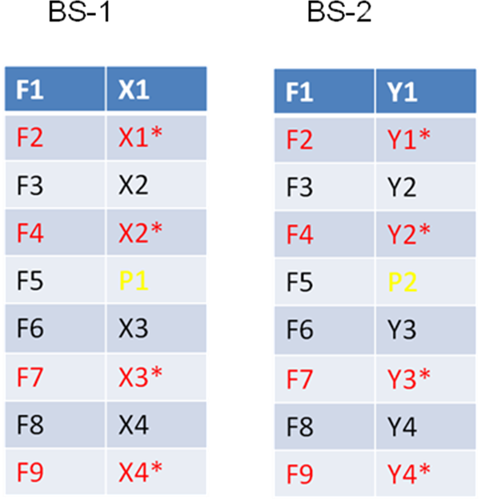
Fig. 1a: Conjugate Data Repetition in a localized RB spanning one OFDM symbol

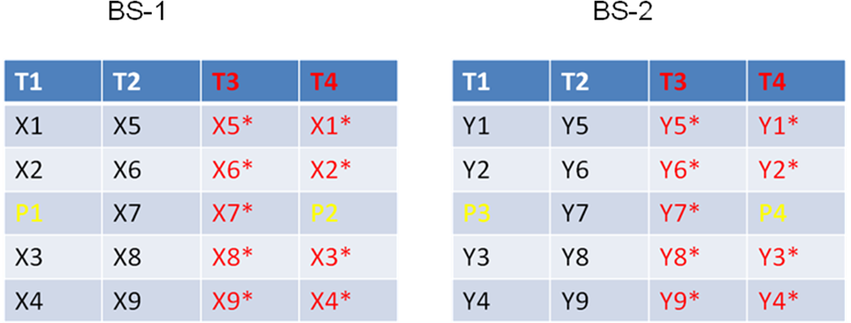
Fig. 1b: Conjugate Data Repetition in a localized RB of size 5x4

  - Simulation Results

In Fig. 2, the histogram of the SINR at the output of the MMSE receiver is shown for a 2-antenna receiver (Nr=2) with conjugate repetition applied at the transmitter. In this simulation, the channel is modeled with flat Rayleigh fading and total CCI is composed of three interferers with equal average power. Ideal CSIT and ideal interference-correlation-matrix (ICM) is assumed in all cases. The total C/I in this case is 0 dB and the interference to noise power is fixed at 20 dB. In this case the MMSE receiver gives nearly 22 dB SINR 80% of the time. In Fig. 3, performance is shown for a LoS channel for the same simulation set up. In this case, the MMSE receiver gives an SINR in the range of 13-22 dB.

In Fig. 4, we simulated the MMSE receiver performance for a cell edge user with an input SINR of -7dB with 8-interferers and SNR=30 dB. The average power profile of individual interferers is given in Table-1. Network simulation showed that this type of interference distribution occurs nearly 50% of time for cell edge users in reuse-1 networks. In this case, a 2-antenna MMSE receiver with conjugation repetition provides nearly 12 dB SINR 90% of the time. With this SINR, excellent cell edge coverage can be ensured for control channel. Moreover, the gain in data throughput is very significant compared to the schemes which use bit level data repetition. Note that the proposed simulation assumes localized RB with flat Rayleigh fading; additional gain can be expected with frequency diversity and channel coding.

Interference Profile | Relative Interference Power with respect to dominant CCI
I₀ | 0
I₁ | -3.5
I₂ | -6.5
I₃ | -9.0
I₄ | -11.0
I₅ | -12.5
I₆ | -13.0
I₇ | -13.5
Table 1: Typical interference power profile for cell edge users in reuse-1 networks

Fig. 2: SINR of MMSE receiver with conjugate repetition in flat fading channel, 3-interferers

Fig. 3: SINR of MMSE receiver with conjugate repetition in a LoS channel, 3-interferers
Fig. 4: SINR of MMSE receiver with conjugate repetition in flat fading channel, 8-interferers

Proposed SDD text
………………………………………………………………………………………………………
Interference mitigation techniques using conjugate data repetition and phase rotated conjugate data repetition shall be used for common control channels. Conjugate repetition based interference mitigation schemes shall be adopted for data channels in a cell edge FFR zone.
……………………………………………………………………………………………………

