IEEE C802.16m-08/595r1

Project | IEEE 802.16 Broadband Wireless Access Working Group <http://ieee802.org/16>
Title | Interference Mitigation using Conjugate Data Repetition
Date Sub. | 2008-07-07
Source(s) | Kiran Kuchi  J Klutto Milleth  Vinod Ramaswamy  Baskaran Dhivagar  K Giridhar  Bhaskar Ramamurthi  CEWiT, India | kkuchi@cewit.org.in  klutto@cewit.org.in  vinodr@cewit.org.in  dhiv@cewit.org.in  giri@tenet.res.in  bhaskar@tenet.res.in
Re: | IEEE C802.16m-08/024 - Call for Comments and Contributions on Project 802.16m System Description Document (SDD), on the topic Interference Mitigation.
Abstract | We propose a scheme in which data repetition is done in conjugate pairs among all co-channel base stations in same subcarrier locations so that the receiver fully exploits interference suppression gain, irrespective of the channel conditions. Moreover, conjugate data repetition permits full IC benefit in a localized resource block (RB) which has limited or no channel variation. Therefore, conjugate data repetition results in a very flexible resource allocation.
Purpose | To be discussed by TGm for incorporation into the SDD
Notice | This document does not represent the agreed views of the IEEE 802.16 Working Group or any of its subgroups. It represents only the views of the participants listed in the “Source(s)” field above. It is offered as a basis for discussion. It is not binding on the contributor(s), who reserve(s) the right to add, amend or withdraw material contained herein.
Release | The contributor grants a free, irrevocable license to the IEEE to incorporate material contained in this contribution, and any modifications thereof, in the creation of an IEEE Standards publication; to copyright in the IEEE’s name any IEEE Standards publication even though it may include portions of this contribution; and at the IEEE’s sole discretion to permit others to reproduce in whole or in part the resulting IEEE Standards publication. The contributor also acknowledges and accepts that this contribution may be made public by IEEE 802.16.
Patent Policy | The contributor is familiar with the IEEE-SA Patent Policy and Procedures:  <http://standards.ieee.org/guides/bylaws/sect6-7.html#6> and <http://standards.ieee.org/guides/opman/sect6.html#6.3>.  Further information is located at <http://standards.ieee.org/board/pat/pat-material.html> and <http://standards.ieee.org/board/pat>.

Interference Mitigation using Conjugate Data Repetition
Kiran Kuchi, J Klutto Milleth, Vinod Ramaswamy, Baskaran Dhivagar, K Giridhar, Bhaskar Ramamurthi CEWiT, Chennai, India

- Background
In 802.16m networks employing frequency reuse-1 deployments, cell edge link performance will be limited by co-channel interference. At cell edge, the data is typically modulated using rate ½ QPSK and same data is further repeated 2, 4, or 6 times to meet the target BLER. For example, in 802.16e networks, DL control channel uses rate ½ QPSK and bit-level data repetition of up to6-times. For data users at cell edge, both UL and DL supports rate ½ QPSK and data repetition up to 6-times which results in significant loss in spectrum efficiency.

In contribution (C802.16m-07/211), Panasonic proposed that, instead of repeating the data in the DL-MAP at bit level one should repeat the QPSK modulation symbols “q” times and map these repeated data symbols to distinct subcarriers. If all base stations map their repeated data on the same set of subcarriers in a synchronous manner, then a receiver with “Nr” antennas can collect multiple copies of the signal along with interference from the “q” subcarriers of the interfering base stations to generate a total of q*Nr observations. With a repetition factor of q=2, and Nr=2 receive antennas, a total of q*Nr=4 observations can be obtained, and it can be used to potentially reject q*Nr-1=3interferers. The basic idea is illustrated by considering a simpler case of q=2 repetitions and Nr=1 receive antenna as follows.

The signal and interference terms collected at the receiver from the two subcarriers can be represented as:
$y_{1}=h_{1}x+g_{1}{\hat{x}}_{1}+n_{1}$ (signal collected from 1st subcarrier)and
$y_{2}=h_{2}x+g_{2}{\hat{x}}_{1}+n_{2}$(signal collected from 2nd subcarrier)
where $h_{1},h_{2}$and $g_{1},g_{2}$are the respective complex-valued channel gains of the own and interfering base stations, respectively and $n_{1}$ and $n_{2}$ represents the complex AWGN with zero-mean and variance $N_{0}$.
A conventional receiver which combines $(y_{1},y_{2})$using maximum ratio combing (MRC) provides:
- A 3-dB SNR advantage with a repetition factor of two, or in general, the SNR gain will be 10log(q) dB.
- In a frequency selective channel, data repetition provides additional diversity gain when the subcarriers are sufficiently spaced apart.
However, an MMSE receiver which jointly filters $(y_{1},y_{2})$using MMSE weights will completely suppress the interference, if $h_{1}≠h_{2}$ and $g_{1}≠g_{2}$ i.e., the subcarriers on which the data is repeated should experience different channel gains. In other words, the channel should have high enough frequency selectivity. In Rician (line-of-sight), or frequency flat fading channels, the channel will have limited or no variation across the subcarriers resulting in $h_{1}=h_{2}$ and $g_{1}=g_{2}$. It can be shown that the MMSE receiver will not be able to suppress the interference. In other words, if data is repeated in a localized slot which has very little or no channel variation, the channel states of repeated data will be nearly same for both signal and interference. This type of situation may occur for example in PED-A type channels (which has nearly frequency flat fading within a resource block (RB)) or near line-of-sight channels LoS, or when mobiles are located in high rise buildings where each mobile has direct line-of-sight connection to several base stations. Recently, Indian operators (during 802.16d deployments) have reported that in the high rise buildings, LoS case occurs quite often which gives rise to severe interference problems. In such cases, it is difficult to ensure interference suppression benefit with simple data repetition.

In this contribution, we propose a scheme in which data repetition is done in conjugate data pairs (preferably across adjacent subcarriers) among all co-channel base stations so that the receiver fully exploits interference suppression gain, irrespective of the channel conditions. Moreover, conjugate data repetition permits full interference cancellation (IC) benefit even though data is repeated in a localized resource block (RB), which has very limited or no channel variation. Therefore, conjugate data repetition results in a very flexible resource allocation and efficient receiver implementation.

  - Proposal

In Fig. 1a, we show an example pattern for data allocation in a localized RB in which data is repeated in adjacent subcarrier locations in conjugate pairs. In Fig. 1b, pairs of conjugate data symbols are repeated in the same subcarrier but in different OFDM symbols. In both figures, F denotes subcarrier index, T denotes the OFDM time index, P denotes pilot locations, and X, Y denote data transmitted from base station 1 and 2, respectively.

The proposal has the following features.
- Conjugate symbol repetition in a pair of subcarriers, or OFDM symbols
- After complex de-conjugation, the receiver has two copies of signal and interference with different channel states
  - 2-receive antenna MMSE can suppress 3-4 dominant CCI
  - An advanced receiver can reject up to 4-5 dominant CCI
- The proposal is suitable for common control channels, which are always transmitted in predetermined locations
- Conjugate repetition is applied in localized RBs of deterministic size
  - Several localized RBs are distributed in the entire band in diversity mode
- More flexible resource allocation compared to Panasonic proposal C802.16m-07/211
- The concept can be applied to data channels as well
- For repetition factors greater than 2, a deterministic or random phase rotation is applied in addition to conjugation
- 2D-POD is the preferred OL transmit diversity mode
- The IC receiver works in virtual (single) antenna mode

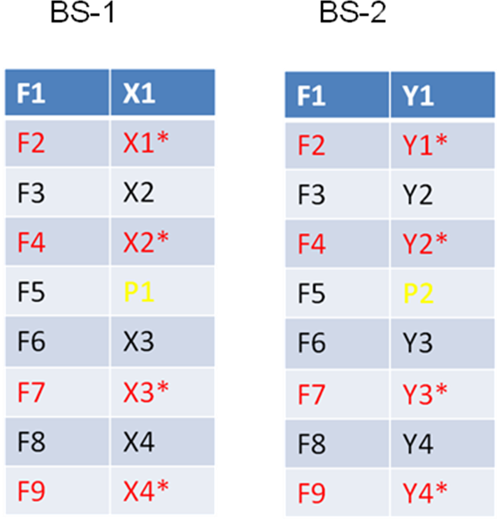
Fig. 1a: An example pattern with conjugate data repetition in a localized RB spanning one OFDM symbol

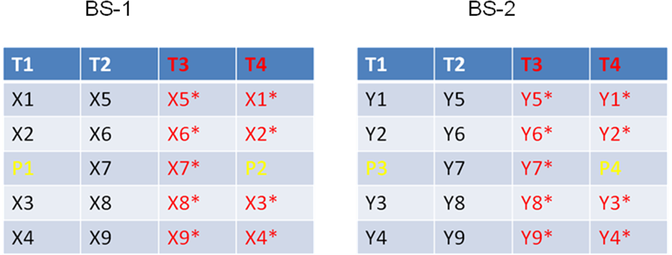
Fig. 1b: An example pattern with conjugate data repetition in a localized RB of size 5x4

  - Conjugate repetition
The method is suited for a repetition factor of two, and in a scenario when $h_{1}=h_{2}=h$ and $g_{1}=g_{2}=g$. This situation may arise either in a line-of-sight or frequency flat fading channel and especially data is allocated in localized slots. In our proposal, when the desired signal is transmitted in symbol pairs as [x, x*] on any two subcarriers, the same operation is performed on those subcarriers at a different BS (or sector) while transmitting a co-channel signal [x_{i} x_{i}*]. The received signal from the two subcarriers can be written as:
$y_{1}=\text{hx}+g{\hat{x}}_{1}+n_{1}$ (signal collected from 1st subcarrier)
and
$y_{2}={\text{hx}}^{}+g{\hat{x}}_{1}^{}+n_{2}$(signal collected from 2nd subcarrier)

where $h$and $g$ are the respective complex-valued channel gains from the own and interfering base stations. Taking the conjugate of the second sample results in
$y_{2}^{}=h^{}x+g^{}{\hat{x}}_{1}+n_{2}^{}$.
Unlike the case with simple data repetition, here due to complex conjugation at the receiver, the channel states (h, h*) are distinct (they have same magnitude with opposite phases). Same applies to (g, g*). It can be shown that by filtering y₁ and y₂* jointly using an MMSE receiver, a single interferer can be suppressed completely because the signal and the interference go through different channels, and the channel states h and g are statistically independent. Therefore, the SINR at the output of the MMSE filter can be expressed as (See Appendix for receiver details):
$$γ=h^{}R_{i+n}^{−1}h$$
where $R_{i+n}={\text{gg}}^{}+N_{0}I$, $g=\left[\begin{matrix}g \\ g^{}\end{matrix}\right]$, and $h=\left[\begin{matrix}h \\ h^{}\end{matrix}\right]$. When the thermal noise power No is small compared to the interference power, it can be shown that the SINR is inversely proportional to No. The SINR becomes infinity for No=0, which implies that the receiver completely nulls out interference. In contrast, a conventional coordinated symbol repetition (CSR) method which relies on the channel frequency selectivity will not be able to suppress interference.
The above result can also be generalized to multi-antenna systems, and, it can be shown that conjugated symbol repetition based receiver can completely reject 2*Nr-1 interferers, irrespective of the channel type. For example with Nr=2 receive antennas, this technique can fully reject 3-interferers.

  - Extension to higher repetition factors

For the case with a repetition factor of two, it is shown that conjugated data repetition ensures full interference suppression irrespective of the channel gain. For the purpose of illustration, a line-of-sight or frequency flat fading channel and a symbol repetition factor of 4 is assumed.
The basic idea is to introduce phase variations such that different subcarriers will undergo different channels. Since this conjugation already ensures full interference suppression when the repetition factor is two, a combination of conjugate repetition and random/deterministic phase variation of the repeated symbols is proposed for repetition factor greater than 2. For example, the repetition pattern for desired signal with q=4 is given by: $\left[\begin{matrix}x & x^{}e^{jθ(1)} & {\text{xe}}^{jθ(2)} & x^{}e^{jθ(3)}\end{matrix}\right]$. Here data is repeated on any four different subcarriers and a co-channel BS transmits $\left[\begin{matrix}{\hat{x}}_{1} & {\hat{x}}_{1^{}}e^{{jθ}_{1}(1)} & {\hat{x}}_{1}e^{{jθ}_{1}(2)} & {\hat{x}}_{1^{}}e^{{jθ}_{1}(3)}\end{matrix}\right]$ on the same set of subcarriers. The phase values in the exponentials may be chosen deterministically or randomly (pseudo-random patterns may be used).
An alternative example implementation can be the following simplified pattern. The desired signal transmits$\left[\begin{matrix}x & x^{} & {\text{xe}}^{jθ(1)} & x^{}e^{−jθ(1)}\end{matrix}\right]$ on any four different subcarriers and a co-channel BS transmits $\left[\begin{matrix}{\hat{x}}_{1} & {\hat{x}}_{1^{}} & {\hat{x}}_{1}e^{{jθ}_{1}(1)} & {\hat{x}}_{1^{}}e^{−{jθ}_{1}(1)}\end{matrix}\right]$ on the same subcarriers. This pattern may simplify the channel and interference parameter estimation, since the phase offset is omitted from the first conjugated symbol. In practice, these phase offset values can be chosen to be pseudo random sequences which can be made either sector or BS ID dependent.

  - Simulation Results

In Fig. 2, the histogram of the SINR at the output of the MMSE receiver is shown for a 2-antenna receiver (Nr=2) with conjugate repetition applied at the transmitter. In this simulation, the channel is modeled with flat Rayleigh fading and total CCI is composed of three interferers with equal average power. Ideal CSIT and ideal interference-correlation-matrix (ICM) is assumed in all cases. The total C/I in this case is 0 dB and the signal to noise ratio is fixed at 20 dB. In this case the MMSE receiver gives nearly 22 dB SINR 80% of the time. In Fig. 3, performance is shown for a LoS channel for the same simulation set up. In this case, the MMSE receiver gives an SINR in the range of 13-22 dB.

In Fig. 4, we simulated the MMSE receiver performance for a cell edge user with an input SINR of -7dB with 8-interferers and SNR=30 dB. The average power profile of individual interferers is given in Table-1. Network simulation showed that this type of interference distribution occurs nearly 50% of time for cell edge users in reuse-1 networks. In this case, a 2-antenna MMSE receiver with conjugation repetition provides nearly 12 dB SINR 90% of the time. With this SINR, excellent cell edge coverage can be ensured for control channel. Moreover, the gain in data throughput is very significant compared to the schemes which use bit level data repetition.
Interference Profile | Relative Interference Power with respect to dominant CCI
I₀ | 0
I₁ | -3.5
I₂ | -6.5
I₃ | -9.0
I₄ | -11.0
I₅ | -12.5
I₆ | -13.0
I₇ | -13.5
Table 1: Typical interference power profile for cell edge users in reuse-1 networks

Fig. 2: SINR of MMSE receiver with conjugate repetition in flat fading channel, 3-interferers

Fig. 3: SINR of MMSE receiver with conjugate repetition in a LoS channel, 3-interferers
Fig. 4: SINR of MMSE receiver with conjugate repetition in flat fading channel, 8-interferers
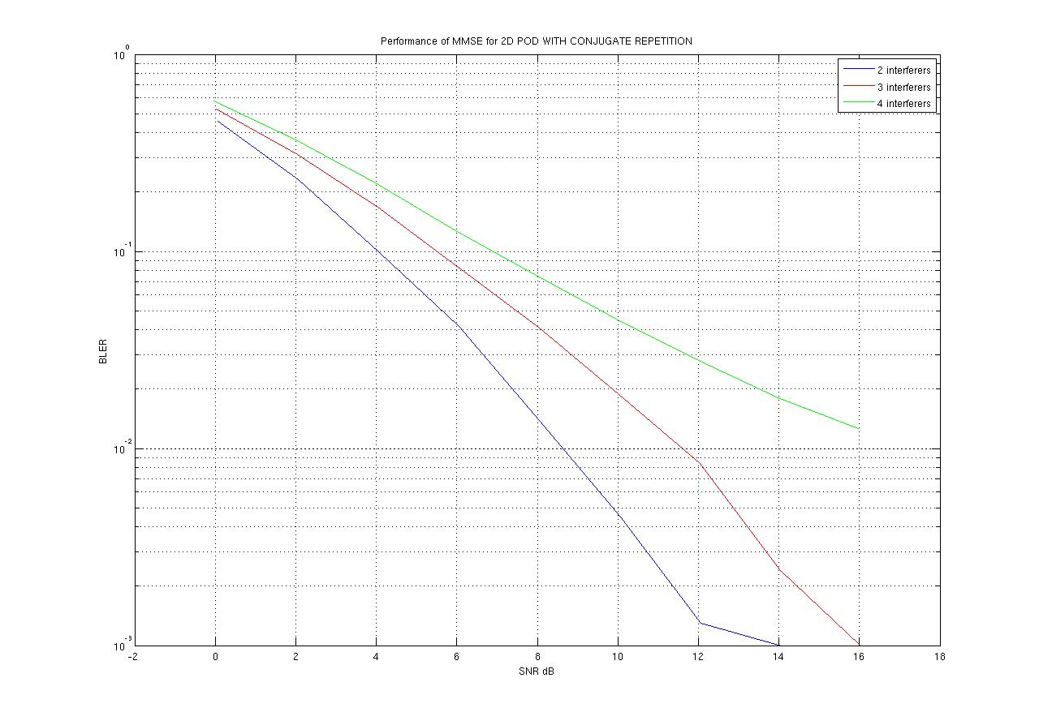
Fig. 5: Link simulation with conjugate repetition factor =2.

  - Link simulation results

In Fig. 5, the link performance is shown with multiple interferers. The results are shown for PED-A channel for a localized RB of size 9 subcarriers and six OFDM symbols. We assumed 2Tx and 2Rx antennas and 2D-POD is applied. Results are presented with 2D-MMSE channel estimation with a total pilot overhead of 11.11%. In this simulation, the interference power level for 4-dominant interferers is set at [0, -3, -6, -9]. The rest of the interference is modeled as AWGN. In Fig. 5, SNR is defined as signal to rest of the interference power ratio. With 4-dominant interferers, the rest of the interference power (SNR) is usually in the range of 10 dB. This scheme provides a BLER in the range of 1-10% for cell edge users. Further BLER reduction may be expected with distributed allocation.

  - Standards support

Our view regarding data repetition is as follows. Transmit data in conjugate pairs in a localized resource block. After de-conjugation, receiver has two copies of signal and interference with different channel states. Receiver provides full interference suppression gain irrespective of channel type i.e., Flat fading, LoS etc. Implement MMSE interference suppression for each localized resource block. Regarding pilot support, we prefer pilots colliding with pilots. Additionally, we prefer orthogonal pilots (with in a RB) which provides good channel and interference covariance estimates. Here, by orthogonal pilots, we mean that a cluster of sectors will use Walsh type codes for pilots. A PN cover is superimposed on the Walsh code to avoid collisions between users having orthogonal codes.

Additionally we propose the following features. Use phase-offset-transmit diversity (POD) for diversity gain. With POD, the receiver works in virtual single antenna mode and this feature is compatible with data repetition and interference suppression.

Regarding base station collaboration, we believe it is possible to coordinate data repetition across several base stations at standards level i.e., communication between base station may not be necessary to implement this feature. We believe that a repetition factor of two is enough provide most of the interference suppression benefit. If different base stations require a variable repetition factors, one can define a common minimum repetition factor of say 2 or 4, and each BS can use an additional uncoordinated data repetition to meet its own SINR requirement.

Proposed SDD text
………………………………………………………………………………………………………
Interference mitigation techniques using conjugate data repetition and phase rotated conjugate data repetition shall be used for data and common control channels.
……………………………………………………………………………………………………

Appendix: Detailed receiver formulation

After collecting the received signal from multiple subcarriers and performing the conjugation operation in those subcarriers on which conjugated data is sent, the received signal samples can be collected in a column vector format as:
$$y=hx+\underset{i}{\underbrace{\sum_{m=1}^{M}{g_{m}x_{m}}}}+n$$
where $M$ is the total number of cochannel interferers . In case of a flat fading or a LOS channel, the various channel vectors can be represented for the simplified repetition pattern as:
$h=\left[\begin{matrix}h \\ h^{} \\ {\text{he}}^{jθ(1)} \\ h^{}e^{−jθ(1)}\end{matrix}\right]$, $g_{m}=\left[\begin{matrix}g_{m} \\ g_{m}^{} \\ g_{m}e^{{jθ}_{m}(1)} \\ g_{m}^{}e^{−{jθ}_{m}(1)}\end{matrix}\right]\begin{matrix} & m=1,2,\text{.}\text{.}M\end{matrix}$
In a highly frequency selective channel, the channel vectors can be represented as:
$h=\left[\begin{matrix}h_{1} \\ h_{2^{}} \\ h_{3}e^{jθ(1)} \\ h_{4}^{}e^{−jθ(1)}\end{matrix}\right]$, $g_{m}=\left[\begin{matrix}g_{m,1} \\ g_{m,2}^{} \\ g_{m,3}e^{{jθ}_{m}(1)} \\ g_{m,4}^{}e^{−{jθ}_{m}(1)}\end{matrix}\right]\begin{matrix} & m=1,2,\text{.}\text{.}M\end{matrix}$
In the proposed receiver implementation, an MMSE filter denoted as $w$filters, the received signal vector $y$to obtain a scalar decision metric :$z=\text{wy}$. Using standard MMSE optimization the optimum filter is given by:
$$w=R_{\text{xy}}R_{\text{yy}}^{−1}$$
Where
$R_{\text{xy}}=E\left[{xy}^{}\right]=E\left[|x|^{2}\right]h^{}$, $E\left[|x|^{2}\right]≃1$
$R_{\text{yy}}=E\left[{\text{yy}}^{}\right]=\left[{\text{hh}}^{}+R_{i+n}\right]$ where
$R_{i+n}=E\left[(i+n)(i+n)^{}\right]=\sum_{m=1}^{M}{g_{m}g_{m}^{}}+N_{0}I$
The optimum solution for the above is given by:
$$w=h^{}{\left[{\text{hh}}^{}+R_{i+n}\right]}^{−1}$$
Using matrix inversion lemma, the MMSE filter can be represented in an alternative form as:
$$w={\left[1+h^{}R_{i+n}^{−1}h\right]}^{−1}h^{}R_{i+n}^{−1}$$
The SINR at the output of the MMSE receiver is given by:
$$γ=h^{}R_{i+n}^{−1}h$$

