Project | IEEE 802.16 Broadband Wireless Access Working Group <http://ieee802.org/16>
Title | Optimization of DL/UL Resource Allocation Configuration for Improved Interference Mitigation
Date Submitted | 2008-07-XX
Source(s) | Ranga Reddy  Thomas Kiernan  US Army  Apurva Mody  BAE Systems | E-mail: Ranga.Reddy@us.army.mil  E-mail: Thomas.Kiernan@us.army.mil  E-mail: Apurva.Mody@baesystems.com  *<http://standards.ieee.org/faqs/affiliationFAQ.html>
Re: | “Interference Mitigation” & “Mobility Management” solicited in C80216m-08/024
Abstract | Creation of DL/UL zones that is coordinated between BSs to be used to support efficient resource allocation/scheduling to mitigate interference and support mobility.
Purpose | Discussion, review, and consideration for acceptance into P802.16m SDD (80216m-08/003r3)
Notice | This document does not represent the agreed views of the IEEE 802.16 Working Group or any of its subgroups. It represents only the views of the participants listed in the “Source(s)” field above. It is offered as a basis for discussion. It is not binding on the contributor(s), who reserve(s) the right to add, amend or withdraw material contained herein.
Release | The contributor grants a free, irrevocable license to the IEEE to incorporate material contained in this contribution, and any modifications thereof, in the creation of an IEEE Standards publication; to copyright in the IEEE’s name any IEEE Standards publication even though it may include portions of this contribution; and at the IEEE’s sole discretion to permit others to reproduce in whole or in part the resulting IEEE Standards publication. The contributor also acknowledges and accepts that this contribution may be made public by IEEE 802.16.
Patent Policy | The contributor is familiar with the IEEE-SA Patent Policy and Procedures:  <http://standards.ieee.org/guides/bylaws/sect6-7.html#6> and <http://standards.ieee.org/guides/opman/sect6.html#6.3>.  Further information is located at <http://standards.ieee.org/board/pat/pat-material.html> and <http://standards.ieee.org/board/pat>.

Optimization of DL/UL Resource Allocation Configuration
for Improved Interference Mitigation

Ranga Reddy, Thomas Kiernan
US Army

Apurva Mody
BAE Systems

Introduction
This contribution introduces concepts that seek to address the interference mitigation and mobility management topics that are solicited in [1] for inclusion in the current draft of the P802.16m SDD [2]. We believe that methods proposed in this contribution can be used to define system procedures and operations that meet the goals of enabling self-organizing networks and mitigate interference as outlined in the P802.16m SRD [3].

Proposal
We introduce the concept of resource allocation instances (RAI) and their persistency. RAIs that are persistent are scheduled in every sub-frame within each frame of a super-frame. Semi-persistent zones are scheduled, based on specific user or system function, as needed.

It is desired to use semi-persistent RAI to allocate capacity on a user group, or per-sector basis. The RAI configurations is then “rotated” or “hopped” through the different sectors or user groups within the cell. Schedule/periodicity of this rotation/hopping mechanism is a configuration item. If the schedule of rotation/hopping is communicated to neighbor BSs through the backhaul or via over-the-air signaling, then BSs can schedule their traffic for periods when the neighbor BS is not transmitting [4]. Semi-persistent RAIs can also be used to reduce signaling required to support mobility. SS/MSs can be assigned to Scanning/HO RAI, reducing the signaling required to setup scanning and start HO procedures.

Configuration of RAIs and control of their persistency (via hopping/rotation is dependent on UL/DL control structures accepted into [2] during Session 56 in Denver.

Text Proposal
[---------------------------------------------------------------Beginning of Text Proposal-------------------------------------------------------------]

3.0 Definitions, Symbols, Abbreviations
3.x RAI - Resource Allocation Instance - an instance of a resource allocation configured for a specific purpose. They may be persistent or semi-persistent in nature.

X.X Interference Mitigation Techniques

X.X.1 Rotation/Hopping of RAI Configuration
Initially each BS allocates RAI to each of its sectors, user groups, or for specific system functions (e.g. mobility). The method that the BS “moves” this configuration to the next sector, user group, or system function is left up to the implementer/operator. Regardless of the method employed, the shift in configuration is executed prior to any determination of overlap in sector configurations. The periodicity of these moves, known as RAI configuration rotations/hops, can be specified on a sub-frame, frame, super-frame, or integer multiple of super-frame basis.

BSs then transmit their RAI configurations to other BSs via the backhaul. Overlap in RAI configurations between cells, that have sectors bordering each other, is discovered using the information on RAI configurations from other cells. Figures X.X.1-1 & X.X.1-2 illustrate a simple counter-clockwise shift. Figure X.X.1-1 is an example of a starting point, where there is overlap discovered by various cells for different group of sectors. Figure X.X.1-2 represents the clockwise shift of RAI configurations.

It is desired that BSs also publish the periodicity and exact method used to employ resource rotations to other BSs. If this is done than overlap (i.e. potential interference) can be estimated into the future. For cases where overlap is expected, a BS can decide to schedule its traffic in order to avoid interference with traffic scheduled by a neighbor BS.

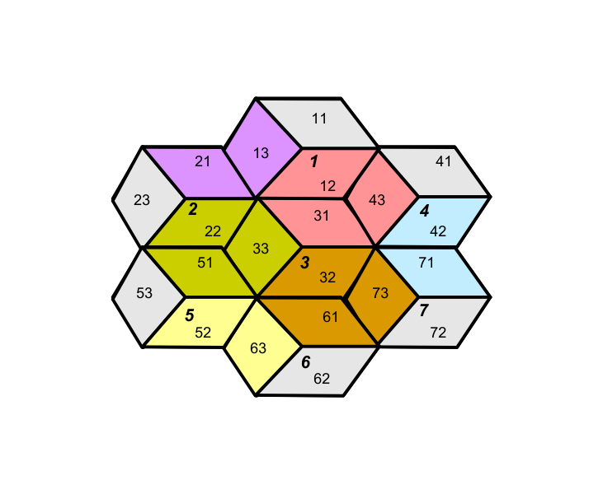
Figure X.X.1-1 – Overlap Detected In Sectors That Border Each Other

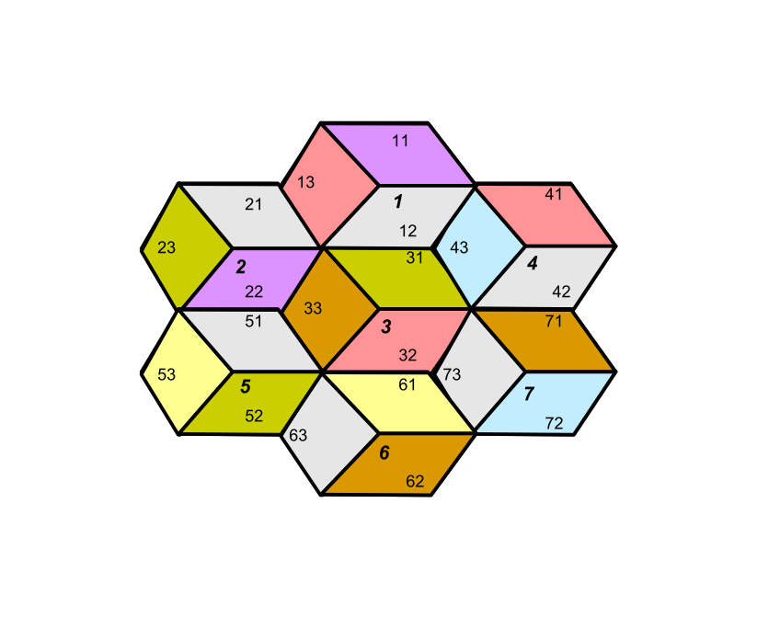
Figure X.X.1-2 – No Overlap After Counter-clockwise Shift

[-------------------------------------------------------------------End of Text Proposal-------------------------------------------------------------------]

References
[1] Kiernan, Brian, “Call for Comments and Contributions on Project 802.16m System Description Document (SDD)”, IEEE C80216m -08/024, June 2008.

[2] Hamiti, Shkumbin, “The Draft IEEE 802.16m System Description Document”, IEEE 80216m -08/003r3, June 2008.

[3] Cudak, Mark, “802.16m System Requirements”, IEEE 802.16m-07/002r4, October 2007.

[4] Cavalcanti, David, “Interference-Free Scheduling”, IEEE 802.22-08/0028r1, April 2008.

