Project | IEEE 802.16 Broadband Wireless Access Working Group <http://ieee802.org/16>
Title | RSSI/QoS-based Mobility Management
Date Submitted | 2008-07-xx
Source(s) | Ranga Reddy  US Army  Weihuang Fu, Jung Hyun Jun, Demin Wang, Xiaoyuan Wang, Dharma P. Agrawal  University of Cincinnati  Andrew DeCarlo, Jonathan Portny  Infoscitex Corporation | E-mail: Ranga.Reddy@us.army.mil  E-mail: dpa@ececs.uc.com  E-mail: jportny@infoscitex.com  *<http://standards.ieee.org/faqs/affiliationFAQ.html>
Re: | “Mobility Management” solicited in C80216m-08/024
Abstract | Enhancement of mobility management techniques using neighbor station link quality and QoS information.
Purpose | Discussion, review, and acceptance into IEEE P802.16m SDD
Notice | This document does not represent the agreed views of the IEEE 802.16 Working Group or any of its subgroups. It represents only the views of the participants listed in the “Source(s)” field above. It is offered as a basis for discussion. It is not binding on the contributor(s), who reserve(s) the right to add, amend or withdraw material contained herein.
Release | The contributor grants a free, irrevocable license to the IEEE to incorporate material contained in this contribution, and any modifications thereof, in the creation of an IEEE Standards publication; to copyright in the IEEE’s name any IEEE Standards publication even though it may include portions of this contribution; and at the IEEE’s sole discretion to permit others to reproduce in whole or in part the resulting IEEE Standards publication. The contributor also acknowledges and accepts that this contribution may be made public by IEEE 802.16.
Patent Policy | The contributor is familiar with the IEEE-SA Patent Policy and Procedures:  <http://standards.ieee.org/guides/bylaws/sect6-7.html#6> and <http://standards.ieee.org/guides/opman/sect6.html#6.3>.  Further information is located at <http://standards.ieee.org/board/pat/pat-material.html> and <http://standards.ieee.org/board/pat>.

RSSI/QoS-based Mobility Management
Ranga Reddy
US Army
Weihuang Fu, Jung Hyun Jun, Demin Wang, Xiaoyuan Wang, Dharma P. Agrawal
University of Cincinnati
Andrew DeCarlo, Jonathan Portny
Infoscitex Corporation

1. Introduction
For reliable service and seamless handover, it is critical to design efficient mobility handling scheme under dynamic network topology. There are a couple of issues to consider when developing solutions in this problem space: link quality and the level of QoS that can be supported. These issues are related to one another, and can be tackled independently, then combined as a cross optimization problem.

2. Proposal

2.1. RSSI-based Mobility Management

The novel mobility management solution is targeted for 802.16m-deployments that employ relay stations (RSs). The management scheme discussed can be supported by OFDMA frame structure design, a robust traffic forwarding scheme, and efficient mobility path management. In addition, we define information elements that are required to support seamless handover.

In order to sustain reasonable delay sensitivity, mobile MSs supported by BSs require the BSs to support efficient and light weighted mobility management. For example, if the MS is currently at location (xi, yi) (supported by BSa), BSa needs to see if the MS can still have a connected path to the destination by moving to its new location (xj, yj). Let BSb be the closest neighboring BS which the MS is attempting to handover to. Let RSSI_{x} be the minimum RSSI required to have a connection between BSx (being a or b) and MS, corresponding to a maximum distance d between them. At the same time, BSa determines the current distance d_{b-MS} between this neighbor and the MS by evaluating the current RSSI_{x} as reported by the MS or by exchanging their location information with the neighbor BS. Therefore, if the distance of BSa to the new location (x(j), y(j)) is less than d or d_{b-MS}, the BS can predict that it does have the destination connectivity at the new location. This process can be exercised when the neighbor station that the MS wants to handover to is an RS or MRS. If not, it needs to find another position from where it can have a connected path to the destination through some other neighbor stations (intra- and inter-cell).

When this approach is integrated with Neighbor information maintenance, the efficiency can be improved further. This is important when dealing with RSs. The basic idea behind this is that each BS/RS maintains 1-hop neighbor station information about their connectivity to destination (or IGW). If an RS needs to move outside the range of its connectivity to its current set of neighbor stations (or attached MSs need to handover), it checks whether its movement will disconnect some of its attached MSs from the destination or not. The BS will authorize handover for RS and the subset of attached MSs that can still maintain the connectivity to destination without it. Algorithm 1 can be used to execute this decision.

Algorithm 1: The CH Connectivity Algorithm
Input: (xCHi ; yCHi ), (xCHi+1; yCHi+1), Neighbor’ List
Output: 1 (Valid) or 0 (not Valid)
Create Neighbor’ List using (xCHi+1; yCHi+1);
if ((xCHi+1; xBS)²+(yCHi+1; yBS)²) < rc² then
if (IsGateway(CHi)) then
NotifyCH(CHi);
Return 1;
else
forall CH neigh in CHi’s Neighbor’ List do
path valid Ã Find BS((xCH(i); yCH(i));
(xCH(i+1); yCH(i+1));Neighbor0 List)
if path valid exists then
If (IsGateway(CHi)) then notify(CHi);
Return 1;
else
Return 0;

However, this algorithm does not sustain connectivity if more than two MSs/RSs are concurrently moving toward two independent locations. To solve this problem, we increase the size of each BSs/RSs neighbor list by including both single hop neighboring stations as well as the 2-hop neighbors. We have analytically proven for mesh networks [4] that including 2-hop neighbors in the neighbor list will double the chance of connectivity to destination. This lemma is also supported by our simulation result displayed in Figure 1. We believe that this methodology can be extended and applied to tree-based network topologies that involve stations (RS/MS) with varying degrees of mobility.

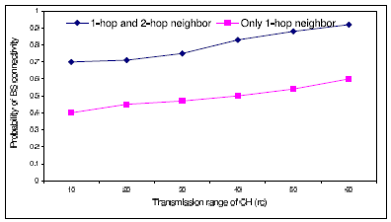
Figure 1: Mobility management and connectivity using analytical modeling

2.2 QoS-based Mobility Mangement
Depending on RSSI information, as described above, alone is not sufficient. As an alternative to the scheme discussed in Section 2.1, the goal is to maximize the quality of link for the edge with minimum link quality while maintaining the quality of service constraint for existing services, Q_{p,} for set of ongoing communication on path P. As the first step, we ignore the interference. Therefore, our objective function is approximately based on the received signal strength K/d_{e}^{2α}, where K is initial transmission power, d_{e} is distance from node i to j and a is the path loss factor. Then, we can formulate this as an optimization problem as follow:

Algorithm 2
Maximize min_{e=(i,j)∈(P|P⊂E)} K/d_{e}^{2α},
Subjected to q_{p} ≥ Q_{p}

Because the quality of service Q_{p} depends on the type of target application, we will not specify Q_{p} in this proposal. However, often delay and throughput are used as a measurement of QoS. For example, as shown as Figure 2, when MS3 enters into an area where there is overlap between coverage from BS1 and BS2, it connects to the M-RS with best link quality (M-RS1). However, its QoS could not be satisfied by associated link quality. So, BS1 contact near by M-RSs, including the ones belonging to other cells and compute the cost of handing over MS3 to one of them. BS1 then orders MS3 to handover to M-RS4, as the link quality and QoS would be higher .

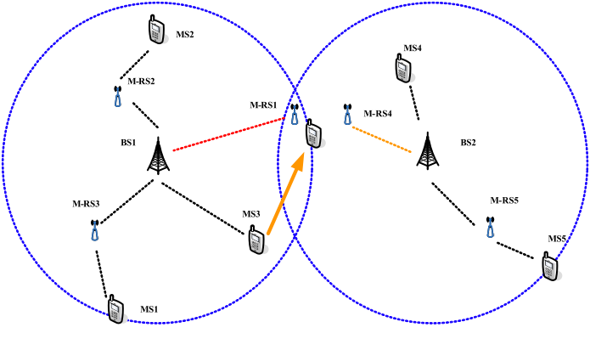
Figure 2: HO procedure

Here, we also propose a heuristic algorithm where BSs or M-RSs move towards the center of traffic when there are more than one MSs arriving in the cell, while maintaining the connectivity for existing communication. The center of traffic is defined as geographical location that is calculated as a weighted average traffic rate and location (x, y) of node i where traffic is originated from. This center of traffic can be calculated using Algorithm 3, where S is set of existing communication and f_{i} is the traffic rate from node i.

Algorithm 3
x_{center} = (∑_{i∈S}(|x_{o}-x_{i}|)f_{i})/ (∑_{i∈S}f_{i})
y_{center} = (∑_{i∈S}(|y_{o}-y _{i}|)f_{i})/ (∑_{i∈S}f_{i})

3. Text Proposal
[-------------------------------------------------Start of Text Proposal---------------------------------------------------]
[insert text in section 2 of proposal into SDD]
[-------------------------------------------------End of Text Proposal----------------------------------------------------]

References
[1] Kiernan, Brian, “Call for Comments and Contributions on Project 802.16m System Description Document (SDD)”, IEEE C80216m -08/024, June 2008.

[2] Hamiti, Shkumbin, “The Draft IEEE 802.16m System Description Document”, IEEE 80216m -08/003r3, June 2008.

[3] Cudak, Mark, “802.16m System Requirements”, IEEE 802.16m-07/002r4, October 2007.

[4] Banerjee, T. et all, “Enhancing the Lifetime of a Sensor Network with Mobile Clusterheads”, Vehicular Technology Conference, 2007 IEEE Volume 66, October 2007, pgs. 133-137.

