Project | IEEE 802.16 Broadband Wireless Access Working Group <http://ieee802.org/16>
Title | Upper MAC Addressing in IEEE 802.16m
Date Submitted | 2008-07-07
Source(s) | Jin Lei, Libra Xiao, Juejun Liu, Zhengzheng Li, Bamboos Lin, Sean McBeath  Huawei Technologies Co., Ltd. | jinlei60020191@huawei.com  smcbeath@huawei.com
Re: | IEEE 802.16m-08/021r2, “Issue Call for Contributions on following new subjects:  - Upper MAC (limited to addressing, mobility and power management)” – Contribution on P802.16m Upper MAC(addressing)
Abstract | This contribution is a high level proposal for upper MAC addressing in IEEE 802.16m
Purpose | For discussion and approval by TGm
Notice | This document does not represent the agreed views of the IEEE 802.16 Working Group or any of its subgroups. It represents only the views of the participants listed in the “Source(s)” field above. It is offered as a basis for discussion. It is not binding on the contributor(s), who reserve(s) the right to add, amend or withdraw material contained herein.
Release | The contributor grants a free, irrevocable license to the IEEE to incorporate material contained in this contribution, and any modifications thereof, in the creation of an IEEE Standards publication; to copyright in the IEEE’s name any IEEE Standards publication even though it may include portions of this contribution; and at the IEEE’s sole discretion to permit others to reproduce in whole or in part the resulting IEEE Standards publication. The contributor also acknowledges and accepts that this contribution may be made public by IEEE 802.16.
Patent Policy | The contributor is familiar with the IEEE-SA Patent Policy and Procedures:  <http://standards.ieee.org/guides/bylaws/sect6-7.html#6> and <http://standards.ieee.org/guides/opman/sect6.html#6.3>.  Further information is located at <http://standards.ieee.org/board/pat/pat-material.html> and <http://standards.ieee.org/board/pat>.

Upper MAC Addressing in IEEE 802.16m

Jin Lei, Libra Xiao, Juejun Liu, Zhengzheng Li, Bamboos Lin, Sean McBeath

Huawei

- Introduction
The topic of upper MAC addressing includes the connection addressing and the MAC message addressing. Connection addressing identifies the connection between a MS and a BS in 802.16m, while MAC message addressing normalizes the MAC PDU format for the MAC data and the MAC signaling message in 802.16m The MAC PDU format in 8021.6m should be different from that of MAC PDU in current 802.16e. These topics will be discussed in the following sections.

2．Discussion
2.1 Connection Addressing
In 802.16e, a connection is defined as a unidirectional mapping between BS and MS MAC layer peers. Two kinds of connections are defined: management connections (Basic, Primary and secondary) and transport connections. These connections are identified by a Connection Identifier (CID), which is used to identify separate MS/SS in a BS, and identify different MAC connections in a MS/SS.
When a BS assigns DL/UL physical resources to a MS using a 16 bit CID to identify a connection in the MS, the resource assignment overhead is high. Additionally, the MAC overhead is unnecessarily large, since the 16 bit CID is transmitted as part of the generic MAC header. On the other hand, when a MS is moving from one BS to another BS, i.e. handover, as per 802.16e, the CID may be changed. Such a scheme is not optimized, since it is unnecessary to change the connections in a MS, rather it is only necessary to change the connection used to identify a MS in a BS. This results in additional overhead.
Therefore, it is recommended that two types of connection ID are introduced in 802.16m. One type is used to identify a MS in a BS, which is referred to as the MAC ID (MAC Identity) and has a length of 12-16 bits (FFS). The other type is used to identify a connection in a MS with a length of 6-8 bits, which is referred to as the inner connection identifier (CID).
Because each service data flow from Convergence Sublayer (CS) layer has a QoS level, it is recommended that the inner connection identifier (CID) in a MS is divided into two parts, one part is called the QoS ID, which means the service data flow with the same QoS level can be multiplexed in one MAC PDU; The other is called the logical ID (LOG ID), where the LOG ID is identified as a service data flow multiplexed into a QoS ID. The QoS ID, which does not represent an actual QoS level such as a scheduling type in 802.16e, is negotiated by a BS and a MS dynamically. Therefore, one service data flow may be allocated to different QoS ID at different times.
Figure 1 is an example of inner connection identifier (CID) division (7 bits).
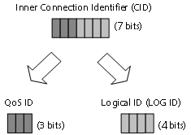
Figure 1 Example of inner connection identifier (CID) division
If the number of Logical connections multiplexed is larger than the maximum number of Logical connections in a QoS connection, another QoS connection is required, and it is identified by another QoS connection identity. Therefore, each QoS ID and each LOG ID is negotiated by a BS and a MS.
Figure 2 is an example of mapping between QoS ID and QoS level. In Figure 2, LOG ID 1 corresponding to service data flow 1 and LOG ID 2 corresponding to service data flow 2 belong to QoS level 1. QoS level 1 may be mapped to QoS ID 1 or QoS ID 2 based on negotiation between the BS and MS. Likewise, QoS level 2 including LOG ID 3 and LOG ID 4 may be mapped to QoS ID 1 or QoS ID 2 by negotiation.
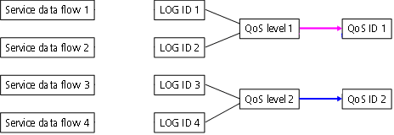
Figure 2 Example of mapping between QoS ID and QoS level
Taking into account the service properties (e.g. VoIP) identified in the service creation procedure (such as DSA message or DSC message), when a MS initiates a BWR (Bandwidth Request) to a BS, the bandwidth request is associated with a QoS connection identity, so the bandwidth request should only contain the QoS identity and should not contain the logical connection identify.

2.2 MAC Message Addressing
Referring to Figure 3, each MAC PDU begins with a fixed-length MAC header. The header may be followed by the Payload of the MAC PDU. The Payload consists of zero or more subheaders and one or more MAC SDUs and/or fragments thereof. The payload information may vary in length, so that a MAC PDU may represent a variable number of bytes, but 2¹¹ bytes at most. This allows the MAC to tunnel various higher layer traffic types without knowledge of the formats or bit patterns of those messages.
A MAC PDU should not contain a CRC because implementation of CRC capability is mandatory in physical layer. All reserved fields shall be set to zero on transmission and ignored on reception.

Figure 3 MAC PDU format

As shown in Figure 4, the generic MAC header in 802.16e is 48 bits. The design of this header considers MAC management messages, data services and other signaling. It not efficient in terms of MAC overhead for the MAC header to contain Subheader types, 16-bit CID and HCS, so we propose a new generic MAC header design for 802.16m.
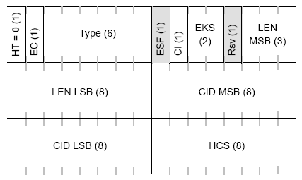
Figure 4 Generic MAC header format

Considering the support of MAC signaling and management message, it is recommended that the MAC header should include the service MAC header and the signaling MAC header which are used for data service flows and signaling separately. According to connection addressing and multiplexing, the data service MAC headers with multiplexing and without multiplexing are shown in Figure 5 and Figure 6, respectively. Each header begins with the HT field, where the value of 0 denotes the 802.16m Generic MAC header which is applied for data service only. If the value of the Ind field is 1, it denotes that this MAC PDU contains inner connection identifier (CID). If the value of the Ind field is 0, it denotes that this MAC PDU does not contain an inner connection identifier (CID).
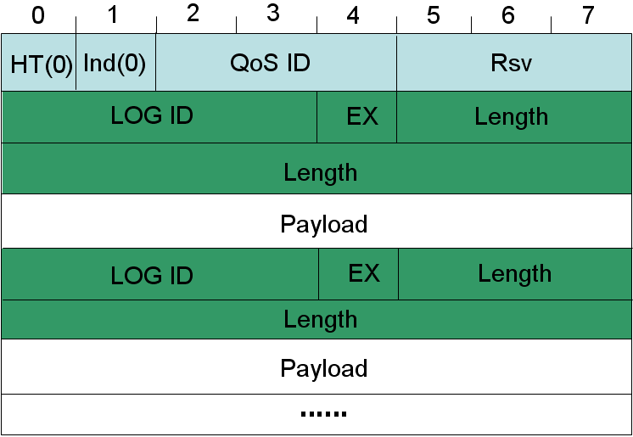
Figure 5 802.16m Generic MAC header format (with inner connection identifier)

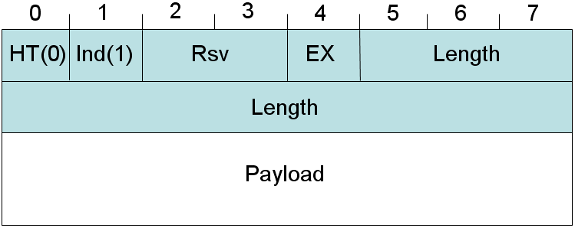
Figure 6 802.16m Generic MAC header format (without inner connection identifier)

The fields of the generic MAC header are defined in Table 1. Every header is encoded, starting with the HT field.

Table 1 802.16m Generic MAC header fields
Field | Length(bit) | Description
HT | 1 | Header type which is used to identify service MAC header or Signaling MAC header. Shall be set to zero.  0 = Generic MAC header for Data service  1 = Signaling MAC header
Ind | 1 | CID Indication, which is used to indicate whether the MAC PDU contains inner connection identifier (CID) (inner connection identifier = QoS ID + LOG ID).  0 = Contains inner connection identifier (CID)  1 = Does not contain inner connection identifier (CID)
QoS ID | 4 | QoS connection identity, several service data flows multiplexed have the same QoS level in a MS. This QoS ID, which does not represent an actual QoS level such as a scheduling type in 802.16e, is negotiated by the BS and MS dynamically.
LOG ID | 3 | Service Data Flow identity multiplexed into a QoS connection
Rsv | 2 or 3 | Reserved field. Shall be set to zero.  2 bits if Ind =1  3 bits if Ind=0
EX | 1 | Extended Subheader indication. If EX = 0, the extended subheader is absent. If EX = 1, the extended subheader is present and will follow the 802.16m generic MAC header immediately.  Note: extended subheader format is FFS.
Length | 11 | Length indication. The length in bytes of the Logical connection not including the MAC header.

Encryption key sequence (EKS) is the index of the traffic encryption key (TEK) and initialization vector (IV) used to encrypt the payload. EKS is only meaningful if the payload is encrypted, so it is placed in the payload. On the other hand, taking into account negotiation about the encryption of the service data flow between the BS and MS for each Logical connection, encryption control (EC) should not be included in the MAC header because whether to encrypt the payload is already known by the BS and MS.
According to connection addressing, the signaling MAC header format is shown in Figure 7, it also starts with the HT field, where the value of the 1 denotes the 802.16m Signaling MAC header which is applied for MAC management messages and MAC or upper layer signaling header.
Figure 7 802.16m Signaling MAC header format
The fields of the Signaling MAC header are defined in Table 2. Every header is encoded, starting with the HT fields.
Table 2 802.16m Signaling MAC header fields
Name | Length(bit) | Description
HT | 1 | Header type which is used to identify service MAC header or Signaling MAC header. Shall be set to1.  0 = Generic MAC header for Data service  1 = Signaling MAC header
Type | 7 | This field indicates the type of signaling present in the message payload.

- Conclusion
From the discussion above, MAC ID and inner CID are introduced. MAC ID identifies MS in one BS, and inner CID identifies connection in one MS. And a new MAC header structure is proposed.

- Text Changes
[note to the editor: Make the following changes to IEEE P802.16Rev2/D5 as shown below;
Blue = insertions
Red = deletions
]
------------------------------------------------------------Start of the Text------------------------------------------------------
[Modify the following text after line#7, page# 19 of TGm SDD]
Connection Management block allocates MAC ID in Ranging procedure and inner connection identifiers (CIDs) during initialization/handover/ service flow creation procedures. Connection Management block interacts with convergence sublayer to classify MAC Service Data Unit (MSDU) from upper layer, and maps MSDU onto a particular transport connection.
-------------------------------------------------------------End of the Text----------------------------------------------------

------------------------------------------------------------Start of the Text------------------------------------------------------
[Modify the following text after line#13, page# 20 of TGm SDD]
MAC PDU formation block constructs MAC protocol data unit (PDU) so that BS/MS can transmit user traffic or management messages into PHY channel. MAC PDU formation block may add sub-headers or extended sub- headers. MAC PDU formation block may also add MAC CRC if necessary, and add generic MAC header.

MAC PDU formation block constructs MAC protocol data unit (PDU) so that BS/MS can transmit user traffic or management messages into PHY channel. MAC PDU formation block may add sub-headers or extended sub headers. MAC PDU formation block may add 802.16m generic MAC header and should not also add MAC CRC. if necessary, and add generic MAC header. Figure A and Figure B show the 802.16m generic MAC header format, and Figure C shows signaling MAC header format. If the value of the HT field is 0, it denotes an 802.16m Generic MAC header which is applied for data service only. If the value of the HT field is 1, it denotes a 802.16m Signaling MAC header which is applied for MAC management messages and MAC or upper layer signaling header. MAC PDUs are multiplexed by packets with the same QoS ID.

Figure A 802.16m Generic MAC header format (with inner connection identifier)
Figure B 802.16m Generic MAC header format (without inner connection identifier)

The fields of the 802.16m generic MAC header are defined in Table A. The 802.16m Generic MAC header shall begin with the HT field.

Table A 802.16m Generic MAC header fields
Field | Length(bit) | Description
HT | 1 | Header type which is used to identify service MAC header or Signaling MAC header. Shall be set to zero.  0 = Generic MAC header for Data service  1 = Signaling MAC header
Ind | 1 | CID Indication, which is used to indicate whether the MAC PDU contains inner connection identifier (CID) (inner connection identifier = QoS ID + LOG ID).  0 = Contains inner connection identifier (CID)  1 = Does not contain inner connection identifier (CID)
QoS ID | 4 | QoS connection identity, several service data flows multiplexed have the same QoS level in a MS. This QoS ID, which does not represent an actual QoS level such as a scheduling type in 802.16e, is negotiated by a BS and a MS dynamically.
LOG ID | 3 | Service Data Flow identity multiplexed in a QoS connection in a MS.
Rsv | 2 or 3 | Reserved field. Shall be set to zero.  2 bits if Ind =1  3 bits if Ind=0
EX | 1 | Extended Subheader indication. If EX = 0, the extended subheader is absent. If EX = 1, the extended subheader is present and will follow the generic MAC header immediately.  Note: extended subheader format is FFS.
Length | 11 | Length indication. The length in bytes of the Logical connection not including the MAC header.

Figure C 802.16m Signaling MAC header format

The fields of the 802.16m Signaling MAC header are defined in Table B. The 802.16m Signaling MAC header shall begin with the HT filed.
Table B 802.16m Signaling MAC header fields
Name | Length(bit) | Description
HT | 1 | Header type which is used to identify service MAC header or Signaling MAC header. Shall be set to 1.  0 = Generic MAC header for Data service  1 = Signaling MAC header
Type | 7 | This field indicates the type of signaling present in the message payload.

-------------------------------------------------------------End of the Text----------------------------------------------------

