Project | IEEE 802.16 Broadband Wireless Access Working Group <http://ieee802.org/16>
Title | Interleaving Rearrangement for 16m
Date Submitted | 2008-07-07
Source(s) | Rongdao Yu, Yinwei Zhao, Chongli Liu  Huawei | Voice: 86-755-28970182  E-mail:liuchongli@huawei.com
Re: | IEEE 802.16m-08/024 - Call for Contributions on Project 802.16m System Description Document (SDD), for “Hybrid ARQ” topic.
Abstract | The contribution proposed an enhanced interleaving rearrangement scheme for 16m system.
Purpose | For discussion and approval by TGm
Notice | This document does not represent the agreed views of the IEEE 802.16 Working Group or any of its subgroups. It represents only the views of the participants listed in the “Source(s)” field above. It is offered as a basis for discussion. It is not binding on the contributor(s), who reserve(s) the right to add, amend or withdraw material contained herein.
Release | The contributor grants a free, irrevocable license to the IEEE to incorporate material contained in this contribution, and any modifications thereof, in the creation of an IEEE Standards publication; to copyright in the IEEE’s name any IEEE Standards publication even though it may include portions of this contribution; and at the IEEE’s sole discretion to permit others to reproduce in whole or in part the resulting IEEE Standards publication. The contributor also acknowledges and accepts that this contribution may be made public by IEEE 802.16.
Patent Policy | The contributor is familiar with the IEEE-SA Patent Policy and Procedures:  <http://standards.ieee.org/guides/bylaws/sect6-7.html#6> and <http://standards.ieee.org/guides/opman/sect6.html#6.3>.  Further information is located at <http://standards.ieee.org/board/pat/pat-material.html> and <http://standards.ieee.org/board/pat>.
Interleaving Rearrangement for 16m System
Rongdao Yu, Yinwei Zhao, Chongli Liu
Huawei

Introduction
In higher order modulation scheme, e.g. 16QAM or 64QAM, bits in a constellation symbol may have different transmission power and reliability. Take 16QAM as an example. As shown in figure 1, bits b1 and b3 are more reliable than bits b0 and b2.

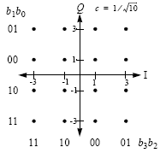
Figure 1 Constellation of 16QAM

Proposal
Bits in higher modulation order may have different reliability. If high reliability bits and low reliability bits exchange their positions in HARQ retransmission, the performance will be improved by averaging the bits reliability. This position exchange operation can be done by interleaving rearrangement.

The interleaving rearrangement scheme is designed as following .The interleaver is defined by a two-step permutation. The first permutation ensures that adjacent coded bits are mapped onto nonadjacent subcarriers .The second permutation insures that adjacent coded bits are mapped alternately onto less or more significant bits of the constellation in HARQ transmission, thus avoiding long runs of lowly reliable bits.

The first permutation is defined by (1).
(1)
The second permutation is defined by (2).
(2)

N_{cbps} is the number of coded bits per encoded block size.
N_{cpc} is the number of coded bits per symbol, i.e., 2, 4, 6 for QPSK, 16QAM, 64QAM respectively .Let s =N_{cpc}/2. And n represents the index of HARQ transmission. For example n =0 for the initial HARQ transmission, n =1 for the first retransmission.

Simulation
Simulation Parameters:
Table 1 Simulation Parameters
Simulation parameters | 16QAM | 64QAM
Number of Transmission | 2 | 2
FFT Size | 512 | 512
CP Ratio | 1/8 | 1/8
Code Type | CC | CC
Code Rate | 1/2 | 1/2
Number of slot in one FEC block | 1 | 1
Nep | 96bits | 144Bits
Subcarrier allocation | PUSC | PUSC
Channel Condition | PB3/VA30 | PB3/VA30

Simulation Results:
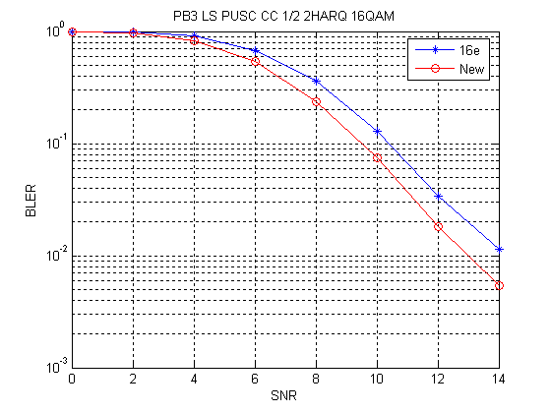

Figure 2 BLER for PB3 16QAM

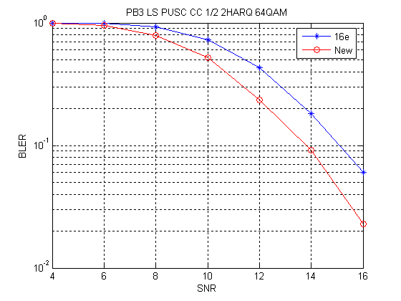

Figure 3 BLER for PB3 64QAM

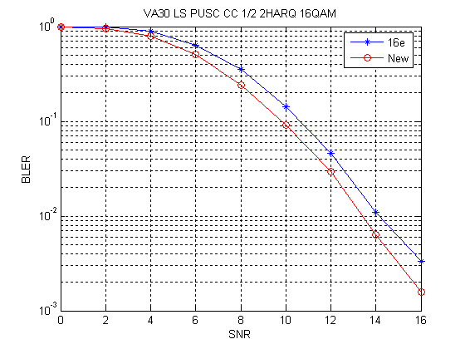
Figure 4 BLER for VA30 16QAM

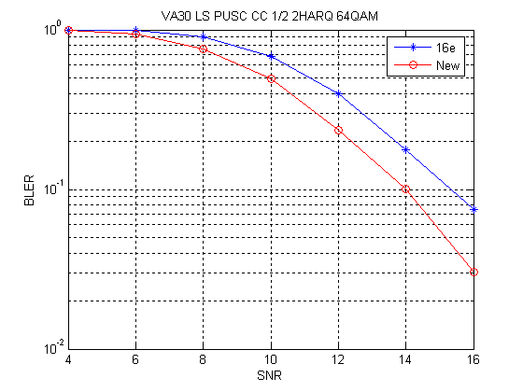
Figure 5 BLER for VA30 64QAM
From above simulation results, we can conclude that the proposed interleaving rearrangement scheme has over 1dB gain than the 802.16e interleaving scheme.

Conclusion
The interleaving rearrangement scheme is proposed in the contribution, which has over 1 dB performance gain than the 802.16e interleaving scheme.

Text Proposal to SDD

------------------------------------Start text proposal------------------------------------
[Adopt the following text in the P802.16m System Description Document (SDD)]

11. x HARQ
11.x.x Interleaver
The interleaver is defined by a two-step permutation. The first permutation ensures that adjacent coded bits are mapped onto nonadjacent subcarriers .The second permutation insures that adjacent coded bits are mapped alternately onto less or more significant bits of the constellation in HARQ transmission, thus avoiding long runs of lowly reliable bits.

The first permutation is defined by (1).
(1)
The second permutation is defined by (2).
(2)

N_{cbps} is the number of coded bits per encoded block size.
N_{cpc} is the number of coded bits per symbol, i.e., 2, 4, or 6 for QPSK, 16QAM, 64QAM respectively .Let s =N_{cpc}/2. And n represents the index of HARQ transmission. For example n =0 for the initial HARQ transmission, n =1 for the first retransmission.
------------------------------------End text proposal------------------------------------

