Project | IEEE 802.16 Broadband Wireless Access Working Group <http://ieee802.org/16>
Title | A Rate Matching Scheme for CTC
Date Submitted | 2008-07-07
Source(s) | Rongdao Yu, Qitao Song, Chongli Liu  Huawei | Voice: 86-755-28970182  E-mail: liuchongli@huawei.com
Re: | IEEE 802.16m-08/024 “Call for Contributions on Project 802.16m System Description Document (SDD)”  Target topic: “Hybrid ARQ”
Abstract | This document proposes a new rate matching scheme to improve the CTC performance.
Purpose | For discussion and approval by TGm.
Notice | This document does not represent the agreed views of the IEEE 802.16 Working Group or any of its subgroups. It represents only the views of the participants listed in the “Source(s)” field above. It is offered as a basis for discussion. It is not binding on the contributor(s), who reserve(s) the right to add, amend or withdraw material contained herein.
Release | The contributor grants a free, irrevocable license to the IEEE to incorporate material contained in this contribution, and any modifications thereof, in the creation of an IEEE Standards publication; to copyright in the IEEE’s name any IEEE Standards publication even though it may include portions of this contribution; and at the IEEE’s sole discretion to permit others to reproduce in whole or in part the resulting IEEE Standards publication. The contributor also acknowledges and accepts that this contribution may be made public by IEEE 802.16.
Patent Policy | The contributor is familiar with the IEEE-SA Patent Policy and Procedures:  <http://standards.ieee.org/guides/bylaws/sect6-7.html#6> and <http://standards.ieee.org/guides/opman/sect6.html#6.3>.  Further information is located at <http://standards.ieee.org/board/pat/pat-material.html> and <http://standards.ieee.org/board/pat>.
A Rate Matching Scheme for CTC
Rongdao Yu, Qitao Song, Chongli Liu
Huawei

Introduction
CTC is an optional FEC encoder in 802.16e. Both CC (Chase Combining) and IR (Incremental Redundancy) HARQ are supported in CTC encoding. The basic coding rate of CTC encoder is 1/3, and other coding rates (i.e. 1/2、2/3etc.) can be generated by rate matching.
In 802.16e, the channel interleaver isn’t used when the FEC encoder is CTC encoder, because CTC encoder has included a sub-block interleaver. However, the performance of sub-block interleaver is worse than the channel interleaver because that channel interleaver has conditional constellation rearrangement effort but sub-block interleaver doesn’t.
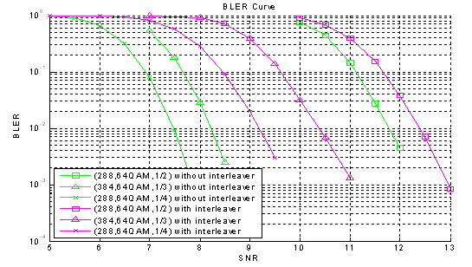
Figure 1 CTC performance w/ and w/o interleaver
As shown in figure 1, “(288, 64QAM, 1/2)” means that Nep = 288, modulation scheme = 64QAM, coding rate = 1/2, and so on and so forth. The simulation channel is over AWGN. Theoretically, the performance with sub-block interleaver should be similar with the performance without sub-block interleaver in AWGN. However, the simulation shows that the real performance of CTC with sub-block interleaver is worse than the performance without sub-block interleaver. The sub-block interleaver should be re-designed for potential performance improvement.
We propose a new rate matching scheme of CTC encoder to improve the CTC performance.

Proposal
The structure of proposed rate matching scheme of CTC encoder is showed in figure 2.
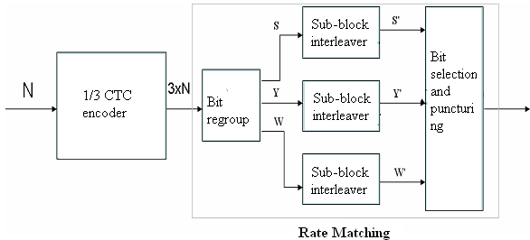
Figure 2 the structure of proposed rate matching scheme
As shown in figure 2, the proposed rate matching scheme comprises bit regroup, three sub-block interleaver and bit selection/puncturing. The 1/3 CTC encoder output bits are distributed into three sub-blocks after bit regroup operation. Each sub-block is interleaved by its own interleaver. With the input of the three interleaved sub-blocks, bit selection and puncturing are performed.
The block diagram of bit regroup is showed in figure 3.
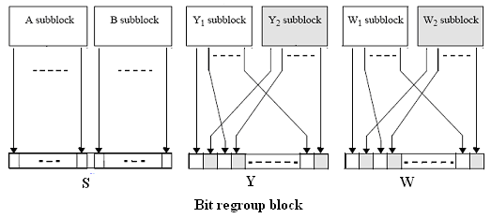
Figure 3 the block diagram of bit regroup
As shown in figure 3, all of the encoded bits shall be sequentially separated into six sub-blocks denoted A, B, Y1, Y2, W1, and W2 just like 16e does. And then the six sub-blocks are multiplexed to three sub-blocks denoted S, Y, W. Sub-block S consist of sub-block A and B which are block-wise multiplexed. Sub-block Y is a bit-by-bit multiplexed sequence of Y1 and Y2 sub-block sequences. Sub-block W is a bit-by-bit multiplexed sequence of W1 and W2 sub-block sequences.
The sub-block interleaver of proposed rate matching scheme is defined by a two-step permutation. The first ensures that adjacent coded bits are mapped onto nonadjacent sub-carriers. The second permutation insures that adjacent coded bits are mapped alternately onto less or more significant bits of the constellation, thus avoiding long runs of lowly reliable bits. Herein, we take the 16e’s channel interleaver (802.16e-2005 8.4.9.3) as example.
The algorithm of bit selection and puncturing is the same as the 16e’s.

Simulation
Link-level simulation parameters are listed in Table 1 .
Table 1 Simulation parameters
FFT Size | 1024
CP Ratio | 1/8
Code Type | CTC encoder
Code Rate | 1/2
Modulation | 64QAM
Channel estimation | Linear interpolation value
Channel model | AWGN、VA30
Receiver | L-MMSE
In this simulation, performance comparison between proposed and 16e rate matching scheme are made and the simulation result is presented in figure 4.
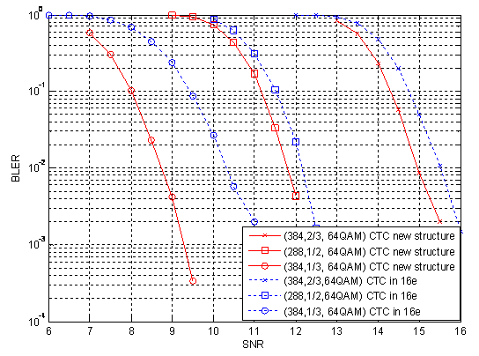
Figure 4 simulation results(via AWGN channel)
“(384, 2/3, 64QAM)” means that Nep(encoding block size) = 384, coding rate = 2/3, modulation scheme = 64QAM, etc. “CTC new structure” means the proposed rate matching scheme, and “CTC in 16e” means the 16e’s rate matching scheme. As shown in the simulation results, the performance of proposed rate matching scheme is much better than the performance of 16e’s rate matching scheme. The gain at (384, 1/3, 64QAM) with target BLER = 0.01 is 2dB more or less.
The simulation result via fading channel is also presented herein in figure 5. “CTC(proposal)” means the proposed rate matching scheme, and “CTC(in 16e)” means the 16e’s rate matching scheme. The fading channel is VA30. As shown in the figure 5, the gain at (288,1/2,64QAM) with target BLER = 0.01 is 1dB more or less.
Figure 5 simulation results(via fading channel)

Based on the simulation results, we can conclude that the performance of proposed rate matching scheme is much better than the 16e’s rate matching scheme.

Conclusion
We proposed a new rate matching scheme for CTC encoder in 16m.

Text Proposal to SDD

------------------------------------Start text proposal------------------------------------
[Adopt the following text in the ToC of P802.16m System Description Document (SDD)]

11. x HARQ
The structure of CTC encoder is showed in figure xx.
Figure xx the structure of proposed rate matching scheme
As shown in figure xx, the rate matching scheme comprises bit regroup, three sub-block interleaver and bit selection/puncturing. The 1/3 CTC encoder output bits are distributed into three sub-blocks after bit regroup operation. Each sub-block is interleaved by its own interleaver. With the input of the three interleaved sub-blocks, bit selection and puncturing are performed.
The block diagram of bit regroup is showed in figure xx.
Figure xx the block diagram of bit regroup
As shown in figure xx, all of the encoded bits shall be sequentially separated into six sub-blocks denoted A, B, Y1, Y2, W1, and W2 just like 16e does. And then the six sub-blocks are multiplexed to three sub-blocks denoted S, Y, W. Sub-block S consist of sub-block A and B which are block-wise multiplexed. Sub-block Y is a bit-by-bit multiplexed sequence of Y1 and Y2 sub-block sequences. Sub-block W is a bit-by-bit multiplexed sequence of W1 and W2 sub-block sequences.
The sub-block interleaver of proposed rate matching scheme is defined by a two-step permutation. The first ensures that adjacent coded bits are mapped onto nonadjacent sub-carriers. The second permutation insures that adjacent coded bits are mapped alternately onto less or more significant bits of the constellation, thus avoiding long runs of lowly reliable bits.
------------------------------------End text proposal------------------------------------

