Project | IEEE 802.16 Broadband Wireless Access Working Group <http://ieee802.org/16>
Title | An Implementation-Friendly Multiple OFDMA Numerologies for IEEE 802.16m
Date Submitted | 7-7-2008
Source(s) | Sassan Ahmadi  Yang-Seok Choi  Intel Corporation | sassan.ahmadi@intel.com  yang-seok.choi@intel.com  *<http://standards.ieee.org/faqs/affiliationFAQ.html>
Re: | Call for contributions on IEEE 802.16m System Description Document  Revised IEEE 802.16m SRD clause 5.4 and IEEE 802.16m SDD section 7 (frequency bands), Frame Structure and OFDMA Numerology
Abstract | This contribution proposes an implementation-friendly multiple OFDMA numerology that scales the current design principles for IEEE 802.16m symbol structure. This contribution proposes text for sections 7 and 11.3 of IEEE 802.16m system description document.
Purpose | To be discussed and adopted by TGm for incorporation in the IEEE 802.16m
Notice | This document does not represent the agreed views of the IEEE 802.16 Working Group or any of its subgroups. It represents only the views of the participants listed in the “Source(s)” field above. It is offered as a basis for discussion. It is not binding on the contributor(s), who reserve(s) the right to add, amend or withdraw material contained herein.
Release | The contributor grants a free, irrevocable license to the IEEE to incorporate material contained in this contribution, and any modifications thereof, in the creation of an IEEE Standards publication; to copyright in the IEEE’s name any IEEE Standards publication even though it may include portions of this contribution; and at the IEEE’s sole discretion to permit others to reproduce in whole or in part the resulting IEEE Standards publication. The contributor also acknowledges and accepts that this contribution may be made public by IEEE 802.16.
Patent Policy | The contributor is familiar with the IEEE-SA Patent Policy and Procedures:  <http://standards.ieee.org/guides/bylaws/sect6-7.html#6> and <http://standards.ieee.org/guides/opman/sect6.html#6.3>.  Further information is located at <http://standards.ieee.org/board/pat/pat-material.html> and <http://standards.ieee.org/board/pat>.

An Implementation-Friendly Multiple OFDMA Numerologies for IEEE 802.16m

Sassan Ahmadi and Yang-seok Choi
Intel Corporation

Introduction and Background
The IEEE 802.16m systems are required to be capable of operation in a wide range of frequency bands identified for identified for the IMT systems. The following frequency bands have been identified for IMT and/or IMT-2000 by WARC-92, WRC-2000 and WRC-07:
- 450-470 MHz
- 698-960 MHz
- 1710-2025 MHz
- 2110-2200 MHz
- 2300-2400 MHz
- 2500-2690 MHz
- 3400-3600 MHz

ITU-R has developed frequency arrangements for the bands identified by WARC-92 and WRC-2000, which are described in Recommendation ITU-R M.1036-3.

It can be shown that one set of OFDMA parameters may not be suitable for operation in such a wide range of frequency bands. On the other hand, the use of different set of OFDMA parameters may result in more complexity of the standard specification as well as implementations. Examples include 1) the system operation in indoor environments such as femto-cells, where the amount of delay spread is relatively less than outdoor environments such as micro and macro cells, requires shorter cyclic prefix and symbol length, 2) there is a need for suitable OFDMA parameters for large delay spread channels that are of interest for multicast broadcast services, and 3) another usage model includes support of high mobility users; e.g., moving on high speed train, where larger sub-carrier spacing or alternatively shorter symbol length is required.

This contribution proposes an implementation-friendly set of OFDMA parameters based on the default numerology. The proposal allows frame-level, sub-frame-level, symbol-level timing alignment between frame structures using the proposed set of OFDMA parameters and the default frame structure.

It must be noted that this contribution does not propose simultaneous operation of IEEE system with different OFDMA parameters or change of these parameters from frame to frame. The appropriate set of parameters are selected upon deployment of the system and based on the propagation characteristics of the radio channel.

Proposal

The IEEE 802.16m systems may be deployed using one of the following OFDMA parameter sets (default, large delay spread channels, and large Doppler spread channels) shown in Table 1 depending on the propagation characteristics of the radio channel and the frequency of the RF carrier. For example, for a deployment at 700 MHz, due to large delay spread effects, a larger cyclic prefix (CP) compared to default value is desired.

The OFDMA parameters for large delay spread scenarios are derived by multiplying the CP size and useful symbol duration by 2 whereas the OFDMA parameters for large Doppler spread scenarios are derived by dividing the symbol duration by 2. It is understood that division or multiplication by 2 scales the OFDMA symbol length by a factor of 2 without affecting the timing alignment of frame/sub-frames/symbols corresponding to these parameters (as shown in Figures 1 and 2)
Table 1: Multiple OFDMA numerology for different deployment scenarios based on the default OFDMA numerology
Parameter | Large Delay Spread Channels | Default Numerology | Large Doppler Spread Channels
Transmission Bandwidth (MHz) | 5,10,20 | 5,10,20 | 5,10,20
Sampling Frequency (MHz) | 28/25*BW | 28/25*BW | 28/25*BW
FFT Size | 512,1024,2048 | 512,1024,2048 | 512,1024,2048
Sub-Carrier Spacing (kHz) | f_{s}/2= 5.47 | f_{s}= 10.94 | f_{s}*2= 21.88
OFDM Useful Symbol Duration Tu (us) | 182.86 | 91.43 | 45.71
Cyclic Prefix CP (us) | 1/8*Tu= 22.84 | 1/8*Tu= 11.42 | 1/8*Tu= 5.71
OFDM Symbol Duration (us) | 205.70 | 102.85 | 51.42
Frame Size (ms) | 5 | 5 | 5
Sub-Frame Size in Number of OFDM Symbols (TTI) | 3 | 6 | 12
Super-Frame Size (ms) | 20 | 20 | 20
Number of OFDM Symbols per Frame | 24 | 48 | 96
Idle Time (ms) | 0.0632 | 0.0632 | 0.0632

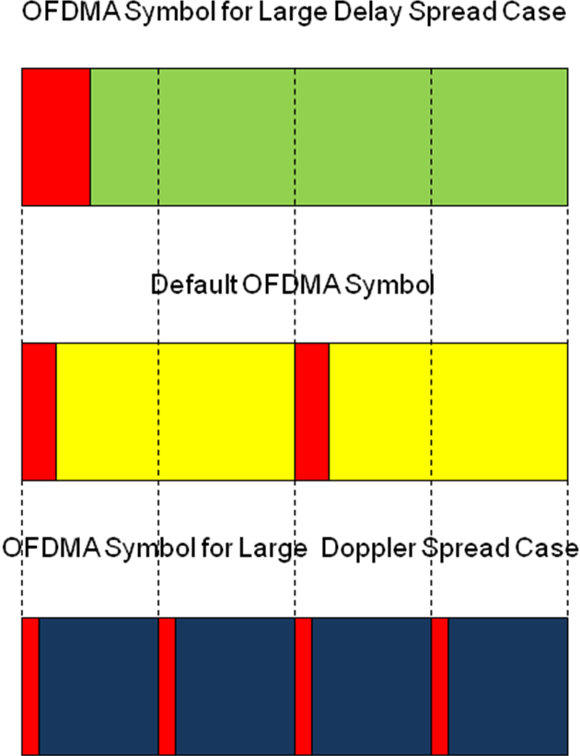
Figure 1: Illustration of the concept and relative timing relationship of different OFDMA symbols

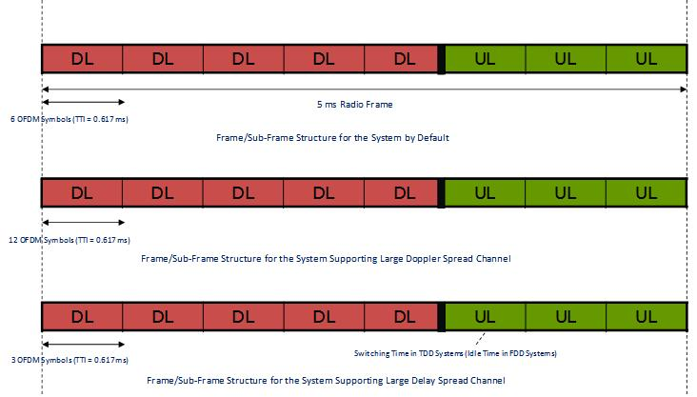
Figure 2: Timing and Frame Structure for two switching points in TDD mode

Recommendation
Recognizing the need for defining suitable OFDMA numerologies for different deployment scenarios and services, this proposal provides an implementation-friendly OFDMA parameter set applicable to large delay spread or large Doppler spread channels without affecting the timing alignment of the corresponding frame structures and associated symbol structures.

Proposed Text for SDD (to be added to Section 7 of IEEE 80216m-08/003r2)

----------------Start of the proposed text------------------------------

IEEE 802.16m systems can operate in RF frequencies less than 6 GHz and are deployable in licensed spectrum allocated to the mobile and fixed broadband services. The following frequency bands have been identified for IMT and/or IMT-2000 by WARC-92, WRC-2000 and WRC-07
- 450-470 MHz
- 698-960 MHz
- 1710-2025 MHz
- 2110-2200 MHz
- 2300-2400 MHz
- 2500-2690 MHz
- 3400-3600 MHz

ITU-R has developed frequency arrangements for the bands identified by WARC-92 and WRC-2000, which are described in Recommendation ITU-R M.1036-3. For the frequency bands that were identified at WRC-07, further work on the frequency arrangements is ongoing within the framework of ITU-R.

Depending on the characteristics of the radio channel in the above frequency bands (e.g., large delay spread or large Doppler spread), an appropriate set of OFDMA parameters are used for deployment of the IEEE 802.16m system. Those OFDMA parameters are specified in section 11.3.

----------------End of the proposed text------------------------------

Proposed Text for SDD (to be added to Section 11.3 of IEEE 80216m-08/003r2)

----------------Start of the proposed text------------------------------

Insert the content of section 2 of this document immediately after table 1 in section 11.3.

----------------End of the proposed text------------------------------

