Project | IEEE 802.16 Broadband Wireless Access Working Group <http://ieee802.org/16>
Title | Results on Downlink Pilot Structures
Date Submitted | 2008-7-7
Source(s) | Havish Koorapaty, Jiann-Ching Guey  Ericsson Inc.  8001 Development Drive, P.O. Box 13969  RTP, NC 27709 | E-mail: Havish.Koorapaty@ericsson.com
Re: | IEEE 802.16m-08/024
Abstract | Results for downlink pilot structure are presented.
Purpose | Adopt proposed pilot structure.
Notice | This document does not represent the agreed views of the IEEE 802.16 Working Group or any of its subgroups. It represents only the views of the participants listed in the “Source(s)” field above. It is offered as a basis for discussion. It is not binding on the contributor(s), who reserve(s) the right to add, amend or withdraw material contained herein.
Release | The contributor grants a free, irrevocable license to the IEEE to incorporate material contained in this contribution, and any modifications thereof, in the creation of an IEEE Standards publication; to copyright in the IEEE’s name any IEEE Standards publication even though it may include portions of this contribution; and at the IEEE’s sole discretion to permit others to reproduce in whole or in part the resulting IEEE Standards publication. The contributor also acknowledges and accepts that this contribution may be made public by IEEE 802.16.
Patent Policy | The contributor is familiar with the IEEE-SA Patent Policy and Procedures:  <http://standards.ieee.org/guides/bylaws/sect6-7.html#6> and <http://standards.ieee.org/guides/opman/sect6.html#6.3>.  Further information is located at <http://standards.ieee.org/board/pat/pat-material.html> and <http://standards.ieee.org/board/pat>.

Results for Downlink Pilot Structures
Havish Koorapaty, Jiann-Ching Guey
Ericsson AB

Introduction
This contribution presents some simulation results for downlink pilot structures. Link simulations are used to assess channel estimation performance of some of the various pilot patterns that have been proposed and the effect of channel estimation performance on link performance. A single transmit and receive antenna is used to transmit information over one block of 18 subcarriers by 6 symbols. Six symbols in the block are used to transmit pilots for each of the pilot patterns considered. The pilot patterns vary in the locations chosen for the pilots. A turbo encoder is used. Channel estimation is performed using an MMSE estimator with knowledge of the covariance matrix of the channel and the noise.
Based on the results a recommendation is given to adopt the pilot structure given in [3], previously described also in [1] and [2].

Simulation Results
Link simulation results for some cases are presented in this section.

Noise Limited Environment
Figure 1 shows simulation results with QPSK modulation, rate-1/2 coding on a Vehicular A channel at 120 kmph. The impairment is assumed to be AWGN. The block error rate is plotted against the signal-to-noise ratio. Results are shown for some of the proposed pilot patterns that have an overhead of 6 symbols over the 18x6 resource block. It can be seen that the differences between the different patterns are quite small.

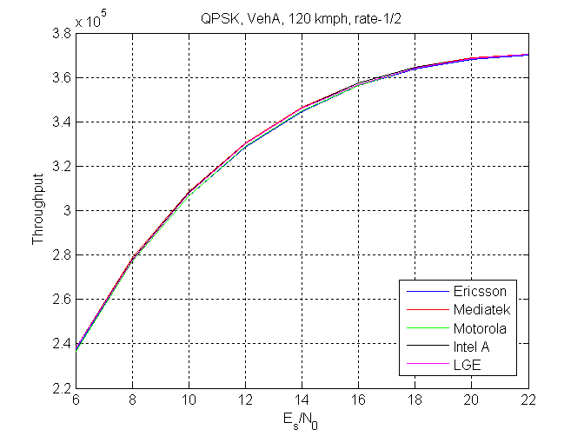
Figure 1: Link simulation with QPSK rate-1/2 in Veh. A channel at 120 kmph

Figure 2 shows the results with the same conditions but with 16-QAM modulation. Here the differences increase to approximately 0.6 dB at some points of the curve.
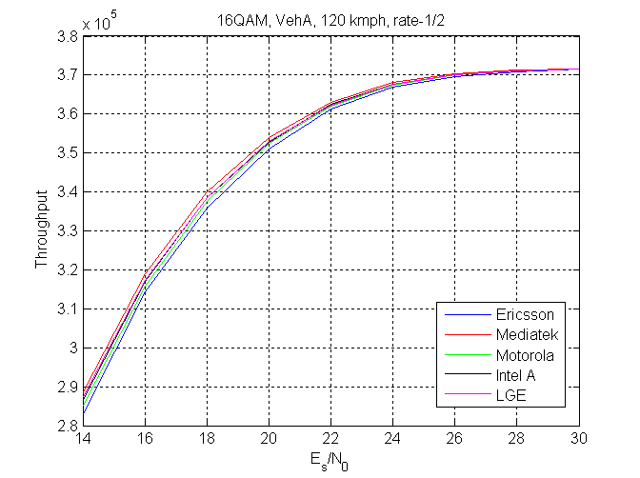
Figure 2: Link simulation with 16QAM rate-1/2 in Veh. A channel at 120 kmph
Figure 3 shows results with the same conditions as in figure 2 with the vehicle speed increased to 350 kmph. The figure shows that some of the patterns proposed are not robust to high vehicle speeds.
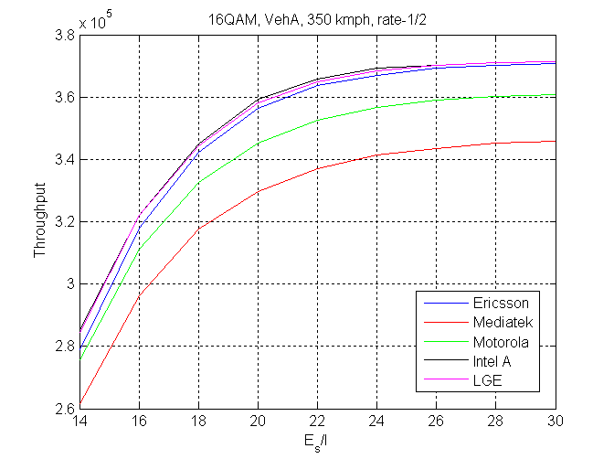
Figure 3: Link simulation with 16QAM rate-1/2 in Veh. A channel at 350 kmph

Interference Limited Environment
Figure 4 shows gains that may be obtained via pilot boosting in an interference limited environment. The interference limited environment is modeled by setting the signal-to-noise ratio (SNR as opposed to SINR) to 50 dB which is much higher than the range of SINR values considered in the figure. The pilot structure labeled ‘Ericsson’ in figure 2 is simulated with different pilot boosting levels. A key element of this pilot structure is the ability to minimize collisions between neighboring sectors. Interference is modeled using two equal strength interferers. Independent fading channel realizations are applied to the signals from each of the desired sector and the interfering sectors.

In figure 4, the desired channel and the two interferers use different pilot locations. This is achieved by using different cyclic rotations of a base pattern. Figure 5 shows the corresponding performance with different boosting levels when pilot locations of the desired and interfering sectors use the same locations. It is notable that the gains achieved through boosting are lower than those shown in figure 3 where pilot to pilot interference is not present.
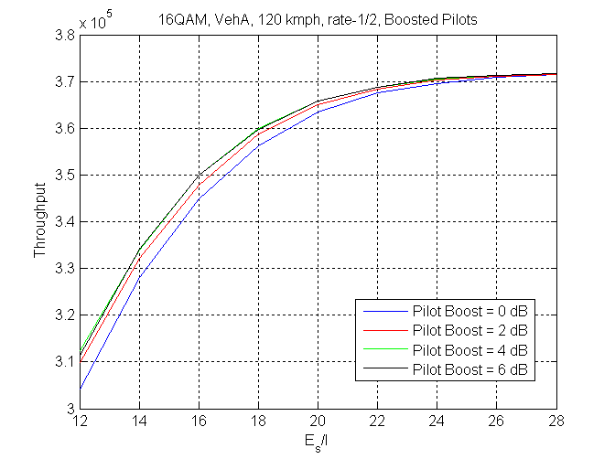
Figure 4: Performance in Interference limited environment with various boosting levels. Pilots interfere with data between sectors.

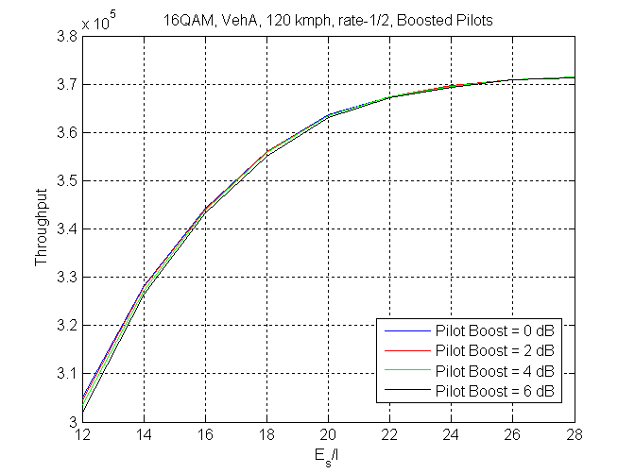
Figure 5: Performance in interference limited environment. Pilots interfere only with pilots between sectors
In figures 6-7, the pattern proposed by Ericsson is compared to the one proposed by Intel. The figure shows that the differences in throughput obtained using the two patterns are negligible for both QPSK and 16QAM modulations.
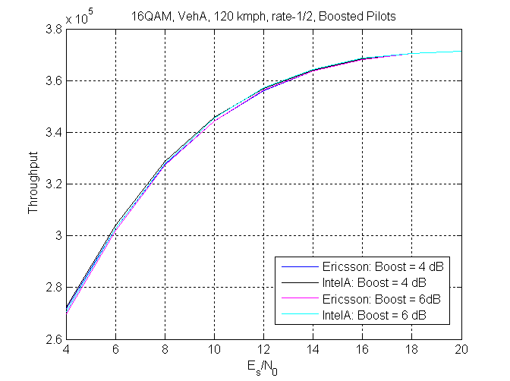
Figure 6: Performance comparison with boosting in interference limited environment with 16QAM modulation.
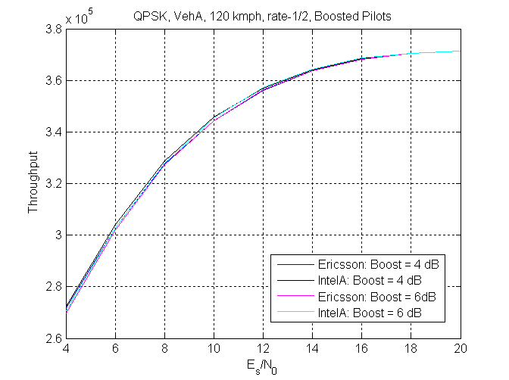
Figure 7: Performance comparison with boosting in interference limited environment with QPSK modulation.

Discussion
Given the same overhead, the performance of various pilot patterns proposed are close when pilot boosting is not considered. Some pilot patterns that perform best at low speeds also show performance degradation at high speed. In general, the pilot patterns exhibiting slightly better performance in a noise limited environment also seem to have a lower degree of uniqueness between sectors, where uniqueness of locations populated by pilots for different sectors determines the ability to avoid collisions between pilots transmitted from different sectors.

Pilot boosting is known to help in noise-limited environments. Pilot boosting can help even in interference limited environments provided pilot locations are different between different base stations. Therefore, pilot patterns that minimize collisions between sectors could take advantage of boosting and improve performance in the system in an interference limited environment. The pilot pattern proposed in [1] minimizes pilot collisions between cells to a greater degree than any of the other proposals.

It is important that the performance of pilot schemes should be considered not merely in a single cell scenario, but rather in a multi-cell scenario. The flexibility of the pilot schemes to accommodate distinguishable pilot patterns over multiple cells and sectors should be an important consideration; e.g., a scheme with a limited number of pilot patterns will require careful planning of the deployment. The uniqueness properties of the pilot structure are even more important when practical multi-cell scenarios are considered where there may be more than 2 interferers with reasonable signal levels.

Conclusion and Recommendation
The differences in performance between the pilot structure proposed in [3] and other proposed pilot structures are quite small or negligible in most cases. However, the pilot structure proposed in [3] has much better uniqueness properties than any of the other proposed pilot structures. This allows much greater flexibility of deployment and potential improvements in performance when more practical interference environments are considered. Hence, it is beneficial to adopt the pilot structure proposed in [3] for 802.16m.

References
- “Pilot Structures for 802.16m”, C802.16m-08/221r1
- “Proposed SDD Text for Pilot Structures”, C802.16mDL_PHY-08/024
- “Downlink Pilot Structures for 802.16m”, C802.16m-08/763

