Project | IEEE 802.16 Broadband Wireless Access Working Group <http://ieee802.org/16>
Title | Inter base station interference coordination
Date Submitted | 2008-07-08
Source(s) | Mark Doll,  Christian Gerlach,  Bozo Cesar,  Hardy Halbauer,  Joerg Schaepperle,  Torsten Fahldieck  Alcatel-Lucent | Voice:  E-mail: mark.doll@alcatel-lucent.de,  christian.gerlach@alcatel-lucent.de,  bozo.cesar@alcatel-lucent.de,  hardy.halbauer@alcatel-lucent.de,  joerg.schaepperle@alcatel-lucent.de,  torsten.fahldieck@alcatel-lucent.de  *<http://standards.ieee.org/faqs/affiliationFAQ.html>
Re: | “Call for Comments and Contributions on Project 802.16m System Description Document (SDD)”. IEEE 802.16m-08/024 (2008-06-16). Interference Mitigation.
Abstract | Proposal to extend the MAC interface to the NCMS to enable inter-sector interference estimation and constrain the scheduling for the purpose of inter base station interference mitigation.
Purpose | Call for Contributions on Project 802.16m System Description Document (SDD)
Notice | This document does not represent the agreed views of the IEEE 802.16 Working Group or any of its subgroups. It represents only the views of the participants listed in the “Source(s)” field above. It is offered as a basis for discussion. It is not binding on the contributor(s), who reserve(s) the right to add, amend or withdraw material contained herein.
Release | The contributor grants a free, irrevocable license to the IEEE to incorporate material contained in this contribution, and any modifications thereof, in the creation of an IEEE Standards publication; to copyright in the IEEE’s name any IEEE Standards publication even though it may include portions of this contribution; and at the IEEE’s sole discretion to permit others to reproduce in whole or in part the resulting IEEE Standards publication. The contributor also acknowledges and accepts that this contribution may be made public by IEEE 802.16.
Patent Policy | The contributor is familiar with the IEEE-SA Patent Policy and Procedures:  <http://standards.ieee.org/guides/bylaws/sect6-7.html#6> and <http://standards.ieee.org/guides/opman/sect6.html#6.3>.  Further information is located at <http://standards.ieee.org/board/pat/pat-material.html> and <http://standards.ieee.org/board/pat>.
Inter base station interference coordination
Mark Doll, Christian Gerlach, Bozo Cesar, Hardy Halbauer, Joerg Schaepperle, Torsten Fahldieck
Alcatel-Lucent

References
[1] Marc Necker. A Graph-Based Scheme for Distributed Interference Coordination in Cellular OFDMA Networks. Proceedings of the 67th IEEE Vehicular Technology Conference (VTC2008 - Spring), Singapore, 2008. DOI 10.1109/VETECS.2008.157
[2] Christian Gerlach, Liu Yang. Dynamic Interference Coordination. IEEE 802.16m-07/165, August 2007.
[3] R1-05-0272: OFDM air interface with QoS at cell edge. 3GPP TSG RAN WG1 #40bis, 4.-8. April 2005, Beijing, China.
[4] 3GPP TS 36.213 v8.2.0 (2008-03): 3rd Generation Partnership Project; Technical Specification Group Radio Access Network; Evolved Universal Terrestrial Radio Access (E-UTRA); Physical layer procedures (Release 8). March 2008.
[5] WiMAX Forum™ Network Architecture (Stage 2: Architecture Tenets, Reference Model and Reference Points) [Part 1]. Release 1, Version 1.2, January 2008.
[6] The Draft IEEE 802.16m System Description Document. IEEE 802.16m-08/003r3. June 16 2008.

Abbreviations
ASN Access Service Network
BS Base Station
DL Downlink
E-UTRA Evolved UMTS Terrestrial Radio Access
FFR Fractional Frequency Reuse
IFCO Interference Coordination
LTE Long Term Evolution
MS Mobile Station
NCMS Network Control and Management System
SINR Signal-to-Interference and Noise Ratio
UL Uplink
UMTS Universal Mobile Telecommunications System

Motivation
For systems operating in multi-cellular deployments with frequency reuse 1 or fractional frequency reuse (mixed reuse 1/reuse 3 operation), simulations have shown that by coordination of transmissions within near-by sectors the sector edge throughput can be improved without sacrificing the overall throughput [1, 2]. Already a rather simple request and grant mechanism between adjacent cells, as presented in [2], increase the cell edge throughput by about 25 % in isolated overloaded cells.
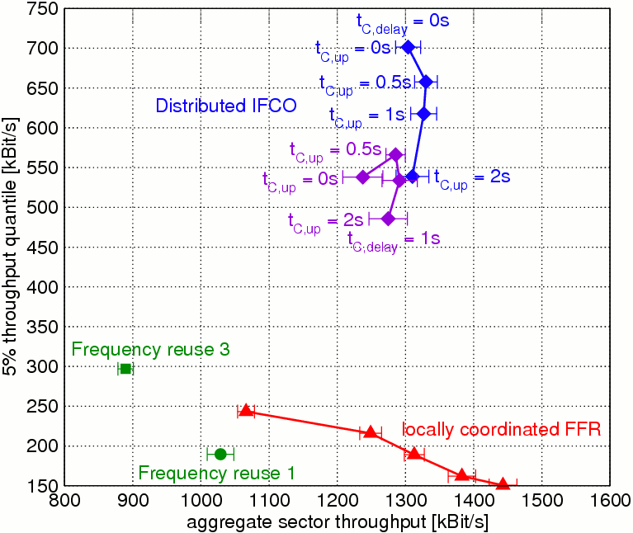

Figure 1: Cell edge and overall sector throughput without (green, red) and with (blue, violet) coordinated scheduling and different update periods t_{C,up} for exchanging information a) & b) and inter-BS signaling/processing delays t_{C,delay} (by courtesy of the author Marc Necker).
Figure 1 with simulation results from a more advanced optimization scheme presented in [1] shows that coordinated scheduling (blue, violet) allows an increase of the sector edge throughput by more than a factor of two compared to uncoordinated scheduling (green, red).

To allow for such coordination, it is required to exchange
- measurements of inter-sector channels, separately for each BS-MS channel, and
- scheduling constraints
between BSs. The former enables the BSs to predict the interference that would occur by certain scheduling constellations, the latter helps avoiding such unfavorable constellations, thereby on average increasing SINR and throughput.

LTE/E-UTRA already contains capabilities to measure path loss/shadowing for each MS to BS and exchange resource blockings (up to every 200 ms) via the X2 interface between eNode-Bs (base stations) [3, 4]. Within WiMAX/IEEE 802.16, an analogous information exchange could be carried over the inter-BS reference point R8 of the ASN reference model [4], but should not be limited to a pure inter-BS exchange so to not preclude (partly) centralized coordination schemes.

We therefore propose to extend the control and management interface and procedures of IEEE 802.16m to allow for an exchange of information a) and b) between BS and NCMS. The interference coordination entity inside the NCMS may be integrated into a BS or be co-located with a set of BSs or be carried out as a network-wide central coordinator, but this is implementation dependent and out of scope of IEEE 802.16m.

Proposed Text for SDD

Add the following text to [5]. Italic text marked yellow is informative only.

-------------------------------------------------------------Start of the Text-------------------------------------------------------
10 Medium Access Control

10.x Interference Coordination

10.x.y Interference Estimation

The exact inter-sector measurement technique to adopt for 16m has been left out, but should be discussed on in an upcoming “interference coordination” rapporteur group.

On request of the NCMS, a BS shall periodically
- measure UL radio channel properties to MSs within and outside its own sector and provide measurement results back to the NCMS,
- instruct its MSs to measure the DL radio channel to its serving BS and other BSs and provide measurement results reported by its MSs back to the NCMS.

On request of the NCMS, a BS shall report to the NCMS
- the DL transmit power and UL (MS’s) transmit power used, and
- antenna configuration and weights used for communication in DL and UL,
separately for each MS or class of MSs or frame region, periodically or after exceeding a configurable deviation from the last reported values.

10.x.z Interference Mitigation

A BS shall obey scheduling/frame building constraints given by the NCMS. This includes the ability of the NCMS to instruct a BS to

- assign each of its MSs to one or mores classes of MSs, and
- define regions within the frequency and time domain resource plane of a frame, and
- constrain
- the regions a class of MSs is allowed or is not allowed to be scheduled within, and
- the transmit power range allowed for transmissions within a certain region, and
- the antenna configuration and weights used for transmissions within a certain region.

Each such configuration by the NCMS shall be associated with a starting frame number and periodicity. These configurations shall be updateable in a dynamic fashion. A BS shall be capable to exchange and enforce configuration changes with a limited latency. (exact latency to be defined)
--------------------------------------------------------------End of the Text-------------------------------------------------------

