Project | IEEE 802.16 Broadband Wireless Access Working Group <http://ieee802.org/16>
Title | Fractional Frequency Reuse in Uplink
Date Submitted | 2008-07-07
Source(s) | JongYoung Han, HanGyu Cho  LG Electronics | Voice : +82-31-450-1852  E-mail: {fanaticey, hgcho}@lge.com
Re: | IEEE 802.16m-08/024 “Call for Comments and Contributions on Project 802.16m System Description Document (SDD)” in response to the following topic – Interference Mitigation
Abstract | Propose the FFR in uplink and show the preferred FFR configuration for interference mitigation
Purpose | To be discussed and adopted by TGm for use in the IEEE 802.16m SDD
Notice | This document does not represent the agreed views of the IEEE 802.16 Working Group or any of its subgroups. It represents only the views of the participants listed in the “Source(s)” field above. It is offered as a basis for discussion. It is not binding on the contributor(s), who reserve(s) the right to add, amend or withdraw material contained herein.
Release | The contributor grants a free, irrevocable license to the IEEE to incorporate material contained in this contribution, and any modifications thereof, in the creation of an IEEE Standards publication; to copyright in the IEEE’s name any IEEE Standards publication even though it may include portions of this contribution; and at the IEEE’s sole discretion to permit others to reproduce in whole or in part the resulting IEEE Standards publication. The contributor also acknowledges and accepts that this contribution may be made public by IEEE 802.16.
Patent Policy | The contributor is familiar with the IEEE-SA Patent Policy and Procedures:  <http://standards.ieee.org/guides/bylaws/sect6-7.html#6> and <http://standards.ieee.org/guides/opman/sect6.html#6.3>.  Further information is located at <http://standards.ieee.org/board/pat/pat-material.html> and <http://standards.ieee.org/board/pat>.

Fractional Frequency Reuse in Uplink

JongYoung Han, HanGyu Cho
LG Electronics

1. Introduction
According to 802.16m system requirements [1], performance of cell edge user is required to be twice improved relatively over the Wireless MAN-OFDMA system. In uplink, since the variance of interference is very large, the target performance requirement is more challenging.
Generally, fractional frequency reuse (FFR) scheme is known to be useful for the enhancement of the cell edge user performance with a reasonable tradeoff with average user throughput.
In this contribution, we show the system-level performance gain from the FFR in uplink and propose the FFR to be adopted in the 802.16m uplink design. Furthermore, we show the preferred FFR configuration and operation, which is practical in terms of signaling overhead and operational feasibility. Some power control issue in FFR is also addressed in a high-level.

2. System-level performance gain from FFR
2.1 Fractional frequency reuse (FFR)
Fractional frequency reuse partitions the frequency resources for use of different reuse factors. Figure 1 shows the concept of hard FFR and soft FFR assuming that reuse 1 and reuse 1/3 are used, respectively. In hard FFR, some resources are dedicated to edge users in one cell and are not allowed to be used by any users in other cells, which results in loss of spectral efficiency. In soft FFR, (inner) users in other cells are allowed to use the resources assigned to the edge users in other cell with some power restrictions. Since we can restrict the power to zero, hard FFR is a special case of soft FFR. In this contribution, we only consider soft FFR which is more promising in terms of spectral efficiency.
Figure 2 shows the cell configurations for hard FFR and soft FFR, respectively.

Figure 1. FFR partition and PSD

Figure 2. Cell configuration with FFR

2.2 System-level performance comparison
In this section, we compares the non-FFR case and FFR case based on system-level simulation of which assumptions and parameters are shown in Appendix.
Figure 3 compares the CDF of user throughput and the detailed results are summarized in Table 1 and 2 for ISD (inter sector distance) = 500m and ISD = 1500m, respectively. As shown in the Figure and Tables, FFR brings cell edge user throughput gain 42% and 25% at the cost of small average user throughput loss 1% and 1.4% for ISD = 500m and ISD = 1500m, respectively.

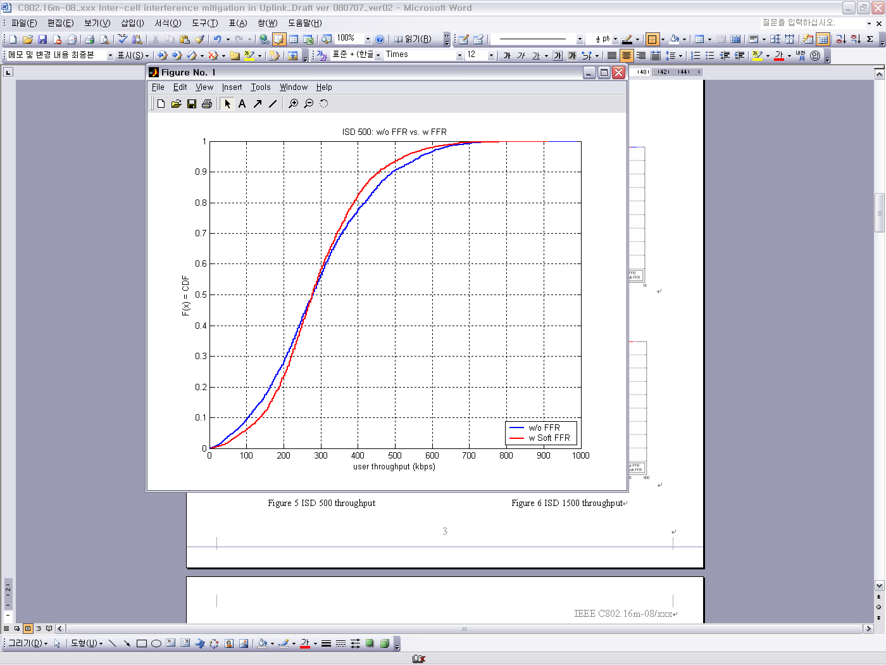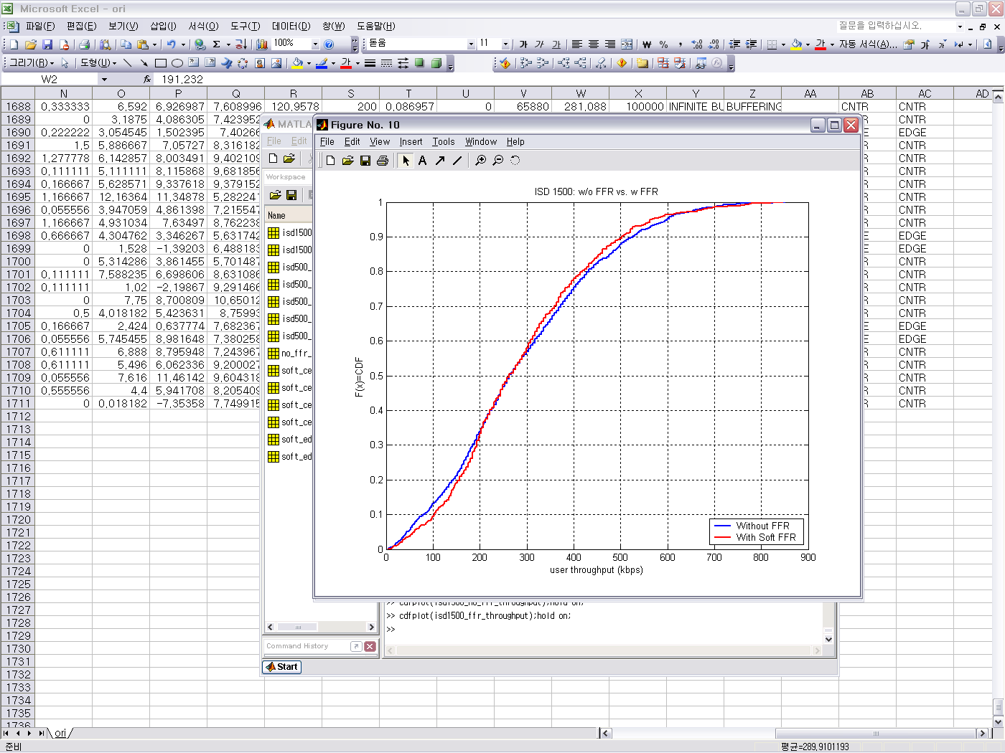
(a) ISD = 500m (b) ISD = 1500m
Figure 3. CDF of user throughput

Table 1. Throughput/spectral efficiency comparison (ISD = 500m)

 | Without FFR | With FFR
Average user throughput | 293 kbps  (0.781bps/Hz) | 290 kbps (-1.0%)  (0.773ps/Hz)
5% tile user throughput | 62.48 kbps  (0.0166bps/Hz) | 88.74 kbps (+42.0%)  (0.0237/Hz)

Table 2. Throughput/spectral efficiency comparison (ISD = 1500m)

 | Without FFR | With FFR
Average user throughput | 290 kbps  (0.773bps/Hz) | 286 kbps (-1.4%)  (0.763 bps/Hz)
5% tile user throughput | 46.2 kbps  (0.0123bps/Hz) | 57.9 kbps (+25.3%)  (0.0154bps/Hz)

3. FFR configuration in UL
In this section, we show our preference on FFR configuration in UL. Our main design criterion on FFR is to confirm the feasibility and real performance gain.
Table 3 shows the FFR configuration. As shown in the table we categorize into only two-modes: FFR-off and FFR-on which is reasonable and realistic in the aspect of signaling overhead, operational complexity, and cell configuration. For flexibility, we support two reuse factors 1/3 and 2/3 and also support flexible partitioning between reuse 1 region and reuse 1/3 (or 2/3) region.

Table 3. FFR configuration

 | Reuse 1 case  (no FFR) | FFR case | Signaling
# of partitioning | 1 | 4 | 2bit signaling
Reuse factor | 1 | 1/3, 2/3 | 2bit signaling
BW partition | BW_{T} | BW_{T}/(3+x)*[1,1,1,x] | 2bit signaling

Summary is as follows:

- Only two modes: FFR-off and FFR-on (4 partitions)
- Adaptive FFR
  - Adaptive to traffic load under BS coordination
  - Adaptive reuse factor
  - Adaptive BW size
- Semi-static FFR
  - Dynamic (period is less than 20ms) FFR is impractical
  - BS to BS sharing of FFR configuration by backbone
  - BS to MS signaling of FFR configuration using broadcast channel per superframe
- Soft FFR
  - Hard FFR is a special case

4. Consideration on power control in FFR
In uplink, mean and variance of interference level (or IoT) is generally large. FFR can help to reduce mean and variance of interference level which is beneficial in the aspect of link adaptation and power control.
Power control in uplink can be considered along with FFR to be fit to each feature of FFR group. Some examples are as follows:

- Tx. power restriction or MCS level restriction for inner bands in reuse 1/3 (2/3) region
  - Different restriction can be applied according to geometry
- Different power control scheme can be applied to users in the edge band
- Inter-cell power control considering FFR groups
  - E.g. explicit (or signaling-based) inter-cell power control for the edge band (or edge users) and implicit inter-cell power control for the inner band

Detailed power control scheme is likely to be more implementation-oriented, but, it seems necessary to consider FFR when designing power control scheme, especially for inter-cell power control.

5. Conclusion
We would like to replace conclusion with the following proposed text for SDD.

================================= Start of Proposed Text ====================================
11.x.x. Interference Management
11.x.x.x Uplink
11.x.x.x.x Fractional Frequency Reuse (FFR)
Fractional frequency reuse (FFR) is considered in uplink. The information for FFR configuration such as the number of FFR groups, bandwidth and power level for each group, and etc., is semi-statically shared among BSs and properly signaled to MSs.

=================================== End of Text Proposal ===================================

References
[1] IEEE 80216m-07_002r4.pdf “IEEE 802.16m System Requirements Document (SRD)”

Appendix
<Simulation Assumptions>
Scenario /Parameters | Baseline Configuration
Site-to-Site Distance | 1.5km / 0.5km
Carrier Frequency | 2.5GHz
Operating Bandwidth | 10MHz for TDD
BS Height | 32m
MS Tx Power | 23dBm / 17dBm
MS Height | 1.5m
Penetration Loss | 10dB
Pathloss model | $$\begin{aligned}\text{Loss}(\text{dB})=\text{130}\text{.}\text{62}+\text{37}\text{.}6{\text{log}}_{\text{10}}(R)+\text{cable} \text{loss} \\ R=\text{distance in km, cableloss 2dB}\end{aligned}$$
Lognormal Shadowing Standard Deviation | 8dB
Correlation Distance for Shadowing | 50m
Channel Type | ITU Ped B
Mobility | 3km/hr
Spatial Channel Model | ITU with spatial correlation
Basic Modulation | QPSK, 16QAM
Duplexing Scheme | TDD
Subchannelization | Band AMC
Resource Allocation Granularity | Band AMC Type: 2x3
Multi-antenna Transmission Format | 1x2 SIMO
Receiver Structure | MMSE
Data Channel Coding | Convolutional Turbo Coding (CTC)
Scheduling | Proportional fairness for full buffer data only  10 active users / sector  Fixed control overhead of 3 symbols, 15 symbols for data, 5 partitions of 48 sub-channels
Link Adaptation | 7 levels, QPSK(1/2) with repetition 1/2/3/4, QPSK(3/4), 16QAM(1/2), 16QAM(3/4)
Link to System Mapping | MMIB
HARQ | Adaptive HARQ, Maximum 4 retransmissions, retransmission duration 3 frames
Interference Model | Average interference on used band
Frequency Reuse Factor(FRF) | 3 sectors with FRF=1, FRF 1/3 for FFR operation
Users dropped | Uniformly in entire cell

