Project | IEEE 802.16 Broadband Wireless Access Working Group <http://ieee802.org/16>
Title | ICI Mitigation Using PMI Restriction in Multi-Cell Environments
Date Submitted | 2008-07-07
Source(s) | Dongguk Lim  Sunam Kim  Jaewan Kim  Bin-Chul Ihm  HanGyu Cho  LG Electronics  LG R&D Complex, 533 Hogye-1 dong  Dongan-gu, Anyang, 431-749, Korea | Voice: +82-31-450-1931  E-mail: dongguk@lge.com  snkim816@lge.com  lgjohnkim@lge.com  bcihm@lge.com  hgcho@lge.com
Re: | IEEE 802.16m-08/024 Call for Contributions on Project 802.16m System Description Document (SDD). Specific topic : Interference Mitigation
Abstract | Propose the PMI restriction scheme for IEEE 802.16m Interference mitigation
Purpose | For IEEE 802.16m discussion and adoption
Notice | This document does not represent the agreed views of the IEEE 802.16 Working Group or any of its subgroups. It represents only the views of the participants listed in the “Source(s)” field above. It is offered as a basis for discussion. It is not binding on the contributor(s), who reserve(s) the right to add, amend or withdraw material contained herein.
Release | The contributor grants a free, irrevocable license to the IEEE to incorporate material contained in this contribution, and any modifications thereof, in the creation of an IEEE Standards publication; to copyright in the IEEE’s name any IEEE Standards publication even though it may include portions of this contribution; and at the IEEE’s sole discretion to permit others to reproduce in whole or in part the resulting IEEE Standards publication. The contributor also acknowledges and accepts that this contribution may be made public by IEEE 802.16.
Patent Policy | The contributor is familiar with the IEEE-SA Patent Policy and Procedures:  <http://standards.ieee.org/guides/bylaws/sect6-7.html#6> and <http://standards.ieee.org/guides/opman/sect6.html#6.3>.  Further information is located at <http://standards.ieee.org/board/pat/pat-material.html> and <http://standards.ieee.org/board/pat>.

ICI Mitigation Using PMI Restriction in Multi-Cell Environments
Dongguk Lim, Sunam Kim, Jaewan Kim, Bin-Chul Ihm, and HanGyu Cho
LG Electronics

Introduction
The IEEE 802.16m System Description Documents (SDD) require twice of the sector throughput, average user throughput and cell edge-user throughput of conventional wireless OFDMA systems. In order to meet the requirement, inter-cell interference mitigation is very important in multi-cell environments, particularly for cell boundary users. Therefore, we propose a PMI (Pre-coding Matrix Index) restriction scheme that restricts the usage of a certain subset of codebook interfering other cell-edge user in order to obtain both increased average user throughput and edge-user throughput by reducing inter-cell interference.

Proposed PMI restriction scheme

In DL closed-loop MIMO, the usage of certain subset of codebook can give a bad influence on a cell edge-user of other cell. It indicates that the usage of certain PMI interfering other cell edge-user should be prohibited to reduce the inter-cell interference. For that purpose, we propose the PMI restriction scheme which restricts the usage of subsets of codebook that highly interfere other edge users.

The proposed operation is simply as follows: The cell edge users search the optimal PMI of interfering signals from other cells, for example, by calculating a received SINR per PMI. Then, the selected PMI information is reported to the serving BS periodically. More other information for PMI restriction can be reported along with the PMI information. Here, we denote the PMI of interfering BS by restricted PMI

The users served by the interfering BS receive the restricted PMI for PMI restriction. The inner users are restricted to use only the reduced codebook set excluding the restricted PMI. Cell edge users, however, can use the full codebook without any restrictions on PMI to maximize the beamforming gain. By doing so, cell edge users get high gain from the mitigated ICI at the cost of small sacrifice of inner users resulting in increase of both the edge user throughput and the average user throughput which will be shown in the simulation result later.

Operation of PMI restriction

Figure 1 shows an example for the operation principle of PMI restriction for ICI mitigation. Here the restricted PMI is colored by red in the codebook for pre-coding and all BSs are connected via the backbone network. In the figure, we assume that all BSs use the same codebook for pre-coding. MSedge means the cell-edge user located at the cell_A boundary and affected by the neighboring cells (cell_B and cell_C). The other MSs that receive high transmit power signals are located at the inner side of each cell.
For the PMI restriction, the MSedge searches the optimal PMIsfrom the reference signals of the interfering BSs (BS2, BS3) and feedbacks them to the serving BS (BS1). And the serving BS (BS1) transfers the PMI restriction information to the corresponding interfering BS (cell_B or cell_C) through the backbone network. If the BS2 of Cell_C receives the PMI restriction information from the serving BS (BS1), it does not allocate the restricted PMI to the inner user.

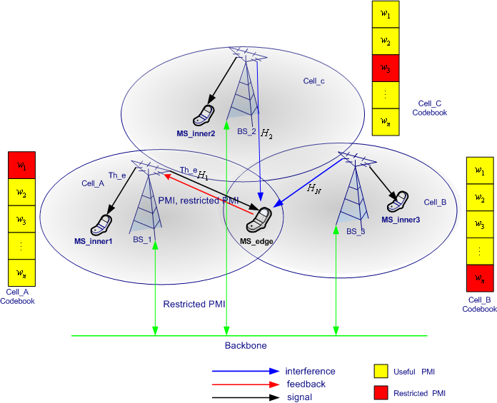
Figure 1 Example of the PMI restriction Scheme for ICI mitigation

There are two kinds of method for the PMI restriction at the interfering BS side. The first one is that the interfering BS does not assign the restricted PMI to the inner users who request the same PMI. This is a scheduling issue but could impact the system performance. The second one is that the inner cell users receive the information about the restricted PMI from the interfering BS and search PMI except the restricted PMI to increase user throughput.

PMI restriction in FFR

Generally, for the mitigation of inter-cell interference in the downlink, FFR (Fractional Frequency reuse) scheme can be considered. The FFR scheme is divided into hard-FFR and soft-FFR. In the hard-FFR, some frequency resources are dedicated to the cell edge users in one cell, so it may bring a low spectral efficiency. The Soft-FFR uses the whole frequency resources with proper power level adjustment per frequency band. In order to obtain high spectral efficiency and reduced ICI, the soft-FFR scheme supporting variable reuse factor can be considered along with the PMI restriction scheme.

Figure 2 illustrates an example of fractional frequency reuse using soft-FFR. Here, we used two reuse factors (1 and 1/3) after dividing the whole frequency band into two regions, i.e. reuse factor 1 region and reuse factor 1/3 region. The reuse factor 1/3 region is divided into three groups for the adaptation of the reuse factors. In addition, each group can have a different power level for soft-FFR scheme. In the reuse factor 1/3 region, we can use various reuse factors by adjusting the P_high power value.

Cell edge-users under the soft-FFR are still influenced by inter cell interference in the multi-cell environments because of the usage of whole frequency resource. So, for more effective ICI mitigation and increase of system capacity, we can utilize both FFR and PMI restriction.

Figure 2 Example of Soft FFR

Performance Evaluation

In this section, we show the performance of the PMI restriction mentioned in the previous section. For the system-level evaluation, we use the basic parameters of 802.16m Evaluation Methodology Document (EMD) [reference].

Table 1 lists the basic parameters for the system-level evaluation.

Table 1. Basic parameters
Parameter | Assumption
Cellular Layout | 19 cell, 3 sectors per cell
Inter-site distance (ISD) | 1500m
Fading Channel | IEEE 802.16m ITU-PEDB
MS speed | 3 km/h,
Center frequency | 2.5GHz
Bandwidth | 10 MHz
Number of MS per Sector | 10
Feedback delay | 3 subframes
Channelization | Band AMC mode
Subframe_duration | 2.5 ms
Antenna configuration | 2 x 2
Receiver type | MMSE
Codebook size | 3bit
Frequency Reuse | 1, 1/3

Here, we assume the perfect channel estimation and no rank adaptation.

In Table 2, we compared the average user throughput and cell edge user throughput with and without PMI restriction based on the relative gain. The cell edge user is defined by the 5th percentile point of the CDF of user throughput. As we can see in the table, 3% gain in the aspect of average user throughput is obtained from the PMI restriction. Moreover, the PMI restriction obtains up to 44% edge user throughput gain.

Table 2. Relative performance gain of PMI restriction
 | Edge-user throughput | Average user throughput
Without Restriction | 1 | 1
With Restriction | 1.44 | 1.03

Table 3 shows the performance when the soft-FFR is applied. Here, we compared two cases : FFR only case and the PMI restriction in FFR. As shown in the table, PMI restriction in FFR gets 47% gains in cell edge user throughput over FFR only case as well as 7% gains in average user throughput. As you can see from the result, even for the case when FFR is applied, PMI restriction still brings large gain.

Table 3 Relative performance gain of PMI restricition in FFR
Case | Edge-user throughput | Average user throughput
FFR without Restriction | 1 | 1
FFR with Restriction | 1.47 | 1.07

In table 4, we compared PMI restriction in FFR and none use of PMI restriction and FFR. It is shown that cell edge user throughput of the PMI restriction in FFR is enhanced up to 70% over the case of none use of PMI restriction and FFR. As you can see from the table, 5% gain in average user throughput is also obtained.

Table 4. Relative performance gain of PMI restriction in FFR over the case with no PMI restriction and no FFR
 | Edge-user throughput | Average user throughput
None use of Restriction and FFR | 1 | 1
Use of Restriction and FFR | 1.70 | 1.05

Figure 3 compares the CDF of user throughputs of various cases, which confirms the above results.

Figure 3 Comparison of CDF of user throughput

Conclusions
Simulation results have shown that the PMI restriction for ICI mitigation provides meaningful gains on cell edge user throughput as well as average user throughput, as amount of 44 % and 3 %, respectively. These meaningful benefits are obtained at relatively infrequent feedback of one interfering PMI per MS which is in low geometry below a certain threshold.
And, as we use the PMI restriction with FFR simultaneously for the ICI mitigation, we could obtain about 47% and 7% gain in aspect of cell edge user throughput and average user throughput, respectively. Here, we can find that ICI mitigation using both FFR and PMI restriction provides significant gains on average user throughput and cell edge user throughput over the case of the FFR only.

As a conclusion, PMI restriction can increase both cell edge user throughput and average user throughput together. In addition, it can provide more enhanced user throughput and reduced ICI as it is used with FFR. Based on the above observation, we propose the PMI restriction as one of the ICI mitigation technologies to meet the target requirements of IEEE 802.16m.

Reference
[1] IEEE 80216m-08/003r3 “Draft IEEE 802.16m System Description Document (SDD)”
[2] IEEE 80216m-08_004, “Project 802.16m Evaluation Methodology Document (EMD)”
[3] IEEE C80216m-08/430, “PMI Restriction for the downlink Closed-loop MIMO”

Proposed Texts
--------------------------------------------------- Text Start ---------------------------------------------------
11.x.x. Interference Management
11.x.x.x Downlink
11.x.x.x.x PMI (Precoding Matrix Index) restriction
Precoding matrix index restriction shall be supported in downlink. For the PMI restriction, the restricted PMI (the PMI of interfering BS) shall be reported to the serving BS.
--------------------------------------------------- Text End -----------------------------------------------------

