Project | IEEE 802.16 Broadband Wireless Access Working Group <http://ieee802.org/16>
Title | Dedicated code based HO ranging for 802.16m
Date Submitted | 2008-07-07
Source(s) | Kyujin Park  Jaehoon Chung  Doo-hyun Sung  HanGyu Cho  LG Electronic Inc.  LG R&D Complex, 533 Hogye-1dong, Dongan-gu, Anyang, 431-749, Korea | Voice: +82-31-450-1909  E-mail: pkj137@lge.com  jhchung329@lge.com  dh.sung@lge.com  hgcho@lge.com
Re: | IEEE 802.16m-08/024 Call for Contributions on Project 802.16m System Description Document (SDD).  Specific topic : “Upper MAC Mobility Management”
Abstract | This contribution proposes dedicated code based HO Ranging to reduce the handover interruption time for 802.16m.
Purpose | For discussion and approval by TGm
Notice | This document does not represent the agreed views of the IEEE 802.16 Working Group or any of its subgroups. It represents only the views of the participants listed in the “Source(s)” field above. It is offered as a basis for discussion. It is not binding on the contributor(s), who reserve(s) the right to add, amend or withdraw material contained herein.
Release | The contributor grants a free, irrevocable license to the IEEE to incorporate material contained in this contribution, and any modifications thereof, in the creation of an IEEE Standards publication; to copyright in the IEEE’s name any IEEE Standards publication even though it may include portions of this contribution; and at the IEEE’s sole discretion to permit others to reproduce in whole or in part the resulting IEEE Standards publication. The contributor also acknowledges and accepts that this contribution may be made public by IEEE 802.16.
Patent Policy | The contributor is familiar with the IEEE-SA Patent Policy and Procedures:  <http://standards.ieee.org/guides/bylaws/sect6-7.html#6> and <http://standards.ieee.org/guides/opman/sect6.html#6.3>.  Further information is located at <http://standards.ieee.org/board/pat/pat-material.html> and <http://standards.ieee.org/board/pat>.
Dedicated code based HO ranging for 802.16m system
Kyujin Park, Jaehoon Chung, Doo-hyun Sung and HanGyu Cho
LG Electronics

Introduction
HO interruption time is specified as an interval during which an MS has no connection with any BSs and cannot get services from any BSs. Therefore it is important to minimize the HO interruption time for service continuity. In the HO procedure of reference 802.16e system, HO interruption time is determined as the duration between MOB_HO-IND reception at serving BS and BR header/CQI report reception at target BS and consists of a BS switching time for DL synchronization with target BS, HO ranging for UL parameter adjustment, and RNG-REQ/RNG-RSP message exchange between an MS and a target BS.
In this contribution, we point out the weakness of the conventional HO procedure of the reference system, especially the HO ranging procedure, and propose a new HO ranging scheme.

Problem statement
By the conventional HO procedure defined in the reference 802.16e standard, an MS accessing a new target BS for handover should perform contention based HO ranging for UL parameter adjustment with the target BS. However, HO ranging codes sent by multiple MSs simultaneously are always prone to collide with each other, since the ranging codes are randomly selected by each MS from the common HO ranging code domain which is defined by the target BS, and therefore two or more MSs might select the same ranging code for their HO ranging. When a HO ranging code collides, the MS should restart the HO ranging procedure after the ranging response reception timer (T3 timer) expiration. As a result, the HO interruption time increases significantly. Therefore, in 802.16m system, it is required to make up for the HO ranging procedure to avoid the code collision.

Proposed Scheme
We propose dedicated code based HO ranging for 802.16m system to avoid the code collision at HO ranging causing HO interruption time increment. An MS assigned a dedicated ranging code by a target BS can proceed non-contention based HO ranging, eventually preventing code collision with other HO MSs.
The allocation of dedicated ranging code to an MS can be signaled either by a serving BS or a target BS. In case that allocation of a dedicated ranging code is signaled by a serving BS, there are two possible ways of delivering dedicated ranging codes. One way is to include the information about dedicated code assignment in MOB_BSHO-RSP. In this method, the serving BS should request the entire candidate BSs in MOB_BSHO-RSP to assign a ranging code from their ranging code domains, and then all of the ranging codes assigned at each candidate BS should be included in the MOB_BSHO-RSP respectively as shown in figure 1. This method may include an unnecessary overhead for MOB_BSHO-RSP as well as inefficient usage of code resources, since the HO MS executes HO with only one of the candidate BSs. Alternatively, dedicated ranging codes can be sent with the response to the MOB_HO-IND message after the negotiation with the actual target BS contained in MOB_HO-IND as shown in figure 2. However, the alternative method is also undesirable, because the MS should defer the access to the target BS until reception of the response message including the code dedication at the serving BS after the MOB_HO-IND message transmission.
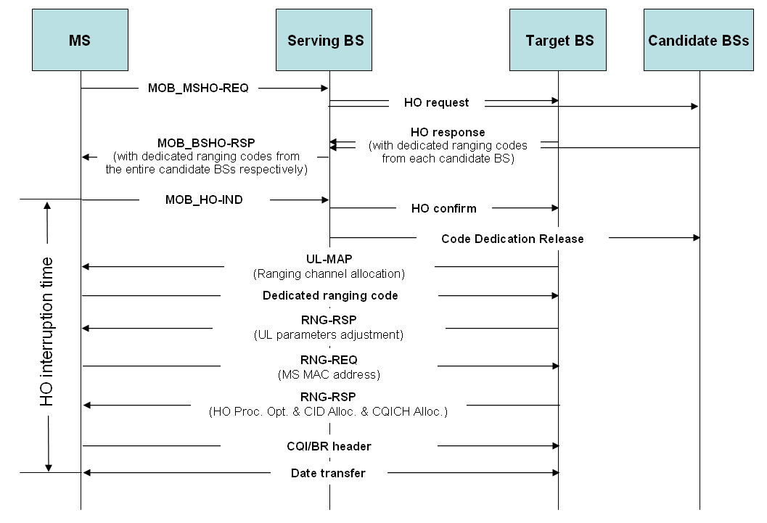
Fig. 1 Code dedication signaled in MOB_BSHO-RSP at serving BS

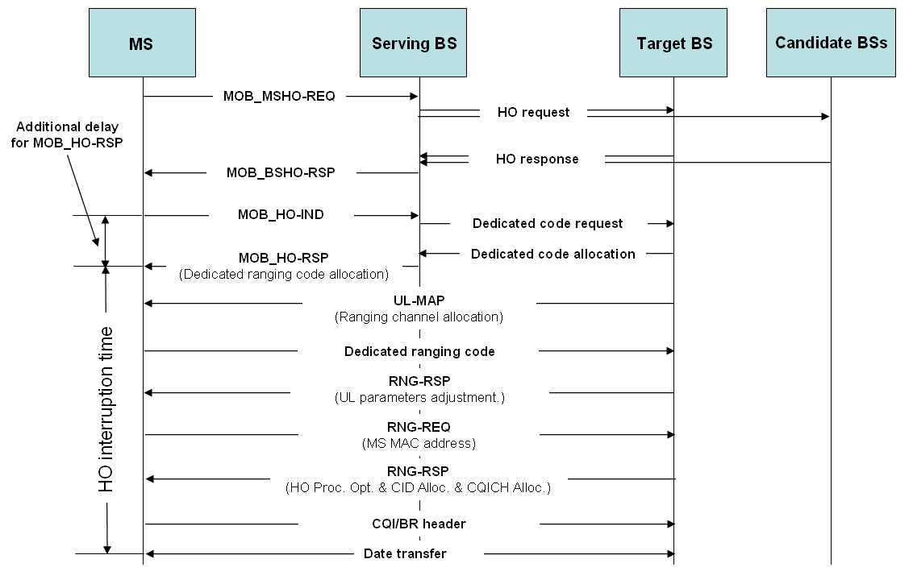
Fig. 2 Code dedication signaled as a response to MOB_HO-IND at serving BS

As a solution to the problems generated by signaling of code dedication at serving BS, we suggest that assignment of a dedicated ranging code should be signaled at target BS as shown in figure 3. Because a dedicated ranging code is signaled to a HO MS directly by target BS, it is not required that the entire candidate BSs in MOB_BSHO-RSP allocate a ranging code. In other words, only the target BS that an MS accesses for HO, allocates a ranging code. Therefore, the proposed scheme enables not only to use code resource efficiently but also to minimize the signaling overhead for code dedication without additional delay in HO procedure.
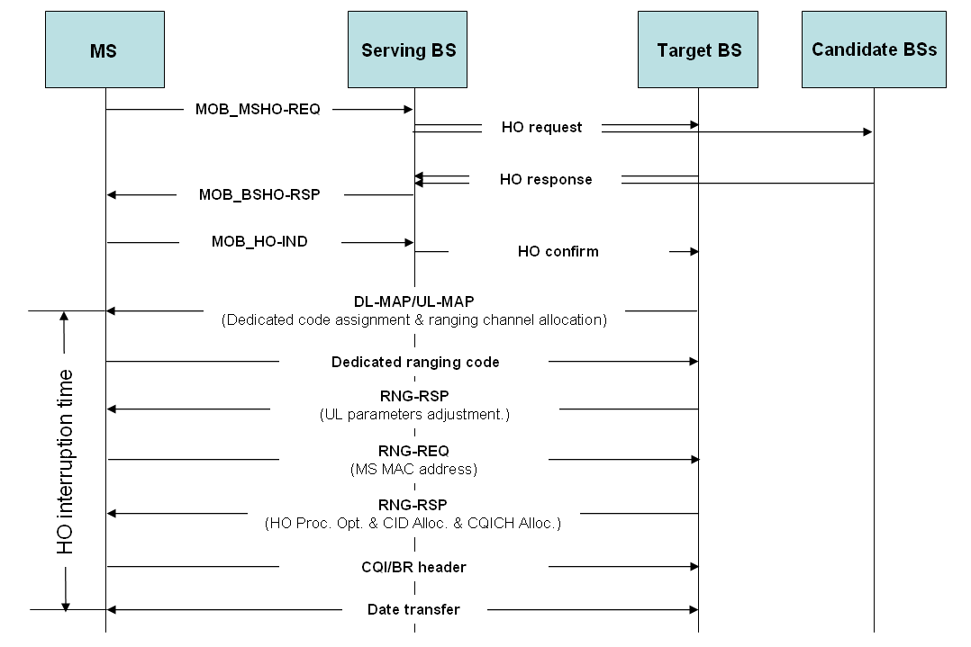
Fig. 3 Code dedication signaled at target BS

Conclusions
The text proposal bellow substitutes the conclusions.

Text Proposal

--------------------------------------------------- Text Start ---------------------------------------------------
11.x.x Mobility Management
IEEE 802.16m supports dedicated code based HO ranging to reduce HO interruption time. The dedicated HO ranging code index is directly signaled to a HO MS by a target BS. The following figure shows the relevant HO procedure.
Fig.xx Example of 802.16m HO procedure
--------------------------------------------------- Text End ---------------------------------------------------

References
[1] IEEE 802.16Rev2/D4, April 2008

