Project | IEEE 802.16 Broadband Wireless Access Working Group <http://ieee802.org/16>
Title | Considerations on HARQ PHY for IEEE 802.16m
Date Submitted | 2008-07-07
Source(s) | Sukwoo Lee, Seunghyung Kang, Jiwook Chung, Woosuk Kwon, Hyungho Park and Minseok Oh  LG Electronics, Inc. LG R&D Complex, 533 Hogye-1dong, Dongan-gu, Anyang, 431-749, Korea | Voice: +82-31-450-1869  E-mail: {sugoo, sh_kang, jwChung, kytloze, hyunghopark, minoh}@lge.com  *<http://standards.ieee.org/faqs/affiliationFAQ.html>
Re: | IEEE 802.16m-08/024 - Call for Contributions on Hybrid ARQ (PHY aspects)
Abstract | This contribution will provide LG’s view on HARQ PHY for IEEE802.16m system including channel coding, MCS, and modulation.
Purpose | To be discussed and adopted by TGm for use in the IEEE 802.16m SDD
Notice | This document does not represent the agreed views of the IEEE 802.16 Working Group or any of its subgroups. It represents only the views of the participants listed in the “Source(s)” field above. It is offered as a basis for discussion. It is not binding on the contributor(s), who reserve(s) the right to add, amend or withdraw material contained herein.
Release | The contributor grants a free, irrevocable license to the IEEE to incorporate material contained in this contribution, and any modifications thereof, in the creation of an IEEE Standards publication; to copyright in the IEEE’s name any IEEE Standards publication even though it may include portions of this contribution; and at the IEEE’s sole discretion to permit others to reproduce in whole or in part the resulting IEEE Standards publication. The contributor also acknowledges and accepts that this contribution may be made public by IEEE 802.16.
Patent Policy | The contributor is familiar with the IEEE-SA Patent Policy and Procedures:  <http://standards.ieee.org/guides/bylaws/sect6-7.html#6> and <http://standards.ieee.org/guides/opman/sect6.html#6.3>.  Further information is located at <http://standards.ieee.org/board/pat/pat-material.html> and <http://standards.ieee.org/board/pat>.
Considerations on HARQ PHY for IEEE 802.16m
Sukwoo Lee, Seunghyung Kang, Jiwook Chung, Woosuk Kwon, Hyungho Park and Minseok Oh
LG Electronics, Inc.

Introduction
IEEE 802.16m system is required to support larger bandwidth, higher spectral efficiency and lower transmission latency. Hybrid Automatic Repeat reQuest(HARQ) scheme provides more reliable transmission due to energy gain and coding gain. However, with the restricted HARQ operation in the legacy system investigated, further enhancement in 16m is necessary by optimizing HARQ procedure and enhancing HARQ related components including channel coding, MCS, and modulation. This contribution will provide LG’s view on HARQ PHY for IEEE802.16m system.

Requirements for HARQ PHY
IEEE 802.16m system should be designed to provide the peak data rate of 15 bps/Hz, normalized peak rate, maximum data latency of 10ms and more than double the user throughput compared with the reference system [1]. HARQ PHY contributes to achieve the target performance by reducing the processing delay, decreasing the number of retransmission and optimizing the transmission format. For low processing delay, it is necessary to accommodate large sized real time traffic. The minimum number of retransmission can be realized by maximizing channel coding gain and time and spatial diversity gain. In addition, with finer MCS granularity and flexible data size per Resource Unit (RU), it is essential to elaborate on the enhancement of channel coding, MCS selection, and modulation associated with HARQ process.

Channel Coding
LG proposes following features for channel coding of IEEE 802.16m.
- Convolutional Codes (CC), Convolutional Turbo Codes (CTC), and Low Density Parity Check Codes (LDPCC) should be considered as channel coding schemes for user data of IEEE 802.16m system.
- Data block size should be increased.
- Data block length for CTC should be redefined.

Larger data block size
As was identified in [2], [3], [4], IEEE802.16m system needs to increase maximum data block size for the purpose of taking advantage of channel coding gain and minimizing transmission overhead. The channel coding gain from larger block size is also verified in [5]; as shown in Figure 1, with the increase of the block size from 480 to 4,800, IEEE 802.16m system has significant SNR gain over the reference system.

LDPCC
As the data block size increases, it is required to raise decoding throughput for the purpose of meeting the requirement for processing delay. Hence, it is desirable to consider LDPCC, a channel coding scheme adequate to get higher decoding throughput. LDPCC can better serve the IEEE 802.16m system when data block size is greater than a certain size which will be decided by network considering MS’s capability.

The followings are the basic requirement for LDPC which should be considered in IEEE 802.16m system [6].
- LDPCC should support Incremental Redundancy (IR) to maximize coding gain
- LDPCC should support various channel code rates

CTC
It is desirable to reuse CTC of reference system as much as possible for the purpose of minimizing additional cost and supporting legacy system. However, there is still a room to improve the legacy CTC in terms of encoding rate, subpacket generation and data block size [5].

- Mother code rate -Although CTC of reference system is able to support the mother code rate of 1/3, it uses only down to 1/2 and repeat symbols for lower code rate. By using the full codeword from mother code rate of 1/3, IEEE 802.16m system increases channel coding gain.
- Data block size - Data block size should be defined to maximize channel coding gain, minimize redundancy, and support variable data block size.
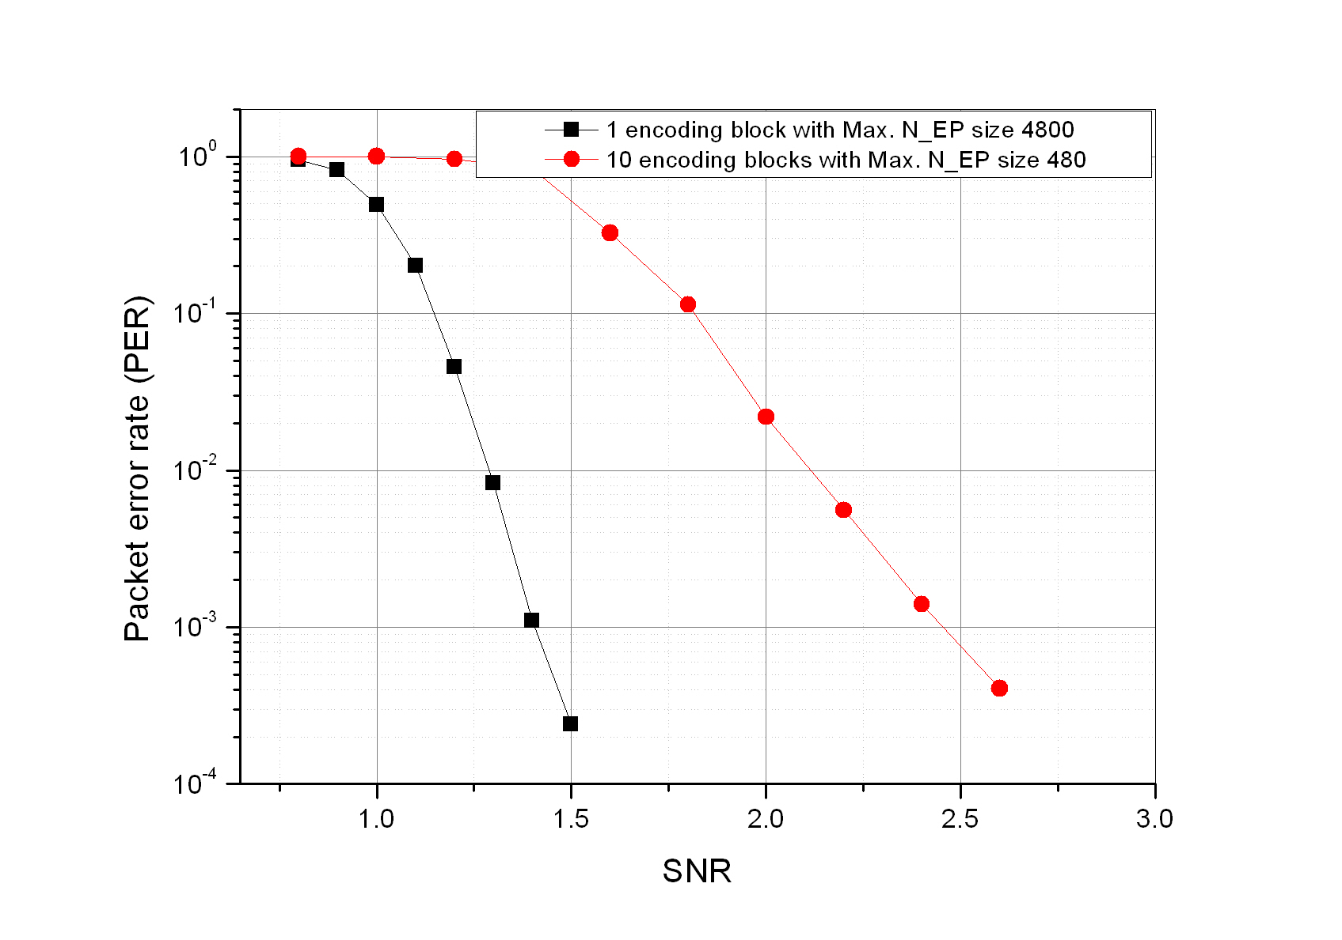
Figure 1. SNR gain of larger block data transmission over reference system

MCS Selection
Reference system defines 8 MCS indexes for each channel coding scheme which is not sufficient to fully utilize AMC gain. In this regard, it is proposed to have much finer MCS to reflect real channel environment more accurately [7]. MCS in Table 1 is defined to enable the required SNR at the BLER of 10% to vary linearly with regard to spectral efficiency and to be dense enough to facilitate more efficient link adaptation.

As shown in Figure 2, unlike reference system, IEEE 802.16m system with the finer MCS reduces the difference between real channel condition and selected one in terms of SIR and its variation over entire spectral efficiency, eventually leading in throughput enhancement as shown in Figure 3 and Table 2.

Table 1. Proposed MCS Table for IEEE 802.16m CTC
MCS Index | Target Code Rate | Modulation | Spectral Efficiency | MCS Index | Target Code Rate | Modulation | Spectral Efficiency
0 | 0.1504 | 2 | 0.3008 | 8 | 0.6025 | 4 | 2.4102
1 | 0.2168 | 2 | 0.4336 | 9 | 0.7148 | 4 | 2.8594
2 | 0.3203 | 2 | 0.6406 | 10 | 0.5146 | 6 | 3.0879
3 | 0.4326 | 2 | 0.8652 | 11 | 0.5898 | 6 | 3.5391
4 | 0.5645 | 2 | 1.1289 | 12 | 0.6904 | 6 | 4.1426
5 | 0.3105 | 4 | 1.2422 | 13 | 0.7656 | 6 | 4.5938
6 | 0.4141 | 4 | 1.6563 | 14 | 0.8281 | 6 | 4.9688
7 | 0.5176 | 4 | 2.0703 | 15 | 0.9033 | 6 | 5.4199

Figure 2. Comparison of Gap between Selected SIR and Received SIR
Figure 3. Throughput Comparison
Table 2. Throughput result from system level simulation

Metric | Legacy MCS | New-Designed MCS | Gain
Average Sector Throughput | 1.864 Mbps | 1.960 Mbps | 5.15%
Cell Edge Throughput | 730 kbps | 776 kbps | 6.30%

Modulation
The performance of HARQ can be further improved with high order modulation and MIMO. Considering unequal reliability of each bit in high order modulated symbol, we propose Constellation Rearrangement (CoRe) at retransmission [8]. Figure 4 shows an example of proposed constellation rearrangement scheme. By swapping bit positions and changing bit values within a symbol, HARQ process can average the bit reliability within a symbol, improving decoding performance. In addition, HARQ process can take advantage of spatial diversity gain with multiple-antenna configuration by conducting bitwise shuffling across symbols and transmit antennas.
Figure 4. Proposed Constellation Rearrangement (2 Tx, 16QAM)

As shown in Table 3, CoRe provides significant gain over reference system.
Table 3. Performance comparison (2 by 2 MIMO, 16 QAM, CTC 1/2)
Performance gain  (10% FER) | CoRe over Chase  (30 km) | CoRe over Chase  (120 km) | CoRe over IR,  (30km) | CoRe over IR  (120 km)
N_{re} = 1 | 1.7 dB | 1.9 dB | 0.30 dB | 0.35 dB
N_{re} = 2 | 2.1 dB | 2.2 dB | 0.15 dB | 0.15 dB
N_{re} = 3 | 2.8 dB | 3.1 dB | 0.47 dB | 0.47 dB
N_{re}:Maximum number of retransmission

Conclusion
To improve the performance of HARQ, LG proposes the followings and recommend the texts in the following section to SDD.
- Channel coding
  - Larger data block size
  - Consideration on LDPCC
  - Modification of CTC
    - Change of the mother code rate from 1/2 to 1/3
    - Redefinition of data block size to maximize coding gain, minimize the padding overhead and support variable block size
- MCS Selection
  - Finer MCS set to fully utilize AMC gain
- Modulation
  - Constellation rearrangement scheme considering high order modulation and MIMO

Text Proposal to SDD

==============================Start of Proposed Text 1================================
CTC shall be used as a mandatory channel coding scheme in IEEE 802.16m system with the following data block size requirements.
The maximum data block size of CTC shall be increased to enhance its coding gain.
The data block sizes of CTC shall be defined with finer granularity for reducing padding bit portion.

============================= End of Proposed Text 1=================================

==============================Start of Proposed Text 2================================
LDPC Codes shall be used to support HARQ in the IEEE 802.16m
============================= End of Proposed Text 2=================================

================================= Start of Proposed Text3====================================

11.x Channel Coding

11.x.1 Channel Coding for data channel

11.x.1.x Convolutional Turbo Codes

MCS should be selected with equal space of required SNR.
MCS should be dense enough to facilitate more efficient link adaptation.

Table 11.x.x.x gives the code rates, modulation, and spectral efficiency.

Table 11.x.x.x – Modulation and Coding Set Table for CTC
MCS Index | Target Code Rate | Modulation | Spectral Efficiency
0 | 0.1504 | 2 | 0.3008
1 | 0.2168 | 2 | 0.4336
2 | 0.3203 | 2 | 0.6406
3 | 0.4326 | 2 | 0.8652
4 | 0.5645 | 2 | 1.1289
5 | 0.3105 | 4 | 1.2422
6 | 0.4141 | 4 | 1.6563
7 | 0.5176 | 4 | 2.0703
8 | 0.6025 | 4 | 2.4102
9 | 0.7148 | 4 | 2.8594
10 | 0.5146 | 6 | 3.0879
11 | 0.5898 | 6 | 3.5391
12 | 0.6904 | 6 | 4.1426
13 | 0.7656 | 6 | 4.5938
14 | 0.8281 | 6 | 4.9688
15 | 0.9033 | 6 | 5.4199

=============================== End of Text Proposal3 ===============================
================================= Start of Proposed Text4====================================

x.x HARQ mode

x.x.x. Constellation Rearrangement

Constellation rearrangement considering both horizontal and vertical bitwise mapping shall be adopted for IEEE 802.16m.

x.x.x.1. Horizontal bitwise mapping

Horizontal bitwise mapping changes the bit position and its value on signal constellation in order to get temporal diversity gain during retransmissions through the following operations. A specific method is FFS.

x.x.x.2 Vertical bitwise mapping

Vertical bitwise mapping perform to exchange components bits between transmit antennas for averaging the channel difference. A specific method is FFS
=================================== End of Text Proposa 4==================================

References
- IEEE 802.16m-07/002r4, “IEEE 802.16m System Requirements”
- IEEE C802.16m-07/010, “Rate Matching in 802.16m”
- IEEE C802.16m-08/305, “The analysis of HARQ maximum throughput per connection”
- IEEE C802.16m-08/362, “HARQ Timing and Protocol Considerations for IEEE 802.16m”
- IEEE C802.16m-08/805, “Considerations on CTC data block sizes”
- IEEE C802.16m-08/806, “Feasibility verification of LDPC codes for HARQ operation”
- IEEE C802.16m-08/809, “MCS Table Generation for IEEE802.16m CTC”
- IEEE C802.16m-08/807, “Constellation Rearrangement for IEEE 802.16m”

