Project | IEEE 802.16 Broadband Wireless Access Working Group <http://ieee802.org/16>
Title | Considerations on CTC data block sizes
Date Submitted | 2008-07-07
Source(s) | Seunghyun Kang, Sukwoo Lee  LG Electronics | Voice: +82-31-450-1918  E-mail: sh_kang@lge.com, sugoo@lge.com
Re: | IEEE 802.16m-08/024 – Call for Contributions on Hybrid ARQ (PHY aspects)
Abstract | In this proposal, we propose the requirement for the CTC data block sizes to enhance its coding gain in IEEE 802.16m system.
Purpose | Discussion and adoption for 802.16m SDD
Notice | This document does not represent the agreed views of the IEEE 802.16 Working Group or any of its subgroups. It represents only the views of the participants listed in the “Source(s)” field above. It is offered as a basis for discussion. It is not binding on the contributor(s), who reserve(s) the right to add, amend or withdraw material contained herein.
Release | The contributor grants a free, irrevocable license to the IEEE to incorporate material contained in this contribution, and any modifications thereof, in the creation of an IEEE Standards publication; to copyright in the IEEE’s name any IEEE Standards publication even though it may include portions of this contribution; and at the IEEE’s sole discretion to permit others to reproduce in whole or in part the resulting IEEE Standards publication. The contributor also acknowledges and accepts that this contribution may be made public by IEEE 802.16.
Patent Policy | The contributor is familiar with the IEEE-SA Patent Policy and Procedures:  <http://standards.ieee.org/guides/bylaws/sect6-7.html#6> and <http://standards.ieee.org/guides/opman/sect6.html#6.3>.  Further information is located at <http://standards.ieee.org/board/pat/pat-material.html> and <http://standards.ieee.org/board/pat>.
Considerations on CTC data block sizes
Seunghyun Kang, Sukwoo Lee
LG Electronics

Introduction
In the scope of HARQ PHY, the channel coding scheme is one of key components for generation of coded blocks in HARQ Chase Combining (CC) and Incremental Redundancy (IR) mode. In order to achieve further throughput gain and lower overhead, Convolutional Turbo Code (CTC) is necessary to be improved in terms of length of code word, padding loss. In this contribution, we investigate technical requirements of the CTC scheme for IEEE 802.16m and propose text to be included in SDD.

CTC in IEEE 802.16e reference system
In IEEE 802.16e channel coding, CTC supports 12 data block sizes such as 48, 72, 96, 144, 192, 216, 240, 288, 360, 384, 432 and 480 since the number of data sub carriers per a resource unit (RU) is always fixed with 48 and the modulation and coding schemes are also fixed as shown in Table571 of [2].
Granularity of CTC in IEEE 802.16e reference system
Since the granularity of the data block sizes is 24, 48 or 72, serious padding loss occurs in supporting various MPDU sizes from the upper layer. Especially, the impact of padding bits is more serious in some rage of MPDU size due to irregularly distributed granularity. Figure 5 shows average padding overhead in the data block sizes according to contiguous MPDU size. In the figure, the average padding bit portion of CTC data block sizes is compared with that of LTE Turbo Code (TC) data block sizes which have 8 bit granularity for the data block sizes less than 512 bits [8]. In order to reduce the padding bit overhead, CTC data block sizes shall be defined with finer granularity considering padding bit portion similar to LTE TC data block sizes.
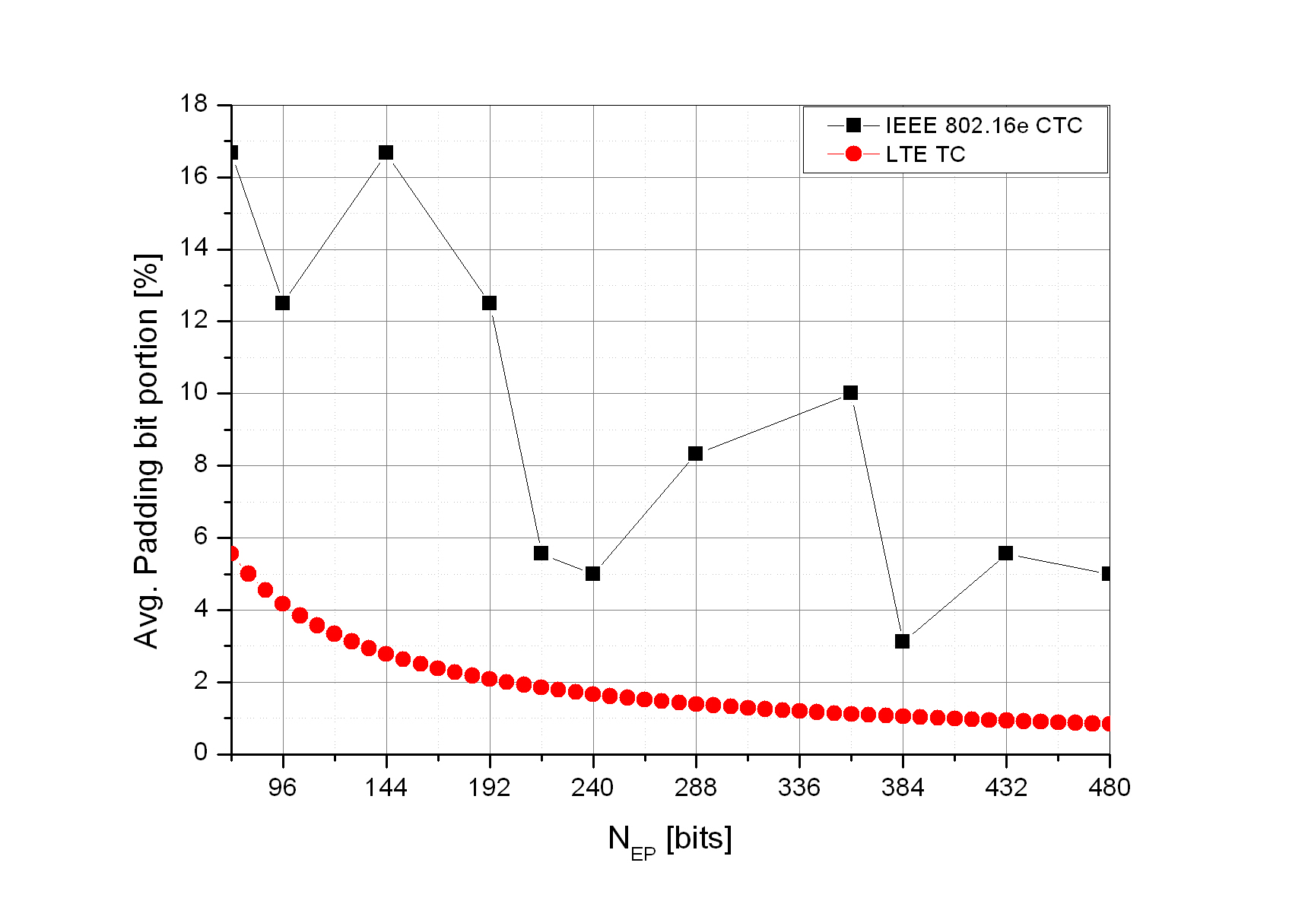
Figure 1. Average padding bit overhead comparison between CTC and TC

Maximum data block size in IEEE 802.16e reference system
In IEEE 802.16e reference system, CTC has the maximum data size of only 480 bits, which is so small for broadband wireless system in the aspect of coding gain. Error: Reference source not foundshow the Packet Error Rate (PER) performance of the different maximum data block sizes assuming that MPDU size is 4800 bits and in the simulation environment of AWGN channel, QPSK, Max-log-MAP decoding with 8 iterations. In the result, it is verified that PER performance can be enhanced by simply increasing its data block sizes in code rate 1/3, 1/2 and 2/3.

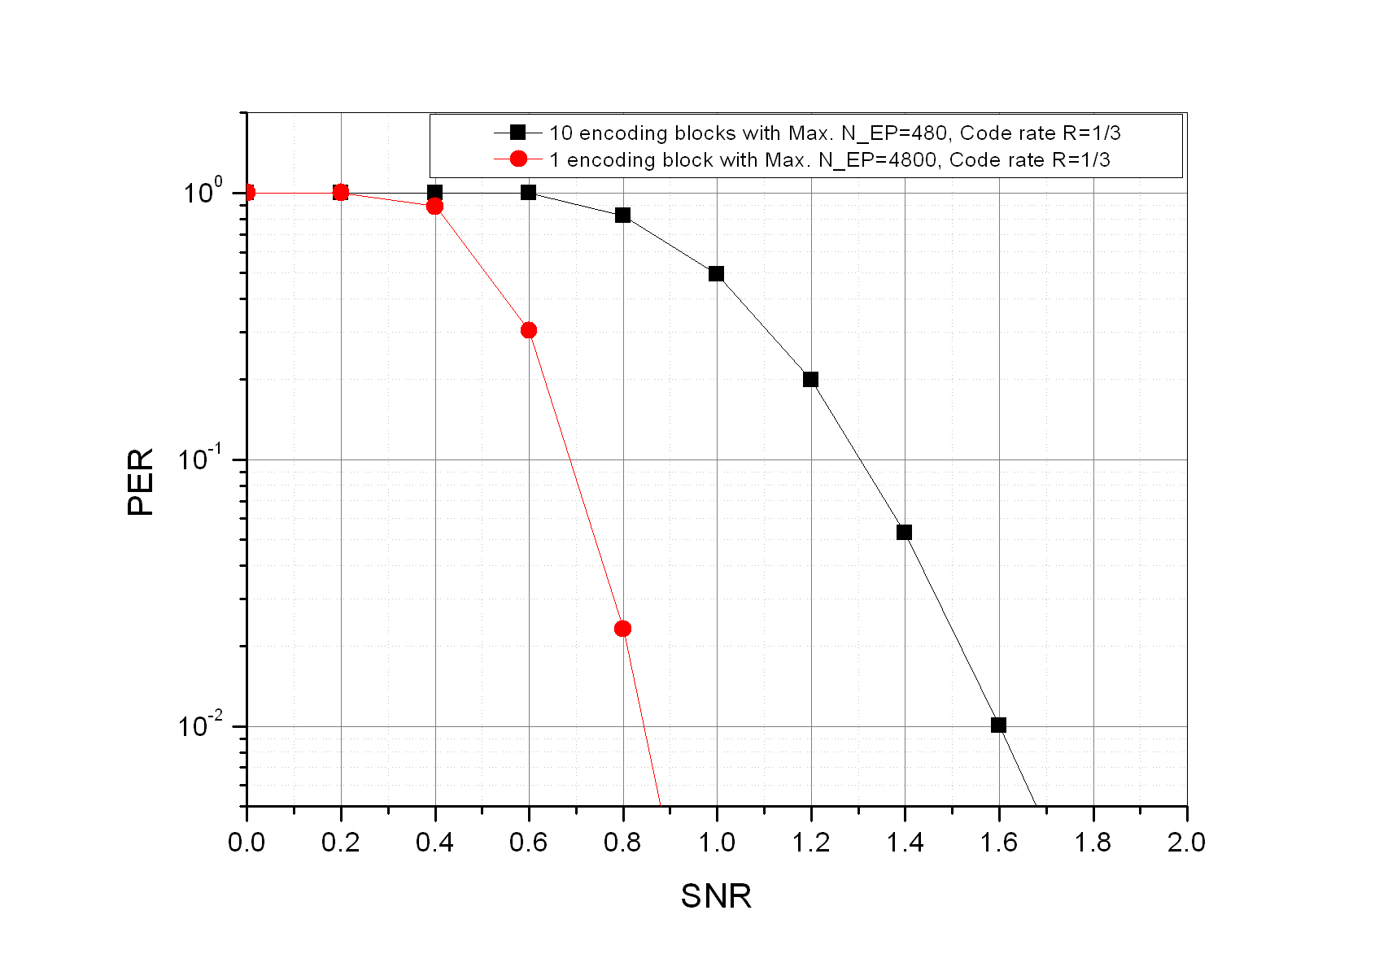
Figure 2. . PER comparison at R=1/3

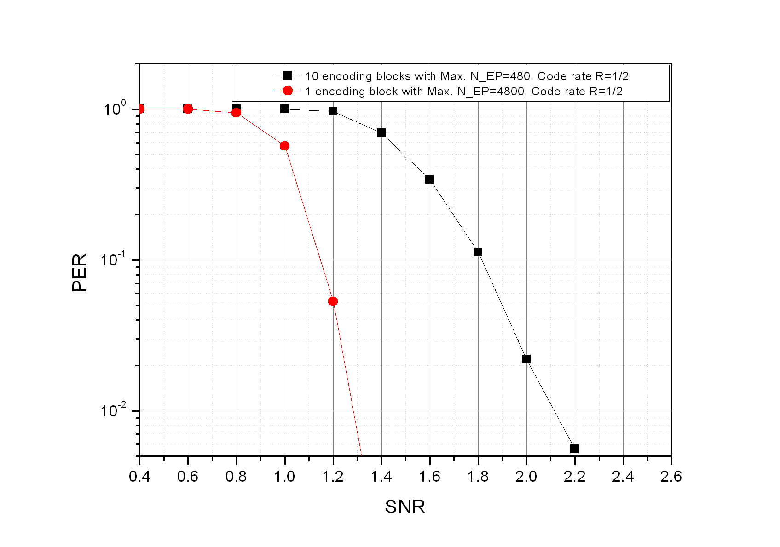
Figure 3. PER comparison at R=1/2

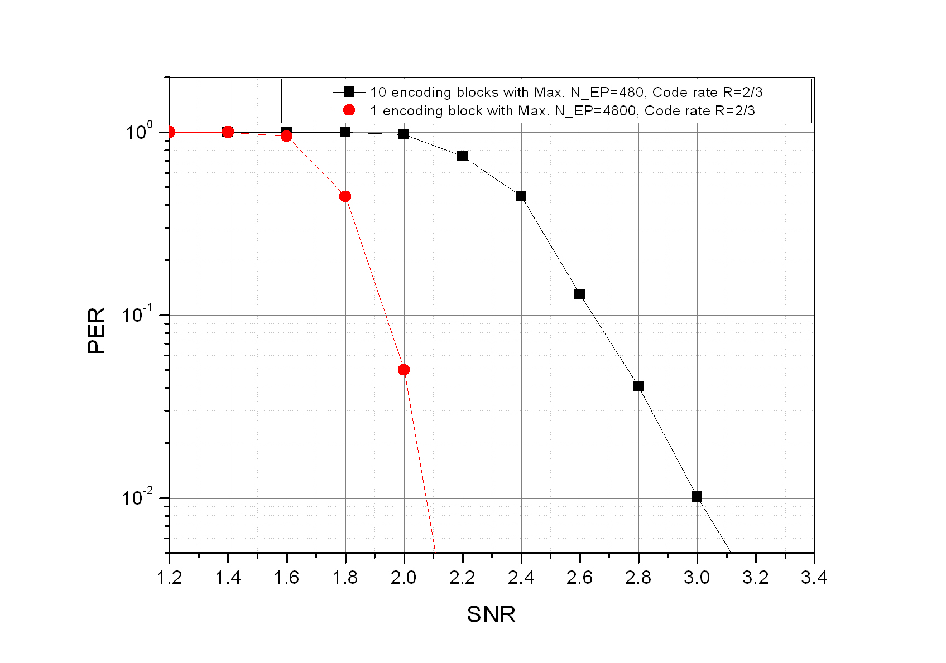
Figure 4. PER comparison at R=2/3

CTC enhancement for IEEE 802.16m system
In order to consider CTC enhancement in IEEE 802.16m, the following requirements are desirable in the design of CTC scheme.

1) Reuse of CTC in IEEE 802.16m (Duo-binary CTC structure)
In order to minimize additional complexity of channel coding in IEEE 802.16m system, it is desirable to reuse CTC which includes duo-binary encoding structure, CTC interleaver and mother code rate 1/3.

2) Large data block support
In order to support large data block from the upper layer, the maximum data block size shall be defined for an encoding block. Also, the maximum data block size shall be increased to obtain inherent coding gain of CTC sufficiently. According to our performance study, the maximum data block size 4800 bits shows good performance enhancement as compared with 480bits. Since there is still a room for the benefit of increasing the block size per an encoding block, the maximum data block size shall be over 4800 bits.

3) Fine granularity
In order to reduce padding overhead for supporting various MPDU and RU in IEEE 802.1m system, the CTC data block shall be defined with finer granularity.
In Table 1, there are 142 data block sizes of which the rage is from 40 bits to 4800 bits. The values of granularity are increased while increasing data block sizes considering limitation on the padding overhead. Figure 5 shows the average padding overhead in the data block sizes according to contiguous MPDU size. As compared with CTC of reference system, the proposed CTC has much reduced padding overhead.
Table 1. Proposed CTC data block size
Index | N_{EP} | Index | N_{EP} | Index | N_{EP} | Index | N_{EP} | Index | N_{EP} | Index | N_{EP}
1 | 40 | 25 | 264 | 49 | 488 | 73 | 928 | 97 | 1728 | 121 | 3264
2 | 48 | 26 | 272 | 50 | 496 | 74 | 944 | 98 | 1760 | 122 | 3328
3 | 64 | 27 | 288 | 51 | 512 | 75 | 960 | 99 | 1824 | 123 | 3392
4 | 72 | 28 | 296 | 52 | 528 | 76 | 976 | 100 | 1856 | 124 | 3456
5 | 80 | 29 | 304 | 53 | 544 | 77 | 992 | 101 | 1888 | 125 | 3520
6 | 88 | 30 | 312 | 54 | 576 | 78 | 1024 | 102 | 1920 | 126 | 3648
7 | 96 | 31 | 320 | 55 | 592 | 79 | 1056 | 103 | 1952 | 127 | 3712
8 | 104 | 32 | 328 | 56 | 608 | 80 | 1088 | 104 | 1984 | 128 | 3776
9 | 120 | 33 | 344 | 57 | 624 | 81 | 1152 | 105 | 2048 | 129 | 3840
10 | 128 | 34 | 352 | 58 | 640 | 82 | 1184 | 106 | 2112 | 130 | 3904
11 | 136 | 35 | 360 | 59 | 656 | 83 | 1216 | 107 | 2176 | 131 | 3968
12 | 144 | 36 | 368 | 60 | 688 | 84 | 1248 | 108 | 2304 | 132 | 4096
13 | 152 | 37 | 376 | 61 | 704 | 85 | 1280 | 109 | 2368 | 133 | 4160
14 | 160 | 38 | 384 | 62 | 720 | 86 | 1312 | 110 | 2432 | 134 | 4224
15 | 176 | 39 | 400 | 63 | 736 | 87 | 1376 | 111 | 2496 | 135 | 4288
16 | 184 | 40 | 408 | 64 | 752 | 88 | 1408 | 112 | 2560 | 136 | 4352
17 | 192 | 41 | 416 | 65 | 768 | 89 | 1440 | 113 | 2624 | 137 | 4416
18 | 200 | 42 | 424 | 66 | 800 | 90 | 1472 | 114 | 2752 | 138 | 4544
19 | 208 | 43 | 432 | 67 | 816 | 91 | 1504 | 115 | 2816 | 139 | 4608
20 | 216 | 44 | 440 | 68 | 832 | 92 | 1536 | 116 | 2880 | 140 | 4672
21 | 232 | 45 | 456 | 69 | 848 | 93 | 1600 | 117 | 2944 | 141 | 4736
22 | 240 | 46 | 464 | 70 | 864 | 94 | 1632 | 118 | 3008 | 142 | 4800
23 | 248 | 47 | 472 | 71 | 880 | 95 | 1664 | 119 | 3072 | $$⋮$$ | $$⋮$$
24 | 256 | 48 | 480 | 72 | 912 | 96 | 1696 | 120 | 3200 | $$⋮$$ | $$⋮$$

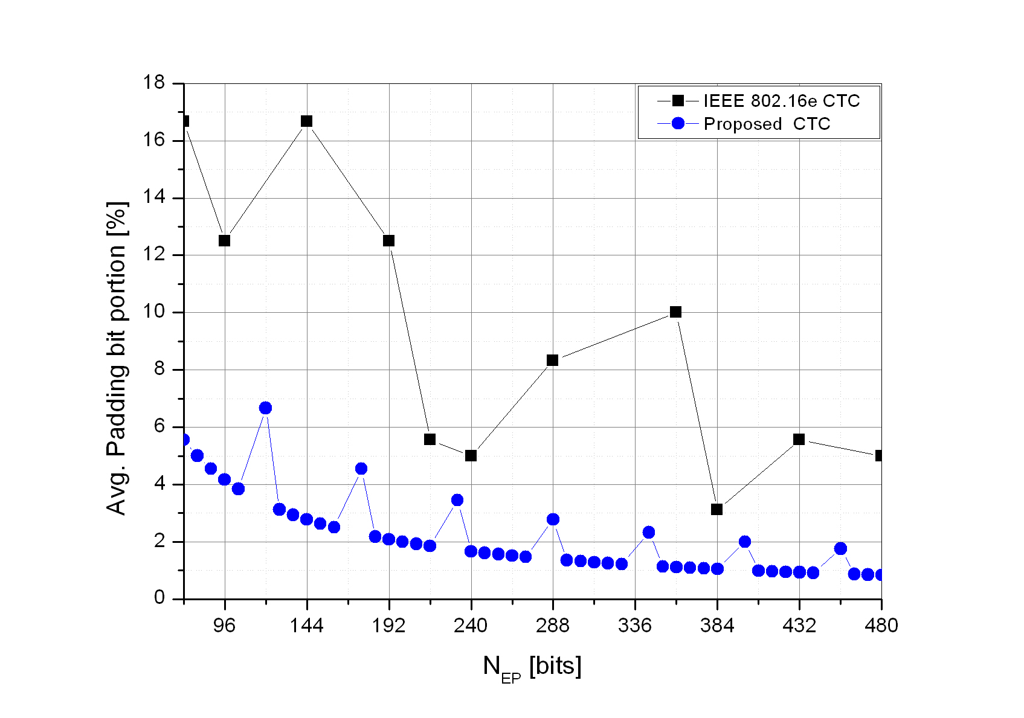
Figure 5. Average padding bit portion for the proposed CTC
In the 802.16m system, the effective number of data sub carriers in an RU is variable depending on type of sub frame and type of resource allocation [4]. Error: Reference source not found and Error: Reference source not found shows both CTC data block of reference system and the proposed CTC data block while increasing the number of RU’s with the modulation and coding scheme, QPSK and code rate 1/2. In an RU, it is assumed that the effective numbers of data sub carriers are 84 and 76. Also, the MPDU size is assumed to be equal to half of the channel bit size, so the code rate should be 1/2. If there is no data block size among the data block which is equal to the MPDU size, we have to choose the smallest one which is larger than the MPDU size. It means that a number of padding bits is required for the encoding of the MPDU size. According to the Error: Reference source not found and Error: Reference source not found, the padding bit portion is 12.5% and 18.75% for the CTC data block of reference system and 4.5% and 2.5% for the proposed CTC data blcok in the worst case.
Table 2. Padding overhead comparison with 84 data sub-carriers per an RU
# of RU | # of channel bit [bits] | MPDU size [bits] | N_{EP} [bits] |  | # of padding bit [bits] |  | Padding bit portion [%]
# of RU | # of channel bit [bits] | MPDU size [bits] | 16e | Proposed for 16m | 16e | Proposed for 16m | 16e | Proposed for 16m
1 | 168 | 84 | 96 | 88 | 12 | 4 | 12.5 | 4.5
2 | 336 | 168 | 192 | 176 | 24 | 8 | 12.5 | 4.5
3 | 504 | 252 | 288 | 256 | 36 | 4 | 12.5 | 1.6
4 | 672 | 336 | 360 | 344 | 24 | 8 | 6.7 | 2.3
5 | 840 | 420 | 432 | 424 | 12 | 4 | 2.8 | 0.9
Table 3. Padding overhead comparison with 78 data sub-carriers per an RU
# of RU | # of channel bit [bits] | MPDU size [bits] | N_{EP} [bits] |  | # of padding bit [bits] |  | Padding bit portion [%]
# of RU | # of channel bit [bits] | MPDU size [bits] | 16e | Proposed for 16m | 16e | Proposed for 16m | 16e | Proposed for 16m
1 | 156 | 78 | 96 | 80 | 18 | 2 | 18.8 | 2.5
2 | 312 | 156 | 192 | 160 | 36 | 4 | 18.8 | 2.5
3 | 468 | 234 | 240 | 240 | 6 | 6 | 2.5 | 2.5
4 | 624 | 312 | 360 | 312 | 48 | 0 | 13.3 | 0
5 | 780 | 390 | 432 | 400 | 42 | 10 | 9.7 | 2.5
6 | 936 | 468 | 480 | 472 | 12 | 4 | 2.5 | 0.8

In Figure 6 and 7, the BLER performance or proposed CTC data block has been performed with the required SNR values versus data block sizes with code rate 1/2 and 1/3 at target BLER 10%, and 1% each. For this performance evaluation, we optimized CTC interleaver for each data block. As shown figures, the CTC performance can be enhanced by increasing the data block size.
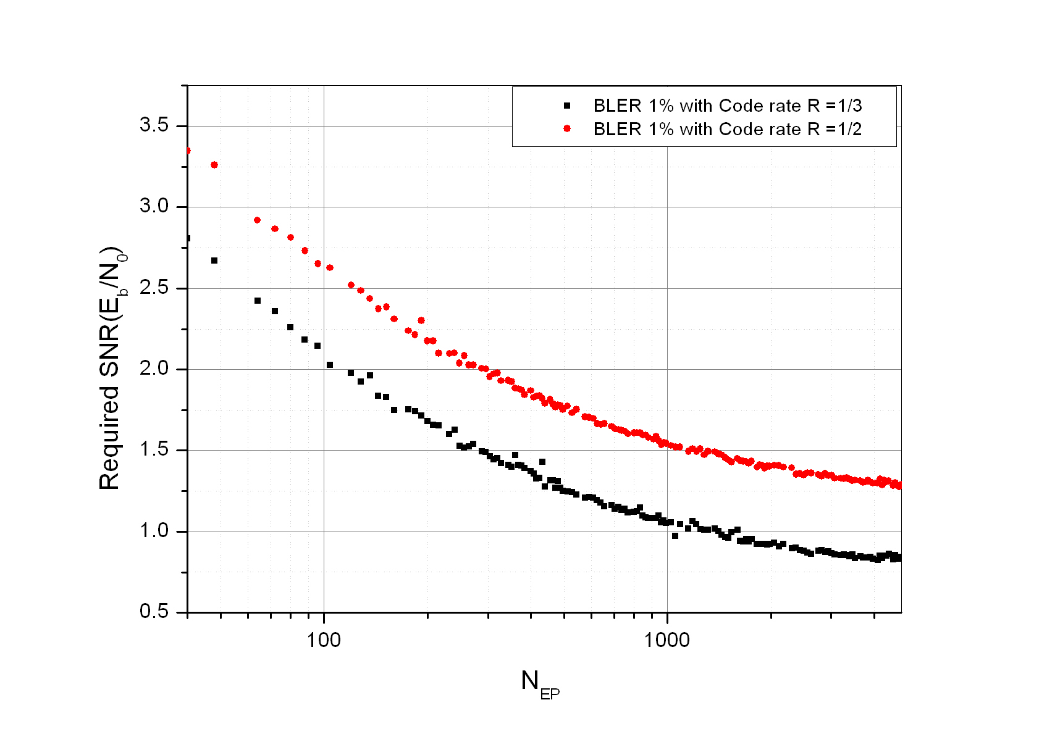
Figure 6. N_{EP} versus Required SNR at target BLER 1%
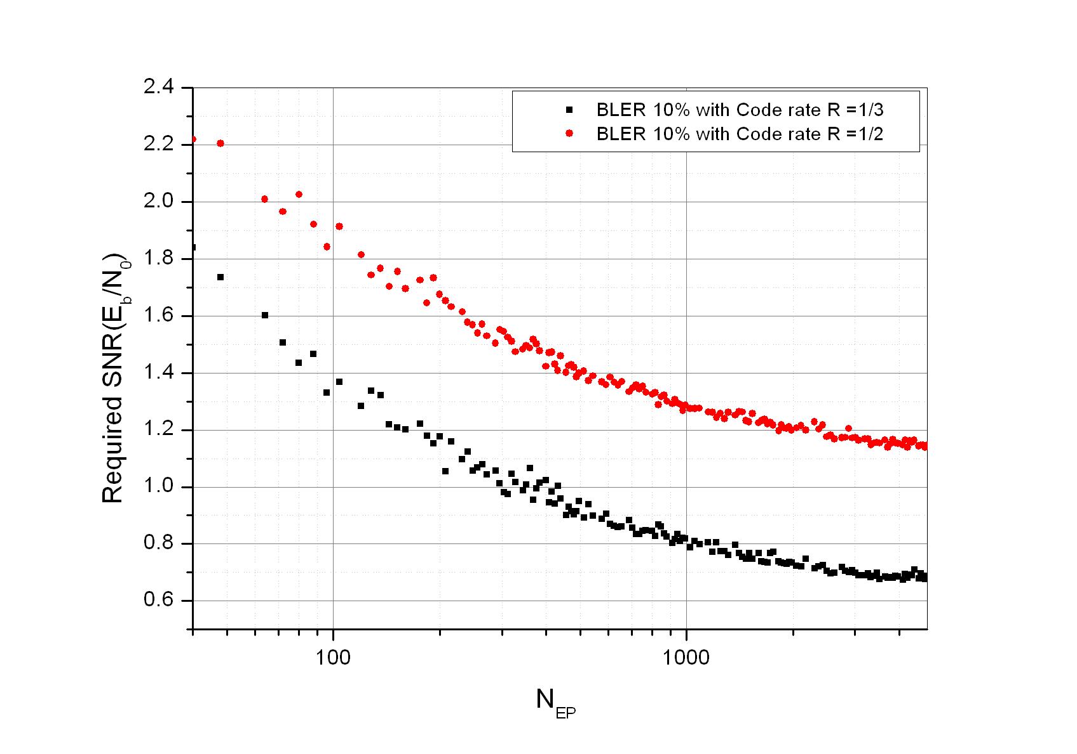
Figure 7. N_{EP} versus Required SNR at target BLER 10%

Conclusion
In order to consider CTC enhancement in IEEE 802.16m, the following requirements are desirable in the design of CTC scheme.
- Reuse of CTC in IEEE 802.16e (Duo-binary CTC structure)
- Data block definition according to new RU in IEEE 802.16m
- Large data block support (over 4800 information bits)
- Fine granularity ( Low padding overhead)

Reference
- IEEE 802.16m-07/002r3, “Draft IEEE 802.16m Requirements”
- IEEE P802.16Rev2 D2, “DRAFT Standard for Local and metropolitan area networks - Part 16: Air Interface for Broadband Wireless Access Systems,”
- IEEE 802.16m-08/003r1, “The Draft IEEE 802.16m System Description Document”
- IEEE C80216m-08/517r1, “802.16m DL PHY Structure Baseline Content Suitable for Use in the 802.16m SDD”
- IEEE C802.16m-07/010, “Rate Matching in 802.16m”
- IEEE C802.16m-08/305, “The analysis of HARQ maximum throughput per connection”
- IEEE C802.16m-08/362, “HARQ Timing and Protocol Considerations for IEEE 802.16m”
- 3GPP TS 36.212, “Multiplexing and channel coding”

Text Proposal to SDD
--------------------------------------------------------------- Start of Proposed Text -------------------------------------------------------------

11.x Channel Coding

11.x.1 Channel Coding for data channel

11.x.1.x Convolutional Turbo Codes

CTC shall support large data size over 4800 information bits with fine granularity providing padding overhead of less than 9 %. Specific code structure is FFS.

--------------------------------------------------------------- End of Proposed Text --------------------------------------------------------------

