Project | IEEE 802.16 Broadband Wireless Access Working Group <http://ieee802.org/16>
Title | Feasibility verification of LDPC codes for HARQ operation
Date Submitted | 2008-07-07
Source(s) | Ji Wook Chung, Sukwoo Lee, Kihyoung Cho  LG Electronics, Inc. LG R&D Complex, 533 Hogye-1dong, Dongan-gu, Anyang, 431-749, Korea | [Voice: +82-31-450-7875]  E-mail: {jwChung, sugoo, kihyoung }@lge.com  *<http://standards.ieee.org/faqs/affiliationFAQ.html>
Re: | IEEE 802.16m-08/024 – Call for Contributions on Hybrid ARQ (PHY aspects)
Abstract | This contribution considers Feasibility verification of LDPC codes for HARQ operation. Low-Density-Parity-Check (LDPC) code is one of data channel coding schemes specified in IEEE 802.16e system, which provides large decoder throughput and comparable performance with CTC.
Purpose | To be discussed and adopted by TGm for use in the IEEE 802.16m SDD
Notice | This document does not represent the agreed views of the IEEE 802.16 Working Group or any of its subgroups. It represents only the views of the participants listed in the “Source(s)” field above. It is offered as a basis for discussion. It is not binding on the contributor(s), who reserve(s) the right to add, amend or withdraw material contained herein.
Release | The contributor grants a free, irrevocable license to the IEEE to incorporate material contained in this contribution, and any modifications thereof, in the creation of an IEEE Standards publication; to copyright in the IEEE’s name any IEEE Standards publication even though it may include portions of this contribution; and at the IEEE’s sole discretion to permit others to reproduce in whole or in part the resulting IEEE Standards publication. The contributor also acknowledges and accepts that this contribution may be made public by IEEE 802.16.
Patent Policy | The contributor is familiar with the IEEE-SA Patent Policy and Procedures:  <http://standards.ieee.org/guides/bylaws/sect6-7.html#6> and <http://standards.ieee.org/guides/opman/sect6.html#6.3>.  Further information is located at <http://standards.ieee.org/board/pat/pat-material.html> and <http://standards.ieee.org/board/pat>.
Feasibility Verification of LDPC codes for HARQ Operation
Ji Wook Chung, Sukwoo Lee, Kihyoung Cho
LG Electronics
1. Introduction
Low-Density-Parity-Check (LDPC) code is one of data channel coding schemes specified in IEEE 802.16e system, which provides large decoder throughput and comparable performance with CTC. However, there are several technical challenges to accommodate enhanced HARQ operation. This contribution shows some technical feasibility and rationale for IEEE 802.16m system, and then proposes that LDPCC is incorporated in SDD.
2. A proposed LDPC codes to support HARQ operation
HARQ techniques for 802.16m should be enhanced in terms of full HARQ mode, large block transmission and larger size of MCS set. In order to support the IEEE 802.16m HARQ operation, it is required to flexible H-matrix structure because unlike CTC, LDPCC does not fully support rate compatibility. Thus, we propose a LDPC coding method satisfying this technical requirement without scarifying flexibility, complexity and performance. The basic attributes in the proposed LDPC codes are summarized as follows.
- Various code word support by the same method of IEEE 802.16e (Size adaptation)
- Similar encoding mechanism to IEEE 802.16e (Dual diagonal parity part)
- Rate compatible H-Matrix structuring by row-combining and matrix dividing (HARQ IR support)

2.1. Size adaptation for the support of various code words
$p(f,i,j)=\left\{\begin{matrix}p(i,j), p(i,j)≤0 \\ \left\lfloor \frac{p(i,j)z_{f}}{z_{0}}\right\rfloor , p(i,j)>0\end{matrix}\right.$Scaling and expansion described in IEEE 802.16e LDPC code is reused as a method to support various sizes of codewords.

$\left\lfloor x\right\rfloor$where the shift sizes {p(f, i, j)} for a code size corresponding to expansion factor zf are derived from {p(i,j)} and where denotes arithmetic flooring function.

2.2. Parity part structure for the support of simplified encoding
LDPC Code in IEEE 802.16e is generated by a simplified encoding method since parity part of H matrix is based on block accumulator as shown in Figure 4. This basic concept is also reused for IEEE 802.16m system.
Figure 1. The block accumulator parity structure of H matrix for supporting multi-rates
2.3. Code rate adaptation method
2.3.1. Row-Combining
H matrix is manipulated by row-combining to support higher code rate. The simple rule of row-combining is that if two rows of H matrix do not have weight in the same column position, then the two rows can be combined to reduce the number of rows. Figure 3 shows one example of combining two rows based on Row-Combining rule.
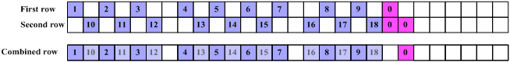
Figure 2. Basic concept of row combing

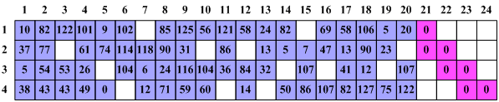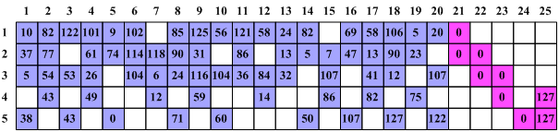
Size : 5x25
Size : 4x24
Disappeared Column because of even weights
Row-Combining
Figure 3. H-Matrix extension by row- combining
2.3.2. Matrix dividing
H matrix is manipulated by matrix-dividing to support higher code rate. The accumulator parity structure is divided to support higher code rates as shown in Figure 4. For example, if we assume that the size of mother H matrix is 40 by 60 and mother code rate is 1/3, then to support higher code rate (1/2) than mother code rate, we can get reduced H matrix whose size is 20 by 40 by reducing the size of row and column in the mother H matrix. Thus, higher code rate can be achieved easily with matrix dividing method over the block accumulator parity structure.
Figure 4. One example of Matrix Dividing

3. Complexity Evaluation
We summarized the well-known complexity of TC and LDPCC in Table 1. It is assumed that average column degree of LDPCC is around 3 for all code rates. As showin in the table, the complexity of LDPCC is lower than TC [2], and it would be much lower if we compare with CTC which is known as having much higher complexity than TC.
Table 1. Operations count comparison of sub-optimal decoders LDPC and TC decoders.
 | LDPCC | TC | Complexity of LDPC / Complexity of TC
Algorithm | Min-Sum+Offset | Max Log Map  +extrinsic scaling
Number of Iterations | 25 | 8
Total cost (R=1/3) | 38K x 25 = 950K | 171K x 8 = 1368K | 69%
Total cost (R=1/2) | 25K x 25 = 625K | 171K x 8 = 1368K | 45%
Total cost (R=2/3) | 18.5K x 25 = 462.5K | 171K x 8 = 1368K | 33%
Total cost (R=3/4) | 16.3K x 25 = 407.5K | 171K x 8 = 1368K | 29%
Total cost (R=5/6) | 14.6K x 25 = 365K | 171K x 8 = 1368K | 26%

4. Decoding Throughput
Decoding throughput of LDPCC and TC are calculated with parallel processing factor. In the case of LDPCC, the parallel processing is inherited in the phase of LDPC code design while TC is dependent on the capability of contention-free interleaver. For detailed comparison, it is assumed that LDPCC and TC of mother code rate equal to 1/3, and the maximum clock frequencies of two decoders both are 100MHz, the maximum numbers of iteration for turbo codes is 8, and the maximum numbers of iterations for LDPC codes is 25, $F_{\text{int}}$ is internal clock rate (100 MHz), z is the expand factor of structured LDPC codes, and K is the information block size of 5114 [4].
[Decoder Throughput of LDPCC]
The information data throughput of LDPC decoders has been calculated as follow:
$$F_{\text{dec}}=\frac{F_{\text{int}}⋅K}{\text{NI}⋅(z/l)+1}=\frac{F_{\text{int}}⋅(n_{b}−m_{b})⋅l}{\text{25}+l/z}=\frac{\text{100}⋅8⋅l}{\text{25}+(l/z)}=(\text{30}\text{.}\text{769}\text{\sim }\text{32})⋅l (\text{Mbps})$$
In case of no parallel processing, $F_{\text{dec}}$= 30Mbps,
In case of maximum parallel processing factor, $F_{\text{dec}}$ is 8*100*639/26=20Gbps.

[Decoder Throughput of TC]
The information data throughput of turbo decoders has been calculated as follow:
$$F_{\text{dec}}=\frac{F_{\text{int}}⋅K}{\text{NI}⋅(2⋅K)+1}≈\frac{F_{\text{int}}}{2⋅\text{NI}}=\frac{\text{100}}{\text{16}}=6\text{.}\text{25}(\text{Mbps})$$
Here we assume that the I/O operation needs 1 clock cycle. If sliding window algorithm is used, interleaver and de-interleaver have been considered, $F_{\text{dec}}$=5.88/1.2 = 5.2(Mbps).
In case of no parallel processing, $F_{\text{dec}}=6\text{.}\text{25}(\text{Mbps})$,
In case of parallel processing factor (60), $F_{\text{dec}}$ is 5.2 *60 = 312Mbps.

5. Performance Evaluation
We will show the performances of 16e LDPC Codes and the LDPC Codes with proposed design structures. The H matrix with proposed design structures can support not only multiple code rate but also HARQ-IR only with a single base H-matrix, while 16e LDPCC can not support HARQ-IR. The performance evaluation is carried out comparing with 16e LDPCC and CTC in Figure 5 and Figure 6 respectively. For simulation assumption: AWGN channel, QPSK, Layered Decoding of Max-iteration 25 for LDPCC, Max-LogMap with scaling factor of 0.75 for CTC

Table 2.Average variable node comparison of proposed LDPCC
Code Rate | Average Variable node 16e LDPCC | Average Variable node of proposed LDPCC
5/6 | 3.33 | 2.92
3/4 | 3.67 | 2.83
2/3 | 3.38 | 2.94
1/2 | 3.17 | 3.12
1/3 | Not support | 2.89

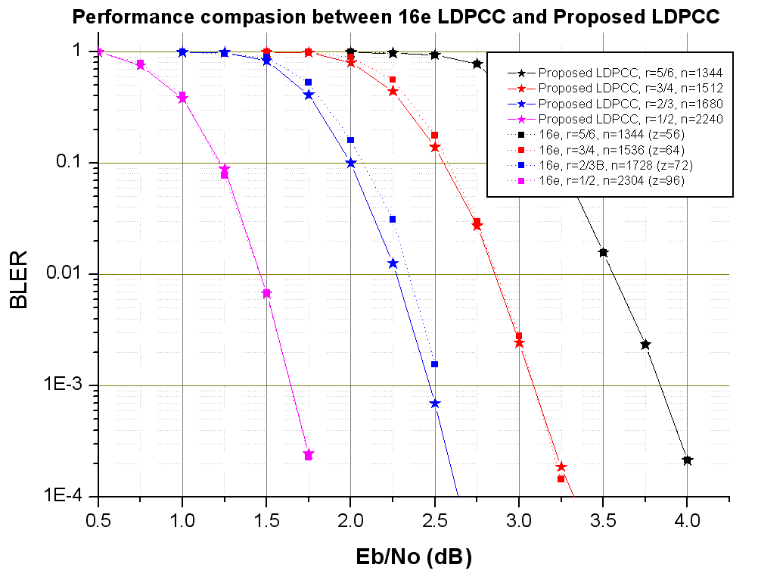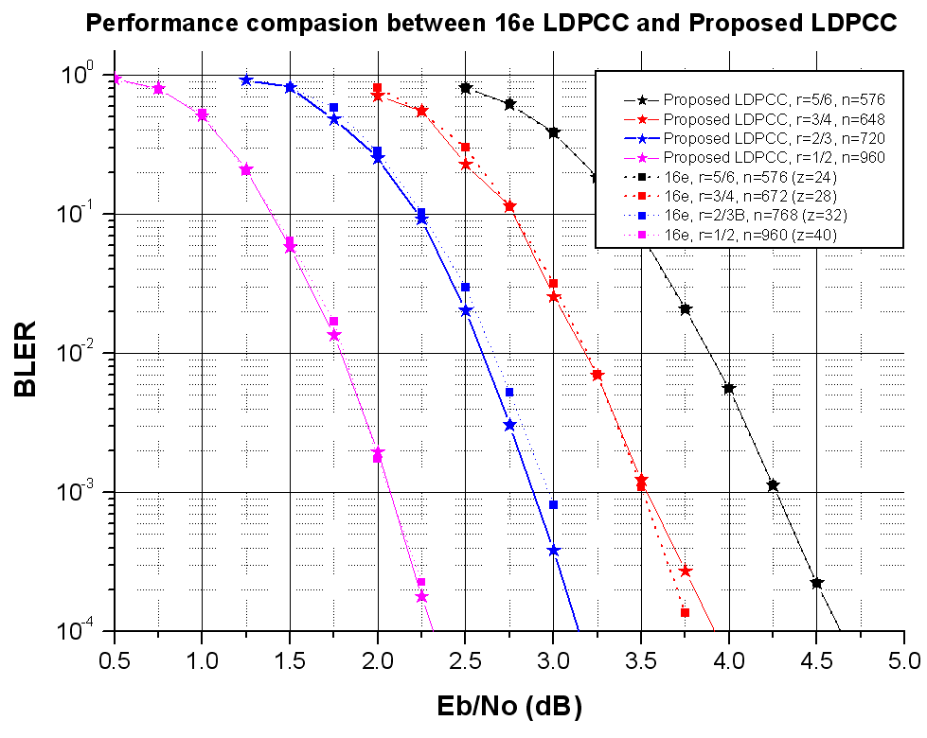
Figure 5. Performance comparison of the proposed LDPCC

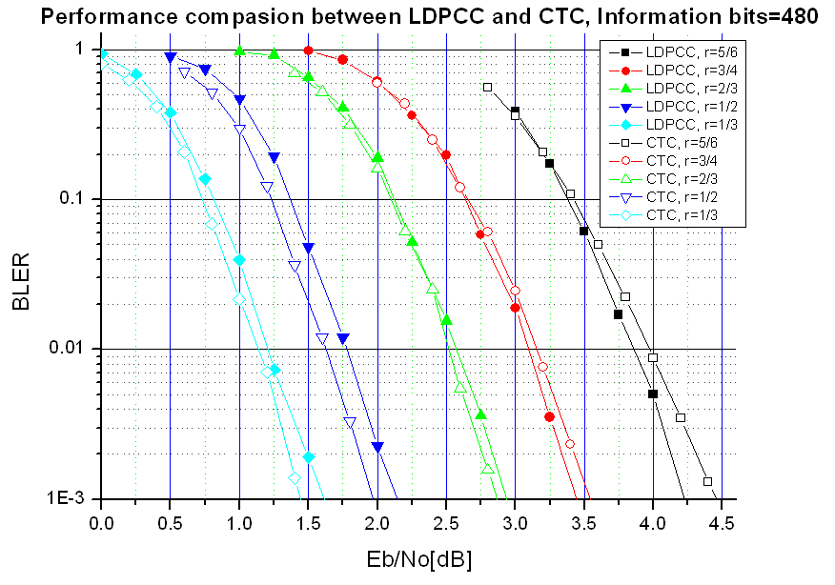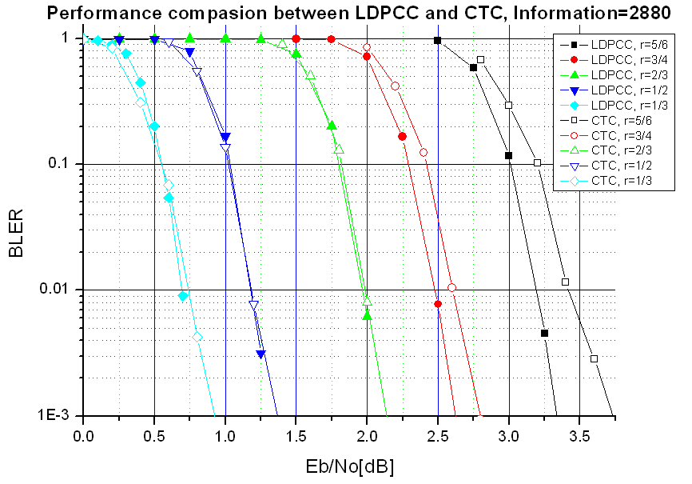

Figure 6. Performance comparison of proposed LDPCC
6. Conclusion
LDPC Codes is one of promising coding schemes in terms of performance, throughput, simplicity, and flexibility. Especially the parallel decoding capability of LDPC coding has strength in reducing large decoding latency which can be a bottle neck for broadband wireless service. Thus we propose that LDPCC should be considered on IEEE 802.16m SDD as follows.
======================Text Proposal for the 802.16m SDD======================
LDPC Codes shall be used to support HARQ in the IEEE 802.16m
======================================================================
References
- E. Eleftheriou, T. Mittelholzer, and A. Dholakia, “Reduced complexity decoding algorithm for low-density parity check codes,” IEEE Electronic Letters, vol. 37, no. 2, pp. 1288-1299, pp. 102-104, Jan. 2001.
- R1-060874, ” Complexity Comparison of LDPC Codes and Turbo Codes,” 3GPP TSG RAN WG1#44bis , Athens, Greece. 27 - 31 Mar 2006.
- J. Vogt and A. Finger: "Improving the max-log-map turbo decoder", in: IEEE Electronics Letters, 2000, Vol. 36, No. 23, pp.1937-1939.
- 3GPP, R1-051360, ZTE et al., “Comparison of structured LDPC codes and 3GPP Turbo codes”

