Project | IEEE 802.16 Broadband Wireless Access Working Group <http://ieee802.org/16>
Title | Constellation Rearrangement for IEEE 802.16m
Date Submitted | 2008-07-07
Source(s) | Hyungho Park, HanGuy Cho, Sungho Moon  LG Electronics | Voice : +82-31-450-1852  E-mail: hyunghopark@lge.com, hgcho@lge.com, msungho@lge.com,
Re: | IEEE 802.16m-08/024 – Call for Contributions on Hybrid ARQ (PHY aspects)
Abstract | The contribution describes and proposes many consideration points and some candidates for IEEE 802.16m HARQ PHY
Purpose | To be discussed and adopted by TGm for use in the IEEE 802.16m SDD
Notice | This document does not represent the agreed views of the IEEE 802.16 Working Group or any of its subgroups. It represents only the views of the participants listed in the “Source(s)” field above. It is offered as a basis for discussion. It is not binding on the contributor(s), who reserve(s) the right to add, amend or withdraw material contained herein.
Release | The contributor grants a free, irrevocable license to the IEEE to incorporate material contained in this contribution, and any modifications thereof, in the creation of an IEEE Standards publication; to copyright in the IEEE’s name any IEEE Standards publication even though it may include portions of this contribution; and at the IEEE’s sole discretion to permit others to reproduce in whole or in part the resulting IEEE Standards publication. The contributor also acknowledges and accepts that this contribution may be made public by IEEE 802.16.
Patent Policy | The contributor is familiar with the IEEE-SA Patent Policy and Procedures:  <http://standards.ieee.org/guides/bylaws/sect6-7.html#6> and <http://standards.ieee.org/guides/opman/sect6.html#6.3>.  Further information is located at <http://standards.ieee.org/board/pat/pat-material.html> and <http://standards.ieee.org/board/pat>.

Constellation Rearrangement for IEEE802.16m HARQ
Hyungho Park, HanGuy Cho, Sungho Moon
LG Electronics

Introduction

In Macau meeting, we proposed the HARQ structure which supports both Chase HARQ and IR HARQ in IEEE802.16m [1]. While Chase HARQ has advantage in the aspect of complexity, it yields some performance loss compared to IR HARQ. Constellation rearrangement is one of cost-effective solution for enhancement of Chase LLR combing by exploiting further coding gain with low complexity of implementation. In this contribution, we suggest an enhanced constellation rearrangement scheme with consideration of both temporal and spatial diversity.

Constellation Rearrangement

Constellation Rearrangement can provide the performance enhancement of 16m HARQ by defining the pre-defined bitwise mapping rule between MS and BS at every retransmission. In case of high modulation order, the reliabilities of the Gray mapped bits vary from most significant bit (MSB) to least significant bit (LSB). These kinds of unequal bit reliability still remain biased during retransmission, which degrades the performance of channel decoding. Since the constellation rearrangement performs an averaging of bit error probabilities over retransmissions, a significant increase in decoding performance occurs. However, constellation rearrangement shall be further improved for IEEE802.16m which has been required to fulfill the IMT-Advanced requirement on high data throughput [2] as follows.

- High modulation order support
Higher order modulated symbol has a larger potential gain from constellation rearrangement due to its increased number of component bits for bitwise rearrangement.

- Incorporation of MIMO
Contrary to Chase HARQ in single antenna transmission, MIMO related Chase combing is not straightforward because the symbols transmitted from each antenna interfere with each other. As the number of retransmission is increased, the interference is further aggravated in course of Chase LLR combing. Therefore constellation rearrangement should be designed in the aspect of averaging the difference of bit reliability in spatial domain.

Proposed Constellation Rearrangement for IEEE802.16m

As an efficient solution for the above consideration points, we propose an enhanced constellation rearrangement so that it can be incorporated in consideration of MIMO configuration [4][5]. Figure 1 shows the concept of proposed constellation rearrangement in multiple antenna transmission, which consists of horizontal and vertical bitwise mapping as follows

- Horizontal bitwise mapping
Horizontal bitwise mapping changes the bit position and its value on signal constellation in order to get temporal diversity gain during retransmissions through the following operations.

  - Swapping operation exchanges component bits (i₁, q₁, i₂, q₂) on signal constellation in order to average the difference of bit error probability.
  - Inversion operation averages out error probabilities of candidate component bits by taking inversion of the corresponding bits on signal constellation

- Vertical bitwise mapping
In multiple antenna transmission, the channel difference between component bits cannot be decreased by spatial selective diversity, because spatial diversity in a unit of symbol is only related to the increase of received SNR. It even aggravates the reliability difference between component bits. Therefore, vertical bitwise mapping perform to exchange components bits between transmit antennas for averaging the channel difference.

For every retransmission, rearrangement mapping rule is designed in the aspect of averaging out unequal bit error probabilities through horizontal and vertical bitwise mapping. Specific mapping rules are FFS.

Fig. 1 Proposed Constellation Rearrangement (2 Tx, 16QAM)

Simulation Result

Table 1 shows the performance comparison of 16e Chase/IR HARQ and proposed constellation rearrangement. As a simulation result, the proposed constellation rearrangement obtains approximately 2~3dB gain (10% target FER) over 16e Chase HARQ regardless of MS’s mobility. In addition, the proposed constellation rearrangement shows a little improvement in link performance gain over 16e IR HARQ. More details of simulation result are provided in appendix.

Table 1: Performance comparison (2 by 2 MIMO, 16 QAM)
Performance gain  (10% FER) | CoRe over Chase (30 km) | CoRe over Chase  (120 km) | CoRe over IR, (30km) | CoRe over IR  (120 km)
N_{re} = 1 | 1.7 dB | 1.9 dB | 0.30 dB | 0.35 dB
N_{re} = 2 | 2.1 dB | 2.2 dB | 0.15 dB | 0.15 dB
N_{re} = 3 | 2.8 dB | 3.1 dB | 0.47 dB | 0.47 dB
N_{re}:Maximum number of retransmission, CoRe: constellation rearrangement

Conclusion

We would like to replace conclusion with the following text proposal.

Text Proposal for the IEEE802.16m SDDs [3]

================================= Start of Proposed Text ====================================

x.x HARQ mode

x.x.x. Constellation Rearrangement

Constellation rearrangement considering both horizontal and vertical bitwise mapping shall be adopted for IEEE 802.16m.

x.x.x.1. Horizontal bitwise mapping

Horizontal bitwise mapping changes the bit position and its value on signal constellation in order to get temporal diversity gain during retransmissions through the following operations. A specific mapping rule is FFS.

x.x.x.2 Vertical bitwise mapping

Vertical bitwise mapping perform to exchange components bits between transmit antennas for averaging the channel difference. A specific bitwise mapping rule is FFS
=================================== End of Text Proposal ===================================

Reference

[1] IEEE 802.16m-08/412, “Hybrid-ARQ structure for IEEE802.16m”
[2] IEEE 802.16m-07/002r4, IEEE 802.16m System Requirement, 2007-10-19
[3] IEEE 802.16m-08/003r3, “The draft IEEE802.16m System Description Document”
[4] IEEE GLOBECOM 2007, “Bit rearrangement for MIMO retransmission”, Sung Ho Moon, Hyung Ho Park, Andrea Goldsmith, and Minseok Oh
[5] WBWF 2007, “A New constellation rearrangement for MIMO systems with Hybrid ARQ, Hyung Ho Park and Jin Sung Choi

Appendix
Fig. A Gray mapped signal constellation for 16QAM; bit mapping order

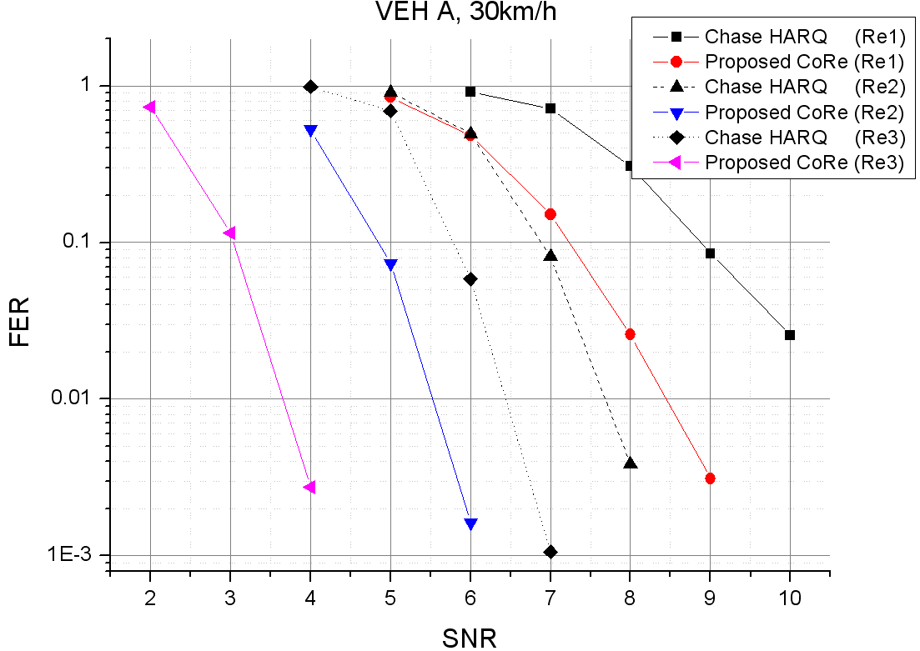
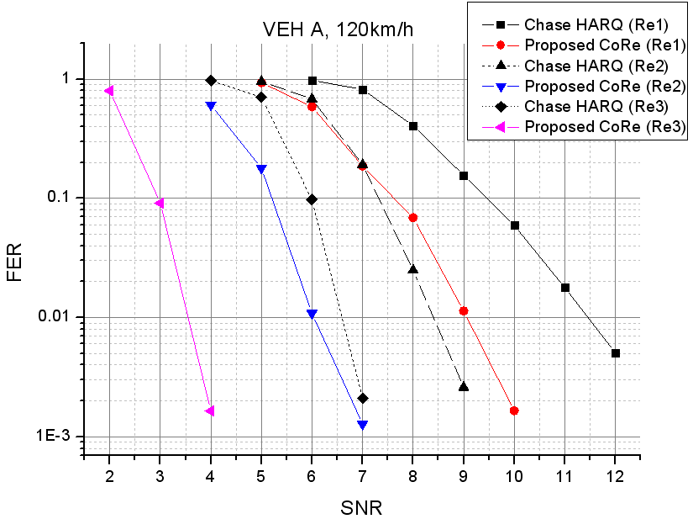
Fig B. Performance comparison of CoRe and 16e Chase HARQ
(Re: Maximum number of retransmission, 16 QAM)
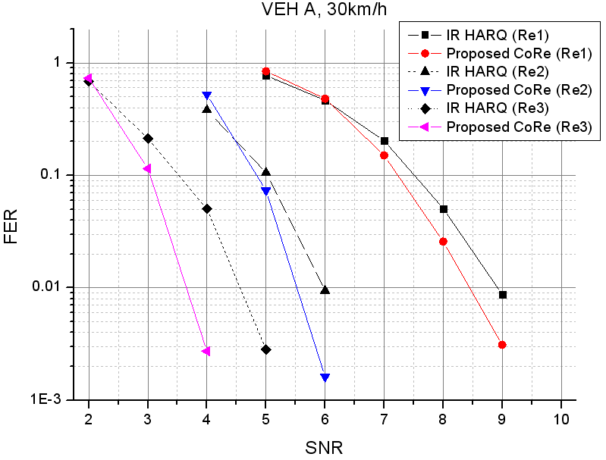

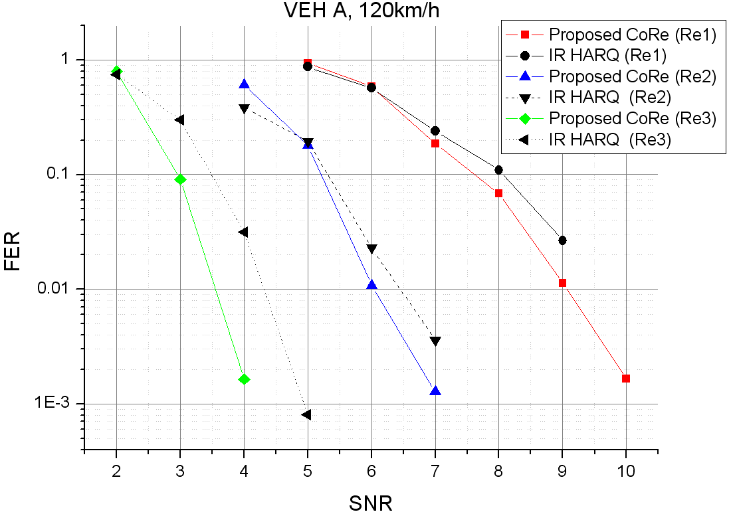
Fig C. Performance comparison of CoRe and 16e IR HARQ (16 QAM)

Table: Simulation Parameters
Parameters | Assumption
Bandwidth | 10 MHz
Number of subcarrier | 1024
Frame length | 5ms
Channel estimation | Perfect
Channel code | CTC 1/2
Modulation | 16 QAM
MIMO configuration | Tx: 2, Rx:2
Resource allocation | PUSC
Channel model | VEH A
MS mobility | 30km/h, 120km/h
Receiver type | Linear MMSE
Maximum number of retransmission | 1, 2, 3
Retransmission latency | 10ms

