Project | IEEE 802.16 Broadband Wireless Access Working Group <http://ieee802.org/16>
Title | MCS for IEEE 802.16m CTC
Date Submitted | 2008-07-07
Source(s) | Woosuk Kwon, Seunghyun Kang, Sukwoo Lee  LG Electronics, Inc. LG R&D Complex, 533 Hogye-1dong, Dongan-gu, Anyang-shi, 431-749, Korea | Voice: +82-31-450-1869  E-mail: kytloze@lge.com, sh_kang@lge.com,  sugoo@lge.com  *<http://standards.ieee.org/faqs/affiliationFAQ.html>
Re: | IEEE 802.16m-08/024 - Call for Contributions on Link Adaptation Schemes
Abstract | This contribution describes the considerations on MCS table in IEEE 802.16e reference system and provides our view of new MCS design for better link adaptation.
Purpose | To be discussed and adopted by TGm for use in the IEEE 802.16m SDD
Notice | This document does not represent the agreed views of the IEEE 802.16 Working Group or any of its subgroups. It represents only the views of the participants listed in the “Source(s)” field above. It is offered as a basis for discussion. It is not binding on the contributor(s), who reserve(s) the right to add, amend or withdraw material contained herein.
Release | The contributor grants a free, irrevocable license to the IEEE to incorporate material contained in this contribution, and any modifications thereof, in the creation of an IEEE Standards publication; to copyright in the IEEE’s name any IEEE Standards publication even though it may include portions of this contribution; and at the IEEE’s sole discretion to permit others to reproduce in whole or in part the resulting IEEE Standards publication. The contributor also acknowledges and accepts that this contribution may be made public by IEEE 802.16.
Patent Policy | The contributor is familiar with the IEEE-SA Patent Policy and Procedures:  <http://standards.ieee.org/guides/bylaws/sect6-7.html#6> and <http://standards.ieee.org/guides/opman/sect6.html#6.3>.  Further information is located at <http://standards.ieee.org/board/pat/pat-material.html> and <http://standards.ieee.org/board/pat>.
MCS for IEEE 802.16m CTC
Woosuk Kwon, Seunghyun Kang, Sukwoo Lee
LG Electronics

- Introduction
In this contribution, we discuss the Modulation and Coding Schemes (MCS) of IEEE 802.16e reference system. Also, we propose the MCS requirements and the new MCS table for IEEE 802.16m system.

- MCS in IEEE 802.16e reference system
In the IEEE 802.16e reference system, there are 11 MCS entries which include 3 MCS entries with repetition scheme as shown in Table 1. Figure 1 shows the required SNR of each MCS entry at target BLER 10%. According to the figure, the required SNR of each MCS entry has been irregularly distributed. In the worst case, the granularity of the required SNR is 4 dB. Also, because of the coarse granularity of the required SNR, it seems to be difficult to reflect the channel condition exactly, and it can cause a poor AMC gain.

Table 1. MCS table for CTC in IEEE 802.16e
MCS Index | Code rate | Modulation  Order | Spectral  Efficiency
0 | 1/12 | 2 | 0.17
1 | 1/8 | 2 | 0.25
2 | 1/4 | 2 | 0.50
3 | 1/2 | 2 | 1.00
4 | 3/4 | 2 | 1.50
5 | 1/2 | 4 | 2.00
6 | 3/4 | 4 | 3.00
7 | 1/2 | 6 | 3.00
8 | 2/3 | 6 | 4.00
9 | 3/4 | 6 | 4.50
10 | 5/6 | 6 | 5.00

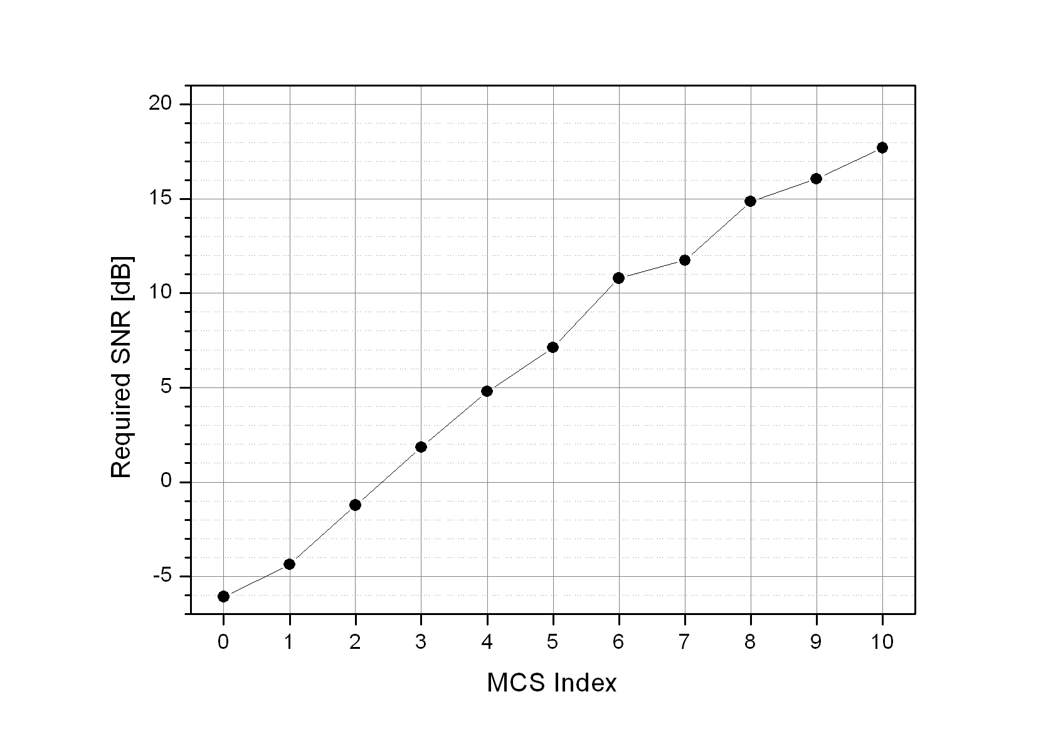
Figure 1. The required SNR of the MCS in the reference system at target BLER 10%

In IEEE 802.16m system, it is necessary to have an equal spacing of the required SNR for MCS entries and a denser MCS depending on the control information bits for MCS indication in order to reflect more exact channel condition.

- New MCS design for IEEE 802.16m system

  - Assumptions
In IEEE 802.16m system, the effective number of data sub carriers in an RU is variable depending on type of sub frame and type of resource allocation as shown in Table 2. In order to design new MCS for the IEEE 802.16msystem, it is necessary to use a typical number of data sub carriers as a baseline. Also, we have used 85 data sub carriers per an RU as a baseline for designing new MCS for 802.16m system in the following chapter.

Table 2. The effective number of data sub-carriers for an RU in IEEE 802.16m
 | 18 × 5 |  |  |  | 18 × 6 |  |  |  | 18 × 7
 | 1 OFDM Control |  | 0 OFDM Control |  | 1 OFDM Control |  | 0 OFDM Control |  | 1 OFDM Control |  | 0 OFDM Control
Tx Antenna | Pilot | Data sub-carrier | Pilot | Data sub-carrier | Pilot | Data sub-carrier | Pilot | Data sub-carrier | Pilot | Data sub-carrier | Pilot | Data sub-carrier
1 Tx. | 4 | 68 | 5 | 85 | 5 | 85 | 6 | 102 | 6 | 102 | 7 | 119
2 Tx. | 8 | 64 | 10 | 80 | 10 | 80 | 12 | 96 | 12 | 96 | 14 | 112
4 Tx. | 16 | 56 | 20 | 70 | 20 | 70 | 24 | 84 | 24 | 84 | 28 | 98

  - MCS design procedure for IEEE 802.16m system
The design procedure of new MCS for IEEE 802.16m system is as follows
- Select code rate range 0.1 ~ 0.9 and required SNR -5 ~ 20 dB in order to have a similarity of MCS in the reference system.
- Map the modulation orders to the code rates in the range in order to make the MCS candidates as many as possible considering overlap of spectral efficiency.
- Select a data block size NEP which can support the MCS candidates properly.
- Evaluate the BLER performance with the combination of code rates, modulation order and NEP.
- Check the required SNR at target BLER 10%.
- Select 16 MCS entries from the candidate code rates and modulation order in order to have uniform required SNR space.

  - New MCS design for IEEE 802.16m system
We have designed new MCS for IEEE 802.16m system with 16 MCS entries as shown in Table 3. Figure 2 shows the required SNR for New MCS at target BLER 10%. Comparing to Figure 1, the required SNR values of new MCS have been uniformly distributed with the granularity around 1.4dB. Also, new MCS are denser than MCS in the reference system assuming 4 bits MCS indication field in the control signal. Also, with a different number of RU, new-designed MCS has dense and linear aspects of required SNR.

Table 3. New MCS table for CTC in IEEE 802.16m
MCS  Index | Target  Code Rate | Modulation  order | Spectral  Efficiency | MCS  Index | Target  Code Rate | Modulation  order | Spectral  Efficiency
0 | 0.1504 | 2 | 0.3008 | 8 | 0.6025 | 4 | 2.4102
1 | 0.2168 | 2 | 0.4336 | 9 | 0.7148 | 4 | 2.8594
2 | 0.3203 | 2 | 0.6406 | 10 | 0.5146 | 6 | 3.0879
3 | 0.4326 | 2 | 0.8652 | 11 | 0.5898 | 6 | 3.5391
4 | 0.5645 | 2 | 1.1289 | 12 | 0.6904 | 6 | 4.1426
5 | 0.3105 | 4 | 1.2422 | 13 | 0.7656 | 6 | 4.5938
6 | 0.4141 | 4 | 1.6563 | 14 | 0.8281 | 6 | 4.9688
7 | 0.5176 | 4 | 2.0703 | 15 | 0.9033 | 6 | 5.4199

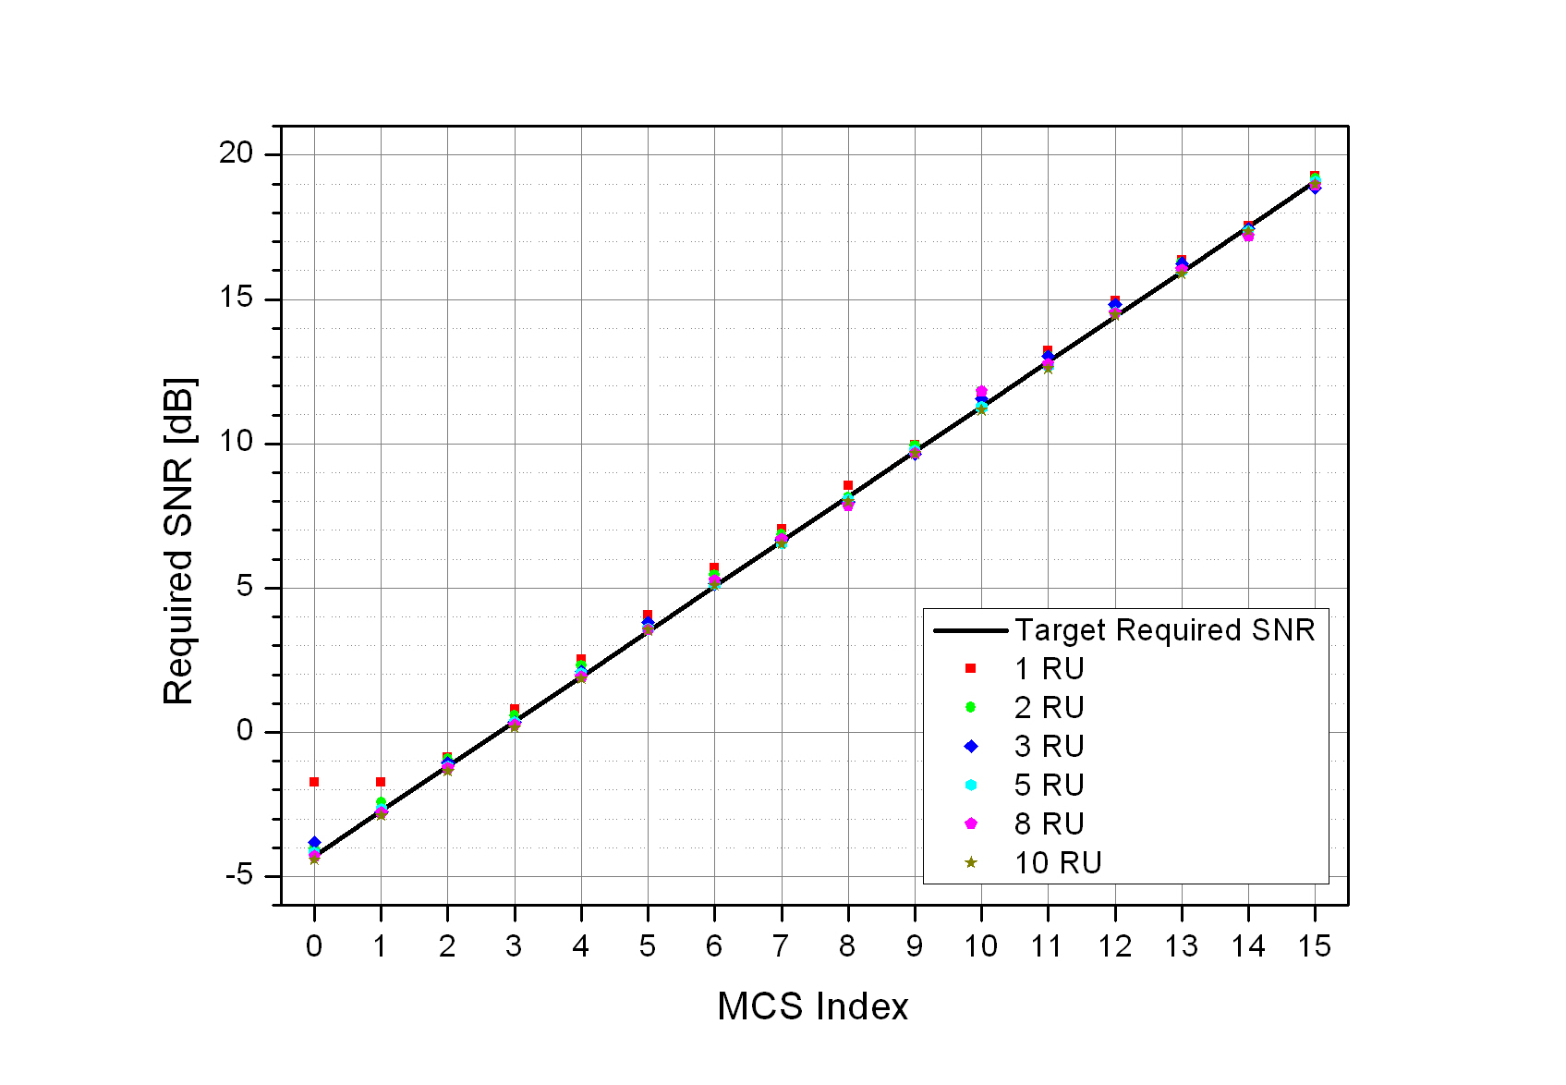
Figure 2. The required SNR for New MCS at target BLER 10% with various numbers of RU’s

  - SLS Performance Evaluation
In order to show the performance gain of new MCS, System Level Simulation (SLS) has been performed with its assumptions & scenarios in the Appendix.
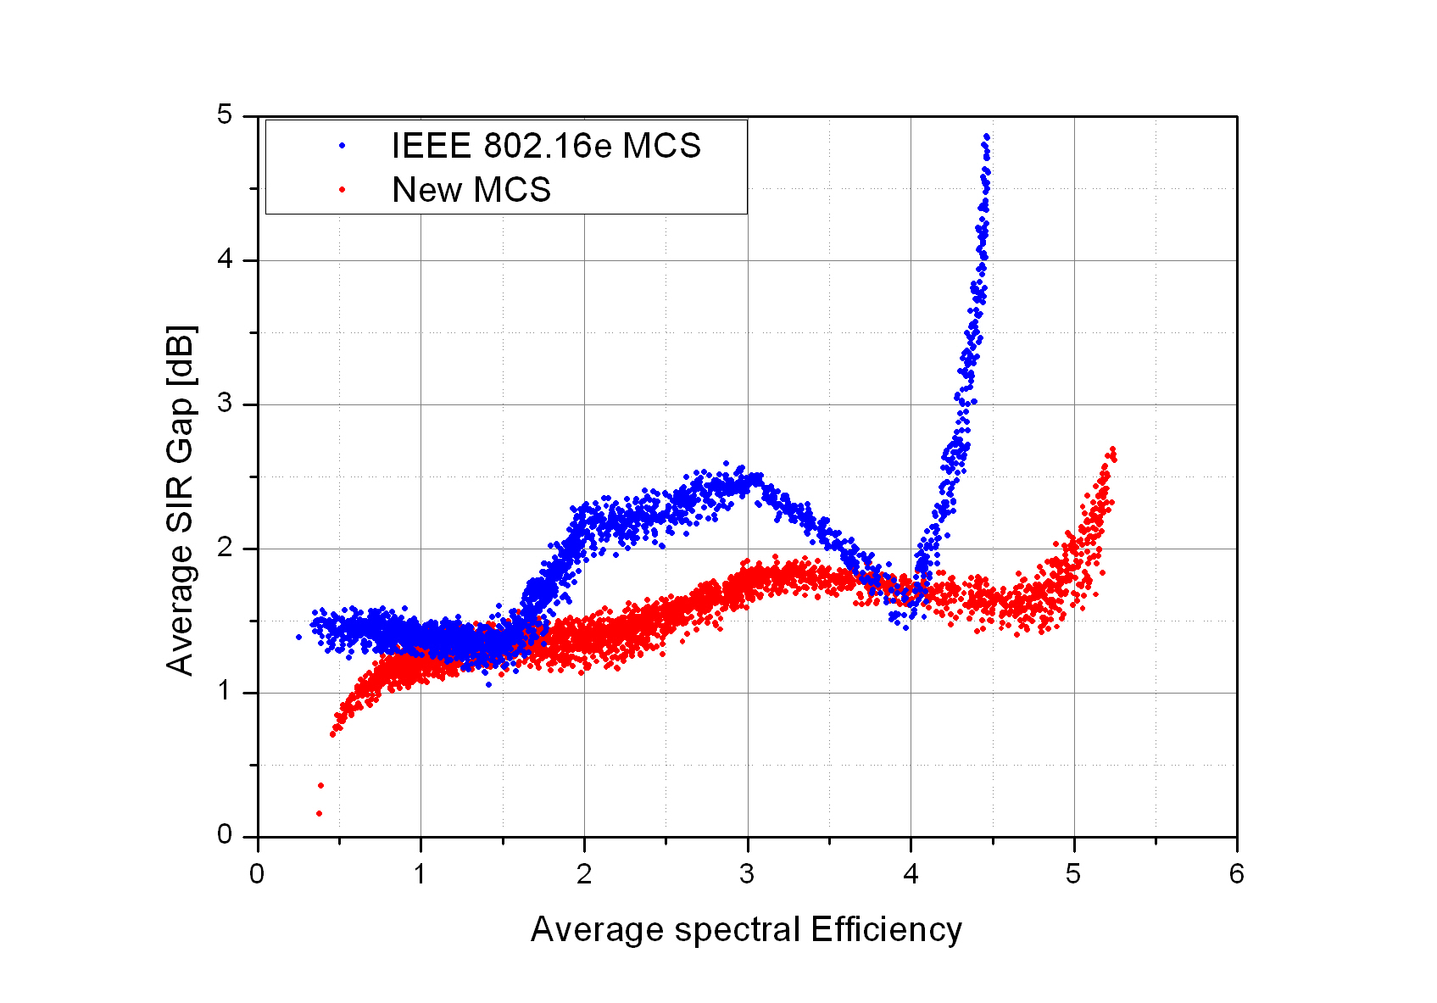
Figure 3 – Difference between Target SIR and Received SIR

Figure 3 shows the SIR gap between target SIR and received SIR versus the average spectral efficacy which has been used for each user within the simulation time 2.5 sec. According to the figure, since the SIR gap for new MCS is smaller than that of MCS of the reference system, new MCS reflect more exact channel condition than that of reference MCS.
Figure 4 shows the throughput comparison as a result of SLS. With new MCS is used, the throughput performance gain is about 5%, and 6% compared to that of reference MCS in the aspect of average sector throughput, and cell edge throughput.
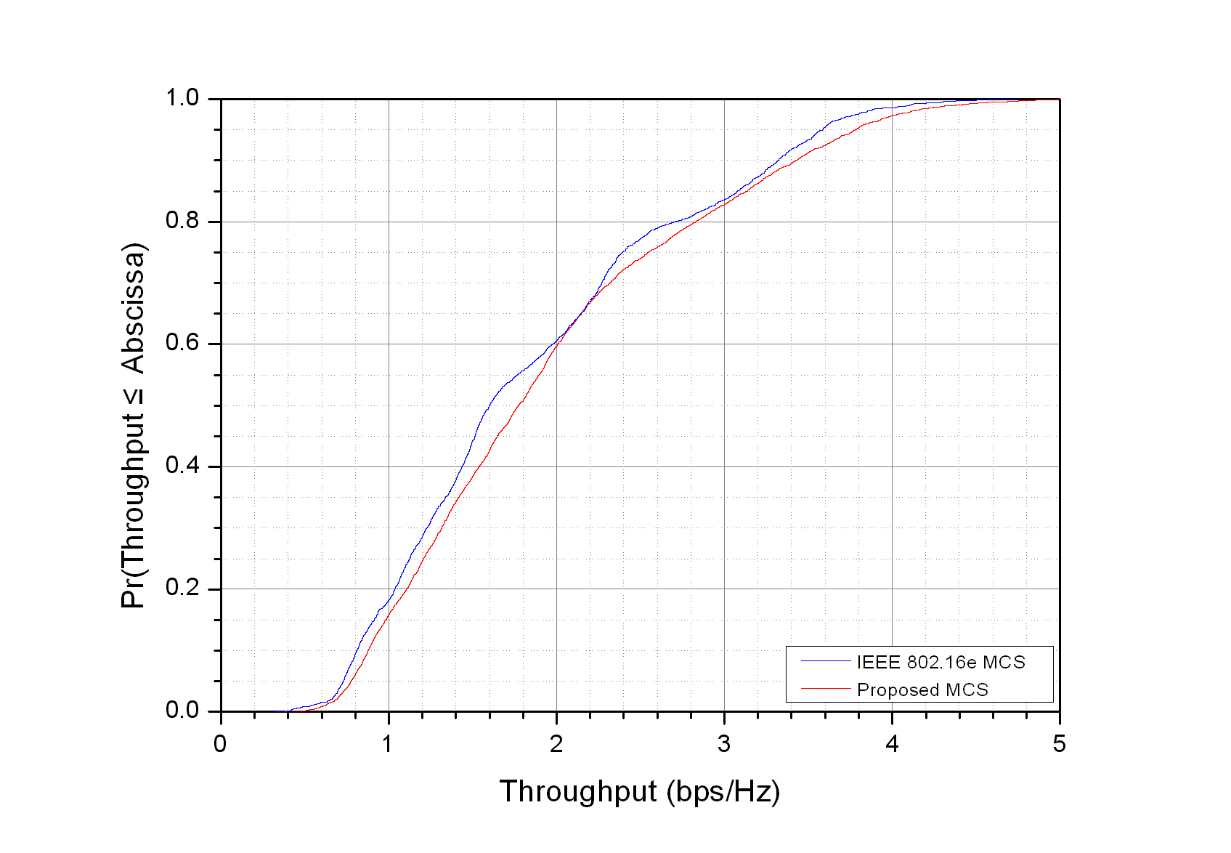
Figure 4. Throughput Comparison

Table 4. Throughput result from system level simulation
Metric | Reference MCS | New MCS | Gain
Average Sector Throughput | 1.864 Mbps | 1.960 Mbps | 5.15%
Cell Edge Throughput | 730 kbps | 776 kbps | 6.30%

- Conclusions
In IEEE 802.16m system, MCS should be selected with equal space of required SNR and should be dense enough to facilitate more efficient link adaptation.

Text Proposal for the 802.16m SDD

============================== Start of Proposed Text ================================

11.x Channel Coding

11.x.1 Channel Coding for data channel

11.x.1.x Convolutional Turbo Codes

MCS should be selected with equal space of required SNR.
MCS should be dense enough to facilitate more efficient link adaptation.

Table 11.x.x.x gives the code rates, modulation, and spectral efficiency.

Table 11.x.x.x – Modulation and Coding Set Table for CTC
MCS  Index | Target  Code Rate | Modulation  order | Spectral  Efficiency | MCS  Index | Target  Code Rate | Modulation  order | Spectral  Efficiency
0 | 0.1504 | 2 | 0.3008 | 8 | 0.6025 | 4 | 2.4102
1 | 0.2168 | 2 | 0.4336 | 9 | 0.7148 | 4 | 2.8594
2 | 0.3203 | 2 | 0.6406 | 10 | 0.5146 | 6 | 3.0879
3 | 0.4326 | 2 | 0.8652 | 11 | 0.5898 | 6 | 3.5391
4 | 0.5645 | 2 | 1.1289 | 12 | 0.6904 | 6 | 4.1426
5 | 0.3105 | 4 | 1.2422 | 13 | 0.7656 | 6 | 4.5938
6 | 0.4141 | 4 | 1.6563 | 14 | 0.8281 | 6 | 4.9688
7 | 0.5176 | 4 | 2.0703 | 15 | 0.9033 | 6 | 5.4199

=============================== End of Text Proposal ===============================

Appendix. System Level Simulation Assumption

Table A. Simulation Assumptions
Topic | Description | Baseline Simulation Assumptions | Proposal Specific Assumptions
Basic modulation | Modulation schemes for data and control | QPSK, 16QAM, 64QAM | QPSK, 16QAM, 64QAM
Duplexing scheme | TDD, HD-FDD or FD-FDD | TDD | FDD
Subchannelization | Subcarrier permutation | PUSC | Band-AMC
Resource Allocation Granularity | Smallest unit of resource allocation | PUSC: Non-: 1 slot, : 2 slots (1 slot = 1 subchannel x 2 OFDMA symbols) | Band-AMC (18 subcarriers x 6 OFDM symbols)
Downlink Pilot Structure | Pilot structure, density etc. | Specific to PUSC subchannelization scheme | Band-AMC
Multi-antenna Transmission Format | Multi-antenna configuration and transmission scheme | MIMO 2x2 (Adaptive MIMO Switching Matrix A & Matrix B) Beamforming (2x2) | MIMO 2x2 (Adaptive MIMO Switching Matrix A & Matrix B)  Codebook based precoding(16e 3bit codebook)
Receiver Structure | MMSE/ML/MRC/ Interference Cancellation | MMSE (Matrix B data zone) MRC (MAP, Matrix A data zone) | MMSE (Rank 2)  MRC (Rank1)
Data Channel Coding | Channel coding schemes | Convolutional Turbo Coding (CTC) | Convolutional Turbo Coding (CTC)
Control Channel Coding | Channel coding schemes and block sizes | Convolutional Turbo Coding, Convolutional Coding (CC) for FCH only | -
Scheduling | Demonstrate performance / fairness criteria in accordance to traffic mix | Proportional fairness for full buffer data only *, 10 active users per sector, fixed control overhead of 6 symbols, 22 symbols for data, 5 partitions of 66 slots each, latency timescale 1.5s | Proportional fairness for full buffer data only *, 10 active users per sector, fixed control overhead of 0 symbols, 6 symbols for data, 6 partitions of 16 slots each, latency timescale 1.5s
Link Adaptation | Modulation and Coding Schemes (MCS), CQI feedback delay / error | QPSK(1/2) with repetition 1/2/4/6, QPSK(3/4), 16QAM(1/2), 16QAM(3/4), 64QAM(1/2), 64QAM(2/3), 64QAM(3/4) 64QAM(5/6), CQI feedback delay of 3 frames, error free CQI feedback ** | WiMAX MCS & LGE MCS  CQI feedback delay of 3 sub-frames, error free CQI feedback **
Link to System Mapping | EESM/MI | MI (RBIR) *** | RBIR
HARQ | Chase combining/ incremental redundancy, synchronous/asynchronous, adaptive/non-adaptive ACK/NACK delay, Maximum number of retransmissions, retransmission delay | Chase combining asynchronous, non-adaptive, 1 frame ACK/NACK delay, ACK/NACK error, maximum 4 HARQ retransmissions, minimum retransmission delay 2 frames**** | Chase combining asynchronous, non-adaptive, 3 subframes ACK/NACK delay, ACK/NACK error, maximum 4 HARQ retransmissions, minimum retransmission delay 8 sub-frames
Power Control | Subcarrier power allocation | Equal power per subcarrier | Equal power per subcarrier
Interference Model | Co-channel interference model, fading model for interferers, number of major interferers, threshold, receiver interference awareness | Average interference on used tones in PHY abstraction (Refer to Section ‎4.4.8) | Average interference on used tones in PHY abstraction (Refer to Section ‎4.4.8)
Frequency Reuse | Frequency reuse pattern | 3 Sectors with frequency reuse of 1 ***** | -

Table B. Test Scenarios
Scenario/ Parameters | Baseline Configuration  (Calibration & SRD) TDD and FDD | Specific Assumption
Requirement | Mandatory
Site-to-Site Distance | 1.5 km | 1.5 km
Carrier Frequency | 2.5 GHz | 2.5 GHz
Operating Bandwidth | 10 MHz for TDD / 10 MHz per UL and DL for FDD | 10 MHz per UL and DL for FDD
BS Height | 32 m | 32 m
BS Tx Power per sector | 46 dBm | 46 dBm
MS Tx Power | 23 dBm | 23 dBm
MS Height | 1.5 m | 1.5 m
Penetration Loss | 10 dB | 10 dB
Path Loss Model | Loss (dB) = 130.19+37.6log₁₀(R) (R in km) ** | Loss (dB) = 130.19+37.6log₁₀(R) (R in km)
Lognormal Shadowing Standard Deviation | 8 dB | 8 dB
Correlation Distance for Shadowing | 50m | 50m
Mobility | 0-120 km/hr | 3 km/hr
Channel Mix | ITU Ped B 3 km/hr – 60%  ITU Veh A 30 km/hr – 30%  ITU Veh A 120 km/hr – 10% | ITU Ped B 3 km/hr
Spatial Channel Model | ITU with spatial correlation (Refer to Section ‎3.2.9 ***) | ITU with spatial correlation
Error Vector Magnitude (EVM) | 30 dB | 30 dB

