Project | IEEE 802.16 Broadband Wireless Access Working Group <http://ieee802.org/16>
Title | Proposed Compressed MAC Header (CMH) for IEEE 802.16m
Date Submitted | 2008-09-13
Source(s) | Sassan Ahmadi (sassan.ahmadi@intel.com)  Muthaiah Venkatachalam  Roshni M Srinivasan  David Johnston (dj.johnston@intel.com)  Intel Corporation
Re: | Call for Contributions on Project 802.16m System Description Document (SDD)  RE: MAC: Data plane  Also MAC: Security (for discussion of EKS bit changes)
Abstract | Proposal for IEEE 802.16m compressed MAC Header (CMH) that shall coexist with the current IEEE 802.16 GMH
Purpose | Discussion and Approval
Notice | This document does not represent the agreed views of the IEEE 802.16 Working Group or any of its subgroups. It represents only the views of the participants listed in the “Source(s)” field above. It is offered as a basis for discussion. It is not binding on the contributor(s), who reserve(s) the right to add, amend or withdraw material contained herein.
Release | The contributor grants a free, irrevocable license to the IEEE to incorporate material contained in this contribution, and any modifications thereof, in the creation of an IEEE Standards publication; to copyright in the IEEE’s name any IEEE Standards publication even though it may include portions of this contribution; and at the IEEE’s sole discretion to permit others to reproduce in whole or in part the resulting IEEE Standards publication. The contributor also acknowledges and accepts that this contribution may be made public by IEEE 802.16.
Patent Policy | The contributor is familiar with the IEEE-SA Patent Policy and Procedures:  <http://standards.ieee.org/guides/bylaws/sect6-7.html#6> and <http://standards.ieee.org/guides/opman/sect6.html#6.3>.  Further information is located at <http://standards.ieee.org/board/pat/pat-material.html> and <http://standards.ieee.org/board/pat>.

Proposal for IEEE 802.16m Compressed MAC Header (CMH)

Introduction and Motivation
The generic MAC header (GMH) in IEEE 802.16e-2005 reference system is 6 bytes, which needs to be present in every MAC PDU. Also for every MAC PDU, there may be a CRC of 4 bytes that are appended as per IEEE 802.16e-2005 specification, if the CRC indication is present in the GMH. Hence, for every MAC PDU, there is an overhead of 6-10 bytes that is added at the MAC layer. While this overhead could be acceptable for larger size data packets, it can be excessive for smaller size packets like VoIP full-rate voice traffic, VoIP silence descriptor, interactive gaming and certain signaling and control messages.

As an example, the size of VoIP RTP (Real-time Transport Protocol) payloads depending on the type of the voice codec is typically less than 40 octets; therefore, each VoIP packet encapsulated in a MAC PDU has more than 25% overhead (typically 50% with smaller packets; e.g., 20 octets for ITU-T G.729) overhead due to the size of the generic MAC header and the optional trailing CRC. Most of the fields in the generic MAC header are usually not used in VoIP and interactive gaming.

Hence it is prudent to design a low overhead MAC header structure for transporting smaller size messages and packets in IEEE 802.16m. We call this new MAC header as compressed MAC header or CMH.

Design considerations for the CMH

Generic MAC Header Fields
The generic MAC header in IEEE 802.16e-2005 consists of the following fields (see Figure 1):
- Length of PDU: 11 bits
- Connection identifier (CID): 16 bits
- Header Type: 6 bits
- Encryption key sequence: 2 bits
- Flag fields: 5 bits
- Header checksum (HCS): 8 bits
Generic MAC Header Format
BW Request MAC Header Format
Header Type
Payload Length
Connection ID
Encryption Control
BW Request
Header Check Sequence
Payload Type
Encryption Key Sequence
CRC Indicator
BW Request Type
Figure 1: Structure of generic MAC Header in IEEE 802.16e-2005

For IEEE 802.16m, the above parameters can be changed as follows:
- Length of PDU: since we are targeting smaller size packets, this parameter can be compressed as well. A length of 6 bits for this field can ensure that we can transport payloads up to 64 bytes. Compact CID: a compact CID is introduced which contains less number of bits (m) compared to the full 16-bit CID (see Figure 3). A value of m=3 is recommended. However, other values may also be utilized, provided that m << 16 to reduce the size of the header.
By reducing the size of the compact CID, the number of unique transport connections are also reduced which may be perceived as a drawback. To mitigate this drawback, the set of compact CIDs is chosen according to certain provisions. In IEEE 802.16e-2005 standard, the notion of Reduced CID (RCID) was used where the RCID is the LSB portion of the set of CIDs that have been currently assigned to the MS and are in use. A similar concept can be used to overcome the limitation of the number of unique CCIDs that can be simultaneously assigned to the user traffic. As shown in Figure 3, the CID is split into user ID (UID) and user connection ID (UCID), where compact CID is set to the more frequently-used user connection ID.
- Header type: since the CMH is needed only for the smaller packets, header type may be eliminated.
- Encryption key sequence (EKS): It is possible to accommodate the signaling of the EC (Encryption control) flag within the EKS bits.
- Flag fields: Of the 5 flags, the important ones for the CMH are the EC (Encryption control) and CI (CRC Indication) flags. As stated above, EC can be absorbed into EKS. Hence, we may only need 1 bit for the CI field.
- HCS: can be a 4 bit entity like a CRC-4 function. This is applied only on the MAC header fields.
Although the parameters above are FFS in the context of the compressed MAC header, it can be seen that there is a possibility of compressing the 6 bytes GMH down to 2 bytes. This is a rather significant 66% compression ratio.

Merging the EC and EKS Bits
The EKS bits form a modulo-4 counter to identify new and previous keys during TEK update transitions. It uses 4 states, however only 3 states are needed to ensure a station can distinguish the previous from the current from the next TEK.

The EKS bits will be mapped as follows.
00 => PDU not encryption

01 => PDU Encrypted, EKS=1
10 => PDU Encrypted, EKS=2
11 => PDU Encrypted, EKS=3
The state transitions during TEK updates are as follows:
Figure-2: EKS Bit State Transitions

GMH CRC considerations
Since the CMH will be used for transporting smaller sized packets, 4 bytes CRC may not be necessary. There is a real possibility that we may be able to get away with a 2 bytes CRC or no CRC (based on CI bit set or not). This allows us for a compression of 50% in the worst case.
The comparison of all the considerations is summarized in table-1.
Field | GMH | CMH*
PDU length | 11bits | Can be compressed down to 6 bits
CID | 16 bits | Can be compressed down to UCID only (3 bits)
Header Type | 6 bits | Can be eliminated
Encryption key sequence | 2 bits | 2 bits, but can also include EC flag
Flag fields | 5 bits | Only CRC Indication flag (1 bit)
HCS | 8 bits | Can be compressed to CRC-4 (4 bits)
CRC (worst case) | 4 bytes | 2 bytes
Total | 10 bytes | 4 bytes
*The exact definition of these parameters for CMH needs to be fine-tuned during stage-3 development.
Table-1: Comparison of generic and compressed MAC headers
Figure-2 shows the proposed CMH format.
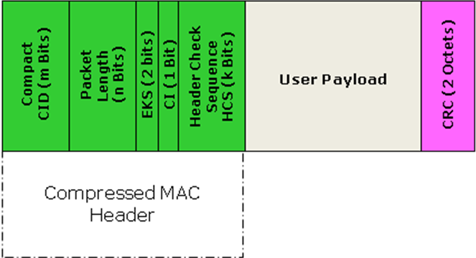
Figure-3: Structure of the compressed MAC header

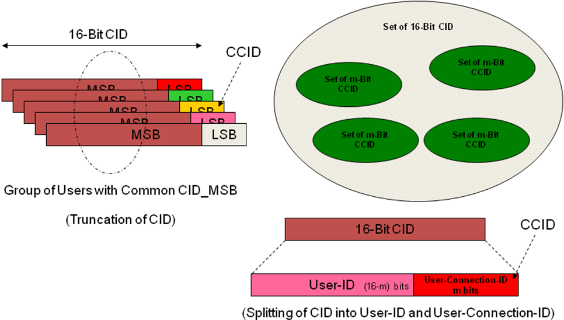
Figure 4: Compact CID selection from the set of 2¹⁶ possible codes

Backward compatibility considerations and coexistence of CMH and GMH
The original GMH is necessary to support larger sized packets. The new CMH can be used for smaller size packets as well as MAC control and signaling. Hence we need to ensure that backward compatibility and coexistence can be maintained.
Backward compatibility can be achieved by ensuring that the CMH is used only with IEEE 802.16m terminals and only in IEEE 802.16m zones. In such a scenario, the CMH will be transparent to legacy terminals.
Coexistence can be ensured in a number of different ways; by setting a bit in the MAP to indicate which GMH is being used for the particular MPDU; by creating separate bursts for PDUs with CMH and regular GMH. The exact mechanism is FFS.

Sample overhead comparisons for certain scenarios
Assuming the 4 bytes CMH for the following scenarios, Table-2 shows the comparisons of byte level efficiencies.
Scenario/Payload size | Regular GMH overhead | CMH overhead
VoIP AMR active with header compression: 36Byte | 10/(36+10) = 22% | 4/(36+4) = 10%
VoIP AMR silence with header compression: 10 Byte | 10/(10+10) = 50% | 4/(10+4) = 29%
G.729 VoIP payload with header compression: 23Byte | 10/(23+10) = 30% | 4/(23+4) = 15%
TCP ACK without header compression: 40Byte | 10/(40+10) = 20% | 4/(40+4) = 9%
TCP ACK with header compression : 4Byte | 10/(4+10) = 71.4% | 4/(4+4) = 50%
12B MAC signaling/control message | 10/(12+10) = 45% | 4/(12+4) = 25%
Table-2: Sample overhead comparisons of CMH and GMH

Proposed SDD text
Insert the following text into clause 3 - definitions
------------------------------- Text Start ---------------------------------------------------
CMH Compressed MAC Header
------------------------------- Text End ---------------------------------------------------

Insert the following text into MAC header sub-clause of the SDD [2]:
------------------------------- Text Start ---------------------------------------------------
10.x IEEE 802.16m MAC Headers
IEEE 802.16m utilizes a compressed MAC header (CMH) for efficient transport of smaller payloads for applications such as VoIP, interactive gaming, and MAC control and signaling.
The CMH is as shown in Figure x.x
Figure-x.x: Structure of the compressed MAC header
In comparison to the existing 802.16 MAC header, CMH employs the following techniques to reduce the header size to 4 bytes.
10.x.1 Compressed CID
A compressed CID is signaled that is derived from the lower bits of the actual CID being sent, using the same mechanism as is used for the RCID in 802.16.

Figure 4: Compact CID selection from the set of 2¹⁶ possible codes

10.x.2 Merged EC and EKS Bits
The signaling of the encrypted state of the PDU is encoded in the EKS bits rather than in an explicit EC bit. The 4 states of the EKS sequence is reduced to three 01->10->11->01, and state 00 is reserved to signal that the PDU is not encrypted, as shown in figure x.
Figure-x: EKS Bit State Transitions

10.x.3 Reduced Length Field
Packets encoded with the CMH employ a reduced size, 6 bit length field, permitting packet lengths up to 64 bytes.

------------------------------- Text End ---------------------------------------------------

References
[1] IEEE Std. 802.16e-2005, IEEE Standard for Local and metropolitan area networks, Part 16: Air Interface for Fixed and Mobile Broadband Wireless Access Systems, Amendment 2: Physical and Medium Access Control Layers for Combined Fixed and Mobile Operation in Licensed Bands, and P802.16Rev2/D5 (June 2008).
[2] IEEE 802.16m-08/003r2, “The Draft IEEE 802.16m System Description Document”

Appendix: Some background on CRC-4 (used for CMH HCS)
CRC-4 (Cyclic Redundancy Check 4) is a form of cyclic redundancy checking (a method of checking for errors in transmitted data) that is used on E-1 trunk lines. In E-1, CRC-4 is structured in a multi-frame consisting of 16 frames numbered 0 to 15.
The CRC-4 multi-frame is then divided into two eight frame Sub-Multi-frames (SMF) called SMF I and SMF II. Each SMF contains four CRC-4 bits designated C1, C2, C3, and C4. Through multiplication and division processes, the CRC-4 bits sent in each SMF are compared to each other and if they match, the frame is considered error free. Bit 1 is used for the CRC-4 bits. CRC-4 support is required for all network switches in Europe. However, some older switches including private branch exchanges (PBXs) do not support CRC-4.
Generation of CRC-4 is performed either per ITU-T Recommendation G.704 (Generator polynomial x⁴ + x + 1) or based on CRC-4 Generator polynomial x⁴+x³+x²+x+1.

