Project | IEEE 802.16 Broadband Wireless Access Working Group <http://ieee802.org/16>
Title | Simplified Differential Feedback Method for IEEE 802.16m CL SU/MU-MIMO
Date Submitted | 2009-01-05
Source(s) | Jaewan Kim,  Wookbong Lee,  Bin-Chul Ihm  LG Electronic Inc.  LG R&D Complex, 533 Hogye-1dong, Dongan-gu, Anyang, 431-749, Korea | Voice: +82-31-450-1883  E-mail: lgjohnkim@lge.com  wbong@lge.com  bcihm@lge.com
Re: | Call for Comments on Project 802.16m System Description Document (SDD), IEEE 802.16m-08/052 (MIMO section)
Abstract | This contribution provides the codebook issues for DL closed-loop MIMO
Purpose | For discussion and approval by TGM
Notice | This document does not represent the agreed views of the IEEE 802.16 Working Group or any of its subgroups. It represents only the views of the participants listed in the “Source(s)” field above. It is offered as a basis for discussion. It is not binding on the contributor(s), who reserve(s) the right to add, amend or withdraw material contained herein.
Release | The contributor grants a free, irrevocable license to the IEEE to incorporate material contained in this contribution, and any modifications thereof, in the creation of an IEEE Standards publication; to copyright in the IEEE’s name any IEEE Standards publication even though it may include portions of this contribution; and at the IEEE’s sole discretion to permit others to reproduce in whole or in part the resulting IEEE Standards publication. The contributor also acknowledges and accepts that this contribution may be made public by IEEE 802.16.
Patent Policy | The contributor is familiar with the IEEE-SA Patent Policy and Procedures:  <http://standards.ieee.org/guides/bylaws/sect6-7.html#6> and <http://standards.ieee.org/guides/opman/sect6.html#6.3>.  Further information is located at <http://standards.ieee.org/board/pat/pat-material.html> and <http://standards.ieee.org/board/pat>.

Simplified Differential Feedback Method for IEEE 802.16m CL SU/MU-MIMO
Jaewan Kim, Wookbong Lee and Bin-Chul Ihm
LG Electronics

1. Introduction
It has been agreed that differential feedback method has been incorporated into the SDD document for IEEE802.16m CL-MIMO in order to enhance its performance with the fixed feedback overhead or reduce its feedback overhead with little performance degradation [1-6].
In this contribution, we introduce a simplified differential codebook scheme of the previously proposed scheme [5] for the IEEE802.16m CL -MIMO with the fixed feedback overhead.

2. Differential codebook
There are two kinds of differential codebook candidates, currently.
First candidate of differential mode makes the codebook entity of base codebook to be differentially rotated so that the total number of codebook size is increased. As a result, the CL-MIMO performance is increased.
In the second candidate of differential mode, MS find a codebook within a limited set of codebook. We can effectively reduce feedback overhead in this case with little performance degradation.
To achieve IEEE 802.16m system requirement, we proposed to adopt throughput enhancement type of differential codebook.

3. Proposed differential feedback scheme
The general procedure of differential feedback scheme and codebook design method is described in [5].
But, we recommend adopting a simplified scheme of the proposal [5] because the previously proposed codebook is too complex. So, we propose its simplified version for 4bit differential feedback for 4Tx like belows.

Figure 1 shows the beam pattern comparison for differential codebook between the proposed scheme in [5] and our proposed scheme, respectively. Figure 1(a) and Figure 1(b) show the similar beam pattern for the differential feedback in the aspect of antenna phase and gain, where a DFT base matrix is used for shifting beam pattern in linear array antenna space of 0.5. Please note that this differential codebook is applicable for any kinds of codebook.

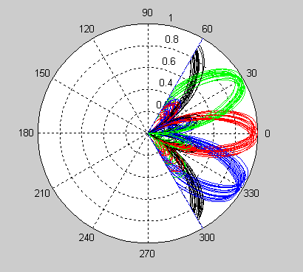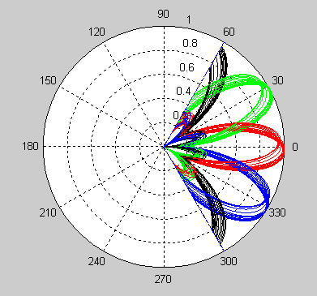
(a) Differential codebook [5] (b) Simplified differential codebook
Figure 1. Beam patterns of proposed differential codebooks for DFT matrix

Beam phase and gain can be adjusted for the optimization according to base codebook to be decided. Here, we used 0.9 as an effective time correlation coefficient, and = as differential phase values for diagonal matrix.

4. Conclusion
- In this contribution, we proposed to adopt throughput enhancement type of differential codebook.
- We proposed the usage of the proposed simplified differential codebook for the IEEE802.16m CL SU/MU-MIMO.
- Optimization will be carried out after the base codebook is decided, if necessary.

----------------------------------------------------------Proposed SDD text --------------------------------------------------------------------
Remedy : Add the following texts at line 35, page 102 and line 4, page 104

The following equation is used for differential feedback mode.
At time instant, the MS choose the appropriate precoder from the base codebook. For time instant , the MS differentially rotates the previous precoder. At time T_{max}+1, the process is reset and is fixed to 0 again.

----------------------------------------------------------------------End--------------------------------------------------------------------------

Reference
- C802.16m-08/1187, “Evaluation of CL SU and MU MIMO codebooks”
[2] C802.16m-08/064, “Evaluation of Codebook and Differential Feedback for DL Closed-Loop SU-MIMO”
[3] C802.16m-08/464, “CQI Feedback Scheme for MCW MIMO”
[4] C802.16m-08/333, “Multi-resolution Precoding Codebook for MIMO Downlink Transmission Schemes”
[5] C802.16m-08/1182r3, “Codebook design for IEEE 802.16m MIMO Schemes”
[6] C802.16m-08/914, “Hybrid Analog/Digital Feedback for CL-MIMO”

