Project | IEEE 802.16 Broadband Wireless Access Working Group <http://ieee802.org/16>
Title | Proposal for Rate2 DL OL SU-MIMO Scheme
Date Submitted | 2009-01-12
Source(s) | Yinggang Du, Hongjie Si, Yinwei Zhao, Qi Li, Xin Chang, Yang Tang  Huawei  Ying Du  CATR  Liu Jianhua.  Alcatel Shanghai Bell  Takaaki Kishigami  Isamu Yoshii  Panasonic  Philip V. Orlik, Andreas F. Molisch, Zhifeng (Jeff) Tao, Jinyun Zhang  Mitsubishi Electric Research Laboratories  Wataru Matsumoto, Toshiyuki Kuze  Mitsubishi Electric Corporation  Hosein Nikopourdeilami, Mo-Han Fong, Sophie Vrzic, Robert Novak, Dongsheng Yu, Kathiravetpillai Sivanesan  Nortel Networks  M.A. (Amir) Khojastepour  NEC  Kim Olszewski  ZTE | E-mail: duyinggang@huawei.com  Email: duying@mail.ritt.com.cn  Email:jianhua.liu@alcatel-sbell.com.cn.  Email: kishigami.takaaki@jp.panasonic.com  yoshii.isamu@jp.panasonic.com  E-mail : Matsumoto.Wataru@aj.MitsubishiElectric.co.jp  Email: hosein@nortel.com  mhfong@nortel.com  *<http://standards.ieee.org/faqs/affiliationFAQ.html>  E-mail : amir@nec-labs.com  E-mail : kolszewski@zteusa.com
Re: | IEEE 802.16m-08/052: “Call for Comments on Project 802.16m System Description Document (SDD)”  SDD Section: 11.8.2.1.1 Open-loop SU-MIMO
Abstract | This contribution proposes Rate2 DL OL SU-MIMO scheme
Purpose | For discussion and approval by TGm.
Notice | This document does not represent the agreed views of the IEEE 802.16 Working Group or any of its subgroups. It represents only the views of the participants listed in the “Source(s)” field above. It is offered as a basis for discussion. It is not binding on the contributor(s), who reserve(s) the right to add, amend or withdraw material contained herein.
Release | The contributor grants a free, irrevocable license to the IEEE to incorporate material contained in this contribution, and any modifications thereof, in the creation of an IEEE Standards publication; to copyright in the IEEE’s name any IEEE Standards publication even though it may include portions of this contribution; and at the IEEE’s sole discretion to permit others to reproduce in whole or in part the resulting IEEE Standards publication. The contributor also acknowledges and accepts that this contribution may be made public by IEEE 802.16.
Patent Policy | The contributor is familiar with the IEEE-SA Patent Policy and Procedures:  <http://standards.ieee.org/guides/bylaws/sect6-7.html#6> and <http://standards.ieee.org/guides/opman/sect6.html#6.3>.  Further information is located at <http://standards.ieee.org/board/pat/pat-material.html> and <http://standards.ieee.org/board/pat>.

Proposal for Rate2 DL OL SU-MIMO Scheme

Yinggang Du, Hongjie Si, Yinwei Zhao, Qi Li, Xin Chang, Yang Tang
Huawei

Ying Du
CATR

Liu Jianhua.
Alcatel Shanghai Bell

Takaaki Kishigami
Isamu Yoshii
Panasonic

Philip V. Orlik, Andreas F. Molisch, Zhifeng (Jeff) Tao, Jinyun Zhang
Mitsubishi Electric Research Laboratories

Wataru Matsumoto, Toshiyuki Kuze
Mitsubishi Electric Corporation

Hosein Nikopourdeilami, Mo-Han Fong, Sophie Vrzic, Robert Novak, Dongsheng Yu, Kathiravetpillai Sivanesan
Nortel Networks
M.A. (Amir) Khojastepour
NEC

Kim Olszewski
ZTE

1. Introduction
This contribution is to propose DL OL SU-MIMO scheme in response to Call for Comments on SDD (IEEE 802.16m-08_052). We propose a 4Tx/8Tx rate 2 scheme which is Double SFBC to be included in the SDD. This contribution also gives the performance evaluation on several rate2 schemes including Double SFBC and Rate2 SM with Antenna Hopping. In this contribution, MLD detector is assumed. The simulation results with MMSE detector can be referred in C802.16m-08_1306r1.

2. Performance Evaluation

2.1 Simulation Assumptions

The simulation assumptions as following：
Parameters | Value
FFT Size | 1024
Bandwidth | 10M
Carrier frequency | 2.5G
Number of Antennas | 4 transmitter, 2 receiver [4Tx, 2Rx] (Rate 2)
Resource block | 18subcarriers X 6 OFDM symbols
Number of OFDM symbols per subframe | 6
Number of total RU in one subframe | 48
Channel encoding | Turbo  （LTE Turbo and Rate matching）
MCS | 1/2 QPSK  1/2 16QAM
Receiver Type | MLD
Channel estimation | MMSE channel estimator (Wiener filter)  - Common pilot  Single-PRU level CE
Data burst size | - PRU-based LDRU  - 4 RUs distributed over 48 PRUs
Permutation | PRU based LDRU
Channel Model | Uncorrelated (mandatory with first priority)  - Modified Veh A 30 km/h  - Modified Ped B 3 km/h  - Modified Veh A 120 km/h
Scenarios | Noise limited (mandatory LLS)

2.2 Simulation Results

2.2.1 BLER and Goodput Link Curve for 1/2 QPSK

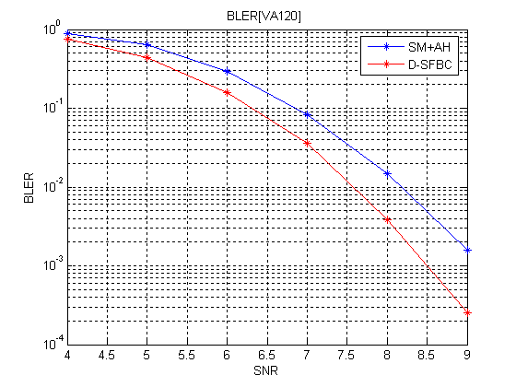
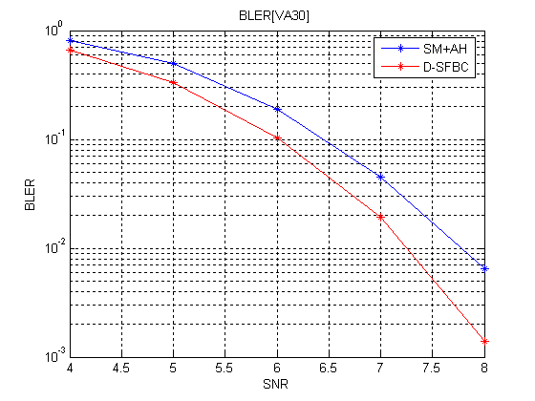
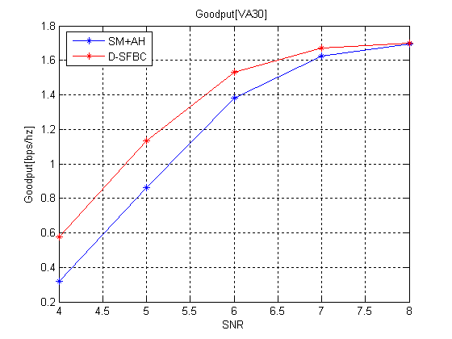
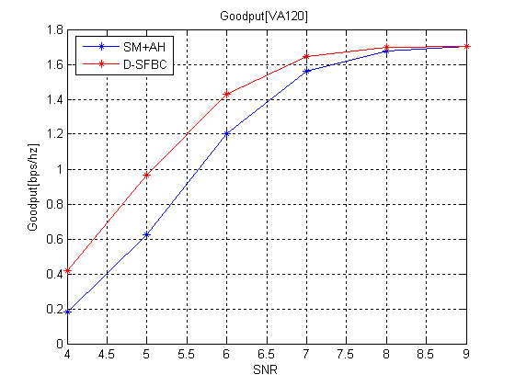
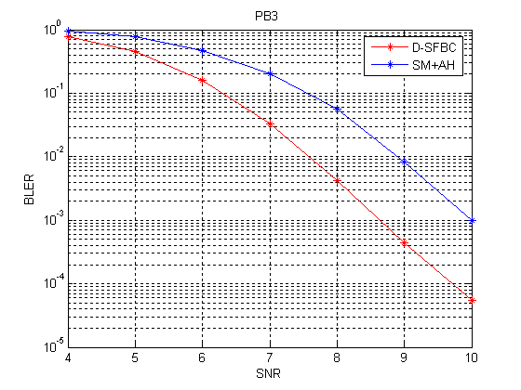
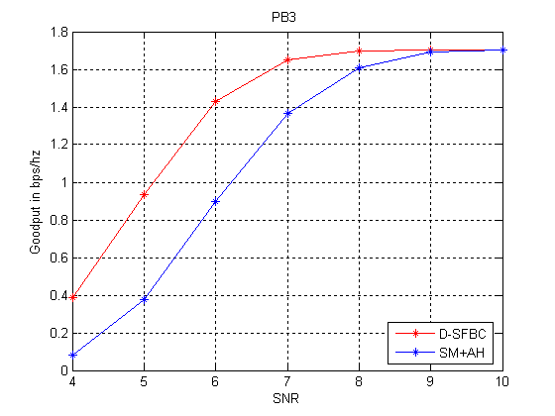

2.2.1 BLER and Goodput Link Curve for 1/2 16QAM
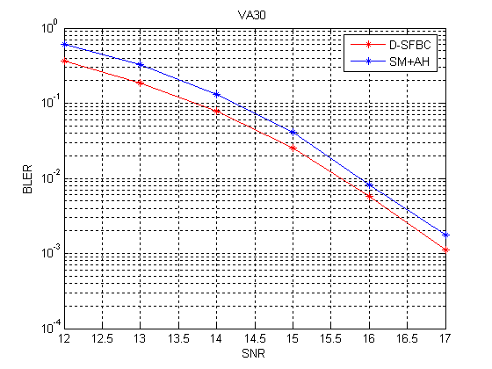
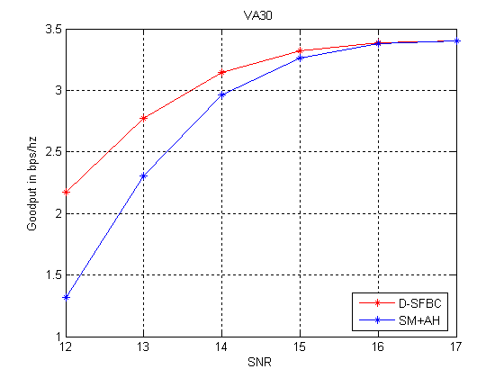
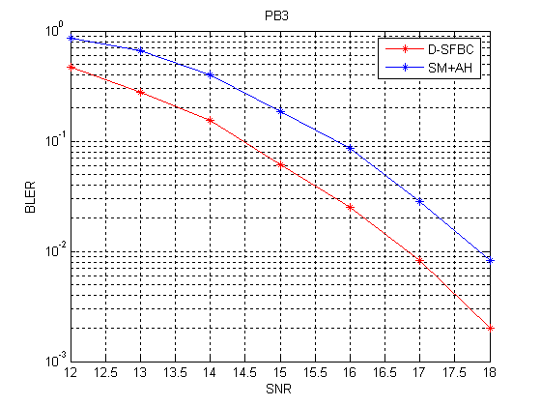
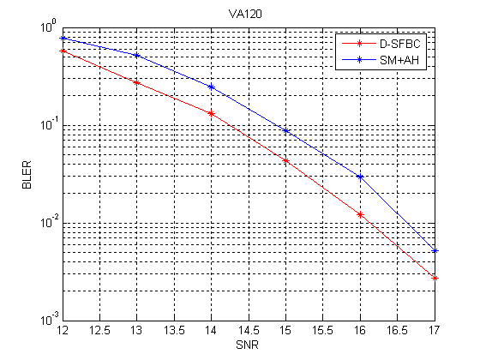
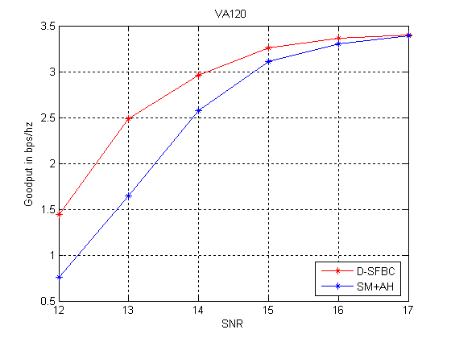
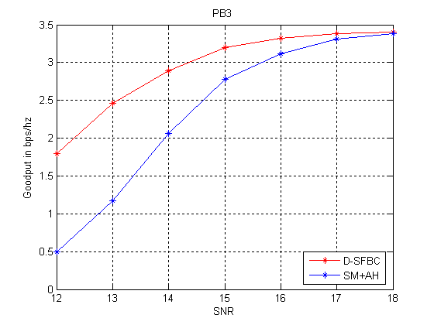

2.2 Simulation Conclusion
From LLS results, Double SFBC is better than SM+AH under QPSK and 16QAM with ½ turbo by PB3, VA30 and VA120.The Double SFBC outperforms more 1db than SM+AH.

3. Text Proposal
------------------------------------Begin text proposal------------------------------------
(Line 15, Page 100)

N_{T} | Rate | M | N_{S} | N_{F}
2 | 1 | 1 | 1 | 1
2 | 1 | 2 | 2 | 2
4 | 1 | 1 | 1 | 1
4 | 1 | 2 | 2 | 2
8 | 1 | 1 | 1 | 1
8 | 1 | 2 | 2 | 2
2 | 2 | 2 | 2 | 1
4 | 2 | 2 | 2 | 1
4 | 2 | 4 | 4 | 2
8 | 2 | 2 | 2 | 1
8 | 2 | 4 | 4 | 2
4 | 3 | 3 | 3 | 1
[4] | [3] | [6] | [4] | [2]
8 | 3 | 3 | 3 | 1
[8] | [3] | [6] | [4] | [2]
4 | 4 | 4 | 4 | 1
8 | 4 | 4 | 4 | 1

Table 4 Matrix dimensions for open-loop SU-MIMO modes
(Line 30, Page 101)
11.8.2.1.1.2 Spatial Multiplexing
The following spatial multiplexing modes are supported for open-loop single-user MIMO:
- Rate-2 spatial multiplexing modes:
  - 2Tx rate-2: rate 2 SM with precoding
  - 4Tx rate-2: rate 2 SM with precoding
  - 4Tx rate-2: Double SFBC with precoding
  - 8Tx rate-2: rate 2 SM with precoding
  - 8Tx rate-2: Double SFBC with precoding
- Rate-3 spatial multiplexing modes:
  - 4Tx rate-3: rate 3 SM with precoding
  - 8Tx rate-3: rate 3 SM with precoding
- Rate-4 spatial multiplexing modes:
  - 4Tx rate-4: rate 4 SM
  - 8Tx rate-4: rate 4 SM with precoding
For the rate-R spatial multiplexing modes, the input and the output of MIMO encoder is represented by an R × 1 vector
, Equation 7
Then the output of the MIMO encoder is multiplied by N_{T} × R matrix W, where W is described in section 11.8.2.1.1.
For the Double SFBC with precoding modes, the input and the output of MIMO encoder is represented by a 4 × 1 vector and a 4 × 2 matrix respectively.
$x=\left[\begin{matrix}s_{1} \\ s_{2} \\ s_{3} \\ s_{4}\end{matrix}\right]$, Equation 8
$z=\left[\begin{matrix}s_{1} & −s_{2}^{} \\ s_{2} & s_{1}^{} \\ s_{3} & −s_{4}^{} \\ s_{4} & s_{3}^{}\end{matrix}\right]$, Equation 9
Then the output of the MIMO encoder is multiplied by N_{T} × 4 matrix W, where W is described in section 11.8.2.1.1. W can be a set of 3 antenna circulation matrices:
$W=\left[\begin{matrix}1 & 0 & 0 & 0 \\ 0 & 1 & 0 & 0 \\ 0 & 0 & 1 & 0 \\ 0 & 0 & 0 & 1\end{matrix}\right],\left[\begin{matrix}1 & 0 & 0 & 0 \\ 0 & 0 & 1 & 0 \\ 0 & 1 & 0 & 0 \\ 0 & 0 & 0 & 1\end{matrix}\right],\left[\begin{matrix}1 & 0 & 0 & 0 \\ 0 & 0 & 1 & 0 \\ 0 & 0 & 0 & 1 \\ 0 & 1 & 0 & 0\end{matrix}\right]$, Equation 10
------------------------------------End text proposal------------------------------------

