Project | IEEE 802.16 Broadband Wireless Access Working Group <http://ieee802.org/16>
Title | Power Balancing of Beamforming/Precoding Schemes
Date Submitted | 2009-01-05
Source(s) | ¹ Hsuan-Jung Su, Chung-Pi Lee, Yu-Han Yang, Chun-Yao Chen, Wei-Shun Liao, NTU  Ren-Jr Chen, Chung-Lien Ho, Chang-Lan Tsai, Zheng Yan-Xiu, ITRI | Voice:  ¹+886-2-33663600  E-mail:  ¹hjsu@cc.ee.ntu.edu.tw  *<http://standards.ieee.org/faqs/affiliationFAQ.html>
Re: | IEEE 802.16m-08/052 “Call for Comments and Contributions on Project 802.16m  System Description Document (SDD)”
Abstract | This contribution addresses the high PAPR issue related to MIMO beamforming/precoding and OFDM. It is suggested that a general remedy to the PAPR issue without introducing signal distortion or side information feeding forward should be considered in 802.16m. A method based on constellation shaping to balance the signal power, such that the high PAPR caused by beamforming/precoding and OFDM can be reduced, is also provided in this contribution as an example of such general remedies.
Purpose | For discussion by IEEE 802.16m TG
Notice | This document does not represent the agreed views of the IEEE 802.16 Working Group or any of its subgroups. It represents only the views of the participants listed in the “Source(s)” field above. It is offered as a basis for discussion. It is not binding on the contributor(s), who reserve(s) the right to add, amend or withdraw material contained herein.
Release | The contributor grants a free, irrevocable license to the IEEE to incorporate material contained in this contribution, and any modifications thereof, in the creation of an IEEE Standards publication; to copyright in the IEEE’s name any IEEE Standards publication even though it may include portions of this contribution; and at the IEEE’s sole discretion to permit others to reproduce in whole or in part the resulting IEEE Standards publication. The contributor also acknowledges and accepts that this contribution may be made public by IEEE 802.16.
Patent Policy | The contributor is familiar with the IEEE-SA Patent Policy and Procedures:  <http://standards.ieee.org/guides/bylaws/sect6-7.html#6> and <http://standards.ieee.org/guides/opman/sect6.html#6.3>.  Further information is located at <http://standards.ieee.org/board/pat/pat-material.html> and <http://standards.ieee.org/board/pat>.
Power Balancing of Beamforming/Precoding Schemes

Hsuan-Jung Su, Chung-Pi Lee, Yu-Han Yang, Chun-Yao Chen, Wei-Shun Liao,
National Taiwan University (NTU)
Ren-Jr Chen, Chung-Lien Ho, Chang-Lan Tsai, Zheng Yan-Xiu,
ITRI

Introduction
In the most recently issued SDD (IEEE 802.16m-08/003r5) [1], the multiple input multiple output (MIMO) architecture of the system adopted the methods which are based on beamforming/precoding as its close-loop MIMO solution. However, beamforming/precoding related methods usually result in increase of the peak-to-average power ratio (PAPR). As a result, the system performance is degraded when the power amplifier (PA) nonlinearity is present.
In this contribution, we use a MIMO OFDM system with singular value decomposition (SVD) based precoding as an example to demonstrate the PAPR issue. It is suggested that PAPR be included as a criterion when beamforming/precoding schemes are proposed to 802.16m. In addition, a general remedy to the PAPR issue without introducing signal distortion or side information feeding forward should be considered in 802.16m. A method based on constellation shaping to balance the transmission signal power is provided in this contribution as an example of such general remedies.

The PAPR Issue
In [2], we have already shown that in a single carrier system, the SVD based precoding can cause high PAPR. To further investigate the PAPR issue, we consider in this contribution a 4-antenna, 1024-subcarrier OFDM system with and without using the SVD precoding scheme. The simulation results are shown in Figure.1. In Figure.1, the green solid line sketches the complementary cumulative distribution function (CCDF) of the PAPR value of the system with SVD precoding, while the blue solid line represents the CCDF of the system without SVD precoding. Comparing the results with the single-carrier PAPR in [2], it is quite clear that OFDM also causes high PAPR. Surprisingly, the figure also shows that the PAPR values with and without SVD precoding are almost the same. In other words, the unitary property of the SVD precoding does not further increase the PAPR already raised by the IFFT at the transmitter.
Figure 1: CCDF of systems with and without SVD precoding.

Power Balancing
When beamforming/precoding across antennas is performed, PAPR on each transmit antenna will increase due to random combining of the information streams. For example, for MIMO systems with SVD based precoding at the transmitter, each information stream is transmitted on an eigen mode which distributes the information stream over all transmit antennas according to a certain set of weights obtained via SVD. The weighted information streams are then combined and transmitted on the antennas. In the worst case, these weighted information streams will add constructively and result in high peak power. The PAPR in general increases with the number of transmit antennas.
In this contribution, we propose a general solution to the PAPR issue of OFDM systems with beamforming/precoding which does not change the signal structure and introduce distortion. Moreover, unlike some PAPR reduction methods which require certain parameters to be fed forward periodically from the transmitter to the receiver, this solution does not need such side information and additional forward channel bandwidth. With these advantages, the proposed method can simply become an add-on component to existing systems. The basic idea of the proposed method is summarized as follows. The detailed derivation and algorithms can be found in [3].
Considering that for a regular single-antenna system using square QAM constellations, the PAPR approaches 3 when the constellation is large, if the boundaries of the constellations on each transmit antenna of a precoded MIMO system can also be made square (i.e., in a cubic shape), PAPR as low as 3 can be expected. To do so, and assuming that QAM constellations are used for the information streams before precoding, the QAM constellation of each information stream can be tessellated over the plane to form cosets with the original constellation points as the coset leaders. With precoding, a point from the coset corresponding to each stream’s data is selected such that after the weighted combining on each transmit antenna due to precoding, the constellation boundary of the combined sing is approximately cubic. This is equivalent to changing the QAM boundary of each information stream to a different shape. In order not to destroy the structure and properties of the precoded signals, a reversible integer-to-integer mapping derived from the precoding matrix has to be used. In [3], several such methods were proposed. This kind of methods can effectively reduce PAPR by balancing the power of transmission signal. The concept of “cubic shaping” is shown in the following figure where the constellation on the left-hand side is the original constellation of each information stream. After precoding, the boundary of the constellation on each antenna will change. The method proposed in [3] changes the original constellation of the information streams, and results in a cubic boundary of the transmitted constellation which has an asymptotic PAPR of 3.
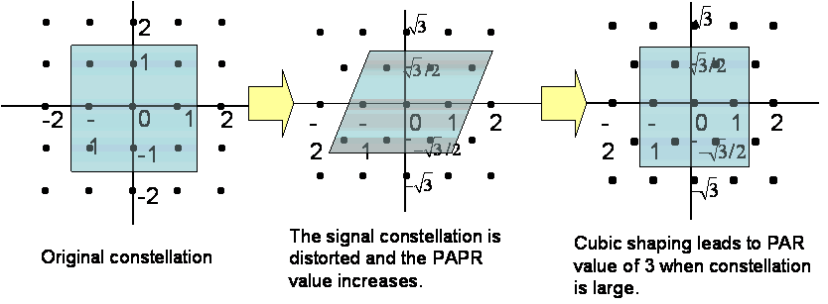
Figure 2: Concept of cubic shaping.
In practice, there are a limited number of possible precoding matrices due to limited channel condition feedback. In this case, the integer-to-integer mapping can be computed offline and stored in a lookup table to reduce the real-time computational complexity.
Since the transmitter IFFT in OFDM can be considered a precoder, the above method can also be applied to reduce the high PAPR caused by IFFT. In the following simulation results, we will show that, even though SVD precoding does not further increase the already high PAPR caused by the IFFT, if we only apply the above method to counter the effect of IFFT but not the SVD precoding, the PAPR will remain high due to the SVD precoding. Similarly, if we only counter the effect of SVD precoding, the PAPR will remain high due to IFFT. Thus, it is suggested that the effects of IFFT and precoding should be considered together in power balancing.

Simulation Results
In all of the following simulations, the systems are all 1024-subcarrier OFDM, equipped with 4 antennas and SVD precoding. The fading is independent on the sub-carriers and antennas.
First, we simulated two systems with and without using the power balancing method to counter the SVD precoding. The simulation results in Figure 3 show that PAPR values with and without power balancing are almost the same. This is because the power balancing method makes the constellation after SVD precoding cubic which is similar to the constellation boundary without SVD precoding. In Figure 1 it is already shown that the PAPR values with and without precoding are almost the same. Thus countering only the SVD precoding does not make a difference.
Figure 3: CCDF of systems with and without power balancing against SVD precoding.
We also considered two systems with and without power balancing against the effect of IFFT. The simulation results in Figure 4 again show that the PAPR is not reduced.
Figure 4: CCDF of systems with and without power balancing against IFFT.
Finally, we considered applying power balancing against both SVD precoding and IFFT. The results in Figure 5 show that the PAPR can be reduced about 1.5 dB at 10⁻⁴ CCDF.
A similar simulation was done for a downlink OFDMA system with 2 users each allocated 512 subcarriers. The power balancing was done separately and independently for the 2 users. Figure 6 shows that, in this situation, power balancing still provides PAPR reduction of about 0.7 dB at 10⁻⁴ CCDF.
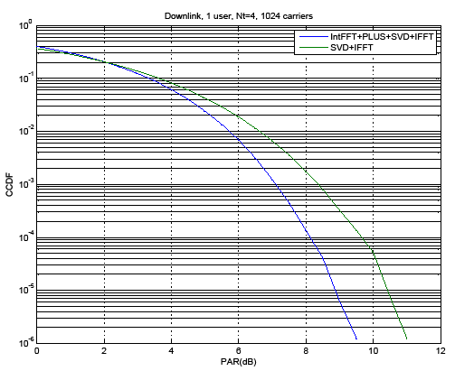
Figure 5: CCDF of systems with and without power balancing against both SVD precoding and IFFT.
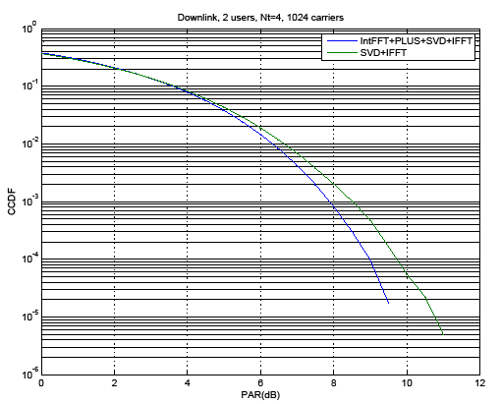
Figure 6: CCDF of a downlink OFDMA system with individual power balancing for two 512-subcarrier users.
For uplink OFDMA, a user only uses a fraction of the subcarriers. The power balancing results for a user using 512, 256 and 128 subcarriers are shown in Figures 7, 8, 9, respectively. These results again show the PAPR reduction of the power balancing method. For all cases, there is a slightly more than 1 dB PAPR reduction.
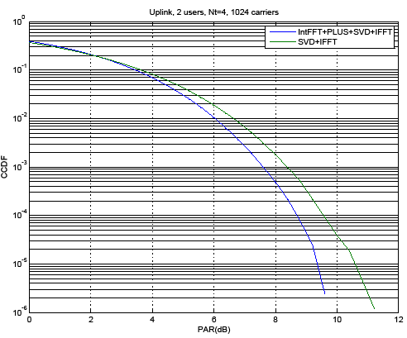
Figure 7: CCDF of a 512-subcarrier uplink OFDMA system.
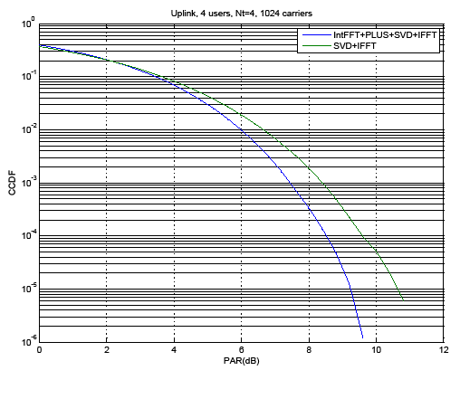
Figure 8: CCDF of a 256-subcarrier uplink OFDMA system.
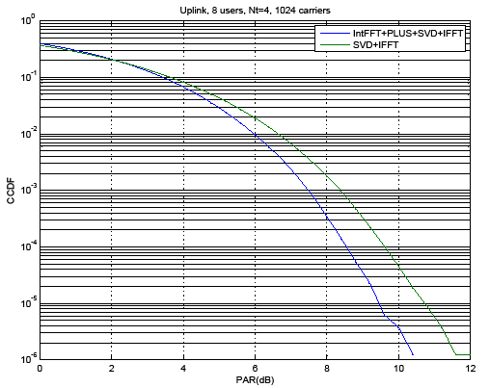
Figure 8: CCDF of a 128-subcarrier uplink OFDMA system.
To show that the power balancing method does not degrade the performance, we consider a simple example where the number of subcarrier is 128. In Figure 9, it is shown that the FER with power balancing is only slightly worse than that without power balancing.
Figure 9: FER with and without power balancing.

Conclusions
In this contribution, we have addressed the high PAPR issue related to MIMO beamforming/precoding and OFDM. It is suggested that a general remedy to the PAPR issue without introducing signal distortion or side information feeding forward should be considered in 802.16m. A method based on constellation shaping to balance the signal power, such that the high PAPR caused by beamforming/precoding and OFDM can be reduced, is also provided in this contribution as an example of such general remedies.
It is proposed that the 802.16m systems should include the PAPR reduction functionality via power balancing for the MIMO beamforming/precoding and IFFT, and the SDD should adopt the proposed texts listed as follows.
Proposed Text:

11.12.1 UL MIMO Architecture and Data Processing

Modify Figure 52 as follows.

User
Data
Encoder
Encoder
Encoder

Resource
Mapping

MIMO
Encode

Beamformer

OFDM
Symbol
Construction
IFFT
IFFT
IFFT
Resource Allocation
MCS / Packet Size
ACK/NAK
MIMO Mode / Rank /PMI

Precoding Matrix

Power Balancing
Figure 42 MIMO Architecture

Add the following text to line 7 on page 115.

Power balancing functionality in the beamformer/pre-coder and IFFT block is FFS.

References
- IEEE 802.16m-08/003r5, “802.16m System Description Document”.
- H.-J. Su, C.-P. Lee, C.-Y. Chen, W.-S. Liao, R.-J. Chen, C.-L. Ho, C.-L. Tsai, Y.-X. Zheng, IEEE C802.16m-08/1302r3, “Peak-to-Average Power Ratio Issue of Beamforming/Precoding Schemes”.
- C.–P. Lee, H.–J. Su, “Peak to Average Power Ratio Reduction of Space-Time Codes That Achieve Diversity-Multiplexing Gain Tradeoff,” IEEE International Symposium on Personal, Indoor and Mobile Communications, September 2008.

