Project | IEEE 802.16 Broadband Wireless Access Working Group <http://ieee802.org/16>
Title | IEEE 802.16m UL PHY Control – Tail Biting Convolutional Codes for the Secondary Fast Feedback Channel with Performance and Complexity Analysis
Date Submitted | January 11, 2009
Source(s) | Jason Chen, Kai Yu, Per Ernström, Sten Sjöberg  Ericsson | Email: jason.t.chen@ericsson.com,  kai.a.yu@ericsson.com
Re: | Comments to SDD (IEEE 802.16m-08/003r6) Subsection 11.9.2.1.2 PHY structure  Ballot id: tgmsdd
Abstract | Tail Biting Convolutional Codes are proposed to be used for the Secondary Fast Feedback Channel, allowing low complexity WAVA (Wrap Around Viterbi Algorithm) decoding, and reuse of tail biting decoder structures already implemented for 802.16e equipment. Over the AWGN channel, the performances of the TBCC with WAVA decoding are simulated and shown to outperform codes previously proposed to be used for the Secondary Fast Feedback Channel, despite the fact that a high complexity ML-decoding (MLD) algorithm was used for those codes. Over the fading channels, the performances of the TBCC with WAVA decoding are about the same or a little bit worse than the codes previously proposed to be used for the Secondary Fast Feedback Channel over the simulated SNR range; however, the decoding complexity of WAVA is much less than that of MLD. We also provide analysis on the complexity of decoding TBCC.
Purpose | Discussion and Eventual Adoption
Notice | This document does not represent the agreed views of the IEEE 802.16 Working Group or any of its subgroups. It represents only the views of the participants listed in the “Source(s)” field above. It is offered as a basis for discussion. It is not binding on the contributor(s), who reserve(s) the right to add, amend or withdraw material contained herein.
Release | The contributor grants a free, irrevocable license to the IEEE to incorporate material contained in this contribution, and any modifications thereof, in the creation of an IEEE Standards publication; to copyright in the IEEE’s name any IEEE Standards publication even though it may include portions of this contribution; and at the IEEE’s sole discretion to permit others to reproduce in whole or in part the resulting IEEE Standards publication. The contributor also acknowledges and accepts that this contribution may be made public by IEEE 802.16.
Patent Policy | The contributor is familiar with the IEEE-SA Patent Policy and Procedures:  <http://standards.ieee.org/guides/bylaws/sect6-7.html#6> and <http://standards.ieee.org/guides/opman/sect6.html#6.3>.  Further information is located at <http://standards.ieee.org/board/pat/pat-material.html> and <http://standards.ieee.org/board/pat>.

Tail Biting Convolutional Codes for the Secondary Fast Feedback Channel with Performance and Complexity Analysis
Jason Chen, Kai Yu, Per Ernström, Sten Sjöberg
Ericsson AB

Introduction

Tail Biting Convolutional Codes (TBCC) are considerably less complex to decode compared to general block codes, since the regular trellis can be used for decoding, using e.g. the Wrap Around Viterbi Algorithm (WAVA) [3]. Note also that tail biting codes are used in 802.16e and thus reuse of already implemented tail biting receiver structures is possible. Therefore TBCC should be utilized unless alternative codes provide very significant performance gains over TBCC.

In [1], each 2x6 feedback mini-tile (FMT) has 2 pilot tones, and a rate 1/5, (60,12), linear block code with minimum hamming distance 24, was proposed to be used to encode a 12 bit payload onto the Secondary Fast Feedback Channel. By using the first half of the same code, a rate 2/5, (30,12), linear block code was proposed in [1] to be used for a 24 bit payload (the first 12 bits and the second 12 bits are encoded separately). By using the first 7 rows of the generator matrix for the (60,12) linear block code, a rate 7/60, (60,7), linear block code was also proposed in [1] to be used for a 7 bit payload.

Here we show that there exists a rate 1/5, (60,12), TBCC, a rate 2/5, (30,12), TBCC, and a rate 7/60, (60,7), TBCC that have better or similar performances than the codes proposed in [1] over the AWGN channel. This holds even though ideal MLD is used for the codes proposed in [1], while simple WAVA is used for the TBCC. The differences between the codes are clearly manifested also in the larger minimum hamming distance (d_{min}), or in the smaller multiplicity (n_{dmin}), for the codes described here (see Table 1). Over the fading channels, the performances of the rate 1/5 and rate 2/5 TBCC with WAVA decoding are about the same or a little bit worse than the codes proposed in [1] over the simulated SNR range; however, the decoding complexity of WAVA is much less than that of MLD. Over the fading channels, the performances of the rate 7/60 TBCC are better than the codes proposed in [1] by about 0.2dB.We propose that the rate 1/5, rate 2/5, and rate 7/60 TBCC are used to encode the 12 bit payload, 24 bit payload and 7 bit payload, respectively, onto the Secondary Fast Feedback Channel when each 2x6 FMT has 2 pilot tones.

In this document, we use the FMT structure proposed by Intel [1] as shown in Figure 1. Based on the simulation and complexity analysis in this document, we propose to use the TBCC for the secondary fast feedback channel.

Figure 1: The 2x6 feedback mini-tile (FMT) structure.

Definition

New terminology used in this document is defined in this section:

Tail-biting convolutional code (TBCC) [2].

Wrap-Around Viterbi algorithm (WAVA) [3]: low-complexity trellis-type algorithm for decoding tail-biting convolutional codes.

Linear Block Codes Derived from Tail-Biting Convolutional Codes

In this section, we show that linear block codes derived from the tail-biting convolutional codes [2][4] can be used to improve the channel coding performances of the secondary fast feedback channel.

When each 2x6 FMT has 2 pilot tones, linear block codes with rates 1/5 and 2/5 are used to encode 12 payload bits, and the linear block code with rate 7/60 is used to encode 7 payload bits. The comparisons between the linear block codes proposed by Intel [1] and the tail-biting convolutional codes with rates 1/5, 2/5 and 7/60 are summarized in Table 1. In Table 1, (n,k) means that a linear block code takes k bits as input and outputs a length-n codeword. For (d_{min},n_{dmin}), d_{min} is the minimum Hamming distance, and n_{dmin} is the multiplicity (number of nearest neighboring codewords). From Table 1, we see that the 2 TBCC proposed in this document have achieved the theoretical limits of d_{min} for corresponding (n,k) pairs. The TBCC proposed in this document are described in the following subsections.
Table 1: Comparisons between the linear block codes proposed by Intel and the TBCC with coding rates 1/5, 2/5 and 7/60.
Linear Block Codes, Code Rate, (n, k), Number of States (for TBCC) | Generator Matrix | (d_{min},n_{dmin}) | Lower and Upper Bounds on d_{min} for Given (n, k) | Available Decoding Algorithm
Intel, 1/5, (60, 12) | G_1_5_Intel | (24, 726) | (24, 24) | MLD
TBCC, 1/5, (60, 12), 128 | G_1_5 | (24, 659) | (24, 24) | low-complexity WAVA, MLD
Intel, 2/5, (30,12) | G_2_5_Intel | (7, 3) | (9, 9) | MLD
TBCC, 2/5, (30, 12), 64 | G_2_5 | (9, 72) | (9, 9) | low-complexity WAVA, MLD
Intel, 7/60, (60, 7) | G_1_5_Intel | (24, 51) | (28, 28) | MLD
TBCC, 7/60, (60, 7), 128 | G_1_5 | (24, 16) | (28, 28) | low-complexity WAVA, MLD

The rate 1/5, (60,12) TBCC is obtained by searching the 128-state (60,12) TBCC with the best (d_{min},n_{dmin}). If more than one TBCC have the same (d_{min},n_{dmin}), the one with the optimum distance spectrum [5] for lowest frame error rate is selected. The set of generator polynomials for this TBCC is (16, 112, 556, 636, 656). The corresponding 12-by-60 generator matrix for the rate 1/5, (60,12) TBCC, G_1_5, is given by

0 0 1 1 1 0 0 0 1 1 1 1 1 0 0 1 0 1 0 1 1 0 0 1 0 0 1 1 1 1
0 0 0 0 0 0 0 1 1 1 0 0 0 1 1 1 1 1 0 0 1 0 1 0 1 1 0 0 1 0
0 0 0 0 0 0 0 0 0 0 0 0 1 1 1 0 0 0 1 1 1 1 1 0 0 1 0 1 0 1
0 0 0 0 0 0 0 0 0 0 0 0 0 0 0 0 0 1 1 1 0 0 0 1 1 1 1 1 0 0
0 0 0 0 0 0 0 0 0 0 0 0 0 0 0 0 0 0 0 0 0 0 1 1 1 0 0 0 1 1
0 1 1 1 1 0 0 0 0 0 0 0 0 0 0 0 0 0 0 0 0 0 0 0 0 0 0 1 1 1
0 0 1 1 1 0 1 1 1 1 0 0 0 0 0 0 0 0 0 0 0 0 0 0 0 0 0 0 0 0
0 1 1 1 1 0 0 1 1 1 0 1 1 1 1 0 0 0 0 0 0 0 0 0 0 0 0 0 0 0
1 0 0 1 0 0 1 1 1 1 0 0 1 1 1 0 1 1 1 1 0 0 0 0 0 0 0 0 0 0
1 0 1 0 1 1 0 0 1 0 0 1 1 1 1 0 0 1 1 1 0 1 1 1 1 0 0 0 0 0
1 1 1 0 0 1 0 1 0 1 1 0 0 1 0 0 1 1 1 1 0 0 1 1 1 0 1 1 1 1
0 0 0 1 1 1 1 1 0 0 1 0 1 0 1 1 0 0 1 0 0 1 1 1 1 0 0 1 1 1

for the first 30 columns, and

0 0 1 1 1 0 1 1 1 1 0 0 0 0 0 0 0 0 0 0 0 0 0 0 0 0 0 0 0 0
0 1 1 1 1 0 0 1 1 1 0 1 1 1 1 0 0 0 0 0 0 0 0 0 0 0 0 0 0 0
1 0 0 1 0 0 1 1 1 1 0 0 1 1 1 0 1 1 1 1 0 0 0 0 0 0 0 0 0 0
1 0 1 0 1 1 0 0 1 0 0 1 1 1 1 0 0 1 1 1 0 1 1 1 1 0 0 0 0 0
1 1 1 0 0 1 0 1 0 1 1 0 0 1 0 0 1 1 1 1 0 0 1 1 1 0 1 1 1 1
0 0 0 1 1 1 1 1 0 0 1 0 1 0 1 1 0 0 1 0 0 1 1 1 1 0 0 1 1 1
0 0 1 1 1 0 0 0 1 1 1 1 1 0 0 1 0 1 0 1 1 0 0 1 0 0 1 1 1 1
0 0 0 0 0 0 0 1 1 1 0 0 0 1 1 1 1 1 0 0 1 0 1 0 1 1 0 0 1 0
0 0 0 0 0 0 0 0 0 0 0 0 1 1 1 0 0 0 1 1 1 1 1 0 0 1 0 1 0 1
0 0 0 0 0 0 0 0 0 0 0 0 0 0 0 0 0 1 1 1 0 0 0 1 1 1 1 1 0 0
0 0 0 0 0 0 0 0 0 0 0 0 0 0 0 0 0 0 0 0 0 0 1 1 1 0 0 0 1 1
0 1 1 1 1 0 0 0 0 0 0 0 0 0 0 0 0 0 0 0 0 0 0 0 0 0 0 1 1 1

for the last 30 columns.

The rate 2/5, (30,12) TBCC is obtained by puncturing the rate 1/3, (36,12) TBCC with 64 states. The search is performed over the rate 1/3, (36,12) TBCC with all possible uniform puncturing patterns, and the one with the best (d_{min},n_{dmin}) is selected. The set of generator polynomials for the rate 1/3 mother code is (464, 474, 670), and the puncturing pattern for the rate 1/3 mother code is [1 1; 1 1; 1 0]. The corresponding 12-by-30 generator matrix for the rate 2/5, (30,12) TBCC, G_2_5, is given by

1 1 1 0 0 0 0 0 1 1 1 1 1 0 1 1 1 0 0 0 0 0 0 0 0 0 0 0 0 0
0 0 0 1 1 0 0 1 0 0 1 1 1 1 1 0 1 1 1 1 0 0 0 0 0 0 0 0 0 0
0 0 0 0 0 1 1 1 0 0 0 0 0 1 1 1 1 1 0 1 1 1 0 0 0 0 0 0 0 0
0 0 0 0 0 0 0 0 1 1 0 0 1 0 0 1 1 1 1 1 0 1 1 1 1 0 0 0 0 0
0 0 0 0 0 0 0 0 0 0 1 1 1 0 0 0 0 0 1 1 1 1 1 0 1 1 1 0 0 0
0 0 0 0 0 0 0 0 0 0 0 0 0 1 1 0 0 1 0 0 1 1 1 1 1 0 1 1 1 1
1 1 0 0 0 0 0 0 0 0 0 0 0 0 0 1 1 1 0 0 0 0 0 1 1 1 1 1 0 1
0 1 1 1 1 0 0 0 0 0 0 0 0 0 0 0 0 0 1 1 0 0 1 0 0 1 1 1 1 1
1 1 1 0 1 1 1 0 0 0 0 0 0 0 0 0 0 0 0 0 1 1 1 0 0 0 0 0 1 1
1 1 1 1 1 0 1 1 1 1 0 0 0 0 0 0 0 0 0 0 0 0 0 1 1 0 0 1 0 0
0 0 0 1 1 1 1 1 0 1 1 1 0 0 0 0 0 0 0 0 0 0 0 0 0 1 1 1 0 0
0 0 1 0 0 1 1 1 1 1 0 1 1 1 1 0 0 0 0 0 0 0 0 0 0 0 0 0 1 1.

The rate 7/60, (60,7) TBCC is obtained by using a subset of the row vectors in G_1_5: G_7_60=G_1_5([0,2,4,5,6,8,10],:).

Simulation Results and Complexity Analysis

Performance Results over the AWGN Channel

Figure 2, Figure 3 and Figure 4 show the packet error rate (PER) performances over the AWGN channel of the 6 codes considered in this document. The advantages of TBCC over the linear block codes proposed by Intel are summarized as follows:

- G_1_5, G_2_5 and G_7_60 can be decoded by low-complexity trellis-based decoding algorithms, like the wrap-around Viterbi algorithm (WAVA) [3], as they are derived from TBCC.
- G_1_5 and G_1_5_Intel have the same d_{min} (24), but G_1_5 has smaller n_{dmin} (659) than the n_{dmin} (726) of G_1_5_Intel. Over the AWGN channel, G_1_5 with WAVA has about the same performance as G_1_5_Intel with MLD, even though ideal MLD is used for decoding G_1_5_Intel while simple WAVA is used for decoding G_1_5. G_1_5 has slightly better PER performance than G_1_5_Intel at the very high SNR region (due to smaller n_{dmin}), if both are decoded by MLD.
  - G_2_5 has larger d_{min} (9) than the d_{min} (7) of G_2_5_Intel. Over the AWGN channel, G_2_5 has about 0.3dB gain over G_2_5_Intel at PER=10⁻⁶.
  - Over the AWGN channel, G_7_60 has about 0.3dB gain over G_7_60_Intel at PER=10⁻⁶.

Despite the use of the low complexity WAVA decoding algorithm, the PER performance of G_1_5 is about the same as G_1_5_Intel decoded with high complexity MLD. Thus, we propose that the length-12 feedback message be encoded by the rate 1/5, (60,12), TBCC G_1_5.

The PER performances of G_2_5 and G_7_60 are clearly better than G_2_5_Intel and G_7_60_Intel, respectively. Thus we propose that the length-24 feedback message be encoded by the rate 2/5, (30,12), TBCC G_2_5, and the length-7 feedback message be encoded by the rate 7/60, (60,7), TBCC G_7_60.

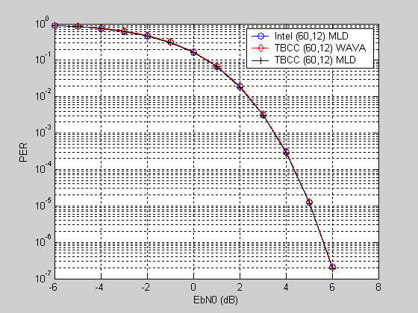
Figure 2: Comparisons of packet error rate (PER) over the AWGN channel. Optimum ML decoding (MLD) is used for the rate 1/5, (60,12) code proposed by Intel. Optimum MLD and sub-optimum wrap-around Viterbi algorithm (WAVA) are used to decode the rate 1/5, (60,12), TBCC.
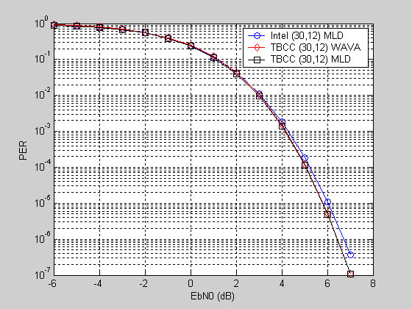
Figure 3: Comparisons of packet error rate (PER) over the AWGN channel. Optimum ML decoding (MLD) is used for the rate 2/5, (30,12) code proposed by Intel. Optimum MLD and sub-optimum wrap-around Viterbi algorithm (WAVA) are used to decode the rate 2/5, (30,12), TBCC.
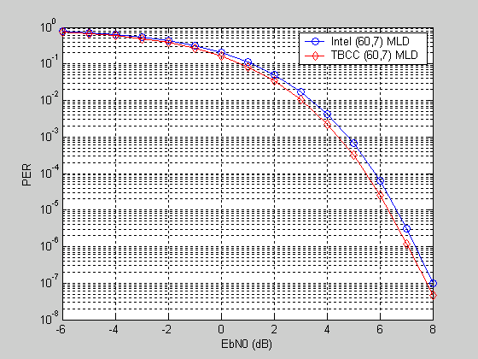
Figure 4: Comparisons of packet error rate (PER) over the AWGN channel. Optimum ML decoding (MLD) are used for the rate 7/60, (60,7) code proposed by Intel, and the rate 7/60, (60,7), TBCC.

Performance Results over Fading Channels

Figure 5 and Figure 6 show the packet error rate (PER) performances over the Pedestrian B fading channel and the Vehicular fading channel, respectively, of the 6 codes considered in this document. The simulation parameters are summarized in Table 2. The results are summarized as follows:

- For the (60,12) codes over the Pedestrian B fading channel with 3Km/hr, the performances of TBCC with MLD and Intel’s code with MLD are about the same, and TBCC is a little bit better over the high SNR region. The performance of Intel’s code with MLD is slightly better than that of TBCC with WAVA decoding; however, the difference is small.

- For the (60,12) codes over the Vehicular A fading channel with 120Km/hr, the performances of TBCC with MLD and Intel’s code with MLD are about the same. The performance of Intel’s code with MLD is slightly better than that of TBCC with WAVA decoding; however, the difference is small.

- For the (30,12) codes over both the Pedestrian B fading channel with 3Km/hr and the Vehicular A fading channel with 120Km/hr, the performances of TBCC with MLD are slightly better than those of Intel’s code. The performances of TBCC with WAVA decoding and Intel’s code with MLD are about the same.

- For the (60,7) codes over both the Pedestrian B fading channel with 3Km/hr and the Vehicular A fading channel with 120Km/hr, the performances of TBCC with MLD are better than those of Intel’s code by about 0.2dB.

From the above comparisons, the performances of TBCC with MLD are better than or about the same as those of Intel’s codes with MLD. If the sub-optimum WAVA decoding is used for TBCC, the performances of TBCC with WAVA are equal to or a little bit worse than those of Intel’s codes with MLD over the simulated SNR range. In the next subsection, we will show that the decoding complexities of WAVA are much lower than those of MLD considered in this document.

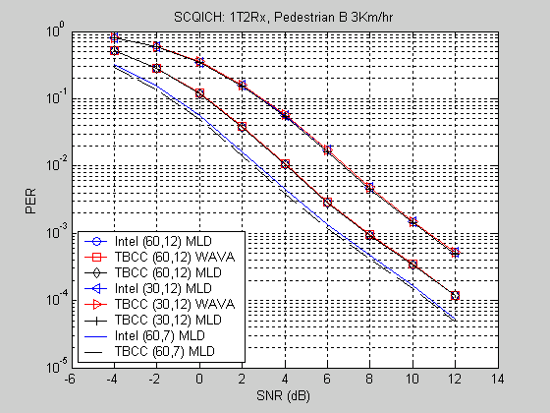
Figure 5: Comparisons of packet error rate (PER) over the Pedestrian B fading channel with speed 3Km/hr. Optimum ML decoding (MLD) is used for the codes proposed by Intel. Optimum MLD and/or sub-optimum wrap-around Viterbi algorithm (WAVA) are used to decode the TBCC.
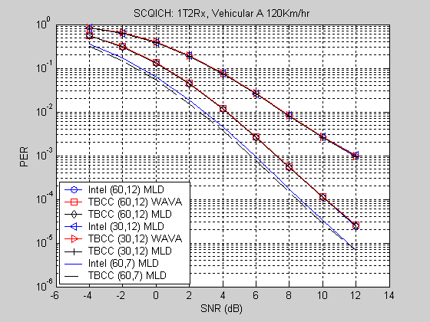
Figure 6: Comparisons of packet error rate (PER) over the Vehicular A fading channel with speed 120Km/hr. Optimum ML decoding (MLD) is used for the codes proposed by Intel. Optimum MLD and/or sub-optimum wrap-around Viterbi algorithm (WAVA) are used to decode the TBCC..
Table 2: Simulation parameters over fading channels.
Simulation Parameter | Value
Channel bandwidth | 10MHz
Oversampling factor | 28/25
FFT size | 1024
Cyclic prefix ratio | 1/8
Fading channel | Pedestrian B 3Km/hr, Vehicular A 120Km/hr
Antenna Scheme | 1Tx at MS, 2Rx at BS
Modulation | QPSK
Pilot boosting | Off (same Tx power as data tones)
Channel estimation | Average of pilot tones in one FMT
Tile size | 2x6 (2 tones by 6 symbols)
Block size | 6x6 (3 distributed FMT)
Decoding algorithm | MLD for Intel’s codes  MLD and WAVA for TBCC

Complexity Analysis

We compare the complexities of the ML decoding algorithm and the wrap-around Viterbi algorithm (WAVA) for decoding the candidate linear block codes. The results are summarized in Table 3. In Table 3, “add” refers to adding 2 real numbers. “multiply” means that the received soft bit value is multiplied by either +1 or -1, and this can be replaced by some simple operation like checking whether a coded bit is 0 or 1. “compare” refers to comparing 2 numbers and picking the larger one. “WAVA with max 4 iterations” means that a maximum number of 4 iterations is allowed during the decoding process, but the decoding can be early terminated if some termination condition (like the simple termination condition [3]) is satisfied. For the rate 1/5 and 2/5 TBCC considered in this document , the average number of iterations used by WAVA (see Figure 7) over the AWGN channel is about 4 over the low SNR region and is about 1 over the large SNR region. Therefore, we use 4 iterations in the complexity computation in the row marked by “low SNR”, and we use 1 iteration in the complexity computation in the row marked by “high SNR”. Over the high SNR region, the decoding complexity of WAVA is about the same as that for the conventional Viterbi algorithm. On the other hand, the MLD complexity is fixed over all SNR region. The complexities of WAVA apply to fading channels as well, since the average number of iterations used by WAVA over the fading channels range from 4 (over the low SNR region) to 1 (over high SNR region).

For an (n,k) linear block code, the complexity of the ML decoding (brute-force and not over the trellis) is proportional to the product of the number of codewords 2^{k} and the codeword length. On the other hand, the complexity of using WAVA for decoding TBCC is proportional to the following parameters: the number of trellis states, the number of decoding iterations and the codeword length. From Table 3, it is clear that the decoding complexity of WAVA is much lower than MLD.
Table 3: Comparisons of decoding complexities. MLD is used for the linear block codes proposed by Intel, and WAVA is used for TBCC.
Linear Block Code, Code Rate, (n,k), Number of States (for TBCC) | Decoding Algorithm | SNR range | # add | # multiply | # compare
Intel, 1/5, (60, 12) | MLD | all | 241664 | 245760 | 4095
TBCC, 1/5, (60, 12), 128 | WAVA with max 4 iterations (over the 128-state trellis) | low SNR | 13824 | 17280 | 6652
TBCC, 1/5, (60, 12), 128 | WAVA with max 4 iterations (over the 128-state trellis) | high SNR | 4608 | 17280 | 1663
Intel, 2/5, (30,12) | MLD | all | 118784 | 122880 | 4095
TBCC, 2/5, (30, 12), 64 | WAVA with max 4 iterations (over the 64-state trellis) | low SNR | 6264 | 4032 | 3324
TBCC, 2/5, (30, 12), 64 | WAVA with max 4 iterations (over the 64-state trellis) | high SNR | 1656 | 4032 | 831

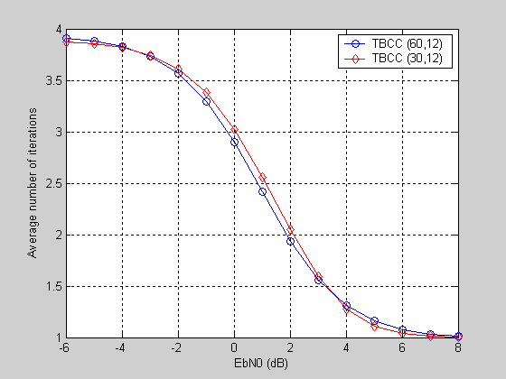
Figure 7: Average number of iterations used by WAVA for decoding TBCC over the AWGN channel. A maximum number of 4 iterations is allowed for WAVA in the simulations.

Based on the above simulation and complexity analysis, we propose to use the TBCC for the secondary fast feedback channel with the FMT structure proposed by Intel.

SDD Text Proposal

Add the following text at the end of subsection 11.9.2.1.2 of the SDD:

Each logical secondary fast feedback channel occupies 3 FMTs and each FMT consists of 2 pilot tones and 10 data tones. For 12 bits payload, the feedback information is encoded to 60 bits by the (60,12) tail-biting convolutional code with generator polynomials (16, 112, 556, 636, 656), and the 60 encoded bits are modulated to 30 QPSK symbols. For 24 bits payload, the first 12 bits of feedback information and the last 12 bits of feedback information are both encoded to 30 bits by the (30,12) tail-biting convolutional code with generator polynomials (464, 474, 670) and the puncturing pattern [1 1; 1 1; 1 0], and the total 60 encoded bits are modulated to 30 QPSK symbols. For 7 bits payload, the feedback information is encoded to 60 bits by the (60, 7) tail-biting convolutional code with the generator matrix consisting of 0th, 2nd, 4th, 5th, 6th, 8th and10th rows of the generator matrix for the (60,12) tail-biting convolutional code, and the total 60 encoded bits are modulated to 30 QPSK symbols.

Appendix: Comparisons with Samsung’s Linear Block Codes

The comparisons between the linear block codes proposed by Samsung [6] and the tail-biting convolutional codes with rates 1/5, 2/5 and 7/60 are summarized in Table 4. For both code rates 1/5 and 7/60, TBCC has the same minimum hamming distance (d_{min}) as that of Samsung’s linear code, but the multiplicity (n_{dmin}) of TBCC is smaller. For code rate 2/5, TBCC has larger minimum hamming distance (d_{min}) than that of Samsung’s linear code. Therefore the performances of TBCC with WAVA are expected to be better than or about the same as those of Samsung’s linear codes decoded by MLD. However, the decoding complexity of WAVA is much less than that of MLD.
Table 4: Comparisons between the linear block codes proposed by Samsung and the TBCC with coding rates 1/5, 2/5 and 7/60.
Linear Block Codes, Code Rate, (n, k), Number of States (for TBCC) | Generator Matrix | (d_{min},n_{dmin}) | Lower and Upper Bounds on d_{min} for Given (n, k) | Available Decoding Algorithm
Samsung, 1/5, (60, 12) |  | (24, 730) | (24, 24) | MLD
TBCC, 1/5, (60, 12), 128 | G_1_5 | (24, 659) | (24, 24) | low-complexity WAVA, MLD
Samsung, 2/5, (30,12) |  | (6, 4) | (9, 9) | MLD
TBCC, 2/5, (30, 12), 64 | G_2_5 | (9, 72) | (9, 9) | low-complexity WAVA, MLD
Samsung, 7/60, (60, 7) |  | (24, 43) | (28, 28) | MLD
TBCC, 7/60, (60, 7), 128 | G_1_5 | (24, 16) | (28, 28) | low-complexity WAVA, MLD

References

- IEEE C802.16m-UL_PHY_Ctrl-08/065r2, “IEEE 802.16m UL PHY Control: CQI Feedback Channel Design”.

- H. H. Ma and J. K. Wolf, “On tail biting convolutional codes,” IEEE Trans. Commun., vol. 34, pp. 104-111, Feb. 1986.

- R. Y. Shao, S. Lin and M. P. C. Fossorier, “Two decoding algorithms for tail-biting codes,” IEEE Trans. Commun., vol. 51, no. 10, pp. 1658-1665, Oct. 2003.

- S. Lin and D. J. Costello, Jr, Error control coding. Upper Saddle River, New Jersey: Pearson, 2004.

- P. Frenger, P. Orten and T. Ottosson, “Convolutional codes with optimum distance spectrum,” IEEE Commun. Letters, vol. 3, no. 11, Nov. 1999.

- IEEE C802.16m-09/0190r1, “Proposal for Physical Structure of UL Feedback Channel”.

The multiplications in either decoder (MLD or WAVA) are by +1 or -1, and they are relatively irrelevant to the complexity.

